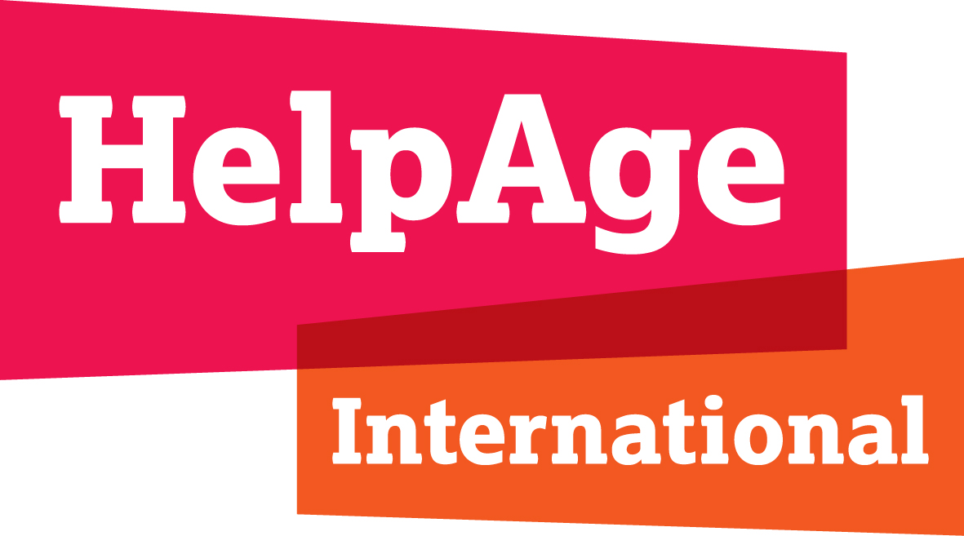

  - HelpAge statements at the
  - 76th World Health Assembly
May 2023

Below are constituency statements that HelpAge is supporting and individual statements we will be making on key agenda items.

Agenda item 13.1 Universal Health Coverage: Reorienting health systems to primary health care as a resilient foundation for universal health coverage and preparations for a high-level meeting of the United Nations General Assembly on universal health coverage

Constituency statement by: Alzheimer’s Disease International, Anesvad Foundation, Christian Blind Mission, Fred Hollows Foundation, Handicap International Federation, HelpAge International, International Alliance for Hospice and Palliative Care, International Federation on Ageing, International Federation of Anti-Leprosy Associations, International League of Dermatological Societies, Royal Commonwealth Society for the Blind (Sightsavers), and The Worldwide Hospice Palliative Care Alliance.
Statement: Governments have committed to ensuring no one is left behind in UHC. Yet today, 1.3 billion persons with disabilities continue to experience lower quality services or find the healthcare they need is inaccessible and unaffordable. Many face catastrophic health expenditure and poverty, and much poorer health outcomes.
UHC will only be achieved through concerted action to tackle these inequities across the continuum of care, with specific investments to reach those at greatest risk of being left behind.
This requires making health systems more inclusive through people-centred, rights-based, community-based and whole of society approaches founded upon primary health care – actions that benefit everyone.
Population ageing and escalating prevalence of non-communicable and poverty-related communicable diseases that cause long-term impairments make this an urgent priority.
We urge Member States to:
- Champion health equity for persons with disabilities and older people and uphold their right to health. This must ensure non-discrimination, progressive universalism, and inclusive health financing and governance with the full participation of persons with disabilities, recognising that they are among those with the greatest needs but often left furthest behind.
- Ensure accessibility of person-centred primary health care close to where people live and reaching the furthest behind first, with essential service packages that enable persons with disabilities to enjoy their right to health-related goods, facilities, services and information that meet their physical and mental health needs across the continuum of care, throughout the life course and on an equal basis with others. This must ensure expanded coverage and improved accessibility of mental health services, sexual and reproductive health services; health information; nutrition services; vision, hearing, oral and skin health services; dementia services; neglected tropical diseases and wider communicable and non-communicable disease prevention and care; immunization; rehabilitation and assistive products; palliative and end of life care; and integrated, long-term and rights-based care and support within the community.
- Strengthen political leadership and country ownership of the fight against eye and skin related NTDs, fully integrated with UHC approaches.
- Ensure systematic disaggregation of health-related data by gender, age, disability and other characteristics, to inform equity-based decision-making focused on access to essential health benefits packages, primary health care, and financial protection.
- Ensure standards, competencies and training on disability inclusion for the health and care workforce and all service providers.
- Meaningfully engage persons with disabilities of all ages at all levels.

Agenda item 13.2 Political declaration of the third high-level meeting of the General Assembly on the prevention and control of non-communicable diseases, and mental health

Constituency statement by: European Society for Medical Oncology, HelpAge International, International Association for Hospice and Palliative Care, The Royal Commonwealth Society for the Blind (Sightsavers), Union for International Cancer Control, World Heart Federation, and Worldwide Hospice and Palliative Care Alliance

Statement: We commend the WHO on its work to expand Appendix 3 as an essential tool that supports effective action on Non-Communicable Diseases, and support statement led by NCD Alliance.

Action on NCDs is more urgent than ever. The COVID-19 pandemic caused extensive disruption to NCD prevention, diagnosis, treatment and palliative care services, which will have far reaching impacts on suffering, mortality and rates of disability resulting from NCDs. As countries recover from the pandemic and review progress against UHC commitments at the UN High-Level Meeting later this year, investment and action on NCDs is critical. NCDs account for 74% of global mortality and 80% of years lived with disability across the life-course, therefore UHC cannot be achieved without a comprehensive NCD service package.

To foster effective implementation, we urge Member States to:

- Utilise Appendix 3 in development and scale-up of national UHC benefit packages, ensuring a coherent patient pathway between detection, diagnosis and treatment, underpinned by rehabilitation and palliative care options as needed from the moment of diagnosis
- Plan for the progressive implementation of core NCD interventions, including costing for and adequate and adequate sustainable investments
- Integrate NCD, palliative care and rehabilitation services into existing NCD healthcare infrastructure, educational curricula and programs to equip healthcare providers with the tools and knowledge to deliver rights-based and person-centred care
- Ensure that services are accessible to all, including those in low resource settings, older persons and persons with disabilities, taking into account that NCDs are often the underlying conditions for persons with disabilities
- Invest in comprehensive disease surveillance systems to monitor the effectiveness of NCD interventions, noting the need to remove discriminatory upper age-caps, and collect, analyse, report and use gender-, age- and disability-disaggregated data to ensure that policies and UHC packages address, rather than duplicate, health inequities
- Include NCD care into national health emergency strategies to ensure the continuation of essential service packages
- Leverage the resources of civil society for implementation of relevant actions at the national level.

Agenda item 15.1 Strengthening WHO preparedness for and response to health emergencies
Constituency statement by: Save the Children, Royal Commonwealth Society for the Blind (Sightsavers), Global Health Council, GNP+, HelpAge International, International Federation on Ageing and NCD Alliance
Statement: COVID-19 brought on an unprecedented crisis for people, particularly for those at higher risk and in vulnerable situations, putting their physical, mental health and wellbeing in jeopardy.
Combined with the effects of conflicts and the climate crisis, the pandemic has exacerbated inequities in access to essential services including health and nutrition, care and support, WASH, education, and shone a light on the need to adopt a multisectoral approach to prevent, prepare for and respond to health emergencies.
In order to preserve the life, health, dignity and wellbeing of all people, governments must:
- Champion equity among and between countries as a central element of the global health architecture to prepare for future emergencies and accelerate progress towards universal health coverage and the realisation of the right to health for all. Progressive realisation of UHC is vital to ensure healthy populations and resilience in the face of pandemic threats.
- Prioritise human rights as the foundation of the Pandemic Accord and any future amendments to the International Health Regulations. Health emergencies legal instruments must enhance States’ existing human rights obligations and the realisation of human rights.
- In health emergencies and beyond, ensure the availability, accessibility, acceptability and quality of essential health services and medical countermeasures across the continuum of care, and to all people, without distinction of any kind. These include personal protective equipment, vaccines, diagnostics, and therapeutics.
- Safeguard the continuity of access to health products, services, facilities and information, including for people living with chronic conditions, including NCDs, and persons with disabilities in health emergencies.
- Build on existing multilateral systems and organisations, including the World Health Organization, to drive global efforts for health emergency prevention, preparedness and response.
- Finally, ensure the full, equal, meaningful and effective participation of civil society, affected people, communities and health professionals in the drafting, decision-making and monitoring & compliance of health policies at national, regional and global levels. This will help to build trust and legitimacy in the policy-making process, ultimately ensuring that policies will be accepted and effectively enforced.

Agenda item: 15.2 WHO’s work in health emergencies
A large and rapidly growing number of older people are affected by emergencies, in which they are often those most at risk, yet most overlooked. This has been brutally highlighted during COVID-19 and in ongoing humanitarian emergencies, including in Ukraine, Horn of Africa and the Turkey Syria earthquake.

A radical shift is needed to ensure emergency preparedness and response upholds the rights of all older people.

WHO and humanitarian actors at all levels must:

- Champion age, gender and disability inclusive responses and strengthen policy and capacities at all levels.
- Ensure older people’s physical and mental health and care needs are met in emergencies, including those related to infectious and non-communicable diseases; promotion, prevention, treatment, rehabilitation, long-term care and support, and palliative and end of life care.
- Collect and use sex, age and disability disaggregated data on people of all ages, including the oldest old to inform inclusive responses.
- Engage and empower older people and persons with disabilities at all levels and address the barriers they face to enjoying full and equal access and participation.

Agenda item 16.3 Social determinants of health
Constituency statement by: Alzheimer’s Disease International, Christian Blind Mission, Handicap International Federation, HelpAge International, International Federation on Ageing, NCD Alliance, Royal Commonwealth Society for the Blind (Sightsavers), Taskforce for Global Health, and The Worldwide Hospice Palliative Care Alliance
Statement: We welcome the WHO’s work on the social determinants of health.
As this work continues, we ask that due attention be given to the close interplay of the social determinants of health with disability, ageing, communicable and non-communicable diseases and neglected tropical diseases.
The social determinants of health underpin the definition and experience of disability. Disabilities are strongly influenced by the environments in which we are born, live, work and age, including the social and economic barriers to accessing social protection, assistive technologies, rehabilitation and other health and care services. They are closely coupled with avoidable health inequities for persons with disabilities, compounded by discrimination and experienced as vicious cycles of poverty, exclusion and poorer health outcomes that accumulate across the life course.
Disability may increase the risk of poverty through lack of employment and education opportunities, lower wages, and higher out-of-pocket health expenses and exposure to catastrophic health expenditure.
Poverty also increases the prevalence and severity of disabilities due to a greater risk of long-term impairments from inadequate access to health services or safe water and sanitation, malnutrition, risk of injuries and violence, risk factors for non-communicable diseases, and exposure to neglected tropical diseases and other communicable diseases.
Multiple intersecting factors exacerbate health inequities for persons with disabilities, including ageism and gender-based discrimination. Women and girls with disabilities, older people with disabilities, those in poverty, and those displaced or in remote or insecure contexts are among those most impacted by social determinants of health.
We urge Member States to ensure alignment of the forthcoming world report on the social determinants of health and the associated guidance and its implementation with WHA Resolution 74.8 and the WHO global report on health equity for persons with disabilities. We also call for:
- Investment in primary health care approaches, including health promotion, prevention, treatment, rehabilitation, palliative care and long-term care and support, that are accessible to everyone and close to where people live.
- Inclusive multi-sectoral action underpinned by the systematic use of standardised systems to collect and use sex-, age- and disability-disaggregated data.
- Meaningful engagement and empowerment of persons with disabilities of all ages and organisations working with them.
- Progressive universalism in health insurance and social protection systems
- Action to advance health equity between countries.

Item 16.4 The highest attainable standard of health for persons with disabilities
We congratulate WHO on the Global Report on Health Equity for Persons with Disability. We welcome its recognition of the relationship between ageing and disability and alignment with the Decade of Healthy Ageing. These are mutually reinforcing agendas.

Despite the devastating and disproportionate impact of COVID-19 persons with disabilities and older people globally, they are still being left behind in global health agendas.

Urgent action is needed to address this gap and to advance health equity for persons with disabilities of all ages.

We call on WHO and member states to:

- Address the attitudinal, institutional and environmental barriers older people and persons with disability face in enjoying their right to health.
- Invest in age, gender and disability responsive models of UHC that promote healthy ageing through person-centred and integrated primary and community-based health and care services that reach the furthest behind first.
- Adopt a rights-based approach to UHC, PPPR and promoting health and wellbeing for all, ensuring the meaningful participation of older people and persons with disability at all levels.

Agenda item 27.1 Group 4.3 Decade of Healthy Ageing 2020-2030

We congratulate WHO for their leadership and action on the Decade of Healthy Ageing.

We strongly support the Decade’s focus on tackling ageism, promoting age friendly cities and communities, strengthening person-centred integrated care and primary health services, and promoting access to long-term care and support for older people and their caregivers. We commend WHO and other partners for progress in these areas.

By 2030, 1.4 billion people will be aged 60 and over. Yet the majority of systems and services worldwide remain unprepared for population ageing. This is especially true in low-and middle-income countries where over 70% of older people live.

Today, 142 million older people globally are unable to meet their basic needs, while ageism, age discrimination and a lack of age, gender and disability responsive policies, laws, systems, services and communities, mean they are unable to enjoy their fundamental human rights. This has been brutally highlighted during COVID-19 when despite being among the groups most at risk, older people have been left behind and discriminated against in responses. It is also witnessed in ongoing humanitarian emergencies, including in Ukraine, Horn of Africa and responses to the Turkey Syria earthquake.

To achieve its ambitions, we call for greater investment and commitment to the Decade at the highest levels, and stronger collaboration across UN, Member States, private sector, academic and research institutes, and civil society to ensure older people’s needs and rights are included within population wide agendas – with a focus on advancing equity between and within countries, reaching the furthest behind first. We call for legal and policy frameworks, systems and services fit for an ageing world, underpinned by a new convention on the rights of older people and inclusive data systems, noting there is currently no indicator on older people in either the SDGs, the UHC index or the WHO GPW13. And we call for the engagement, meaningful participation and empowerment of older people at all levels.

