Final External Evaluation “Mainstreaming Older People’s Participation in Building Disaster Resilient Communities”

Submitted by
Rachel Peters and Chiara Ferri
In 5 municipalities of Mindanao, Philippines

October 2013

TABLE OF CONTENT

EXECUTIVE SUMMARY 3
INTRODUCTION TO THE PROJECT 4
DESIGN AND SCOPE OF THE EVALUATION 9
METHODOLOGY 9
SAMPLING 12
LIMITATIONS 13
FINDINGS 14
RELEVANCE 14
EFFECTIVENESS 16
SUSTAINABILITY 19
IMPACT 21
BENEFICIARY PARTICIPATION 25
MONITORING AND EVALUATION 26
RECOMMENDATIONS 27
CONCLUSION 31

EXECUTIVE SUMMARY

This evaluation report is divided into five sections:

- Introduction to the project: In this section, the project background is presented to provide an overview of the project, including the target area and target group, the different components of the project, its overall and specific objectives, its expected results and related activities, partners and key stakeholders and the implementation arrangements with the partners.

- The design and scope of the evaluation: In this section, the purpose and the methodology of the review are explained along with the sampling and the limitations of the evaluation.

- Findings: In this section, the relevance of the project components, as well as the effectiveness, sustainability and impact of the project activities are presented. Relevance demonstrates how the project design, component and the approach matched the needs of the people. Effectiveness implies whether or not the project met its indicators and objectives. The impact of the project is the heart of the project as it explores the benefits of the project as well as the major changes the project brought to the lives of the target groups. Additionally, beneficiaries’ participation and the monitoring & evaluation system are also discussed.

- Recommendations: In this section, based on the findings related to the relevance, sustainability, effectiveness and impact of the project, the evaluator provides recommendations for an eventual extension of the project and further future initiatives which will be undertaken by COSE-HelpAge International in the Philippines.

- Conclusion: The evaluator makes conclusions on the way forward for COSE-HelpAge International.

INTRODUCTION TO THE PROJECT

Context: Mindanao, located in the southern part of the Philippines, is one of the most disaster-prone areas in the Pacific region and its population is particularly affected by the triple factors of persistent poverty, insecurity and natural hazards.
In fact, in the past few decades, weather-related hazards, such as heavy rains and storm surges have significantly increased in the region and especially on the coastal line - affecting the poor the hardest - by causing repeated flooding, displacing thousands of people and destroying their houses, livelihoods and social infrastructure.
It has been recognized that older people - one of the most vulnerable group - have been particularly affected by the impacts induced by the above mentioned natural hazards. Not least, disasters such as Typhoon Sendong in 2011 and Typhoon Pablo in 2012 have exacerbated the situation of elderly in Mindanao and have rendered them particularly vulnerable.
This scenario drove COSE, in partnership with HelpAge International, to launch the eighteen months project “mainstreaming older people’s participation in building disaster resilient community” in May 2012.
Target area: The project has been designed and implemented in eleven municipalities of seven provinces of Mindanao, including 50 barangays (local communities) with a focus on those living in the most disaster-prone areas on the coastal line. More specifically, the project has been targeting the following regions:
- Region X (Northern Mindanao – Malaybalay City, Maramag, Calamba, Ozamis City)
- Region XI (Davao Region, Davao City, Mati City)
- Region XII (Socsargen –General Santos City, Dadiangas)
- Region VIII (Caraga, City of Bislig, Trento, Bunawan, Rosario)
Target group: The project specifically targeted older persons, who, due to their physical limitations (such as limited mobility as well as visual and audio faculty) and, sometimes, discrimination from other social groups, are considered to be one of the most vulnerable sectors during disasters. With regards to the direct beneficiaries, the project targeted Older People Organizations (OPOs) present in Mindanao. More specifically, through the empowerment of those OPOs, the project intended to reach 10,600 individual (60% women) as further direct beneficiaries, out of which 5,500 were older people. Moreover, out of the total number of the beneficiaries, 2,450 were people from other vulnerable groups and 2,650 other key community members. Finally, the project planned to benefit indirectly other 238,916 older people and other community members in 7 target provinces in Mindanao.
Objectives: In order to enhance community’s resilience and capacity to prepare and respond to disaster, the overall objective of the project has been to include older people in emergency prevention and DRR, as well as to sensitize the wider public and different stakeholders at all levels about their specific vulnerabilities in the region of Mindanao through capacity building of OPOs. The specific objective of the project has been the increased capacity of 50 local communities in order to reduce their vulnerability to multiple natural disasters. Furthermore, another specific objective emphasized on the increased knowledge and understanding of the vulnerabilities, roles and contributions of older peoples in disaster preparedness, prevention and mitigation among the wider public and civil society organisations. These objectives were intended to be achieved by (i) making older persons actively participate in disaster preparedness trainings, by (ii) further organizing awareness raising campaigns and finally, by (iii) implementing small-scale community based disaster preparedness, prevention and mitigation activities with older people as key community champions.
Components: The project had the following components: (a) building the capacity of 50 local communities by working with OPOs, (b) establishing 50 community disaster prevention and preparedness committees (CDPPCs) with strong OPO member representation, (c) organizing trainings on basic first aid, use of communication equipment on Early Warning Systems, emergency assessments, light searches and rescues, and finally, (d) conducting community emergency planning activities with a focus on vulnerable people.
Results and related activities: The project presented the following two results, as well as related outputs and activities in order to achieve those expected results:

Result 1: Increased capacity of 50 local communities to reduce their vulnerability to multiple natural disasters by actively participating in the disaster preparedness training, awareness raising campaigns, and implementing small-scale community based disaster preparedness, prevention and mitigation activities with older people as key community champions.

Activity 1.1: Identification of best practice Community Based DRR training models and methods.

Activity 1.2: Role out of identified CBDRR training models through the OPO network of older people in the Philippines in 50 communities.

1.2.1 Hold OPO and community trainings on DRR and national disaster management – Introductory workshop

1.2.2 Conduct 50 community hazard vulnerability and capacity assessment and community risk analysis

1.2.3 Over one week the project team will conduct scientific and inter-generational learning space activities (pilot initiative)

1.2.4 Organise community media and activities work on preparedness and community wide hazard and disaster management education

1.2.5 Undertake community emergency planning activities with a focus on vulnerable groups

1.2.6 Formation of Community Disaster Prevention and Preparedness Committees (CDPPCs) with strong OPO member representation

1.2.7 Training of 50 CDPPCs

1.2.8 Provision of preparedness materials for newly formed preparedness and emergency response committees (CDPPCs)

Result 2: NGOs/CSOs and the wider public in the Philippines and regionally have increased knowledge and understanding of the vulnerabilities, roles and contributions of older people in disaster preparedness, prevention and mitigation and are more willing to include them in their policies and programmes as a result of the advocacy activities in this project.

Activity 2.1 Capacity building activities on how CSOs/NGOs can translate DRR law into concrete collaboration.

Activity 2.2 Capacity building to capture lessons learned from the country level activities to document the role of older people in DRR to use for advocacy in both national and regional work.

Activity 2.3 Production of a short publication - “Role older people can play in DRR”.

Activity 2.4 Conduct two training and awareness session with donors, the CSOs and other stakeholders to raise awareness of the vulnerabilities and contributions of older people in disaster preparedness and emergency response.

Activity 2.5 Organize trainings for older people to speak effectively on radio programmes and to build their capacity on DRR.

Activity 2.6 Advocacy

Stakeholder and implementation arrangements: The design and the implementation of the project have been based on the collaboration of COSE with HelpAge International for which an agreement of cooperation has been signed. Beyond this agreement, key stakeholders have been identified at the community and field level.
On the community level the key stakeholders have been the OPOs present throughout the project area. Since in 25 out of 50 barangays, OPOs were already existing and functional, HelpAge and COSE identified them as an effective mechanism to accomplish the objectives of the project, namely to enhance the older people’s capacities so they can prepare for and respond to disaster within the communities.
On the field level, COSE has implemented the project in collaboration with different local NGOs, namely FPOP, MQDOI and Pasali in General Santos City, as well as with the support, in some barangays, of the local government.

DESIGN AND SCOPE OF THE EVALUATION

METHODOLOGY
At the end of the project in October 2013, a final evaluation and impact assessment was carried out. The purpose of the review was to assess the performance of the project in meeting its objectives and expected outcomes. Furthermore, a valuable amount of work also went into capturing the relevance, sustainability, effectiveness and finally, the impact of the project on the 5 interviewed target municipalities and stakeholders in terms of disaster preparedness and awareness.
The methodology used for the evaluation and impact assessment was principally participatory and qualitative. It included Focus Group Discussions, Qualitative Interviews with the beneficiaries, as well as qualitative interviews with Local Government Officials and the local staff.

Table 1: Key tools used for the evaluation of the project
Group | Tools | Description
OPOs | Focus Group Discussions (FGD). The FGD is a relevant participatory tool through which the evaluator can easily gather information and the knowledge of the direct beneficiaries. | 5 FGDs have been conducted during the evaluation period.  - The first FGD has been conducted in Malayalay City, Barangay Bangcud, with 13 participants (9 female and 4 males).  - The second FGD was conducted in Maramag, Barangay Panadtalan and Camp 1, with 25 participants (16 females and 9 males).  - The third FGD was conducted in Mati City, Barangays Macambol and Dawan, with 19 participants in total (10 males and 9 females).  - The fourth FGD was conducted in Davao City with 5 different barangays (Bago Aplaya, Matina Pangi, Matina Aplaya, 76-A SIR/ Bukana, Matina Crossing/Arroyo Chapter). The participants were 20 (11 males and 9 females).  - The fifth FGD was conducted in General Santos, Barangay City Hights, with 14 participants, all women.  The FGD assessment tool covered 8 areas of concerns:  - Benefits of the project;  - Preparedness and awareness;  - Organization;  - Local ownership;  - Leadership;  - Networking and partnership;  - Advocacy and participation in governance;  - Relationship with other vulnerable sectors.  In order to get information about the above mentioned 8 areas of concern, the FGD included:  - ranking questions with open discussion;  - open questions leading the discussion, and  - closed questions  For each FGD, the evaluator was being assisted by one facilitator and interpreter.
Direct beneficiaries | Qualitative interviews are a strategic tool in order to catch the impact of the project on the life of the beneficiaries as well as the beneficiaries’ perception. | The qualitative Interviews were conducted with 5 direct beneficiaries of the project attending the FGDs in the respective project locations, with the assistance of one interpreter.  The interviews were structured in 4 open questions in order to get information and understanding of the situation of the beneficiaries before and after the project.
Local Staff | Qualitative interviews are a strategic tool in order to catch the impact of the project from the perspective of the implementing local staff. | Qualitative interviews were conducted with 3 members of the local staff. They were structured in 16 open questions.
Local Government Officials (LGOs) | Qualitative interviews are a strategic tool in order to catch the local government’s perspective, as well as the LGOs’ role in the project. | Qualitative interviews have been conducted with 2 Local Government Officials, in Maramag and Mati City.

SAMPLING
Concerning the conduction of the evaluation, COSE was compelled to select 5 out 11 municipalities where the project has been implemented over the past one and a half years. COSE decided to choose those municipalities/cities in order to allow the evaluator capturing a different picture of the target group including municipalities that benefited from the previous COSE’s projects, as well as those with whom COSE has not work before.
The following barangays of the selected municipalities were included in the 5 FGDs: Bangcud (Malaybalay City), Panadtalan and Camp 1 (Maramag), Macambol and Dawan ( Mati City), Bago Aplaya, Matina Pangi, Matina Aplaya, 76-A SIR/ Bukana, Matina Crossing/Arroyo Chapter (Davao City) and City Hights (General Santos City). Furthermore, those specific municipalities were selected in such manner that travel distances and the time schedule would be feasible for the evaluator as well as for the local staff. Additionally, considering the fact that in Davao City, final activities had been planned matching with the evaluation schedule, it was decided to conduct the FGD right after the activities.

LIMITATIONS
One limitation has been identified in the time frame of the external evaluation. Actually, due to time constraints and far travel distances, consultations have been reduced to 5 out of 11 municipalities/cities in Mindanao. Consequently, it only has been possible to conduct the Focus Group Discussions as well as the individual interviews in a few selected barangays, namely Bangcud (Malaybalay City), Panadtalan and Camp 1 (Maramag), Macambol and Dawan ( Mati City), Bago Aplaya, Matina Pangi, Matina Aplaya, 76-A SIR/ Bukana, Matina Crossing/Arroyo Chapter (Davao City) and City Hights (General Santos City).

FINDINGS

The Philippines is the third most vulnerable country to disaster risks and natural hazards in the world. Based on this fact, a project aiming to enhance communities’ resilience in facing disasters is certainly relevant for Mindanao, considering the triple factors of insecurity, natural hazards and persistent poverty which continue to affect its population.
Thus, the project contributes to reduce people’s vulnerability by enhancing their capacities facing disaster through the empowerment of the OPOs. Accordingly, the project embraced the three following components:

- to enhance community’s resilience and capacity to prepare and respond to disaster through capacity building of OPOs;
- to include older people in emergency prevention and Disaster Risk Management;
- to sensitize the wider public and different stakeholders at all levels about older people’s specific needs and vulnerabilities.
This evaluation indicates that each component has its own relevance, efficiency, effectiveness and levels of sustainability.

RELEVANCE

Relevance: whether the design of the project was originally, and still is, targeting the real needs and problems of the right beneficiaries.
Before going through the relevance of the projects in terms of matching the needs of the target beneficiaries, a consideration needs to be stressed. Mindanao is a disaster prone area and over the past few decades the number of natural hazards, such as flooding, typhoons, droughts and fire, has considerably increased, making its population - especially older people - extremely vulnerable. Moreover, this scenario has been aggravated by the lack of implemented social welfare programs, national laws and funds for older people by governmental agencies as well as the insecurity situation linked to the persistent poverty. Consequently, the situation of older people is particular critical, especially when disaster strikes. Indeed, beyond the OPOs, there are any further NGOs or CBOs present in the area addressing older people’s needs and concerns related to disasters.
Thus, the project’s objective of building disaster resilient communities through older people’s participation has been particularly relevant in this area. During the FGDs as well as the individual qualitative interviews with direct beneficiaries in 5 municipalities, it was found that the majority of older people felt that their needs and vulnerabilities had been taken into account by the project. Indeed, as stated in the project proposal, the design of the project has been made in consultation with key stakeholders including governmental bodies and community members, in particular older people. These consultations aimed at reflecting older people’s needs and vulnerabilities in the most effective way.
For instance, during the project implementation, the beneficiaries were able to express and share their main concerns and obstacles regarding disaster through activities such as community hazards, risk, capacity and vulnerability assessment in all the target areas. Moreover, another successful outcome of the project can be identified on the organizational aspect of the OPOs that has been empowered through the establishment of Community Disaster Prevention and Preparedness Committees (CDPPCs) in each OPO. Indeed, the empowered OPOs have had a positive impact in their respective communities. However although they have been created committees in all 50 barangays, it was found that some of them were not fully functional and their role were not clear to all committee members.
On the other hand, the FGDs as well as the individual qualitative interviews with direct beneficiaries also revealed the importance of the project in providing trainings as well as Disaster Risk Reduction Equipment in order to prepare the community for disaster. At the same time, OPO members identified how the lack of some DRR materials rendered them vulnerable and less prepared. Thus, the provision of further DRR equipment and trainings would have been significant for the empowerment of the OPOs. Additionally, it has been acknowledged that some of the DRR materials, trainings as well as communities’ drills have not met the real needs and problems of the beneficiaries. For instance, in some barangays, such as City Hights in General Santos and SIR in Davao City, which have recently been affected by fires, the DRR materials and training did not address this kind of natural hazards leaving the community not fully prepared. Thus, some DRR materials and training (e.g. fire drills) focusing on these specific disasters would have been required.
Of further note has been the partnership of some of the OPOs (such as the OPOs of barangay City Hights in General Santos City) with other vulnerable sectors, including PWDs, women and children in their activities. This shows that the project’s target groups expanded to a higher number of beneficiaries, taking the specific needs and vulnerabilities of other vulnerable sectors into account. Furthermore, after having been informed about the project in the target municipalities, other zones of the barangays, “puroks”, realized the benefits of the implemented activities and started to participate in meetings and the organization of trainings.

EFFECTIVENESS

Effectiveness: whether the planned benefits were in fact received, whether the beneficiaries' behavioural patterns changed.
Concerning the level of effectiveness of the project, some findings can be reflected. Those are based on the revision of the expected outcomes as well as the interviews and FGDs in the 5 visited communities.
The planned major achievements of the project were the following:
- 50 fully functional Community Disaster Prevention and Preparedness Committees (CDPPCs) formed. One in each targeted community is well equipped with relevant knowledge and skills and continuously updated on relevant information and has equipped with relief material (emergency stock supplies);
- 50 community based DRR plans formulated with active participation of the members of the community led by leaders of the OPOs and key partners in the community;
- Available and updated community Maps on Vulnerable areas, Hazards, assets and capacity made accessible to public for 50 communities (part of the HCVA);
- 11 radio stations broadcast regularly about the role and participation of older people in disaster prevention;
- One brochure on disaster risk reduction management (DRRM) published.
According to these expected outcomes, the evaluator has drawn 5 observations, including the positive and negative shades of the project.
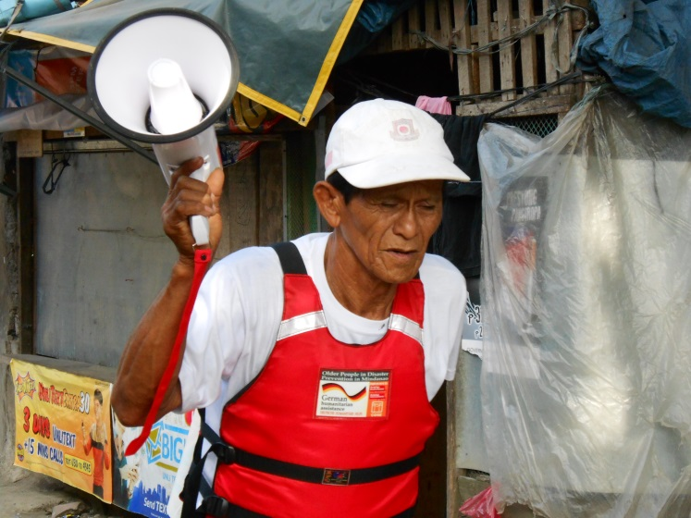
Firstly, the project, through the implementation of trainings, community drills and orientation workshops on how to use DRR materials, as well as awareness raising activities such as weekly radio broadcasts, and the draft of contingency plans, was able to enhance people’s knowledge on DRR. All 5 visited municipalities were equipped with DRR materials, and the participants to the FGD mentioned receiving DRR trainings as one of the most benefitting activity of the project. The DRR equipment has been received by the OPOs and was usually being taken care of by one of the OPO members. This means that the materials were placed in one single location, so the visibility and accessibility to them were limited. Suggestions have been made that the DRR materials should be easily accessible by everyone and displayed in different locations. Additionally, during the FGD the participants suggested that, in some cases, the DRR material was insufficient and that it should be fulfilled with medical/first aid kits, radio communication (VHF), flash lights, etc. At the same time, it has been acknowledged that some of the DRR materials, trainings as well as communities’ drills have not met the real needs and problems of the beneficiaries. For instance, in some barangays, such as City Hights in General Santos and SIR in Davao City, which have recently been affected by fires, the DRR materials and training did not address this kind of natural hazard leaving the community only partially prepared. Thus, some further DRR material and training (e.g. fires drills) focusing on these specific disasters would have been required.
However, the target beneficiaries recognized the vital function of DRR equipment for the OPOs in case of disaster. Additionally, based on the FGD it has been found that especially trainings, community drills and orientation workshop on how to use DRR equipment were one of the most important benefit identified by the beneficiaries. Furthermore, in past occasions, OPO members have made use of the early warning systems, either for preparedness measures such as evacuation exercises in their communities or for making announcements.
With regard to the CDPPCs, they have been established in all the target municipalities. Moreover, most of them have been able to respond effectively to recent disasters (such as typhoon Pablo in December 2012) during the implementation period of the project. However, not all of them have been identified as fully functional. In fact, from the FGD came up that additional guidance and trainings would have been necessary for the understanding of the committee member’s roles and functions (such as medical assistance, relief operations, communications etc.).
Secondly, community based DRR plans have been formulated in the 5 interviewed communities, with the active participation of the community members, led by leaders of the OPOs and key partners in the community. However, the DRR plans were not always fully understood and known by all OPO members and the community.
Thirdly, concerning the disaster mapping, the FGD revealed that project activities included the constant update and revision of the hazard map of the target communities. Furthermore, in some barangays, notably Bangcud, particular attention was given to the needs and vulnerabilities of disabled and bed-ridden people. Thus, the activity of the hazards mapping has been fully accomplished and successful.
Fourthly, broadcasting activities through radio stations have been initiated. In some barangays, such as in Davao city, the beneficiaries themselves took part in the broadcasting process sharing their knowledge and the importance of being prepared in case of disaster.
Fifthly, a brochure entitled “Older People in Disaster Prevention in Mindanao, Philippines” has been published.
With regard to the behavioural pattern changes, some interesting findings came out of the FGDs. Firstly, through trainings and orientation workshop, OPOs members stated that they have found motivation to organize themselves before and during disaster. For instance, in terms of disaster preparedness, older people are now the ones to take the lead within their community to spread the news about the upcoming calamities and to help evacuate. It means that from a psychosocial perspective the project have contributed to enhance the self-esteem and confidence of the OPOs’ members by providing them information, knowledge, organizational skills and DRR equipment. Actually, from the FGDs came out that the older people do not tend anymore to panic during disaster but rather be the ones able to actively participate in the emergency response. Moreover, the last two positive effects of the project on the behavioural pattern of the beneficiaries have been the strengthened solidarity and group spirit as well as the importance to help those in need. Finally, thanks to the project, the older people are now active agents who take initiatives by mobilizing the community instead of being isolated.

SUSTAINABILITY

Sustainability: Whether the project has encouraged the involvement of the communities by meeting their present needs without compromising the ability of future generations to meet their own needs. Furthermore, it measures to what extent the project has enabled the community to organize itself in the future.

In terms of sustainability, the OPOs and CDPPCs have been identified as the most effective mechanism to ensure the project’s continuity. In fact, after having undergone trainings and drills, the OPOs are now able to plan and lead responses to disasters by using their acquired knowledge and skills.
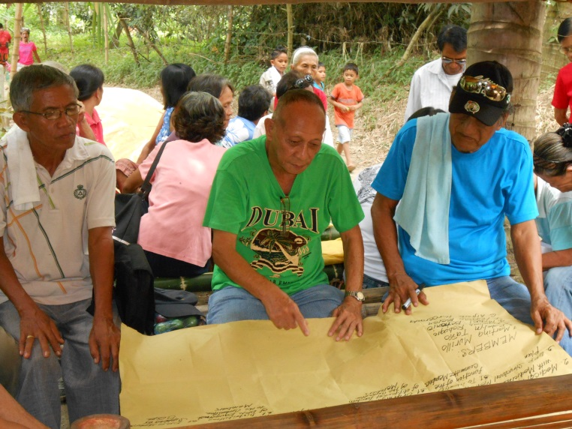
By undertaking community preparedness planning through the existing OPOs, disaster risk reduction measures will be mainstreamed into daily community life. Thus, the project’s objective to mainstream ageing in disaster risk reduction plans and activities are a sustainable mechanism for a post project implementation, as the OPOs and CDPPCs will continue to exist independently and include DRR in their programmes, implementing activities even after the project has ended. This will be assured by the project’s last activities, which include the revision of roles and functions of the CDPPC members, revision of the OPOs contingency and emergency plan, as well as constant update of hazard and vulnerability maps of the community. It is planned that OPOs will continue to work closely with the beneficiaries (older people, other vulnerable sectors and the community as a whole) to organize and monitor activities (e.g. trainings), review the progress by holding regular meetings and mobilize the community as well as other stakeholders to take an active part in the implementation of DRR measures. Furthermore, the OPOs will serve as a link to the local government, advocating for a greater inclusion of older people’s in DRR and emergency response planning in collaboration with the local government.
Furthermore, it was found that the OPOs in the 5 visited municipalities were able to establish partnerships and coordinate with the younger generations, including community health workers and young volunteers in rescue teams. For instance, in barangay Bangcud in Malaybalay city, young volunteers participated in meetings and DRR trainings of OPOs and consecutively shared their knowledge and skills with older people in more remote areas. Thus, this intergenerational link between OPOs and younger volunteers showed how the project can be sustainable in terms of involving the community by sharing knowledge and capacities.
However, even if the initial design of the project did not consider the potential linkages and relationship between the OPOs and the barangays in implementing DRR measures, it has been established during the project’s implementation. Actually, it has been recognized that the barangays’ support has been vital for the sustainment of the project. Thus, it has been suggested on the part of the local staff, the beneficiaries themselves and the evaluator that in order to make the project sustainable it is necessary to ensure the support of the local government, may it be organizational or financial.
Moreover, the qualitative interviews with the local staff revealed that, in order for the older people to be able to receive support and access funds from the local government or other potential donors, sensitization on older people’s rights has been identified as one of the most strategic aspect to sustain the OPO’s activities. It means that once older persons are conscious of their rights, such as the R.A. 10121 Disaster Risk Management Law of 2010, they will be able to stand for their entitlements and access resources.
Finally, in light of the facts mentioned above, there is an observation that needs to be stressed at this point of the evaluation. Actually, in order to enhance the sustainability of the project, this DRR project related to the empowerment of OPOs should also be linked with other concerns of older people, such as health care and livelihood. In fact, relating DRR activities to other areas of concern of older people has been one of the main issues stressed by the beneficiaries as well as the local staff who have been interviewed. This, in turn, highlighted the importance of the local government’s support and cooperation, since government programs provide guidelines and trainings on medical care and livelihood programmes.

IMPACT

Impact: The wider outcomes for a larger group of persons or for society as a whole; the successes and failures in achieving the overall objectives, and the main reasons why.
Regarding the outcomes of the project for the communities as a whole, it has been stressed by the beneficiaries as well as by the local government that the project’s activities have been beneficial in several ways: on the one hand, by empowering the OPOs in their organizational structure, and by providing their members with knowledge, skills and DRR materials (such as Early Warning Systems), and by involving other community members in the DRR activities, it was made sure that the whole community could benefit from the project. This is particularly true considering the fact that older people are a respected source of knowledge within the community and therefore, their advices, strategies and instructions would be followed. For instance, in recent events, OPO members had the opportunity to guide their respective communities in preparing for and responding to disaster. Moreover, beyond the fact that the project has created a positive picture on how older people are essential in disaster preparedness and response, it also had positive effects on older persons, by mobilizing them and raising their self-esteem and consciousness about their capabilities. Finally, in terms of wider benefits not only for the direct target groups but also for the society, the project was able to strengthen the solidarity between older people, other vulnerable groups and the community members, as well as to create a sense of unity.
The following case study illustrates how the project has been successful in strengthening the capacities of OPO members.

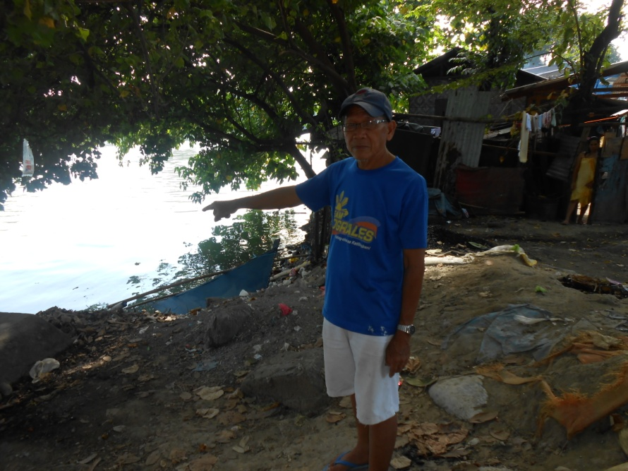
Santos Boluso,
SIR
commonly known as “Tatay Santos”, is 69 years old and he comes from Barangay Bucana SIR in Davao City. He is the president of the Slum Improvement Resettlement (SIR) and, at the same time, president of the CDPP Committee and OPO in his area. Living with his family near the Davao River, he is part of the community which is affected the most in times of heavy rains and storm surges.

“It was five years ago when this river overflew for the first time”, says the community organizer. “Ever since, we have been living with the constant threat of future calamities.” Thus, when the DRR project of COSE was initiated in May 2012 in his barangay, conducting trainings and community drills, he was one of the first to join and actively participate in these activities and decided to devote all his time to the project. “Be prepared. You never know if it can become worse!”, is his device. “Therefore, it is important to prepare ourselves, especially the most vulnerable like older people, in order to face future calamities.”
By the second time the water level rose up to his knees, in January 2013, he was able to organize and mobilize his community. “The project, through trainings and orientation workshops, has taught me how to serve and rescue other Senior Citizens when disaster strikes, as well as how to inform all older persons living in the barangay about coming calamities, so they can be safe.”
In the community drills, he learned how to evacuate people in the most effective way, by using a rope as a life line and guiding older people to the evacuation center, the safest place in the area. “I feel prepared 100%,” he says.
Currently, Tatay Santos is in charge of keeping the DRR equipment material of his community; the hazard map of Barangay Bucana decorates the wall of his living room. Being one of the most devoted community organizers among the older persons living in this area, he is constantly organizing and expanding DRR activities along with the help of his companion and vice-president, Tatay Ricardo.
With the ambition of sharing his acquired knowledge and skills with others, he coordinates the DRR effort of his community with older people coming from other zones (puroks) in order to involve them in current DRR activities, such as community drills on hazards, so they can share it with their own communities and get prepared for future disasters.
On the other hand, regarding the impact of the project, various issues must be taken into account.
Firstly, the strict time schedule of the project did not always allow exploring different ways of implementing the activities, if and where needed. In fact, the qualitative interviews with the local staff have revealed that some activities, if developed and structured more in depth, could have highlighted further strategic shades that could have enhanced the older people resilient. Furthermore, the time constraint has limited the possibility to examine other areas of older people concerns such as education (information and knowledge about the National Disaster Risk Reduction Management NDRRM Law) and health issues.
Secondly, another constraint has been found in the long travel distances that rendered a continued and updated monitoring more difficult. Indeed, it might be a problem when, in the rush of accomplishing the implementation of the activities, the eventual needs and concerns of the beneficiaries could not be taken into account. Thus, an alternative monitoring mechanism should be designed in order to avoid potential failures.
Finally, although the impact of the project has been generally satisfactory, the benefits of the project have been partially reduced by the following aspects: i) limited coordination and support of Barangays/local government in implementing the activities; ii) limited understanding and application of the different roles and function within the CDPPCs in some barangays; iii) external factors such as the political elections and disaster such as the Typhoon Pablo in 2012 that hampered the timely implementation of some activities of the project (trainings, workshops etc.).

BENEFICIARY PARTICIPATION
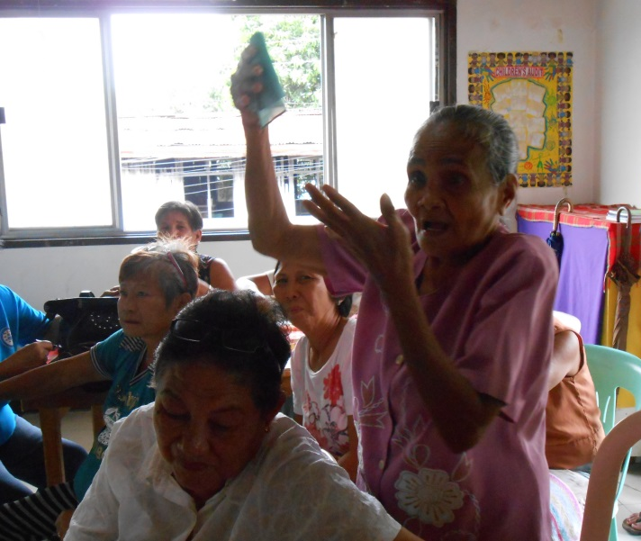
The active participation of vulnerable group such as older people finds its legal basis in the R.A. 10121 Disaster Risk Management Law of 2010. It is clear from the title as well as the overall objective of the project that the participation of the beneficiaries was essential in order to enhance the capacity and resilience of the targeted OPOs in Mindanao. In this sense, it could be concluded that the project matched its goal since it has been extremely participatory considering the active involvement of the beneficiaries in planning and implementing the activities as well as in all decision making processes. Hence, whenever there were decisions to discuss, OPO members in all 5 visited communities have been consulted. For the evaluator it has been a tangible and visible aspect due to the fact that the OPO members showed a high level of knowledge and skills that they had acquired by participating in the capacity building activities. For instance, older people’s participation has been especially important for disaster mapping of their own communities due to their invaluable knowledge of the territory, disaster history and traditional coping mechanisms. Moreover, the beneficiaries’ involvement has been particularly remarkable concerning the broadcasting activities where the older people have been the main actors by spreading the warnings of upcoming disaster and sensitizing their own community about disaster preparedness and prevention. Finally, another aspect that proves the efficiency of the project in terms of participation is the example of including older people from surrounding communities, which initially were not involved in the project, in the DRR activities such as training and meetings at the federation level.
However, limited resources (for transportation etc.) did not allow some of the older people to attend OPO meetings, or to participate in workshops and community drills and trainings. Consequently, they have been less involved in the activities and this has rendered them less prepared for coming disasters.

MONITORING AND EVALUATION
Over the 18 months period of the project, the latter has been monitored on a regular basis by a locally recruited project coordinator. Moreover, COSE’s Regional Officer has reviewed activities monthly and an online newsletter on COSE website was created in order to document and reflect on the progress of the project. According to the agreement of cooperation, reports were submitted every 2 months. In fact, till the end of June 2013, five complete reports have been delivered by COSE to the German Federal Foreign Ministry in order to inform about the progress of the project, as well as about some challenges that might have arisen during the implementation period. For instance, in the reports it was highlighted that some activities could not be implemented and monitored in the planned time schedule due to external factors such as ongoing political campaigns and elections as well as disasters. Added to this, another constraint for the regular monitoring of the project has been the long travel distances that rendered it more difficult. Indeed, as highlighted before, it may have been a problem when, in the rush of accomplishing the implementation of the activities, the eventual needs and concerns of the beneficiaries could not be taken into account.
However, all the challenges mentioned so far did not impede COSE to go ahead with the project as well as to report on the regular basis concerning the progress and encountered challenges. By describing the problems the organization faced during the implementation, COSE put efforts in finding ways to overcome such obstacles (e.g. by rescheduling the activities etc.). Finally, activities implemented during the last two months of the project, September and October 2013, were part of the internal evaluation assessing the impact of previous activities. For instance, activities such as the revision of the committees contingency and emergency plan as well as the revision of role and functions of the committee members, have been designed for this purpose.

RECOMMENDATIONS

The recommendations from this evaluation can be used by COSE – HelpAge International for developing and designing their strategies for an eventual extension of the project: “Mainstreaming older people’s participation in building disaster resilient communities”. In order to ensure the success of future strategies and projects, considering these recommendations will be important. Based on the observations and reflections drawn from Focus Group Discussions as well as the qualitative interviews with the direct beneficiaries and the local staff in the 5 visited municipalities, the evaluator has identified the following 6 recommendations.

- NEEDS OF THE BENEFICIARIES
During the FGD and the qualitative interviews, it was highlighted that some of the trainings and DRR material were not only incomplete but also, in some barangays, they did not meet the real needs of the target groups. For instance, as barangays such as City Hights and SIR in Davao City were identified as fire-prone areas, it would have been necessary to adjust the material and trainings (e.g. fire drills) to this type of disaster and consequently, to the specific needs of the target group.

Moreover, regarding the organization of the OPOs and CDPPCs, it was recognized that DRR Committees had been created in all 5 visited target communities. However, not all of their members had a clear understanding of their roles and functions (such as relief operations, medical assistance, communication, etc.) during the disaster response. Therefore, more emphasis should be put on the guidance of the DRR committees in identifying their leaders, as well as their respective roles and functions.

- LINK DRR TO LIVELIHOOD AND HEALTH&CARE ISSUES
During the FGDs and the qualitative interviews, another major need has been stressed. In fact, with the exception of one barangay, namely Bangcud, where a homecare and a governmental livelihood project has been implemented at the same time, in the other visited communities the DRR project was not linked to other priorities of the beneficiaries such as health care and livelihood. For instance, some beneficiaries highlighted during the FGDs that, without good health condition and proper income, they would not be able to participate in the activities of the project. Moreover, DRR related to a livelihood and health care project will lead to more sustainability as, for example, relief goods could be bought with funds from the livelihood project. Thus, since the main goal of the project aims at enhancing the older people’s participation in order to strengthen their capacities in case of disaster, DRR should be linked to these concerns. It is clear that there is a need to implement DRR activities in a holistic approach. It means that for the sustainability and impact, there are other areas of concerns that beyond the project should be taken into account in order to enhance the beneficiaries’ resilience to disaster.

In light of this fact it is also important to consider the potential support and relationship with the local government since it is in charge of delivering medical care assistance and livelihood programmes. Thus, it is highly recommended to coordinate the future activities with the local government which has the resources and the capacities, in combination with COSE’s technical support.

- RELATIONSHIP WITH THE LOCAL GOVERNMENT
The project has been designed in consultation with key stakeholders, such as local governmental bodies. Some of the barangays have been very supportive to the project and continuously reaffirmed their realization of the importance of this kind of prevention measures (e.g. trainings and drills) in order to prepare older persons as well as the community as a whole to disasters. Contrariwise, other barangays did not recognize the benefits of the DRR project and they did not provide any organizational and technical support to the project.
Hence, in a perspective of extension of the project it is highly recommended to emphasize more on advocacy with the local government not only on the part of the organization but also on the part of older people. Through information and education on the R.A. 10121 Disaster Risk Management Law and the Expanded Senior Citizens Act of 2010, as well as their entitlements to medical and social services, older people should be encouraged to advocate for their concerns with the local government.

- STRENGTHEN NETWORKS AND PARTNERSHIPS
During the FGD and the qualitative interviews, it was found that most of the OPO did not develop any partnership with other vulnerable sectors or NGOs. However, few exceptions could be found in City Hights and Bangcud communities since the OPOs there linked their activities with other vulnerable groups such as PWDs, women and children by including them in hazard mapping and prioritizing their needs during evacuation in disasters. Furthermore, the project activities have been implemented in cooperation with some NGOs present in the area, namely FPOP, PASALI and MQDOI. This partnership strengthened the project in General Santos and rendered the project more sustainable as the NGOs will continue to work with older people starting to include a DRR approach in their own action plan. On the other hand, COSE could not establish the same kind partnership with other NGOs and agencies in the other 4 visited communities; in fact COSE was the first NGO to implement DRR activities in collaboration with the OPOs. However, for an eventual extension of the project, it is recommended to focus more on creating this kind of network and partnerships in order to make the project more sustainable as it has been in General Santos. Actually, such network could be useful for mobilizing financial, technical and organizational resources. Finally, regarding the relationship with the other vulnerable groups, the positive example of City Hights and Bangcud should be followed in future projects in order to have a more comprehensive and inclusive approach in DRR.

- MOBILIZE RESOURCES
It has been found that most of the OPOs had difficulties in mobilizing resources and raise funds by themselves in order to sustain their future activities. As mentioned in the fourth recommendation point, one solution would be to encourage the OPOs to create some partnerships with other NGOs and agencies in order to receive financial and technical support from them. At the same time, one recommendation would be to teach them how to write formal proposal and request to the local government during their trainings.

- LONG TRAVEL DISTANCES AND TIME CONSTRAINTS
During the qualitative interviews with the local staff, it was stressed that both long travel distances and time constraints impeded on monitoring and time management of the activities in the 5 interviewed communities. On the one hand, the implementation of the activities has been interrupted various times by disasters and elections. On the other hand, the strict time schedule did not allow flexibility or space for experimentation and deepening of activities. Actually, in some cases, the activities could have been improved by assessing them more comprehensively leading to better results. With regard to an eventual extension of the project, long travel distances, time constraints as well as external factors (such as disasters and electoral campaigns) should be taken into account. Consequently, it is recommended to concentrate the project in only a few strategic areas, making the implementation and monitoring of activities easier.

CONCLUSION

Mindanao, located in the southern part of the Philippines, is one of the most disaster-prone areas in the Pacific region. In fact, in the past few decades, weather-related hazards, such as heavy rains and storm surges have significantly increased in the region and they have affected the poor the hardest. According to these facts, it has been recognized that older people are one of the most vulnerable group to disaster.
Considering this scenario as well as the absence of NGOs working in the target areas and addressing older people’s needs related to disaster, COSE launched the 18 months project “mainstreaming older people’s participation in building disaster resilient community” in partnership with HelpAge International in May 2012.
Furthermore, concerning older people’s situation in the project area, although there a wide range of initiatives and opportunities for continued and active participation in development, nothing much has been done about older people’s involvement in disaster management. Actually, even if the government has recognized the need for addressing older persons’ special concerns such as health care, housing, income security and other social services related to disasters; in reality no plans have been implemented so far. These facts make the situation of older persons who frequently are affected by disasters even more challenging. Thus, a project based on older people’s participation in order to build disaster resilient communities has had a huge impact and relevance since it is a promising way to deal with disaster for the future.
Finally, according to the effectiveness, sustainability and impact of the project, beyond some weaknesses that should be improved, the 18 months project “Mainstreaming older people’s participation in building disaster resilient community” has been strategic in strengthening older people’s capacity in order to face possible future disaster.

The structure of this report has been based on the External Evaluation and Impact Assessment submitted by Samantha Chattaraj, "Building Community Organisations to Reduce Poverty and Vulnerability Amongst Older People and their Families in Myanmar", March-April 2012.
CDPPCs in each Barangay consists of 5 members. COSE will ensure that two members are older people representing the OPA. The remaining members are from different sectors.
See http://www.unocha.org/roap/top-stories/hc-interview-philippines.
COSE-HELPAGE International, Mainstreaming older people’s participation in building disaster resilient communities, 14 September 2011, p.16.

