Internal Evaluation Report

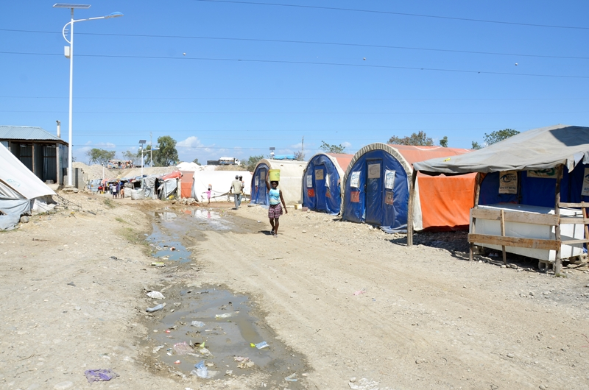

Resettlement of vulnerable people living in IDP camps
July 2012– June 2013 (ECHO/HTI/BUD/2012/91014)

Internal Evaluation made by: Kizito Chiwala - June 2013

This document has been produced with the financial assistance of the European
Commission. The views expressed herein should not be taken, in any way, to reflect the official opinion of the European Commission.

Table of Contents

Acronyms 3
Executive Summary 4
Introduction 5

Methodology 6

Project Results 7

Performance 9

Sustainability 12

Conclusions 13

Recommendations 13

Lessons Learned 14

Annexes (attached)

Annex 1 – Internal Evaluation Questionnaire
Annex 2 – Key Informant Guide
Annex 3 – Objectives Achieved
Annex 4 – Individual interviews
Annex 5 – T.O.R for Evaluation

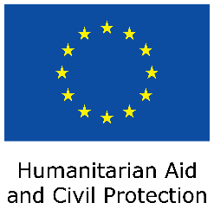
The European Commission’s Humanitarian Aid department funds relief operations for victims of natural disasters and conflicts outside the European Union. Aid is channelled impartially, straight to people in need, regardless of their race, ethnic group, religion, gender, age, nationality or political affiliation

ACRONYMS

DAC Development Assistance Committee
DEC Disaster Emergency Committee
DTM Data Tracking Matrix
ECHO European Commission for Humanitarian Aid and Civil Protection
IDPs Internally Displaced Persons
IGA Income Generating Activities
IOM International Organisation for Migration
NFI Non Food Item
OECD Organisation for Economic Co-operation and Development
OP Older Persons
OPA Older People’s Association

UCLBP Unité de Construction de Logements et de Bâtiments Publics

- Executive Summary

The project to resettle vulnerable older people (OP) and their dependents living in IDP camps was funded by the European Commission’s Humanitarian Aid department – ECHO, and implemented by HelpAge International in 31 IDP camps mainly in four communes of Croix des Bouquets, Delmas, Port au Prince and Tabarre, from 1st July 2012 to 30th June 2013.

The aim of the project was to provide humanitarian and recovery assistance to older IDPs and their dependants through housing rental subsidies, the provision of Income Generating Activities, Relocation and resettlement and education grants.

The project intended to target 1,050 direct beneficiaries comprising of 350 older IDP women and men and 700 children (an average of 2 children per household) in the 20 camps where HelpAge had existing work
Actual beneficiary numbers exceeded this during the project implementation and the project effectively targeted 350 older IDP women and 1,083 dependents (as there was an average of 3 children per household) in 31 camps. It was also effective in providing access to adequate accommodation to the beneficiaries thereby reducing security risks associated with IDP camps as the beneficiaries relocated to more secure and protected living environments.
The project was relevant and the selection of the resettlement package – a combination of Rental subsidies, Resettlement, Income Generating, and education/school grants was highly appreciated by both beneficiaries and local authorities.

The project initially targeted 700 children beneficiaries but ended up benefiting 1,083; this is shows efficiency and effectiveness in supporting beneficiaries through the project. The efficiency of the project is also evidenced by the timely delivery, right packages and reliable delivery methods for the different grants. There were small to no hitches along the service provision pipeline and all staff attached to the project was qualified, competent and dedicated.

Summary of recommendations:
- Continue with the provision of Housing, IGA and education grants to older people affected by the earthquake and still living in IDP camps, who as a result of the earthquake have lost their source of income and have been unable to restore their livelihoods.
- The rental subsidies method should continue to be to be used whilst underlining any advantages related to it, as opposed to other alternatives such as house reconstruction and/or retrofits.
- HelpAge should encourage staff (especially those attached to humanitarian programmes) to further build their capacities through training in humanitarian standards and norms.

- Introduction

This project was an effort by HelpAge and ECHO to provide targeted humanitarian and early recovery responses to older people and their families, affected by a 7.0 magnitude earthquake that struck Haiti on 12 January 2010 and resulted in large-scale urban displacement. As at April 2012, there were 420,513 Internally Displaced People (IDP) living in 602 camps across the earthquake-affected area, 7% were, older IDPs with dependants under their care.

The objective of the project was “To improve the living conditions and livelihoods of older IDPs and their dependants” affected by the earthquake.

Specifically, the project aimed at resettling 350 targeted older IDPs and 700 dependants.

The project successfully targeted 1,433 direct beneficiaries comprising of 350 older IDPs and 1,083 children (383 more than planned at proposal stage) by:

- Providing improved shelter through rental subsidies, allowing beneficiaries to move out of camps into rented accommodation. A grant of 400 euros per household for one year was provided to 350 households.

- Provision of a resettlement grant (80 euros) for essential Non Food Items (NFIs). The beneficiaries were also given information, linked with local and neighbourhood authorities, social services, and supported through regular visits by HelpAge staff throughout the life of the project.

- Improving the beneficiaries’ livelihood sources. To this effect, all 350 households received an Income Generating Activity (IGA) grant of 200 euros each to carry out these activities. 92% of the respondents said they had started or reinforced “peti” small businesses.

- Improving the dependants’ education. 1,083 children under the care of 350 older people benefitted from education/school grants (80 euros per family).

This internal evaluation was one of the activities foreseen at project proposal stage. The main objective of the evaluation was to conduct an internal evaluation based on the overall performance against the principal and specific objectives as set out in the proposal, with particular emphasis on the extent to which the results were achieved, relevance/appropriateness, efficiency and effectiveness of the intervention.

To this effect, the evaluator used the project objectives and indicators approved by the donor and assessed HelpAge’s performance in reaching the target population; undertook an analysis of the fulfilment of the indicators and the influence of external factors and actors on the project; and interviewed 60 direct beneficiaries in 4 targeted communes.

- Methodology

This was a cross-sectional descriptive evaluation conducted using participatory methods involving both quantitative and qualitative approaches for triangulation purposes. Desk review, relevant literature and documents were also reviewed to add to the knowledge base.

3.1) Evaluation Tools: Data collection tools were developed through a participatory approach. During the last month of the project, the evaluator consulted the project team before the final tools for data collection were adopted. The tools were further reviewed during the training and translated by the enumerators to have a common understanding.

3.1.1) Individual Beneficiary questionnaire: One questionnaire was used and contained questions related to the rental subsidy, resettlement, IGA and school grants. Focus group discussions were discarded because the beneficiaries had been relocated and were therefore spread across different communes, making it difficult to bring them together.

3.1.2) Key Informant Interview guide: One set of tools was used for relevance, Effectiveness and Coherence components. Key informants were selected by the consultant (in consultation with the Project manager) based on perceived knowledge and experience in the project.

3.2) Aim of interviews: The aim of the interviews was to collect information on the nature and implementation of the resettlement project; its relevance to the prevailing contexts; intervention strategies; perceived impact of activities; and the achievements and best practices, gaps and limitations of the activities as well as existing opportunities for action.

3.3) Resources: The evaluator reviewed all project documentation and interviewed:
- the Resettlement Project Manager whose responsibility was to oversee the proper implementation of the project;
- HelpAge’s Finance Manager who was responsible for financial management and financial reporting of the Project;
- three staff members (1 Database Officer and 2 Resettlement Case Workers) and;
- The HelpAge Country Director.

To assess project impact the evaluator, assisted by the Resettlement Project Manager for translation purpose, conducted 60 interviews in 4 targeted communes with individual direct beneficiaries; two OPA leaders of who, one was an IDP settlement OPA leader and the other, a commune OPA leader, to assess their involvement in the project.

In addition, separate interviews were held with IOM Delmas Commune Coordinator and a UCLBP official to discuss their perception of HelpAge’s contribution a coordination mechanisms in the resettlement programme.

The internal evaluation did not included school children that benefited from the grant, as it was not a specific objective; the objective was to assist the family in sending them to school only.

- Project results

According to the design of the project, HelpAge was expected to resettle 350 older people headed households from the camps/settlements through a “Resettlement Package” that comprised of rental subsidies; IGA, resettlement grants, plus education grants to cater for 700 children under the care of older IDPs. All these activities were fulfilled.
All the 350 older IDPs received and benefitted from a full resettlement package as follows:

4.1.1) RENTAL SUBSIDIES: which allowed them to move out of the IDP camps into rented accommodation of their choice. A grant of 400 euros per household for 12 months was provided by HelpAge to cover the rental of new accommodation for 350 households (1,433 beneficiaries – 1,083 children and 350 older people). 100% of the respondent beneficiaries expressed satisfaction at the rental subsidy alternative, whilst 70 percent said they will be in a position to continue renting the houses as a result of the revenues they are getting from their new or reinforced tibiznis (small businesses).

4.1.2) RESETTLEMENT GRANT: Through this grant, HelpAge ensured that all beneficiaries were provided with information and linked with local and neighbourhood authorities, social services and supported through regular visits by HelpAge staff throughout the project life. A resettlement grant for essential Non Food Items (NFIs) was also provided to these families upon their relocation within one to 2 weeks of their move from the camps. 80 euros per household was given. Respondents said that this activity helped them to be integrated into the commune OPAs where they sought useful information. The 80 euros was essential to pick up life soon after relocation by starting or reinforcing their small businesses.

4.1.3) IMPROVED LIVELIHOODS through INCOME GENERATING ACTIVITIES (IGA): The 350 targeted older people (head of households) benefitted from a 200 euro grant each to carry out income generating activities. 92% of the respondents said they had started or reinforced small businesses; the money was used mostly to acquire a start-up inventory or add more products to their actual one. The other 8% said they had to use the grant for other purposes such as repaying debts, others were sick and used the money to get health services and finally some had had money stolen by close relatives.

4.1.4) EDUCATION / SCHOOL GRANT: This Action was meant to benefit 700 children under the care of 350 older people with education grants (80 euros per household). However, the number of beneficiaries exceeded to 1,083 due to an under family composition calculation when designing the project. The grant hugely reduced the number of times the children missed classes per week to 0 to 1 day per week.

4.2) Demographic Characteristics

A total of 60 respondents were interviewed, where 47 (73%) were female. This percentage also shows the number of female older people household heads, underlining their vulnerability and thus likely dependency on resettlement packages. The majority (67%) of the respondents were aged between 50 and 59 years. In addition, 80% of the respondents reported having no education at all, a factor that could lower their chances of getting formal employment after relocation.
When asked what their biggest needs were in the order of importance whilst in the camps, 98% put housing. Asked if they will afford paying rent after the project’s period, 70% answered positively, clearly indicating how pertinent the IGA grant pack was to the resettlement project. In terms of economic activities, 70% of the respondents indicated that they did not have any income source nor did petty trading in the camps as compared to 85% that have started small businesses after the resettlement as shown by figure 4.2
Figure 4.2: What are your economic activities today? (Camp Economic Activity)
Figure 4.3: What was your economic occupation in the camp? (Post project period)
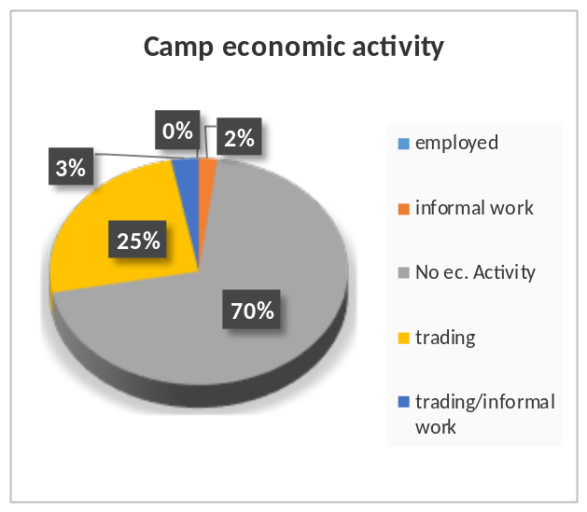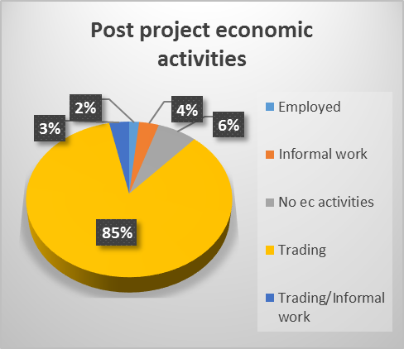

81% of the dependants now attend school on a five-day basis as compared to 30% during the time of living on an IDP camp. The other 19% may miss school for 1 day or 2 as compared to 4 or 5 days a week whilst they previously living in the IDP camps.
- Performance

The section below will assess the project using the OECD/DAC evaluation criteria: Relevance, effectiveness, efficiency and sustainability.

5.1) Relevance of the project

The relevance of the project was assessed based on; beneficiaries’ perception on conformity of the resettlement packages, utilization, dependency, dignity and respect.

The project was relevant both at the time of its design and during the actual implementation. The earthquake left many people without their livelihood sources and could therefore not afford to rent houses, nor afford school fees for their dependants. 90% of the respondents confirmed that the combination of Rental subsidies and IGA grants was an excellent choice as the latter helped them to start small-scale trading activities which would not only sustain their rentals post project period, but also give them income for their daily living spending, as testified by Aladin below.

I'm really happy what the project has done for me because now my children go to school, my small business works well with the hope that I can pay the rent next year. Things have improved for me I live in a more comfortable house than the tent in which I lived before. Aladin Anette (71 years old)

5.2) Resettlement Package Appropriateness

During the individual interviews, 41% of the respondents indicated that they were very satisfied with the quality of the resettlement package and therefore considered the project very appropriate. Further, 44% of the respondents indicated that the resettlement package was appropriate as presented in figure 5.2 below. However, 15% of the respondents indicated that the package was inappropriate. Those who showed dissatisfaction expressed either that the package was not enough or that they would have preferred to use the IGA grant for other issues such as health services and/or repaying debts. In cases where the grant had been used to pay off individual debts, it was impossible to prevent this because people do not have registered debts, like a bank loan, but informal debts which they would never talk about it. Secondly, beneficiaries where the most vulnerable families headed by an older person; particularly in the IDP camp setting in Haiti, as they are very vulnerable to diseases and one became ill after receiving the grant.

Figure 5.2 Appropriateness
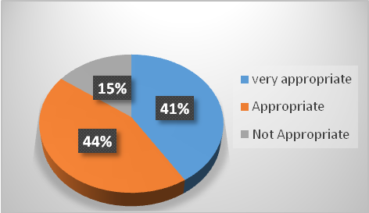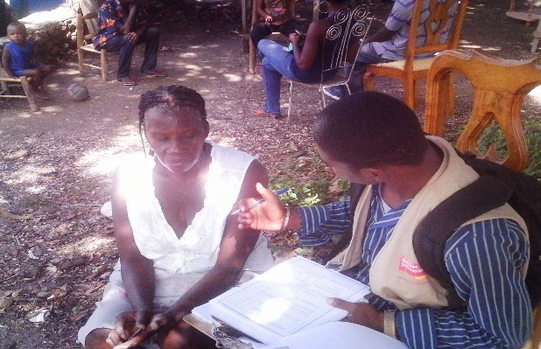

5.3) Efficiency of the Resettlement Project

Efficiency is a factor of ensuring that the services of the project are 100% delivered and as planned. This should consider the timely delivery, right quantity and the organization. In an efficient system, there should be no hitches along the service provision pipeline. In the HelpAge Resettlement project, all went on as planned and small glitches in the system were exceptional, and were treated as soon as they arose. The distribution of resettlement and IGA packages method (using PINs – personal identification numbers) was selected based on a strict criterion; PINS were the suitable form of distribution of cash since over 90% of the beneficiaries did not have National Identity cards and could therefore not open bank accounts. This method also considered the security of the beneficiaries as a priority (banks have security guards as opposed to other ways of cash distribution), protection of the grant recipients and availability of services like bank branches where older people had specific queues to reduce waiting time.

5.3.1) Grant Distribution Mechanisms: The money transfer agents and existing banking institutions necessitated efficient and cost effective transfer of cash to the beneficiaries. The selection for the transfer agent (UNITRANSFER/UNIBANK) was based on the capacity to handle the cash, the branch coverage and reliability. This was transparent and there were no complaints by other transfer agents. Secondly, the cash management was both on a pre-financing mechanism, where HelpAge deposited it in the bank and then gave a list of beneficiaries to UNIBANK, which in turn provided PINS to each one of the beneficiaries. The beneficiaries then collected the grants from the bank using their camp IDs as appropriate documentation, thereby demonstrating that the distributions had been carried.

5.3.2) Human resources and logistics management. - Staff performance. All beneficiaries interviewed stated that they were very satisfied with the work of the Resettlement Case Workers. The distributions of grants were timely, well announced and well organised. Interviewees also referred to HelpAge’s staff as “very patient” and “polite”. However, all staff linked to the project expressed their desire for more training in basic humanitarian standards and norms.

5.3.3) Finance: All the funds were used as planned with minor changes to below 10% in each budget line. There was no need to ask for permission from the donor as per the donor regulation.

5.4) Effectiveness

The project contributed to achieving the goal of ensuring basic living conditions for the earthquake-affected population. The project provided a much needed resource - housing and at the same time reduced security risks of living in the overcrowded IDP camps, provided school grants as well as grants to start or reinforce previous/existing livelihoods of vulnerable older people. All of the target beneficiaries had lost their homes during the earthquake. They all practically scarped by with no income. The project made it possible for the families to regularly send their dependants to school whilst living in adequate accommodation, and have regular meals to improve their health/nutritional intake.

5.5) Connectedness and Coherence
Connectedness and coherence are additional OECD/DAC criteria applied to humanitarian projects. They refer to the linkages between humanitarian intervention and longer-term development effort and the policy level coordination with other actors.

The project is well connected to HelpAge Global Action 3 which states that, “HelpAge will enable older people to actively participate in and be better supported during emergency and recovery situations”, through humanitarian assistance. The Action was also coherent with DGECHO’s humanitarian mandate. Most of the target population had been assisted by HelpAge during the emergency phase of the earthquake through other external funding received; beneficiaries from the IDP camps had received NFI support, cash transfers and health services. Some of the beneficiaries were included in an income generation project funded by the UK Disasters Emergency Committee (DEC), foreseeing support to small business development.

Throughout the project implementation period, coordination with relevant stakeholders was ensured at all levels. HelpAge worked with the IOM which had the largest relocation programme in Haiti. HelpAge also coordinated with the UCLBP, a government agency that leads the reconstruction and relocation process. Participation in the Resettlement Cluster was applauded by other agencies such as OXFAM, CARE and Catholic Relief Services (CRS). Coherence was also sought in the distribution of equal amounts of resettlement, IGA and school grants to all the beneficiaries. Rental packages of USD$500/400 Euros was an agreed amount by all agencies undertaking resettlement projects as a way of avoiding inflation in the country. This is an example of coherence and connectedness.

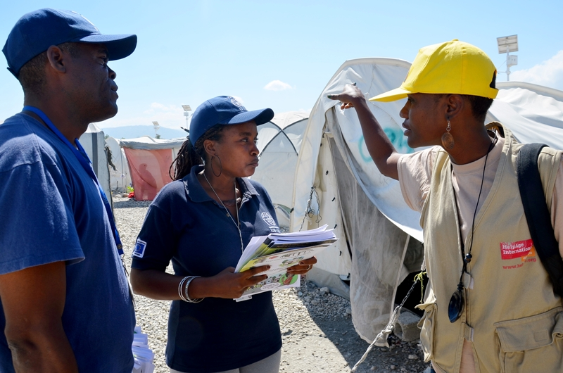
All activities were closely coordinated with the UCLBP office and information was regularly shared at the Shelter Cluster Meetings. As at the time of the project’s implementation HelpAge was the only agency specifically targeting older people. It was not difficult to have a coherent approach because selection of targeted old people beneficiaries was in close coordination with the Camp leaders and Mayor’s office.

5.6) Sustainability

A certain degree of sustainability was ensured through the distribution of the IGA grants although it remains questionable what portion of the target population will continue paying rent for the houses after the project. Estimates made by the DTM study in the affected area indicate that over 90% of the beneficiaries throughout will be able to pay for rent. However of the 60 HelpAge beneficiaries interviewed in this evaluation, 70% said that they will continue paying for rent thanks to the IGA grants. The other 30% said they might try to return to the camps /other camps, or reunite with family members or friends.

- Conclusions

The Resettlement, IGA and education grants distributed to vulnerable older people headed households effectively targeted 350 households (1,433 individuals, 64% of whom were women). Due to an under calculation of the number of children under the care of the older aged IDP, the project managed to cover 383 children more than initially planned. This is an indicator of good efficiency and flexibility HelpAge.

The project was highly relevant to the needs on the ground, and the selection of the Resettlement package – a combination of IGA, school and relocation grants was highly appreciated by both beneficiaries and local authorities. It was also effective in achieving the objective of providing adequate accommodation for vulnerable old people headed families. An additional impact of the project was the reduced security risk associated with living in the camps.

The project was implemented in very good coordination with other agencies and the government authorities (UCLBP). HelpAge was complemented by UCLBP officials for its high degree of collaboration. The only recommendation that came through from one official was for projects to try to target all vulnerable households in the camps because all are equally vulnerable and the selection of some and not others results in dissatisfaction and tensions. But it was explained to them that contrary to other interventions. This is challenge was planned for and resolved by 1) mainly targeting older people headed families, which in itself had an intergenerational approach, 2) targeting camps that had already been targeted by IOM, which meant that all the IDPs were attended to and evacuated. In order to avoid this type of complaints in the future, HelpAge will have to continue working in close collaboration with other agencies.

- Recommendations

- IGA grants should continue to be provided to older people still living in camps, which due to lost access to previous economic activities, have not been able to restore their livelihoods after the earthquake.
- Health insurance for the older person heading the household should be included, probably through DASH as this is one of the answer/solution identified by beneficiaries.
- All IDPs in one camp should be target by the various partners as to avoid unnecessary tensions. Continued collaborations with other agencies such as the IOM are recommended.
- Project staff should be encouraged to undertake minimum humanitarian standards and norms courses to make sure the implementation of the project complies with all the international stands.
  - All ECHO FPA partners can participate in their free online courses on how to manage their funded projects, an opportunity that should not be missed.
- Although this was not a big factor, in the future, project management should work on effectively anticipating any delays that may occur due to coordination problems with other stakeholders.

- LESSONS LEARNED.

Based on conclusions, the Evaluator has identified several lessons that can be drawn in 3 main areas, from the experience of resettlement project in Haiti:
- Targeting
- Project delivery
- Management and co-ordination

8.1) Targeting: The targeting modality applied in this project was designed for urban settings and can also be considered in a wider context of potential scale up. Such a methodology should be adopted in urban settings where there are no community mechanisms of identifying the most vulnerable.

8.2) Project delivery: Work in a post-earthquake urban setting can be a major challenge given the weak leadership structures and poor governance. HelpAge considered this during implementations, where all the levels of leadership were reviewed and used effectively. HelpAge supported the creation of Old People Associations in each IDP camps; these self-motivated people, played a major role in overcoming the dynamics of implementation through supporting activities in the settlements, including selection of the beneficiaries.

8.3 Accountability and co-ordination
- The nature of the group of agencies undertaking Resettlement allowed for increased coordination amongst actors and propagated learning and sharing, and was ideal for implementing the resettlement project. Sharing beneficiary lists among these actors deterred double registration and thus increased the number of ultimate beneficiaries.

- HelpAge have established a hotline dedicated to receiving complaints related to the Resettlement process that all the beneficiaries had and also the numbers of key staff members, in particular, Case Workers responsible for a specific geographic area. However, only 53% of the respondents indicated that they at one time did they contact the staff members. To ensure effectiveness of these lines, there should be more rigorous education, information sharing and orientation of the beneficiaries on its use. Case Workers are highly encouraged to give there contact details on business cards.

Annex 1: ECHO Internal Evaluation Questionnaire
- Individual interviews with direct beneficiaries
Croix de Bouquet, Delmas, Tabarre
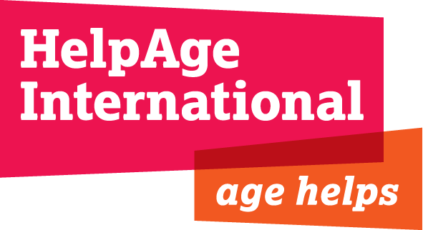

Annex 1 – Questionnaire used in the direct beneficiary survey

Section 1 - General
- Name of respondent:... … … … … … … … … … … … … … … … … … … …

- Age of respondent: … … … … … … … … … … … … … … … … … .

- Respondent’s gender: M / F

- Name of current Commune: Croix de Bouquet, Delmas, Tabarre,

other: ... ... ... … … …. …. …. … … … … … … … … … … … … … … … …..

- In which camp and commune were you before resettling:

Camp:... ... ... ... ... ... ... ... … …. Commune:… … … … … … … … … …

- What was your biggest need before being resettled:
a) Housing ... ... b) livelihood ...... c) school fees and/or support for

dependants, d) other:.. … … … … … … … … … … … … … … … … … … …

Annex 1: ECHO Internal Evaluation Questionnaire
60 Individual interviews with direct beneficiaries
Croix de Bouquet, Delmas, Tabarre

Section 2 – Livelihoods – IGA grant
- What was your economic occupation in the camp? a) none b) trading c) manual labour (informal) d) work (formal)

- What are your economic activities today? a) none b) trading c) manual labour (informal) d) work (formal)

- What did you use the IGA money for: a) to buy food, b) to repay debts c) pay for health services, d)start a small business, e)

other:…………………………………………………………………………………………………

- Would you have liked to use it on something else? Yes/No

- On what?................................... Why?......................................

- If you have an Income Generating Activity,
- What is it?...............................................................................
- Why did you decide to do this particular activity? A) Advice from HelpAge staff, b) this is what I did before relocating, c) It yields a
better profit d) other:……………………………………………………………………………

- Will you continue doing the same activity in the future? Yes/No

Annex 1: ECHO Internal Evaluation Questionnaire
60 Individual interviews with direct beneficiaries
Croix de Bouquet, Delmas, Tabarre

Section 3 – Improved shelter through Rental Subsidies and Resettlement grants

3A: Rental Subsidies
- Who chose the house in which you live now?................................

- Did you encounter any difficulties in getting the house? Yes/No

- If yes, what kind of difficulties?.....................................................

- Was the house in good conditions? Yes/No

- Will afford to pay for your house after the end of the project as a result of the IGA grant? Yes/No

- If not, what will you do?............................................................

- How and who did you contact at HelpAge if there was a serious problem or complaint with the landlord, neighbours etc?: (staff of

HelpAge, resettlement agent, etc.). Who? ... ... ... ... ... ... ... ... ...

How? ... ... ... ... ... ... ... ... ...

3B: Resettlement grants

14. In what form did you receive the resettlement grant? A) Cash, b) cheque, c) bank deposit, transfer etc.

- Would you have preferred another method? Yes/No

- Which method?.....................................................................

- Why this particular method?.....................................................

- How soon after relocation did you receive the resettlement grant? Weeks: 1, 2, 3, 4, 5, 6

16. Did HelpAge staff show up whenever they said they would to give support and training? Yes/No
17. Are you participating in any of the neighbourhood OPA activities? Yes/No
- If yes, what activities? a) nothing b) regular meetings c) excursions, socio-cultural -films, games d) ADA campaign days, e) other: ... ... ... ... ... ... ... ... ...

- How did you link up with the neighbourhood OPA after the relocation? a) help from Helpage staff, b) I was referred to by the local authorities, c) I knew the OPA before relocating from the camp, c) other:……………………………………………………………………………….

- What awareness or information have you received from the OPA A) DRR / b) cyclone/Hurricane b) hygiene/cholera, c) other

... ... ... .. … … … … … … … … .. … … … … … … … … … … … … …

Annex 1: ECHO Internal Evaluation Questionnaire
60 Individual interviews with direct beneficiaries
Croix de Bouquet, Delmas, Tabarre

Section 4 – Education grants
- How soon after relocation was the education grant given to you? Months: 1, 2,3, other:……………………………………………………...............

- When you were in the camps, did your dependant miss class often? Yes/No
- If yes, at least how many times per week?

- How many times do they miss classes per week now?

- Does your dependant still go to the same school as when they were in the camp? Yes/No

- If not, why?..............................................................................

- Did any Helpage staff visit the school in which your dependant is to talk to their teachers about? Yes/No

Section 5 - Advice
- Looking back what advice do you have for HelpAge? Is there a continuing need for this type of projects? Yes/No

- If yes, why?.........................................................................

- In general, what worked well and what did not? How could it have been done better to avoid the problems, if any?

NOTE: Other comments are from either, a) the respondent or b) the surveyor

Annex 2: Key Informant Guide

- How transparent was the selection process for the beneficiaries? Were the community leaders involved, community members and other stakeholders? In which way?

- Considering the available options in Port au Prince, was the most cost effective method applied in ensuring that the resettlement, IGA and education grants were given to the beneficiaries at minimal cost? If yes, which one? What other alternatives did you not use? And why?

- What do you think HelpAge should put in place that would give a more sustainable/lasting solution to the current situation especially for those depending on the rental subsidies?

- In your opinion, to what extent did the grants (IGA, Relocation, Education) mechanism benefit target groups (most vulnerable Older people and their dependants)?

- To what extent has the project achieved its objective of providing livelihood security, shelter and better education to the most vulnerable older people and their dependants in the camps?

- Considering the current situation in Port au Prince Metropolitan, how relevant/ appropriate/suitable was the resettlement project?

- In your opinion, how appropriate are rental subsidies in reaching targeted beneficiaries as compared to other alternatives like reconstruction of houses?

- Do you think a one year resettlement package is a dignified/appropriate way of helping older IDPs from the camps? If yes, why? If no, why not?

- Given same resources, what else similar or different would you implement to ensure that older people, their dependants, and other vulnerable members of the community are livelihood secure, go to school regularly?

- Did you work in partnership with other actors doing relocations? If yes which ones? If not, why not?

- In your opinion, has the partnership between HelpAge and IOM worked? If so, what has worked well? If not, what has not worked well and what can be done to make it work better in the future?

Annex 2: Key Informant Guide

- To what extent has the project intervention conformed to the needs and priorities of target groups? Policies of HelpAge? The European Commission? The Haitian government?

- How do you compare HelpAge resettlement project with other resettlement interventions being undertaken by other actors?

- What humanitarian principles and standards (if any) did you take into account during the relocation process?

- What standard procedure did you use to respond to or solve the beneficiaries’ complaints whenever they arose? Give examples.

- Was any of the HelpAge staff involved in any case that did not respect older people and therefore could not enhance HelpAge’s reputation? If yes, how was the case resolved?

- Did the programme develop any particularly effective and/or innovative approaches that could improve humanitarian recovery for older people in future? Have these been documented and shared internally or with the donor?
- Did you undertake any training during the project implementation process? If yes, which ones and how did they help you to improve your skills? If not, why not? Would you have liked to undertake one? Why? What training?

- What general/other information can you tell me about the resettlement intervention by HelpAge?

- Any questions for me?

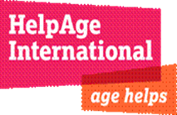
Annex 3
HELPAGE INTERNATIONAL HAITI
ECHO RESETTELMENT PROJECT
Title of action: Resettlement of vulnerable people living in IDP camps
Areas of intervention: Delmas, Port-au-Prince, Croix-des-Bouquets, Tabarre, Cite-Soleil
Objectively Verifiable Indicators |  |  | Objectively achieved
 | Target value expected |  | Target value achieved
 | Quantity | % | Quantity | %
350 older people and their 700 dependants are more secure and better protected through improved housing. | 350 Older People | 100% | 350 Older People | 100%
 | 700 Dependants | 100% | 1083 Dependants | More than
Percentage of increase in household expenditure on education and health by end of the project |  | 100% |  | 100%
350 of selected vulnerable older IDPs and 700 dependant children are provided with safe and rented accomodation according to standards for a period of 1 year. |  | 100% |  | 100%
% of target IDPs having access to adequate hygiene and sanitation arrangements |  | 100% |  | 100%
350 older IDPs provided with resettlement grant within one week of leaving camps and moved into new homes. |  | 100% |  | 100%
At least 350 older IDP household increase their expenditure on health and nutrition per month by the end of the project |  | 100% |  | 100%
% children of resettled IDPs regularly attending school 3 months after resettlement |  | 90% |  | 90%
% of reduction in instance of physical abuse and thefts of resettled children. |  | 90% |  | 90%
Annex 4

Individual Beneficiary interviews
Name of commune | No of OP | F | M | Type of interview | % of households represented
Croix de Bouquets | 44 | 35 | 9 | Individual with a questionnaire | 16
Delmas | 1 | 1 |  | Individual with a questionnaire | 33
Port Au Prince | 2 | 2 |  | Individual with a questionnaire | 40
Tabarre | 13 | 9 | 4 | Individual with a questionnaire | 18
Total | 60 | 47 | 13

Staff and other actors interviewed

Name of interviewee | Position | F | M | Type of interview
Jean-Claude Gosselin | Country Director - HT | M | 9 | Senior Management Team Meeting/Individual
Magdala Suire | Resettlement Project Manager | F |  | Group/Individual
Michael Dubisso | Finance Manager | M |  | Individual
Joselito | Resettlement Case worker | M | 4 | Group
Miguelina | Database Officer | F | 13 | Group
Peter Guchu Kioy | IOM Delmas Commune Coordinator and DataBase | M |  | Individual
Serges saintime | Croix de Boquets Camp OP leader | M |  | Individual
Jean Julme Dienfaite | Croix de Bouquets Commune OPA leader | M |  | Individual

Annex 5
HelpAge International

Terms of Reference for an internal evaluation of
ECHO resettlement of vulnerable people living in IDP camps
BACKGROUND
Name of project being evaluated: Resettlement of vulnerable people living in IDP camps  Reference number: HTI 709  Project duration 12 months  Evaluation period: July 2012 – June 2013  Evaluation report release date:  Type of evaluation: Internal  Evaluation purpose: Donor requirement  Main project objectives:  To improve the living conditions and livelihoods of older IDPs and their dependants  - To resettle targeted older IDPs and their dependants through housing rental assistance and to improve income generating activities opportunities and schools fees. | Implementing agency and partners: HelpAge International  Project budget: 439,035 Euros  Internal evaluation budget : 4,000 Euros  Project funding sources: ECHO, Age UK
OVERVIEW OF PROGRAMME
In line with the government and International commitment of relocating all the people affected by the Earthquake and are still living in Camps, HelpAge implemented an ECHO funded resettlement project in the metropolitan area. The project is involving the issuance and monitoring of grants for resettlement, Education and Income Generation Activities.

The project targeted 350 old people and 700 dependants living in camps in metropolitan area (Croix-des-Bouquets, Port-au-Prince, Delmas, Tabarre and Cite Soleil) for their relocation and giving them some training support to manage their income generating activities and supports their children education through older people associations, Home visitors, case workers and project manager.

HelpAge’s resettlement strategy is to ensure that OP received the resettlement grants for their relocation according to the project criteria and donor requirements. And ensuring that the ECHO team addresses the needs of older people living with dependants in accordance with the principle of impartiality and human dignity
PURPOSE OF THE EVALUATION
- To assess the extent to which the project met its objectives as set out in the proposals with particular emphasis on the appropriateness, timeliness, efficiency and effectiveness of the intervention.
- To learn lessons from the experience in order to improve HelpAge’s future resettlement interventions and humanitarian assistance for older people more specifically.
- To collect and analyze information on different grants (IGA, relocation, education) allocated to beneficiaries in the project;
- To make a comparison between the situation of the beneficiaries before the earthquake and the living conditions in the camps to see the change made ​​by the project in terms of economic and better access to basic social services (housing conditions, hygiene and sanitation, security, healthy environment, etc.);
- To link the educational and nutritional status of dependent children before and after the project.
- To consider the operating environment of the other humanitarian actors (OIM) and take into account its affect on the responses of HelpAge in the relocation of old people in Metropolitan area.

The evaluation report will be published in accordance with the HelpAge and ECHO evaluation policies.

SCOPE AND FOCUS
Quality, appropriateness, timeliness and effectiveness
- Did the response achieve what it set out to do?
- Were humanitarian principles observed and standards met?
- What has been the change of the project for the direct beneficiaries, indirect beneficiaries and the wider communities?
- Was the programme relevant to the particular needs of older people? Did it target and reach them effectively and appropriately? Did it target the most vulnerable older people? Did it impact women and men differently?

Accountability
Were the following elements of the HelpAge Accountability Framework followed:
- Participation – What was the level of involvement of and accountability to beneficiaries?
- Complaint Handling - To what extent was the cash transfer complaints mechanism used by beneficiaries?
- Monitoring, learning and evaluation – Was the program informed by lessons and experience from previous resettlement programmes?
- Transparency – Did the organization provide information and consult with stakeholders to ensure the understanding of the Organization’s commitments and program activities.
- Human Resource Practice – Did HelpAge staff and partners behave in a manner that respected older people and enhanced HelpAge’s reputation?

Efficiency:
- Did the project provide the best way for giving grants?
- Did the project ensure processes were in place at the appropriate community level? Did the project spend funds and manage with quality and timeliness?

Sustainability:
- Is there a continuing need for the activities and services provided by the project? Have plans been made and measures taken to ensure the continuation of the project after first phase ECHO funding ceases?
- How can the benefits of the project be most appropriately and effectively continued or extended for the target population?

Partnership
- Did the project work appropriately and effectively with partner agencies (international and local)?
- Did the old people associations involve in the resettlement process?
- Would it be appropriate to continue any or all of the partnerships in order to ensure continuing assistance to the target population? If so, how?

Learning
- Did the programme develop any particularly effective and/or innovative approaches that could improve humanitarian recovery for older people in future?
- Have these been documented and shared internally?

EVALUATION PROCESS AND METHODOLOGY
Evaluator Profile
- Experienced in evaluating humanitarian and recovery programs
- Fluent English and working knowledge (at least) of French.

Evaluation Methodology
- Review of secondary data including proposals, reports, case studies and evaluations by other ECHO members (for context and issues)
- Analysis of any baseline and other data
- Interviews and focus group discussions with key stakeholders including HelpAge staff and partners in Haiti (OIM, City hall and old people associations); other key humanitarian actors in Haiti; HelpAge and ECHO staff in London.
- Participatory discussions with beneficiary groups in the project locations. The views of non-beneficiaries should also be included.
TIMEFRAME and DELIVERABLES
Outputs

- Presentation and discussion of draft findings and recommendations to HelpAge staff.
- Final report including a clear, concise Executive Summary.
- Presentation of final report findings and recommendations to HelpAge staff.
- All written outputs to be delivered in English.

Timeframe
- A total of 10 days (June 17 to June 28th 2013) : 5 days to collect all data, 3 days to analyse data and finalise the report, 1 days for preliminary briefing and presentations to HelpAge SMT.
- Final report to be delivered to HelpAge by 28th of June 2013.

Management & support
- HelpAge Country Director, Resettlement ECHO Manager, Program Support Manager
- International flights, local accommodation, transport and assistance in the field will be arranged by HelpAge in Port-au-Prince.

Data based on HelpAge’s database from the camps that HelpAge worked in and matches with IOM’s family structure in the DTM, registration phase 2
IOM Data Tracking Matrix (DTM)
See annex 1 for this tool
See annex 2 for this tool
See annex 4 (Staff and other actors interviewed)
Assisted by 12 enumerators that went to different comunes each
See Annex 3 - completion of results as per indicator
See Annex 5 (Dépouillement), for respondent’s information on the other use of grants.

