Older women and Beijing: 20 years on

Older women in the Beijing Declaration and Platform for Action
20 years ago, the Beijing Declaration recognised age discrimination as one of the factors contributing to the barriers to women’s empowerment and advancement. Older women were specifically mentioned in the Beijing Platform for Action with regard to their poverty, health, violence against them, obstacles they face in entering the labour market, discrimination at work and as a civilian group particularly affected by armed conflict. Demographic ageing in developed and developing countries and the need for age-disaggregated data were emphasised. Recommendations for government action were made in each of these areas but there were also gaps, including the complete omission of widows and widowhood.

Beijing + 20 review
A review by HelpAge International of how these recommendations were being implemented by governments as part of the Beijing+15 review in 2010 revealed that older women and population ageing were a low priority for the vast majority of countries reviewed.

Five years on as part of 20-year review of implementation of the Beijing Platform for Action governments have been asked by UN Women to provide information on the situation of older women wherever possible. This review of 131 Member States’ national reports explores the extent to which they have done that. Despite a growing body of evidence on discrimination affecting women in older age and the adoption of a new CEDAW General Recommendation on the rights of older women (No. 27, 2010), the challenges older women face are almost entirely absent from these national 20-year reviews of the implementation of the Beijing Platform for Action.
Achievements and Challenges since 1995
Only 21 reports (16% of the 131 reports reviewed) specifically mentioned older women or ageing in their review of achievements and challenges. The achievements mentioned were raising
retirement ages, supporting older women’s employment, abolishing gender differences in pensions, a law addressing multiple discrimination and specific projects for older women. Two reports recognised population ageing as a challenge. The other challenges listed included older women’s poverty, lower pensions than men and multiple discrimination based on gender and older age.

Implementation of 12 areas since 2009

A. Women and Poverty
33 reports recognised the particular poverty that older women experience. Some countries identified older women, and in particular single older women who live alone, as among the most at risk of poverty. Others provided data showing that the difference in poverty rates between men and women is highest in the over 65 age group. The most common reason given was lower pensions due to gender inequalities in the work histories. Social security policies to address this gender inequality were the most common response given, in line with the recommendation (58 o) in the Beijing Platform for Action.

B. Education and Training of Women
Only one country described educational opportunities for older women.

C. Women and Health
The Beijing Platform for Action recognises older women’s distinct reproductive and sexual health issues, and that these are often inadequately addressed (paragraph 95). However, only three of these reports reviewed mentioned the menopause and only one the use of contraception by women over 50. The Beijing Platform for Action also states that with increased life expectancies, the health concerns of older women require particular attention (paragraph 101). Twelve reports mentioned cancer screening programmes which include some older women but which all have upper age limits. Only two reports mentioned any other specific health concerns for women in older age, osteoporosis in one report and experiencing higher rates of injury and hospitalising due to fall-related injuries than men in another. There was no mention of dementia or other mental health issues older women experience.

D. Violence against women
The Beijing Platform for Action recognises older women are particularly vulnerable to violence (paragraph 116). 13 of the reports recognised that women are at risk of violence in older age but only two reports referred to a specific form of violence that disproportionately affects older women: medication abuse and witchcraft related killings. There was no reference to the violence older women may experience in the different settings where they receive care and support, to neglect or to financial exploitation and abuse.

E. Women and armed conflict
One report referenced a study on internally displaced and conflict-affected women that included a focus on older women. Another said that data on asylum seekers is available disaggregated by age and sex.

F. Women and the economy
The Beijing Platform for Action recommends governments implement support programmes that enhance the self-reliance of older women (paragraph 175 d) and tackle discrimination in the workplace especially considering older women workers (paragraph 178 c). 17 reports addressed older women’s employment and the barriers they face. One report addressed the burden of unpaid care work on older women and another that the additional work that women do in resource poor settings ages them prematurely. One country reported that gender pay gaps increase with age, the biggest pay gap being in the age group 60 - 70. The report stated that reasons for this are not clear, especially given the fact that women in this country are more educated than men. Differences in retirement ages were mentioned in two reports.

G. Women in power and decision-making
One country presented information on participation in decision making disaggregated by age. In this case the oldest women elected to a constitutional assembly was 66 years old. The oldest man was 80.

H. Institutional Mechanisms for the Advancement of Women
Three reports referred to older women. One referred to a new divorce law that splits pension entitlements between the man and the women. The second referred to a European Union Ministerial level workshop on labour market activation of older women. The third included a government funded report on issues facing older women.

I. Human Rights of Women
Three reports referred to older women, two in relation to laws that address multiple-discrimination where both age and sex are prohibited grounds. The other report described the setting up of a body to regulate standards related to the care of older women (and men).

J. Women and the media
Two reports discussed the negative images of older women in the media: one described a project aimed to break stereotypes of beauty based on youth in order to increase women’s self-esteem, regardless of age. The other recognised that images of women are often degrading but that data on older women was rarely collected or analysed as a separate group.

K. Women and the environment
None of the reports addressed older women.
L. The girl child
None of the reports mentioned older women. One report mentioned an intergenerational activity between children and older people generally.
Section 3. Statistical data
The availability of data on older women disaggregated by age varied enormously from one report to another. Overall availability of age and sex disaggregated data over the age of 65 is weak although 11 reports provided disaggregated data on poverty rates or risk of poverty for older women. Eight reports said they had data on physical and sexual violence that had an upper age limit of 74.

Section 4. Future priorities
Two of the reports reviewed identified population ageing as a future priority. Three recognised the need to look at women’s diversity, including based on age, in their gender equality policies. Four said that social protection to ensure older women’s income security was a priority. Individual reports prioritised older women’s social inclusion, employment, care, health and rural transport respectively.

Conclusions
The only areas where older women have received any significant attention in the reviews were in relation to their poverty and barriers to employment. With regard to other aspects of their lives, older women were virtually ignored in the other 10 areas. Their sexual and reproductive health was almost completely ignored and there was no recognition of, or data on, the violence they face in the different settings where they live.

There were occasional mentions of the intersectional discrimination that older women face: in the need to break stereotypes of beauty based on youth, of their disproportionate subjection to medication abuse. However, what these 20-year reviews indicate is that this stage in women’s lives is still considered less important, less equal, less deserving of respect, less part of mainstream society, and that gender-based discrimination in older age is less harmful or debilitating.

Looking ahead: the next 5 years
The accumulation of gender-based discrimination over a lifetime combined with the additional discrimination based on older age can have a devastating effect on women’s lives unless it is explicitly addressed. The 1995 Beijing Platform for Action recommendations for action on older women’s income security, health, property rights, access to non-discriminatory employment and on collecting data disaggregated by age and sex must be put into practice.

Gaps in the Beijing Platform for Action recommendations must also be addressed, inter alia, in relation to:
- older women’s enjoyment of human rights on an equal basis with others
- eliminating gender pay gaps throughout women’s working lives, including in older age
- compensating unpaid care and other work that women do throughout their lives, including in older age
- preventing and providing redress for violence against women in their older age
- changing social norms that promote negative and degrading images of older women in the media
- tackling intersectional discrimination, particularly on the grounds of age and marital status
- addressing the impact of armed conflict and other situations of risk on older women
- ensuring older women’s non-discriminatory access to services, including lifelong education and training, transport and financial services
- ensuring older women’s participation in decision-making processes
- enabling older women to live autonomous lives of dignity and continued personal development whatever their physical or mental condition.

Written by Bridget Sleap, HelpAge International

Endorsed by
 | 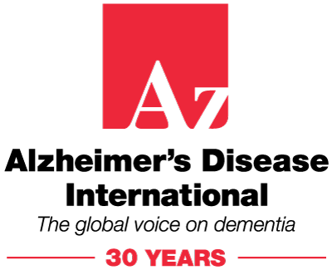 | 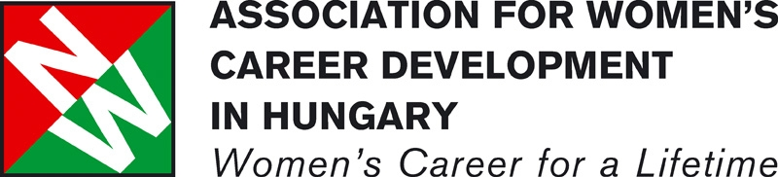
  Age and Youth in Action | 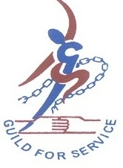 | 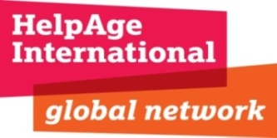
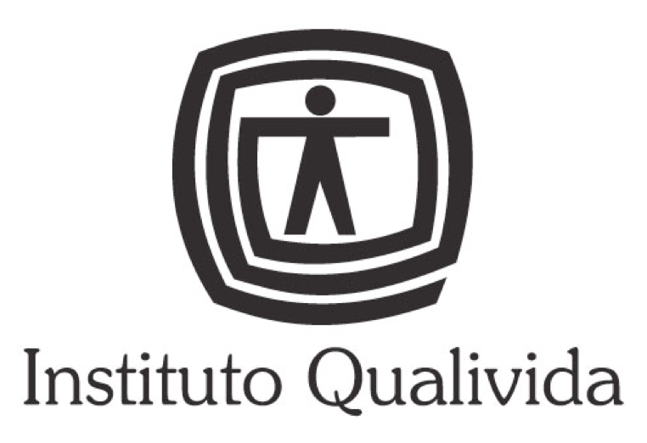 |  | 
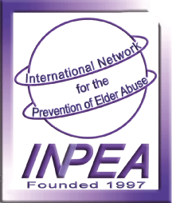 | 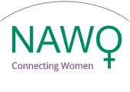 | 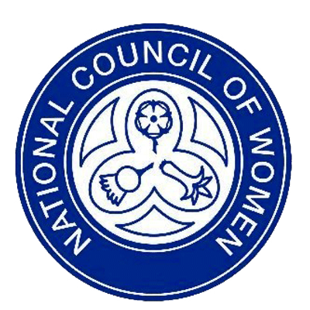
 | 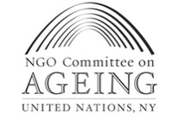 | 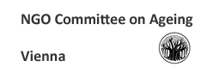
 |  | 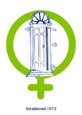
 | 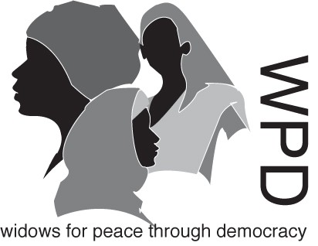

AARP, Alzheimer’s Disease International, Association for Women’s Career Development in Hungary, Gray Panthers, Guild of Service India, HelpAge International, Instituto Qualivida, International Council on Social Welfare, International Longevity Centre- Global Alliance, International Network for the Prevention of Elder Abuse, National Alliance of Women’s Organisations UK, National Council of Women of Great Britain, NGO Committee on Ageing in Geneva, NGO Committee on Ageing in New York, NGO Committee on Ageing in Vienna, Older Women’s Network-Europe, Soroptimist International, The Haven Wolverhampton, War Widows Association New Delhi, Widows for Peace through Democracy

Sleap, Older women and Beijing: 15 years on, February 2010, http://www.bridge.ids.ac.uk/go/global-resources-database/browse-by-theme/household/ageing-and-older-people&id=58794&type=Document

