By  Jugnoo Salahuddin | Impact Assessment of HAI Interventions and Older People’s Access to Microcredit Programs  In Districts Jacobabad and Shikarpur, Sindh  Impact Assessment of HAI Interventions and Older People’s Access to Microcredit Programs  in Districts Jacobabad and Shikarpur, Sindh  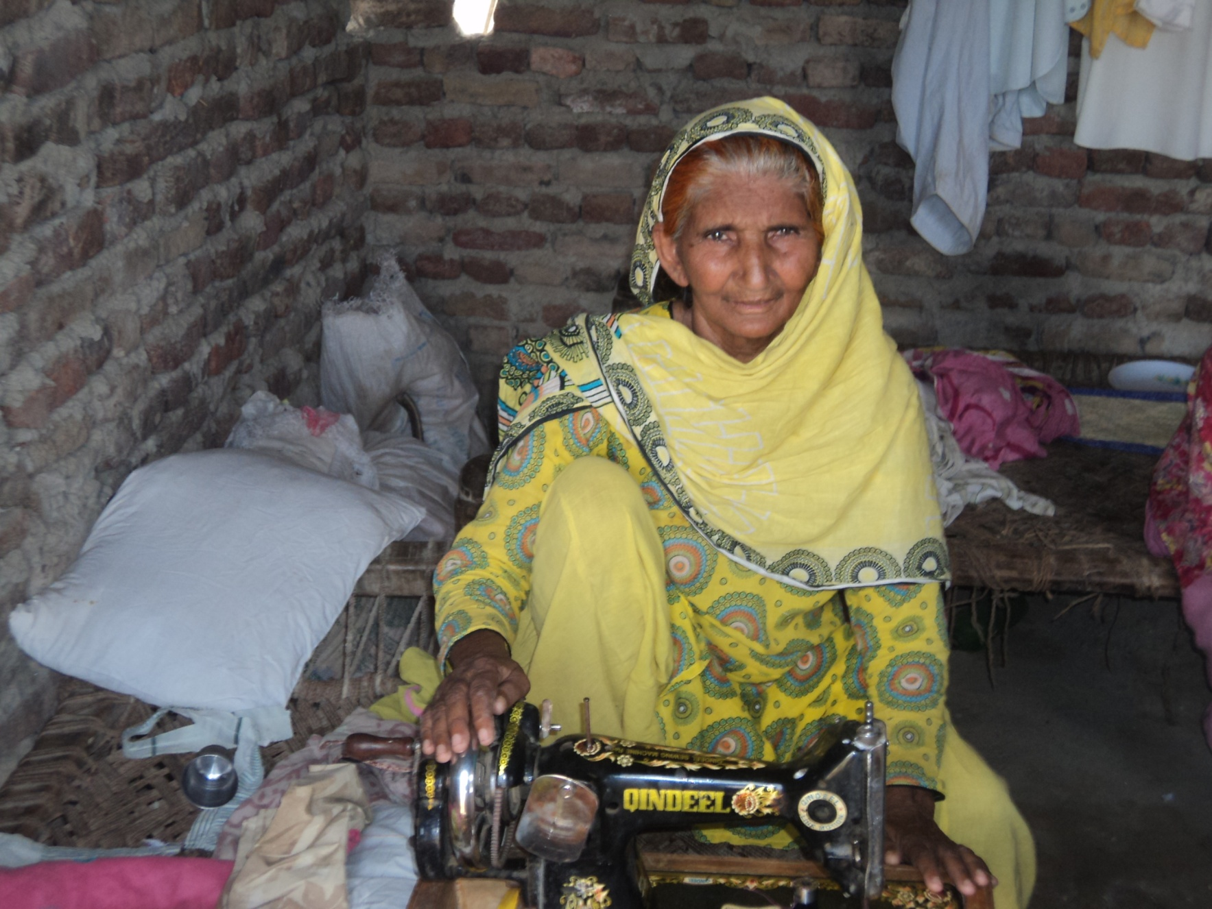

Table of Content

ABBREVIATIONS / ACRONYMS 3

EXECUTIVE SUMMARY 5

Chapter I: BACKGROUND AND STUDY OBJECTIVES 8
1.1 Background
1.2 Scope of Study
1.3 Study Objectives

Chapter II: METHODOLOGY 10
2.1 Study Design
2.2 Targeted Population
2.3 Sampling
2.4 Data Analysis
2.5 Data Collection Methods
2.6 Sampling Size and Strategy
2.7 Tools for data collection
2.8 Data Analysis
2.9 Ethical Consideration

Chapter III: Findings 13

Chapter IV: CASE STUDIES 30

Chapter V: DISCUSSION AND CONCLUSION 34

REFERENCES 42

LIST OF PEOPLE INTERVIEWED 43

Abbreviations / Acronyms

BISP | Benazir Income Support Program
CBOs | Community Based Organizations
CRF | Community Revolving Funds
DDMC | District Disaster Management Committee
FGD | Focus Group Discussion
GoP | Government of Pakistan
GoS | Government of Sindh
HAI | HelpAge International
IDI | In-depth Interview
INGO | International Non-governmental Organization
NGO | Non-governmental Organization
OCHA | Office of the Co-ordination for Humanitarian Affairs
OPAs | Older People Associations
OP | Older People
OW | Older Women
PDMA | Provincial Disaster Management Authority
SRSO | Sindh Rural Support Organization
MoSW | Ministry of Social Welfare

List of Tables and figures
Table 1: | Average monthly income Page 14
Table 2: | Women participation in OPAs Page 15
Table 3 | Distribution of Micro Credit Programmes Page 26

List of Figures
Figure 1: | Gender Distribution of OPs Page 13
Figure 2: | Improvement in conditions Page 14
Figure 3: | Trainings delivered to OPs and community By OPAs Page 17
Figure 4: | OPS paying back CRF Page 18
Figure 5: | Developed Community Action Plans Page 19
Figure 6: | Worked for living before floods page 21
Figure 7a: | Formation of OPAMCs Page 22
Figure 7b: | Distribution by Committees page 22
Figure 8: | Access to other Micro Credit Programmes Page 26

List of Boxes – (Case Studies)
Box 1: | OPA- Achar Jogee, Shikarpur Page 16
Box 2: | Rahib Ali Moorani, Shikarpur Page 23
Box 3: | OPA - Haji Abdullah Lashari, Jacobabad Page 24
Box 4: | Shahzadi, Jacobabad Page 31
Box 5: | Mai Bibul, Jacobabad Page 32
Box 6: | Mai Panah And Rasheeda, Shikarpur Page 33

EXECUTIVE SUMMARY

The Pakistan floods in 2010 are reported to be the worst this country has faced since its inception. The sixth most populous country (187 million) was not ready for this disaster but responded well to the situation as highlighted by various experts with help from International and Local organizations. The number of individuals affected by the flooding exceeds the combined total of individuals affected by the 2004 Indian Ocean tsunami, the 2005 Kashmir earthquake and the earthquake in Haiti. At least 2,000 people died in this flood and almost 20 million people were affected by it. Where there was lot of focus on children and women affected by the floods, little efforts were made to help older people during the floods.
Age specific cash assistance offered to older people during the floods either from government or voluntary sources were unavailable. The invisibility of older people due to comparatively small proportion of total population perhaps was the reason for older people to remain the most vulnerable group affected by the floods.
In these circumstances, interventions of HAI in Shikarpur and Jacobabad districts, proved to be a ray of hope to older people. Social protection in the form of interest free loans, called community revolving funds for restoring livelihoods, is a well known strategy to enter any community while implementing Madrid International Plan of Action on Ageing 2002.
Older People Associations were formed at village level for optimized participation of Older People, and to ensure transparent distribution and timely recoveries of the loan. These loans would be subjected to re- distribution to other eligible candidates. The amount of loan to each beneficiary was Rs.10,000.
The aim of the research is to gather evidence of impacts of HAI interventions on restoration of livelihood of older people and assess the access of Older People to other Microcredit programmes in districts Shikarpur and Jacobabad, Sindh, Pakistan.

The assessment thus consisted of surveying 144 beneficiaries of Community Revolving Fund from the two districts and 40 older people Associations (20 from each district). Focus Group Discussions (FGDs) were conducted with Older People and Older People Association representatives and case studies developed to assess the impact of HAI interventions.

Overall Impact

- Social status of CRF beneficiaries has been lifted.
- Older people transformed into productive figures of household instead of non-contributory dependents.
- Older Women entrepreneurs have emerged which is uncommon in rural settings.
- Improvement in the average monthly income of Older People before and after receiving Community Revolving Fund.
- Improvement in households’ situation thus improving older people wellbeing.
- Attitudes noticed towards innovative ideas for income generation.
- Changes in behaviors of Older people for instance: abandoning of begging
- Older People show active participation in social networking.
- Older People have emerged as key resource persons to provide trainings on disaster risk management, managing funds, and emergency relief program.
- Ownership and responsibility exhibited by Older People in returning loans on time.65% are already returning the amount on time.
- Older People along with communities of 40 villages have shown high level of resilience, skills developed to absorb future shocks.
- Community Action Plans formed and submitted to district disaster risk management committees for future planning.
- OPAs registered as CBOs.

Risks:
Low amount of community revolving funds: There is a risk that low amount of CRF will not be able to fulfill the livelihood needs of OPs in future.
Weak coping strategies for livelihood insecurities: Insecurities related to agriculture and livestock are not effectively addressed that may affect the sustainability of HAI interventions regarding CRF loans.
Un- registered OPAs at the moment are monitored by HAI and SRSO. In case of withdrawal of these stakeholders / in absence of a accountable authority, OPAs might not perform their task with responsibility and dissolve.
Low priority given to OPs: There is a wrong perception about OPs, they are seen as a redundant force amongst stakeholders.
Governance: Due to Inefficiency of Government systems and institutions affects the performance of team in meeting key outcomes.
Lack of capacity building/livelihood activities for Women: A large no of older women are consuming CRF loans and few have shown interests in establishing livelihood activities other than agriculture and maintaining livestock. Due to less exposure to outside world they need comprehensive trainings on livelihood development. Women are not found in leading roles.
OPs remain Vulnerable due to limited access to Microcredit: There is a risk that limited access to Micro credit programmes offered may affect OPs overall well being if timely interventions are not made. OPs will remain a vulnerable group.
Overall Conclusions
- Overall objectives of the project have been met.
- HAI interventions have visible impacts on livelihood of OPs.HAI interventions have broken the perceived image of OPs as non contributory to productive figures of households.
- Primary (OPs) and secondary stakeholders (other communities) are sensitized regarding ageing. Key stakeholders needs to be thoroughly sensitized.
- Resilience of communities developed to face disasters, OPAMCs formed to mitigate risks during disasters and CAPs developed.
- HAI has emerged as a trustworthy friend of older people in addressing their needs.
- Older people are marginalized in existing poverty reduction programmes, other than HAI offered in the targeted districts.
- Social assistance scheme for older people by government through Zakat fund invisible in both districts.
- Six case studies have been produced to elaborate the impacts of the programme.
Recommendations
- There is a dire need to expand HAI intervention in other parts of the province to address the issues of older people and exposing their productive image throughout Pakistan. HAI has emerged as the only organization to work for livelihood endeavors for this vulnerable group; it must scale up its initiatives to other parts of the province/nation after successfully implementing it in these targeted areas.

- It is also recommended that the amount provided under social protection for livelihood restoration should be increased. It would reduce the risks to sustainability of the program by not meeting livelihood needs. New grants for livelihoods catering the needs of the whole village can be introduced to benefit large number of OPs.

- HAI should integrate effectively with provincial and federal government for mainstreaming aging in existing poverty reduction programs. For instance: WASEELA-E-HAQ .

- In reducing risks to livelihood insecurities of communities’ advocacy and capacity building should remain an integral part of HAI policy program.

- HAI needs to collaborate with government’s livestock and dairy department at national and provincial level to minimize the livelihood insecurities. HAI needs to suggest government that un-employment due to loss of livestock, crops, and landlessness be addressed through social security and older people must be included in all social protection programmes initiated by government.

- HAI needs to work hard to advocate all OPAs to acquire the status of a registered CBO to minimize the possibility of becoming dormant.

- HAI also needs to strengthen their relations with social welfare department by using top down approach. Awareness, sensitization sessions should be organized with higher social welfare officials regarding Elderly Population and their specific needs.

- HAI by disseminating findings of the successful implementation of its interventions can minimize the risk to sustainability. Global donors can find it appropriate to continue to work for the welfare of older people.

- HAI needs to establish a consortium of potential stakeholders working in same villages so that time and energy spent in development is not repeated.

- HAI needs to help Government in helping them learn from other similar countries like Bangladesh and Srilanka who have undergone through similar emergency situations and are coping well in developing systems and strategies to overcome issues.

- Women OPs should be given more attention in terms of trainings for livelihood.

Chapter I: Background and Study Objectives

1.1. Background

Approximately 20 million people were affected in Pakistan during the floods of 2010. The financial loss that Pakistan suffered during 2010 floods is estimated to $10 million and has impacts on agriculture (major occupation), livestock, livelihood and infrastructure. 17,553 villages were reportedly damaged and total area of160,000 sqkm was affected. In this situation of emergency and disaster combined efforts of the government, (I+N) donors and civil society could not found to be enough. A Report by OCHA has identified many gaps in the assistance provision mechanism. The evident unorganized system of goods distribution and corruption exposed within the relief activities has made the overall situation pathetic particularly for disable and older people.

Poor people of Sindh living under the poverty line of $2 per day after this natural disaster had been pushed down into the poorest of poor categories. Six to seven districts were severely affected in the floods of 2010 and later in 2011 the affected area increased to 23 districts of Sindh. Only 80,000 people were displaced in Shikarpur district that lived in camps and other buildings provided by the government of Sindh. Several steps had been taken to cut down the negative impacts of this massive destruction. Provision of food, health services, hygiene kits, medicines, drinking water, shelter and assistance in cash were made possible for the people of Sindh to survive and later to re-establish themselves.

Micro credit programs, thus, assume significance since they facilitate poverty reduction through promotion of sustainable livelihoods and bring about empowerment through social and collective action at the grassroots. In addition, micro finance interventions lead to increased social interaction for poor people within their households and in the community, besides, greater mobility that increases their self-worth and self-assertion in the social circle.

The repercussions on elderly population during these floods have serious implications. 70,000 older people were affected only in district Badin. Gender disparity in the cultural web deprived women of relief assistance making them a more vulnerable group within older population.

HelpAge Pakistan is currently focused to cater the needs of older people in the flood affected areas. The purpose of HelpAge efforts is to, rebuild and empower people above the age of 50, through well planned interventions. Social protection is offered in the form of CRF to Older People for livelihood restoration. The idea of revolving of funds reflects sustainability of the programme. HelpAge came to Pakistan to deal with issue 8 of the MIPAA PLAN 2002 to meet priority direction one: older persons and development. There is a significant shift in the development paradigm to move from top down to bottom up approaches and sustainable livelihood approaches to fight poverty especially for rural poor. This shift has allowed the world to look upon older people as stakeholders in the process of policy making rather than victims.

Older People Associations were established with the help of HelpAge in 2010 to support and mobilize older people in emergencies and generally in development, in Sindh. Help Age’s dual objectives had been to enable sustainable development in the community through social protection programme and secondly, to establish a network for continuous future interventions and mainstreaming Aging(another objective of MIPAA). HelpAge has also been involved in capacity building, training and education of Older People Associations to develop resilient OP communities.

HelpAge with the support from SRSO, as implementing partners, began work in two most affected districts with OPs to re-establish livelihood (post flood) by providing them Community Revolving Funds (CRF) through OPAs as channels. It is expected that CRF can play crucial role in imparting family wellbeing and improve access to basic needs to older persons.

There are other programs such as, Benazir Income Support Program, Relief funds from Bait-ul-Maal Pakistan, and some other NGOs providing social protection schemes to reduce poverty.

1.2 Scope of the study

This study is focusing on HAIs interventions, aiming to provide opportunities to OPs in restoring livelihood activities through community revolving funds.
Secondly, it will assess the access of OPs to other Microcredit Services.
This study will be carried out in the two districts of Province Sindh, Shikarpur and Jacobabad, where Older People Associations had been established to manage CRF distribution and also enable local communities to manage future shocks through capacity building activities.

1.3 Study Objectives

- Identify changes as a result of the HAI project and the potential socio-economic impacts of the project’s interventions on the OP community.
- The direct and indirect community sensitization and capacity building related impacts (e.g. DRR ) of the project and Identify the factors that are impeding or enhancing the impact
- The level of resilience of communities and community based organizations (OPAs) in adjusting or managing changes associated with potential risks to livelihoods in the future, and the capabilities to adjust to such external shocks
- Recommending a way forward for addressing livelihood insecurity,
developing safety net mechanisms in targeted areas, including access to microcredit programs, and at the provincial and national levels, while incorporating the impacts accomplished through HAI project and propose the activities to be prioritized ( as lesson learnt) in this regard in future
- Assess the effectiveness of the established linkages with the partner organizations and other stakeholders and suggest measures for their integration in the future programs.
- Finally, a comprehensive review of access to microcredit programs of OP, identifying available to sources, limitations in terms of access to these sources, and suggesting measures to improve access of microcredit to this vulnerable group including women.

Chapter II: Methodology

2.1 Study Design

A mix-method approach was used to collect the firsthand data. Both quantitative and qualitative methods were used.

2.2 Targeted Population

The target populations for this study were beneficiaries of CRF(older people) and OPAs established by HelpAge in district Jacobabad and Shikarpur, Sindh.

2.3 Sampling

- OPA Component: Initially all 51 OPAs were included as primary sampling units (PSU) to determine the mechanisms and priorities developed by each OPA for distributing CRF and re-collection. But due to limitations the sample size was reduced to 40.
Limitations: By the time data was being collected eight OPAs did not receive CRF money according to the list provided by the POs of Shikarpur and Jacobabad. Therefore, they were not contacted.
One OPA in Shikarpur and two in Jacobabad could not be reached due to time constrains.
- OPs Component: 10% of the total 144 respondents population who have received loans were successfully interviewed in both districts.

  - METHODS OF DATA COLLECTION AND ANALYSIS:

Quantitative data was collected after making corrections raised during the pre-testing phase to maximize the validity of the instrument i.e questionnaire and will be analyzed through SPSS (version 16 for Windows). Descriptive statistics for the subjects was done to obtain and report mean (±SD), median, ranges and frequencies.

Qualitative component was used to understand the perception and attitude of targeted population in depth.

2.5 Data Collection Methods
For the purpose of qualitative component, we used in-depth interviews and focus group discussion methods to collect firsthand data from OPAs and Older Persons (beneficiaries of CRF) and other stakeholders. In addition, we also conducted some case-studies, and informal discussions with stakeholders.

2.6 Sampling Size and Strategy

Qualitative research has seen an increased popularity in the last two decades and is becoming widely accepted across most disciplines. Purposeful sampling is the dominant strategy in qualitative research. Purposeful sampling seeks information-rich cases which can be studied in depth. Ideally, in qualitative research, we collect data till theoretical saturation. In other words, the researcher continues expanding the sample size until data collection (e.g. interviews) reveals no new data. But due to limited time and resources, for the purpose of this study, we conducted following numbers of in-depth interviews and focus group discussion with study respondents.

Study respondent | Data Collection method | Total number of interviews / group discussions
OPs & OPAs(Sh) | FGD | 24 in two FGDs
DDO(Shkrpr)S.W | IDI | 1 interview
OPs and OPAs(J) | FGD | 22 in two FGDs
DistrictTeamLeader Jacobabad (BISP) | IDI | 1 interview
D.M SRSO (SH &J) | IDI | Single interviews

2.7 Tools for data collection

After translating in-depth interviews and focus group discussions guidelines of all the study respondents into the native language Sindhi, we pre-tested these guidelines for pick out any flaw in questions and to understand as well as test the conceptual clarity of the instruments. Therefore, the process of pre-testing was conducted to observe the validity of instruments in accordance with objectives of study. Minor inaccuracies were experienced which were in-corporated during the session due to time constrains.

2.8 Data Analysis

Data analysis in qualitative research is an ongoing process which starts simultaneously as the survey begins. For the purpose of this study, qualitative data was analyzed manually by going through all the transcriptions again and again.

2.9 Ethical Consideration

All the interviews and group discussions were conducted with the prior permission of the study respondents for which they had been informed. FGDs were taped transcribed and translated, classified, and incorporated into matrix as appropriate.

Chapter III: Findings

Changes in socio-economic conditions of Older People through HAI’s interventions on livelihood

Older people recognize community revolving funds as a supportive measure (only 10,000) in restoring their livelihood activities after the floods. The changes due to CRF provision are not far reaching but visible.

During FGDs, majority of the respondents reported CRF as valuable intervention for Old People. One of the respondents mentioned, “It is a unique intervention. It is especially for the older peoples who are being neglected, isolated and discriminated in our societies”.

OPs have noticed changes in their social status that has been lifted due to income generation or assets in hands. This has given older people the opportunity to regain their dignity and self esteem within their families and communities. This change is highly praised by the OP community. The program is gaining popularity and OP community wishes this programme to be continued.

CRF successfully induced the spirit of participation within the OPs. Young old and the Oldest old had been given an equal chance to establish their livelihoods and participate in the process of re-adjusting to difficult living conditions as reported by 60.4% of the respondents.

Women are also taking part in establishing livelihood activities for supporting families which is not a traditional role of older women in rural settings. Older women are seen travelling, participating in trainings, resolving issues and fighting for their rights to receive CRF, is a significant change indeed. Traditionally women young or old are restricted to fields and household chores, but this intervention of HAI have provided rural elderly women to emerge as business women who are busy in developing partnerships and gaining new experiences at this later stage. 48% of the total respondents were women.
Figure No. 1: Gender Distribution of OPs

Source: Questionnaire OPs, Question no 1
Improved monthly incomes are evidences of OPs hard work in re-establishing livelihoods that has indirectly complementing their access to clean drinking water, enough food and health services along with their lifted social status. Comparison of OPs average incomes before and after receiving CRF clearly indicates the merits of receiving CRF.

Table 1: Average monthly income
Monthly Income in Rs | Maximum | Mean
Monthly income before receiving CRF | RS. 26,000 | 5059.03
Monthly income after receiving CRF | RS.30, 000 | 6450.00
Source: Questionnaire OPs, Question no: 10 &11

Figure No. 2: Improvement in Conditions

Source: Questionnaire OPs, Question no 22
96.5% respondents reported, “Improved house hold situations” after receiving CRF. These are evidences of well being in the lives of older people.

When asked, how they have felt about receiving community revolving funds, majority responded, “We have taken part to increase the income of our families through CRF. There is no interest on borrowed amounts and easy to avail as well as easy to pay back”. When asked, how they utilized the amount, “70% of the borrowers have invested the loan in Agriculture inputs and 20% have purchased livestock and remaining 10% have invested in different income generation activities such as tuck shops, tea stalls in their villages”.

Profession’s adaptability is seen in men as well. Men are switching professions from agriculture to raising livestock, or exploring business options (meat shops, khokhas) largely due to their decreasing efficiency to work in the fields. Process of OPA formation and participation in activities for the distribution of CRF has developed a sense of responsibility and accountability in Older People. This is evident from the fact that 77.5% of the OPAs reported that people are paying back the loans

Behavior changes have also been observed due to CRF provision to the older people of poor communities. For instance, Achar Jogee’s OPs have abandoned begging (previous profession) and have been busy in utilizing CRF in income generation activities. (Case study – Achra Jogee)

Trainings regarding CRF management have empowered men and women members of OPAs in maintaining records, and resolving issues. These processes induct democratic values within OP communities and give them learning opportunities.

Another change observed through data is about the willingness and acceptability of communities about changing role of women. About 96.5 % of the respondents agreed that women should work in OPAs.

Table 2: Women participation in OPAs

Should women participate in OPA activities | Respondents | %
Yes | 139 | 96.5
No | 5 | 3.5
Total | 144 | 100

Source: Questionnaire OPs, Question no: 37

Case StudY no. 1 – ACHAR JOGEE, sHIKARPUR

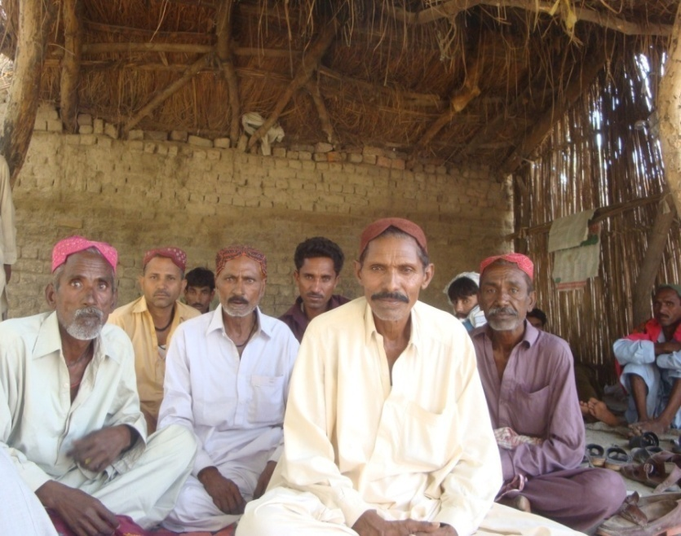
Changing professions for better lifestyle!
“Achar Jogee is a village where older people beg as major source of income to support themselves. Family members due to extreme poverty could not support their elderly economically. The habit of begging is carried out by older men and women along with widows without shame” reported Hakim, OPA president.
Help Age fund for older people have not completely changed the old norm but few older people have been given the opportunity to engage in income generating activities to become independent.
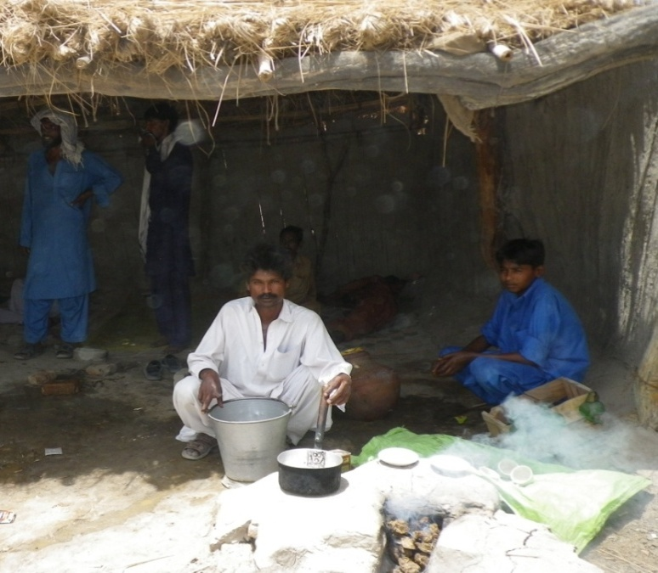
Achar Jogee’s president Hakim himself is a beneficiary and these days is working to establish a fish farm so that he can live with pride and dignity.
“I have been exposed to various other possibilities of income other than begging while interacting and socializing with other OPs from nearby villages and I want to earn money for my family in a respectable manner” CRF has given me the opportunity to change for better.
“A widow in our village has also abandoned begging after receiving CRF and is running Chaiy ka hotel (Tea shop) with the help of her son” reported Hakim.

Impact of direct and indirect community sensitization & capacity building activities.

Older people engaged in productive work force, list of reserve candidates for CRF, OPs emerging as leaders, example of saving life of an infant and holy book (Quran) in a recent fire emergency and the revolving of funds are all positive impacts of sensitization and Capacity building activities.

Most valued impact of the sensitization on communities is their acceptance of OPs in this new role of participating in restoring livelihood. These new roles are associated with the wellbeing of the whole family as 83.3% of the OPs still live in Joint families. These loans sometime are not directly consumed by OPs but by their families/children.

The formation and continuous participation of 51 OPAs since 2010 shows high level of commitment by the community and quality of sensitization at the grass root level. It is evident from the data collected that all OPAs have received trainings from HAI and also conducted trainings.

Figure No. 3: Trainings delivered to OPs and community by OPAs

Source: Questionnaire for OPAs, Question no 11

The trend of responsibility exhibited by the OPAs and OPs reflects highly sensitized behavior and well developed understanding of the concept of social protection. 65% of OPAs reported that beneficiaries are paying back CRF. Reasons mentioned for not refunding was, seasonal income and loss in business. It is expected that the remaining 35% will pay back the loan within their allocated timelines.

Figure No. 4: OPs paying back CRF

Source: Questionnaire for OPAs, Question no 8
As an implementing partner SRSO has also been sensitized to the needs of this marginalized group and their expected potentials. SRSO’s District Manager Shikarpur labeled HAI’s initiative as a new dimension towards development through social mobilization and protection in Pakistan. He appreciated efforts made by HAI and would welcome any other interventions for the welfare of OPs by HAI, any other organization or government.

Another group known as LSO (local support organization) supported by SRSO showed signs of sensitization towards OPs and resulted in establishing links with OPAs in MudKhoso village. They have assigned OPs important roles and responsibilities in establishing shelters.

Utilization of aids provided to communities such as wheel chairs, emergency kits, assistance in constructing community halls have positive impacts on community people. They recognize HelpAge as kind friend of old people.
“This is my first aid kit provided by Help Age that saved me from going to the doctor”

CRF Management Activities enable them to understand the importance of opening bank accounts, record keeping, maintaining records, importance of holding meetings, process of eligibility to become a CRF beneficiary, and how to raise and resolve issues regarding eligibility criteria. OPs of rural communities are being exposed to democratic political process and professional understanding, which they are utilizing affectively. All 40 OPAs have opened bank accounts with the support of the implementing partner SRSO. During one FGD in Jacobabad, an OPA leader said, “Older people realized that these trainings have provided us opportunity to come out of our villages and explore new things about the world”

CAP and DRR training have developed skills of not only older people but young men and women. These trainings have taught communities how to deal with medical emergencies in any disastrous situation, where to shift/migrate in emergency situations, which routes are safe and how to save elderly population and children .Older men and women not necessarily CRF beneficiaries have participated in developing Community Action Plans to deal with future shocks and hold meetings to disseminate information regarding CAP. These CAP have also been shared with District Disaster Management Authority in Jacobabad.

Figure No. 5: Developed Community Action Plans

Source: Questionnaire for OPAs, Question no: 16
52.% OPAs have developed Community Action Plans with the involvement of other OPs.
35.% OPAs reported that they have not formed Community Action Plans as yet and 13% said they are in process of forming the community action plans.

HAI’s support in developing community halls, meeting rooms, and IEC materials along with promoting a feedback culture in the community can be seen as an effective method of sensitization.
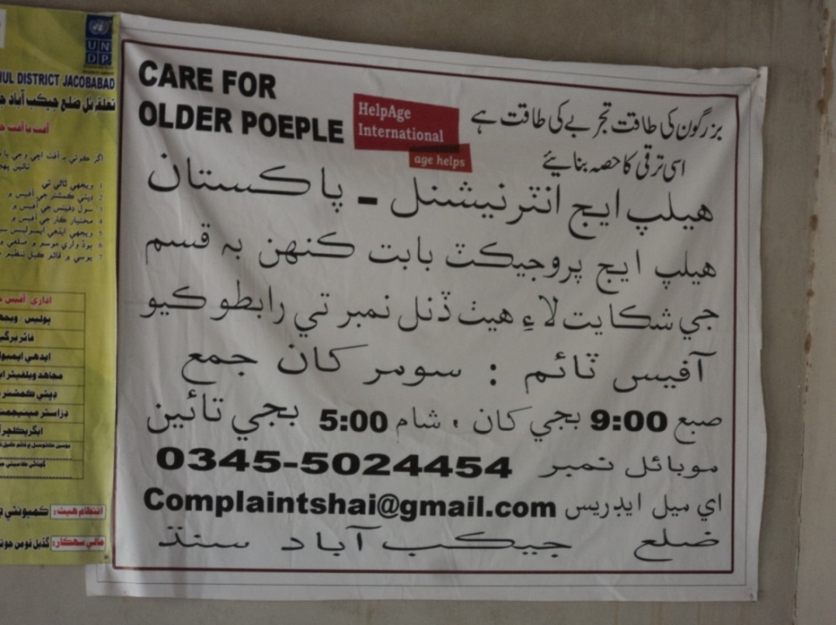

A significant impact of sensitization activities by HAI, resulted in the registering of all 26 OPAs in the District Jacobabad and 01 in Shikarpur. This way the Government which is a key stakeholder for policy intervention will realize the importance of the needs of OPs in society. HAI capacity building initiatives have enabled the OPAs to establish and organize to an extent that they got registered in a short span of time. The Social welfare departments of the government of Sindh are now aware of the fact that there are 27 local level organizations working for the welfare of aging population in Sindh and probably the only CBOs working at the grass root level for older persons.
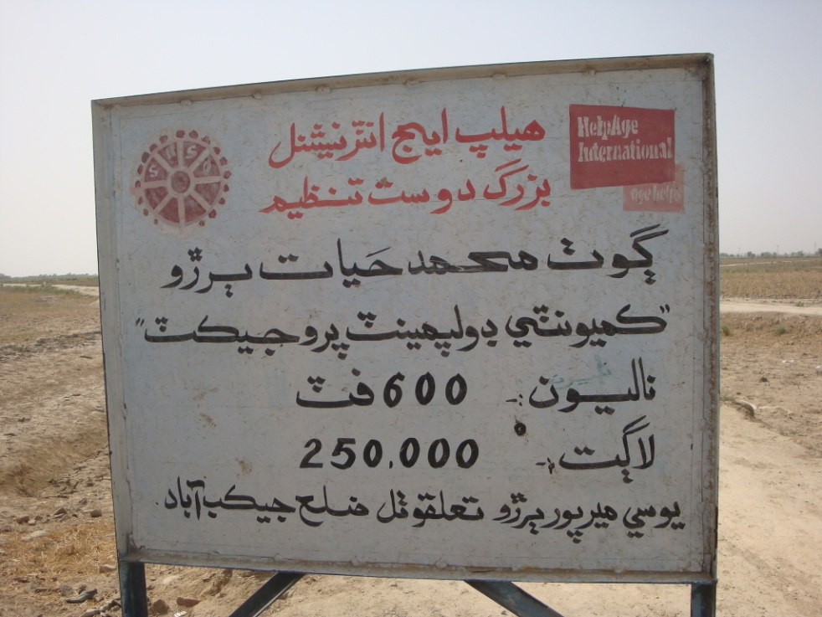

Level of resilience of communities and OPAs in adjusting or managing changes associated with potential risks to livelihoods in the future, and the capabilities to adjust to such external shocks

After the floods, people from affected areas received huge amount of aid from several local and international organizations which had both positive and negative impacts on their lives. Where the focus was on re-establishing and relocating IDP’s, HAI focus was on developing the capacities of people to prepare themselves for future disasters. A small amount of Rs 10,000 through CRF given to OPs is a good example of sustaining their livelihood with limited resources to generate income.

It has been shown through data that 100% of the respondent OPAs had received trainings i.e 40 villages have more than one master trainer to train other community members regarding potential risks to livelihoods and human lives and how to control them.

Communities’ level of resilience can be estimated through the percentages of people who have started to work after the floods as soon as the opportunity is provided. Approximately 30% Older people were not engaged in income generating activities before floods who are availing CRF for restoring livelihood at present. This shows that there is an increase in number of people working to generate income which is helping them to re-adjust. Increase in the work force of older people within communities reflects resilience.

Figure No. 6: Work for a living before floods

Source: Questionnaire for OPs, Question no 20
Livelihoods insecurities vary from losing livestock due to epidemics and stealing (security reasons) to damaging of irrigated lands. People also fear that their small businesses would be ruined if another flood hits back.

HAI interventions have induced skills and enhanced capabilities of OPAs to fight with future shocks through trainings in DRR and CAP. OPAs have been assigned roles and responsibilities to develop the communities stronger, skillful and capable to fight with any shocks in the future through training other community members.

Figure No. 7a: Formation of OPAMCs by OPAs

Figure No. 7b: Distribution by Committees

Source: Questionnaire for OPAs, Question no: 13 AND 15

The figures depicted in the chart show strong resilience in the community for absorbing future shocks.

Case Study 2 – Rahib aLI Moorani, sHIKARPUR

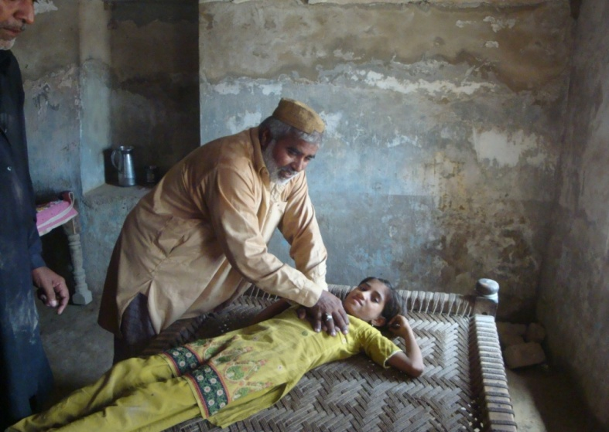
Empowering OPs to build strong and safer communities
Rahib Ali Moorani, who is also the information secretary of village Morani’s OPA is very happy with HAI interventions.
“I have consumed the fund in “Bhag” (buying seeds) and planting them. This is our family profession and I am well trained in agriculture”
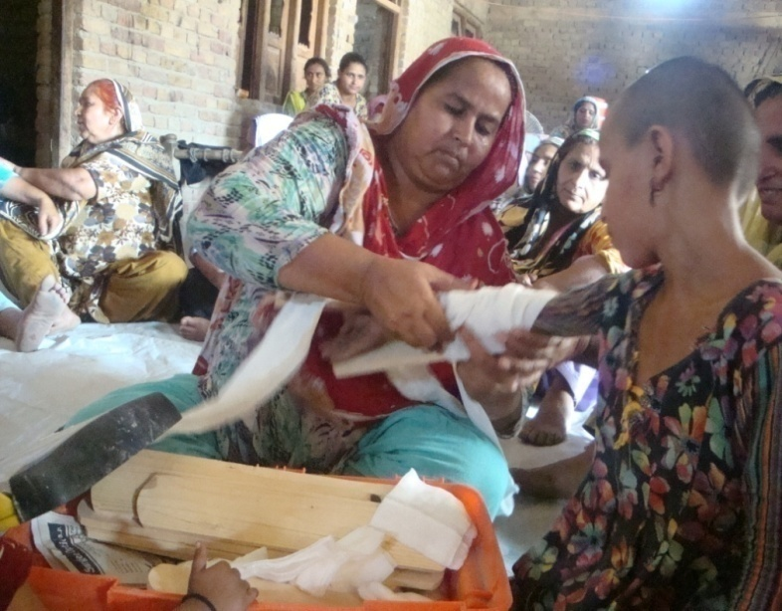
Rahib looked very enthusiastic about training drill that he received recently. “I am well trained in methods of rescuing people during emergencies in case of fire and floods”
He has encouraged his whole family to attend the trainings and become empowered. In the picture his sister in law is showing how to provide first aid to any victim of fracture during an emergency situation.
Rahib said, “we are ready to face any disaster now and are confident in training others to make their villagers highly resilient to absorb shocks”.

Case Study 3 – opa - Haji Abdullah lashari, jacobabad

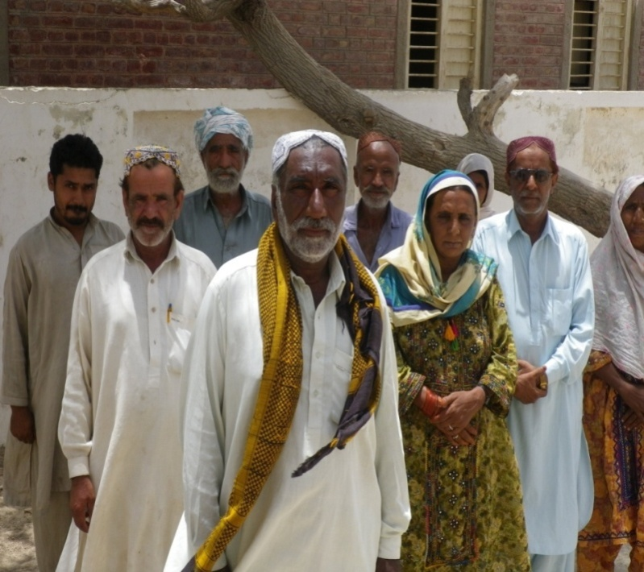
United we stand!
“By establishing these OPAs we have gained back our lost respect and dignity”, said Ali Muhammad Lashari, Finance Secretary of Haji Abdullah Lashari village.

In our village, 7 – 8 tribes were living together for decades with less interaction but now we have a purpose to meet twice a month to discuss issues and work towards their solution. There is a total of 200 OPs in our village, 46 have benefited from CRF initially and 5 more are on the waiting list.

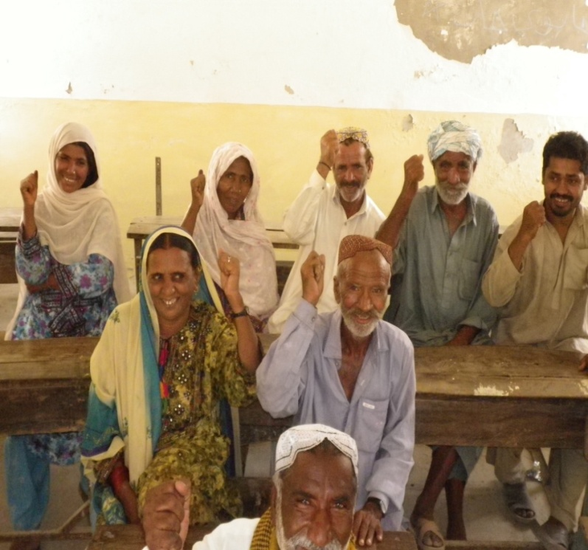
“We were able to return all funds back to HAI and successfully create opportunities for new beneficiaries” said Lashari.

While praising HAI interventions he said that “The CRF scheme is remarkable as it gives interest free loans which are not the case with other MFI loans. This helps us reduce our stress and worries.
“My dream is it to empower every elderly in my village so that we are not dependent on others”

Assess the effectiveness of the established linkages with the partner organizations and other stakeholders and suggest measures for their integration in the future

The implementing partner of HAI, SRSO is a key stakeholder of the targeted area. During meetings with D.M of Sikarpur and Jacobabad, both have appreciated the CRF interventions of HAI for older people. DM Shikarpur and Jacobabad have praised the role of women in making a similar intervention (CIF) sponsored by government of Sindh highly successful. They were of the view that involvement of women can bring impactful changes in economic conditions of household.

SRSO run programs for the most marginalized section of Pakistani society, therefore, they understand the dynamics to successfully run such programs. Most likely this is the reason that SRSO initially agreed to become implementing partner and would be glad to continue to play the role in the same capacity.

HAI interventions are extended to most flood affected and dangerous areas of the two districts only because of this key stakeholder. In few instances HAI’s work is overshadowed by SRSO’s name. Working through SRSO has more advantages than disadvantages.
The partnership has been highly effective for HAI.

Shikarpur district has been unfortunate as there has been no active disaster management committees, no officer in the bait-ul-Maal office and even there was no DCO at the time of data collection. The linkages of HAI with Social Welfare Departments in Shikarpur does not sound very effective as, they have not register 24 OPAs out of 25. Whereas, in Jacobabad all 26 OPAs have been registered, including those who are formed recently and did not receive loans yet. This has been checked through records kept by the Jacobabad office.

Bait-ul-maal in Shikarpur and Jacobabad is not working since 2010. This has been informed by the POs and counter checked by visiting the offices in both districts. The offices were locked and there were no staff available to provide further information.

Jacobabad office has managed to develop working relations with the Disaster Management Authority of the District and subsequently handed over the CAPs to the officials. Shikarpur office is struggling to locate officials to handover the Community Action Plans in absentia of any designated officer.

BISP is working with young women through Micro Finance but does not show any effective partnership with HAI at any level in both districts.

Access to microcredit programs of OP, identifying available to sources, limitations in terms of access to these source

59% OPs have identified that there are other Microcredit financing opportunities available, but older people have limited access to these micro-credit programs due to age specification and gender disparities (males are excluded).

Figure No. 8: Access to other Micro credit programmes

Source: Questionnaire for OPs, Question no 27

Table 3: Distribution of Micro Credit Programmes
Distribution of Micro Credit Programmes out of 59% | %
Benazir Income Support Programme (BISP) | 38.2
Baitul Maal (BM) | 1.4
Govt of Sindh ( GoS) | 4.9
Sindh Rural Support Organization (SRSO) | 12.5
UN-Habitat | 2.1
Source: Questionnaire for OPs, Question no 28

There is very less access to knowledge as well as funds to OPs from Bait-ul-Maal which is government’s programme to provide relief to these most vulnerable groups of society. The institution is dormant at the moment in both districts under study.

During FGD in Shikarpur OPs identified BISP as leading microcredit programme, benefitting families. 37.9% are benefitting from the BISP microcredit fund (RS.1000/Pm) that counts as a large portion of microcredit availing population.
There is also Waseela-e-Haq loan available under the BISP umbrella but is age specific. Older women are excluded from entering into this programme. To be Eligible for BISP, I.D card is an essential pre-requisite which at times is considered a barrier.
Another Microcredit Programme, OPs have access to is Watan Card,government of sindh for flood affected people provided by the government. OPs with NADRA I.D cards can be benefitted under this programme. The figure 4.9% shows their strength.
2.1% of older people have access to microcredit programme introduced by UN habitat. These are not specifically designed for older people but provided to flood affected population whose houses have been completely damaged. The Amount provided is RS.48, 500/.
12.5% OPs have access to SRSO funds (CIF) which only focuses on women. The population consuming microcredit shows a minute figure as compared to the figure of knowledge about SRSO initiatives. 100% communities have access to knowledge about SRSO initiatives for livelihood of women.
OPAs (leaders) during FGDs have recognized access to knowledge about other MFI’s for instance, Zaraee Taraquiati Bank and Khushhali Bank but are not availing it due to high interest rates “We like CRF because it has no interest rate over it, loans from banks are not good as they charge heavy interests”

Recommending a way forward for addressing livelihood insecurity, developing safety net mechanism in targeted areas, including access to microcredit programs, and at the provincial and national levels

Livelihood insecurities confronted by older people include loss of livestock, loss of Crops, landlessness and loss of valuable documents.

During FGDs, majority OPs have shown fears towards losing livestock due to epidemics and injuries and robberies. A man said, “how am I going to return my loan if my Bhair(goat) dies before giving birth ”

Livestock are the major source of income and food for rural population. A large no of CRF beneficiaries have also spent their funds in purchasing livestock.

Safety net mechanism in the future should also include vaccination services to the livestock and proper care to maximize their productivity and life span. Access to safety nets should be given high priority to secure livestock within communities.

Collaboration with government’s livestock and dairy department at national and provincial level can be made for providing any such services to OPs livestock in the targeted areas. Training should be designed and conducted to make livestock healthy and productive.

Insecurity regarding loss of crops and damaging of land especially in floods and monsoon season should be dealt through effective safety nets. The most effective is the provision of social protection whether in cash or in kind form. Decisions can be made according to the situation, but Proactive initiatives are better than reactive initiatives.

In targeted areas of Sindh, suitable safety nets would include establishment of dams, establishment of vegetated buffer zone along rivers, watershed-scale land using zoning maps, good governance and integrated regional water resources. These nets would require establishment of strong and effective partnerships with different government departments for instance agriculture.
HAI needs to stress the Government on extending of social security’s and EOBI social schemes to traditional professions such as farming and agriculture.
Concept of social insurance, flood insurance, should be introduced within communities.
Good governance for flood management is the most desirable safety net for minimizing future damages to livelihood. Capacity building of Govt officials by organizing exploratory visits to similar countries like Srilanka and Bangladesh to mitigate livelihood insecurities should be organized. HAI can organize regional policy dialogue events on lessons learned to promote awareness amongst key stakeholders.

Gender perspective:
During interviews with DM Shikarpur and DM Jacobabad, SRSO, both explained the success of their Micro credit poverty reduction programme, stands on women participation. They recognized the role of Sindhi illiterate women in bringing about the change in socio-economic conditions of the households. They shared their experiences that if women are provided with appropriate opportunities and direction they can bring about positive changes and prosperity in the communities and in societies.

Although, HAI’s interventions also provided equal chances to receive CRF to older women but lack of skills to consume these loans is identified as a gap in the study . Learning from the experiences of SRSO and other Microcredit Programmes older women should also be provided with better livelihood trainings and encouraged to take leading roles within OPAs. Realizing their capabilities and courage HAI should workout plans to properly direct these older women (OW) and make use of others’ experiences.
Exposure and Trainings in entrepreneurship, business development, export of handicraft to cities and international forums, production of dairy products at small scale can be potential areas of trainings for older women to generate income.
Young old especially women should be provided with trainings to develop new skills for livelihood activities. These can include knowledge of information technology and vocational trainings etc.

Case studies

Case Study no. 4 – SHAHZADI, jacobabad

Stitching my own future!
“I could not sew properly due to age factor as I did when I was young” says Shahzadi from Chandan village, Jacobabad. This barrier caused economic stress for myself and my family and the delay of meeting deadlines was affecting business but soon our OPA was established and after receiving CRF my worries stopped. A lot of people in my village were using the money for livestock which is the traditional profession of our village people but I wanted to continue with what I knew better so that I remain active and continue to support my family. After purchasing the sewing machine I was able to resume work with more speed and increase my monthly income. Previously I used to earn approximately Rs 750-1000 per month but now this has reached to Rs 3000. This way I am able to return the loan money and also remain active at this age. My daughter in law is also helping me in my work now to increase productivity.

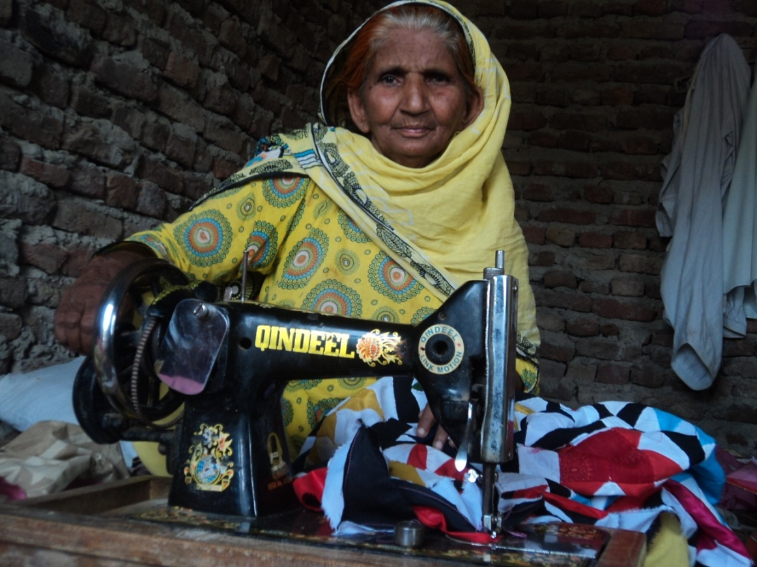

Case Study no. 5 – MAI BIBUL , jacobabad

Safe Savings!
Mai Bibul, from Muhamad Hayat Buriro village, Jacobadad was very happy after receiving CRF as she was able to multiply her savings into a fortune. “I had never thought that my little savings could come in handy for my family”. Fortune favors the brave and my belief in this has strengthened. I live in a large family set up with total 24 members but yet again I had been saving money to invest in livestock so that I could increase my income. I had planned it for next year but as soon as the 10,000 CRF came I added 4000 from my savings and bought a Ewe (female sheep). Soon it gave birth to a lamb which I was able to sell in 8,000 and my sheep is again expecting making me feel proud of my safe savings!
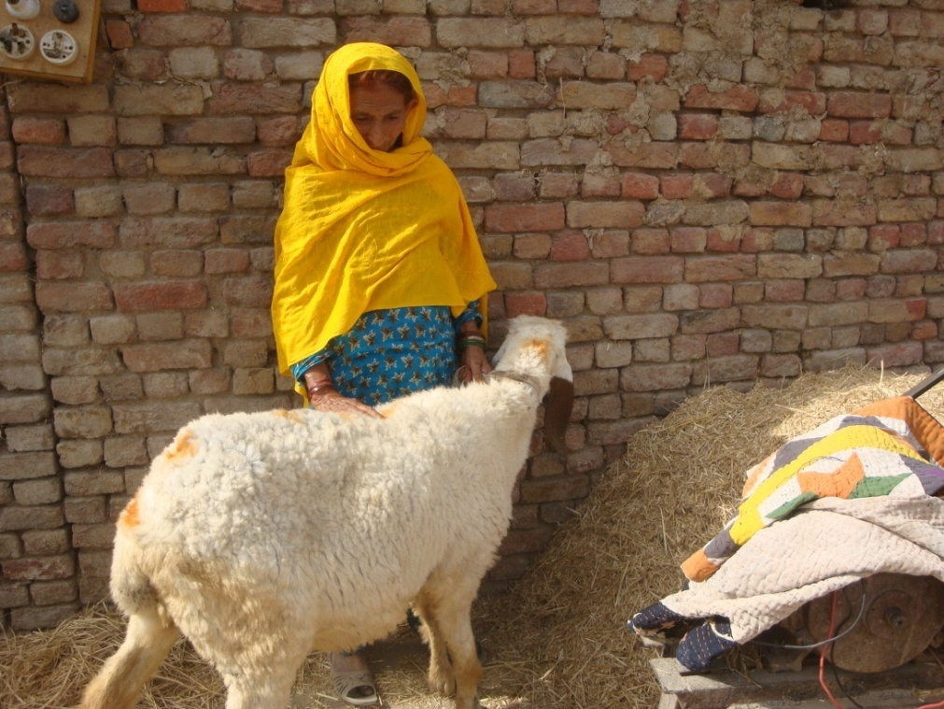

Case Study no. 6 – MAI PANAH AND RASHEEDA, sHIKARPUR

Two heads are better than one!
Mai Panah and Rasheeda from village Talib Husssain channa, tehsil Khanpur,District Shikarpur used to work in the fields before receiving CRF. “ I wanted to spend it on agriculture but also wanted to do something that would be safe, more profitable and quick in recovery” said Mai Panah. They decided to join their funds and open a shop in their village that could serve the nearby families. Due to the large sum they were able to buy enough stock for their shop to avoid the trouble of transportation and increase in price. “Spending in agriculture is traditional but needs more patience to see benefit and after floods it is high risk to livelihood” said Rasheeda. These women earn more than 200 every day now which makes it Rs 6000 every month. “We are now able to easily return the loan money and are also able to save some which we spent on livestock” commented Panah.
These two women have developed business partnership that has improved their economic well being. This is a new practice adopted by them and is a role model for other OPs in their village.
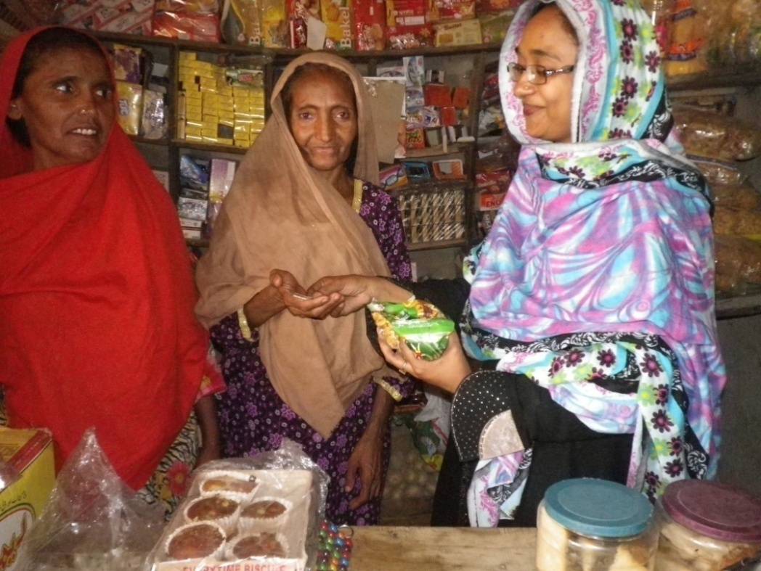

Chapter V: Discussion and Conclusion

STUDY 1: Impact Assessment of Community Revolving Funds on restoration of /development of Livelihoods of OPs
Sustainable livelihoods approach (SLA) has been in existence, and has been evolving, since the 1980s. It is used by a number of development agencies such as UNDP and the UK Government's Department for International Development (DFID). DFID's approach to sustainable livelihoods was formalized in UK Government's White Paper on International Development in 1997.
Although SLA is comparatively a new approach for poverty reduction but it has been a successful model for judging impact and success of livelihoods programs across the globe in the development sector.
HAI intervention religiously followed the SLA framework that focused on people centered, responsive and participatory, Multi-level, partnerships, sustainable, dynamic and holistic principles of SLA.
Globally older people are the victims of social and economic marginalization, throwing them in the group of most vulnerable sections of society. In humanitarian emergency situations, as these floods older people tend to be disproportionately affected by the impacts of disaster. Their comparatively small proportions in the population 7% in Pakistan’s case make them invisible and often not being responded appropriately according to their specific needs during the post disaster relief activities.
HAI program focuses on Older People’s restoration of livelihood and readjustment in society after the shock. Older men and women are equally benefitted. HAI’s interventions has also build communities’ capacities through trainings ranging from, developing better action plans to managing community based organizations. It has been discovered that 65% OP did not use to work for living before the flood but these interventions have given them the opportunity to explore new dimensions for them.

Although, HAI’s interventions provided equal chances to older women for CRF, lack of skills to consume these loans is identified as a gap during the study. Learning from the experiences of SRSO and other Microcredit Programmes, OWs should also be provided with livelihood trainings for better utilization of these loans and also minimizing the risk of losses. Older Women have been bold enough in choosing new professions for them without prior experience.

During interviews with DM Shikarpur and DM Jacobabad, SRSO, both explained the success of their Micro credit poverty reduction programme, stands on women participation. They recognized the role of Sindhi illiterate women in bringing about the change in socio-economic conditions of the households. They stressed, if women are provided with appropriate opportunities and direction they can bring about positive changes and prosperity in the communities and in societies.

OW should also be encouraged to take leading roles within OPAs. Realizing their capabilities and courage HAI should workout plans to properly direct OW and make use of others’ experiences.
Once again, Older people have been given the opportunity to participate in work force and contribute in households through income generation and OPs emerged as productive kfigures instead of non-contributory dependents.

HAI interventions have been instrumental in bringing about behavioral changes in older people of poverty struck areas. Adaptable behaviors for livelihood restoration and abandoning of bad practices are welcoming. These impacts will throw a dignified image of OPs on the future generations. This is a significant positive change.

Programme’s strategy to involve younger generations in OPMACs has narrowed down the generation gap. Young boys are seen accompanying older people during meetings and training sessions. Training drills have raised a sense of responsibility in young girls and they become volunteers for demonstration and exposed to trainings. These efforts can increase inter generational solidarity.

HAI interventions have reduced OPs sufferings and raised their social standings in their families. According to the research, 96% of OPs are head of their households and participates in decision making. Various trainings to OPs have made them skillful and master trainers for Disaster Risk Reduction and Managing welfare organizations.
It was evident from the interventions made by HAI that it has followed an inclusive and participatory approach in mitigating the difficult circumstances faced by the older people in flood emergency. Data reflects that HAI has been completely successful in formation of Older People Associations and restoring livelihood activities.

HAI has successfully met targets set out to train and prepare communities for future emergency situations through capacity building activities involving other stakeholders (community members). HAI has been partially successful in developing and registering CAPs and delivering it to DDMC. CAPs were being formed by few OPAs.

OPAs are advocating OPs about existing safety net institutions through regular intervals. HAI’s interventions for the first time Organized Older People as, In-Groups. This minute change in the societal web at the moment would be effective in mainstreaming aging issues in the future and breaking other discriminatory practices such as social marginalization, policy deformation, abuse and exclusion. It will also affect the well being of older people through staying active in processes of life.
These opportunities of restoring livelihoods to older people proved as a challenge for OPs. They have shown their best potentials to participate in economic activities and reject age based discrimination and marginalization. Such responses are remarkable. Improved average incomes and access to basic facilities complemented their potentials and are considered positive impact.
Formation of 51 OPAs is an achievement of HAI, registering of 27 OPAs with the Social Welfare Department is an effort that would be counted as added value on HAI part. These 27 CBOs, brainchild of HAI can play significant role in mainstreaming aging at community, city and district level. These CBOs can achieve the status of national level NGOs fighting for the rights of aged. These CBOs can also expand their objectives and integrate other vulnerable groups for example: Aids Affected families or disables.

At government level HAI has also managed to develop links with the District Disaster Management committee and shared their community action plan for emergency situations. Various Government departments’ officials and other NGO are invited to events for developing and maintaining good relations and also disseminate HAI achievements in the districts. Strong relationships are formed with OPAs (CBO) through monitoring and training activities.
SRSO is HAI’s implementing partner in these two districts. HAI’s decision to work in partnership with SRSO has been very effective. It has given considerable weight-age to HAI’s interventions at grass root level. SRSO is very well recognized within communities and is being trusted. SRSO understands the dynamics of running Social Protection programmes, through SLA approach with vulnerable groups in poverty struck rural areas. It has experience of running and bringing success to such programmes. At the moment SRSO is implementing Government of Sindh’s programme for poverty reduction.

The programme is similar to HAI interventions and has been successful in Sindh. However, SRSO needs to play aggressive role in establishing effective relationships between HAI and the government departments. SRSO can also play vital role in disseminating HAI’s achievements and highlight OPs productive role to key stakeholders for instance, government of Sindh as, it is closely working with it.
HAI’s interventions are holistic and dynamic in approach. It supports people in utilizing CRF in agriculture and livestock restoration measures. Realizing the changing needs of older people and losses after the floods, HAI did not restrict loans for innovative and new endeavors from OPs.

Risks:
Low amount of community revolving funds: There is a risk that low amount of CRF will not be able to fulfill the livelihood needs of OPs in future.
Weak coping strategies for livelihood insecurities: Insecurities related to agriculture and livestock are not effectively addressed that may affect the sustainability of HAI interventions regarding CRF loans.
Un- registered OPAs at the moment are monitored by HAI and SRSO. In case of withdrawal of these stakeholders / in absence of a accountable authority, OPAs might not perform their task with responsibility and dissolve.
Low priority given to OPs: There is a wrong perception about OPs, they are seen as a redundant force amongst stakeholders.
Governance: Due to the inefficiency of Government systems and institutions it affects the performance of the team in meeting key outcomes.
Lack of capacity building/livelihood activities for Women: A large no of older women are consuming CRF loans and few have shown interests in establishing livelihood activities other than agriculture and maintaining livestock. Due to less exposure to outside world they need comprehensive trainings livelihood development. Similarly, many women are not found as leaders in OPAs.

Recommendations:
- HAI Interventions should not be withdrawn and should be expanded. OPs have emerged as advocates for their rights in such a short period of time and can play a pivotal role at the policy level. The programme should be offered to other districts. Because HAI has emerged as the only organization to work for livelihood for this vulnerable group, it has the capability to scale up its services to other districts in Sindh.HAI should continue to empower OPs through social protection schemes.

- Existing master trainers from within the OPAs can play a role in cascading the trainings to nearby villages to increase participation of OPs which would allow HAI to develop a pool of local trainers. This will add sustainability to the component of capacity building in reaching out to more OPs .

- Women’s participation in the scheme has enabled them to become role models which can encourage other women OPs to participate in important roles of OPAs. Women should also be trained as volunteers as observed in Community based poverty Reduction Programme by government of Sindh. Older women had been showing same potential as shown by young women in SRSO projects and are seen as the strength to increase income of households.

- It is strongly recommended that exposure and trainings in entrepreneurship, business development, supply/ export of handicraft to cities and international forums, production of dairy products at small scale can be potential areas to generate income by older women.

- Government departments, at district and provincial level should be taken more seriously and interaction with them should not be ceremonious. They should be engaged in the design phase of the project and be given the responsibility of co-creating the planned outcomes to increase ownership.

- HAI needs to establish a consortium of existing and other potential stakeholders working in same villages so that time and energy spent in development is not repeated.

- HAI should continue with its efforts and should take a step forward in enduring that loss of livestock, crops, and landlessness be addressed through social insurance mechanisms. This will increase the capacity to sustain livelihood and ensure income for OPs in difficult times. Trainings to sustain livelihood, collaboration with government’s livestock and dairy department at national and provincial level, establishment of dams, vegetated buffer zone along rivers, watershed-scale land using zoning maps etc. Capacity building in good governance (Public and private sector) is an integral part of sustaining resources and should remain a priority for HAI.

- The amount of loan for future should be set after proper research in the area of service. As mentioned earlier there should be an increased due to the high inflation rate. This can be addressed by launching a scheme that benefits a whole village rather than individuals. For example, grant given to them for agriculture development in their area will benefit more people in comparison to one individual /household in the existing scheme. HAI can propagate the success of OPAs and OPs amongst various stakeholders i.e. Govt, Donors, INGOs as important players of society and encourage the registered OPAs to bid for grants offered.

STUDY 2: Access to other Microcredit programmes for older people

“Micro credit in this research is referred to any such financial assistance that is being provided to poor people in combating poverty. This could be in form of loan or grants”.
In a democratic welfare state, as Pakistan social security is the right of every citizen. Every welfare state recognizes the right to a standard of living adequate for health and well-being of people, the right to security in the events of un-employment, sickness, disability, widowhood, old age or other lack of livelihood in circumstances beyond their control.

In the absence of a comprehensive programme of social security in Pakistan, social protection is an alternate mechanism adopted to fulfill the needs and wants of poor. It is estimated that 80% of the world’s population live in a state of social insecurity. A research done by Dr Michael Samsung from the economic policy research institute showed the crucial impact social transfers make in reducing poverty in south Africa. These social grants reduced the poverty gap by 48% while supporting human capital and development. South Africa’s oldest social transfer programme provides extensive evidence by showing remarkable success in helping to achieve the Millennium Development Goals in areas of poverty reduction, nutrition, education and health. South Africa’s cash transfers also supported labor market participation and promoted local economic activity.

HAI’s intervention has used the findings in its favor by ensuring that OPs are given maximum opportunities through similar social protection scheme, on livelihood restoration. The results as discussed above have shown positive impacts in the overall livelihood conditions and well being of OPs. HAI’s contribution needs to be expanded by ensuring that policy to support poverty reduction for OPS is formulated at the highest level through partnerships and consent of key stakeholders. There is an opportunity to replicate the success of such programmes in other districts of Sindh through collaboration and support from the public and private sector.

59% OPs have identified that there are other Microcredit financing opportunities available, but older people have limited access to these micro-credit programs due to age specification and gender disparities (males are excluded). It has also been reported that the government’s policy to support older people through the institution of Bait-ul-Maal is covering a small proportion of the older population. Only a petite figure of 1.4% had access to Bait-ul-Maal funds in the past. Currently the institution is dormant in both districts under study.
A comparatively large no of people are consuming BISP grants that are available to household to fight poverty. In the current situation of older people it is a positive sign that they are not excluded from the scheme but measures can be taken to improve the results of the programme on OPs.

OPAs (leaders) during FGDs have recognized access to knowledge about other MFI’s for instance, Zaraee Taraquiati Bank and Khushhali Bank but are not availing it due to high interest rates “We like CRF because it has no interest rate over it, loans from banks are not good as they charge heavy interests”

Risks:
OPs remain Vulnerable: There is a risk that limited access to micro credit programmes offered may affect OPs overall well being if timely interventions are not made. OPs will remain a vulnerable group.
Governance: Due to inefficiency of institutions, OPs are not benefiting from schemes offered for their welfare.
Recognition: OPs are not recognized as beneficiary of micro credits by a number of poverty reduction programmes.
Recommendations
- Older people have highly restricted access to any micro credit programme other than banks (which are not consumed by communities due to high interest rates and processing fee). HAI’s small contribution has made visible impacts, mostly on the social aspects of the OPs. Endeavors under the umbrella of social protection should be continued by HAI, may be for some other basic needs (Housing ,Sanitation, Nutrition) prioritized by OPs in FGDs. During an informal interview, LSO president in MudKhoso has intimidated about nearby villagers interest in forming OPAs and receiving CRF. These villages include, Dairy farm, Village Suleman Sheikh, Jhando tanwari, Chuttal Shah and Dairgro Goth.

- In Pakistan for effective participation and change on government’s part (policy intervention), it is recommended to adopt top down approach. Awareness, sensitization sessions should be organized with higher government officials regarding Elderly Population and their specific needs.

- HAI at provincial and national level should start dialogues with governments to include older people in their eligibility/priority list for poverty reduction programmes and other welfare programmes. HAI should share their programme’s success to stress their point across, government’s departments.

- HAI can strive for allocation of adequate funding from international donors for older people in disaster response as well as development aid budget for disaster prone areas by showing the positive impacts of CRF on older people.

- In order to promote the initiative and mainstream ageing, radio campaigns highlighting the success stories of OPS should be launched along with print campaign so that the impact of the programme can be celebrated. This will generate interest amongst masses that would help programme objectives. Various representatives of organization offering Microcredit facilities can participate as guests in the radio show and share their product information with OPs so that access to them can be increased.

- OPAs and OPs have emerged as resource persons for various trainings conducted by HAI on health, managing funds, DRR, etc and now can also be used for other programmes introduced by other partner organization. OPs being the decision makers of their village will have the influence to promote health and education on behalf of other organizations such as UN, save the children, USAID etc. The purpose of establishing a consortium within the community will help reduce repetitive interventions to the same group and will allow partners to focus on one area. This way partner’s contribution will be seen as a significant step towards improving community cohesion in the area.

CONCLUSION:

It is concluded that older people have resumed their normal economic and social lives after floods which was the primary objective of HAI interventions. The data indicates that they are now well aware of disasters management in comparison to their previous knowledge about Disaster Risk Reduction. This knowledge and skills helped them to be more resilient communities.

OPs thus, most vulnerable group amongst the flood affected, have been flexible to change and can play a vital role in bringing about changes in the social and economic knitting as evident through the data collected. HAI strategic entry into the communities is well received by OPs and other community members.

Without HAI interventions older people would have remained marginalized. Older people potentials and willingness to participate in economic and social life would not have been discovered. Their reservations regarding traditional occupations as the only means of income generations would have not been exposed. Lifting up of social standing of OPs in families and communities would have not been possible and OPs and communities would have not offered/ availed opportunities to turn into human capital.

It is only through HAI Initiatives that OPS become visible to other stakeholders and partners. However, a lot needs to be done to promote the issues of OPs through main-stream media to highlight OPs as significant stakeholders in national policy and program.

The OPs are now seen as significant contributors in social and economic atmospheres combating poverty within families and communities due to the role played by HAI. 96% of OPs believe that there has been improvement in their lives after these interventions. There has been no other program which focuses on elderly especially in emergency situations. Without HAI even older people would have not known about the concept of “AGING”. They would only recognize CRF as another loan for purchasing sheep and seeds.

Other stakeholders can play various roles in issues of OPs by empowering them. Government can arrange dialogues and work on common agenda with HAI, justifying its signatory status of MIPAA 2002. The role of Community Support Organizations can be of providing an insight into the psycho-social dynamics of the community to plan the best implementing strategy with the ultimate goal to improve conditions of the older community. For achieving Millennium Development Goals, donors can play significant role through investing decent amounts in the programmes designed for the development of OPs apart from emergencies. Communities, effectively sensitized play important roles in the success of any programme either for development or change.

HAI’s initiatives through SLA framework is working well in implementing MIPAA 2002. Will it work to keep OPs mobilized and productive? Depends on HAIs commitment to meet possible risks to the sustainability of the program! Risks and recommendation provided in the report will assist HAI to develop new programme outcomes. At policy level HAI should stick to propagating, “mainstreaming ageing” through working at provincial and national level with public and private institutions’.

References

- Baker J. (2000). Evaluating the Impact of Development Projects on Poverty: A Handbook for Practitioners. Directions in Development, World Bank, Washington: D.C.

- Barry Fitzpatrick and Irene Kingston for the Equality Commission for Northern Ireland (2000).Older People’s Access to Financial Services, Reportage, March 2010, Age Concern: UK.

- Guiding framework and toolkit for practitioners and policy makers, Desa, UN

- Hannagan.T.H. (1986). Mastering statistics (2nded). London: Macmillan.

- Jock Campbell (1999). Linking the sustainable livelihood Approach and the code of conduct for Responsible fisheries, The Innovation Centre, University Of Exeter Campus, UK

- Ministry of Water and Power, Govt.of Pakistan, Annual flood report: 2010,pg. 4

- SocialProtectionhttp://ec.europa.eu/employment_social/spsi/social_protection_en.ht

- W.LawrenceNeuman(2000). Social research methods qualitative and quantitative approaches (4th ed).New York: Allyn and Bacon.

- http://www.un.org/ageing/documents/building_natl_capacity/guiding.pdf

- Alischa Kugel and Jenefer Nazareno(2007). Social Protection – an effective tool to fight Intergenerational Poverty, Global Action on Aging.

List of people interviewed

Mr.Gul Buredi, Team Leader, Benazir Income Support Program | Jocobabad
Mr.Abdul Lateef Soomro, District Manager, SRSO | Shikarpur
Ms.Zahida Pooro , Deputy District Officer, Department of Social Welfare, GoS | Shikarpur
Mr.Abdul Sammad Phulpoto, District Manager, SRSO | Jacobabad
Ms. Naseem, President Local Support Organisation, Mud-Khoso | Shikarpur

