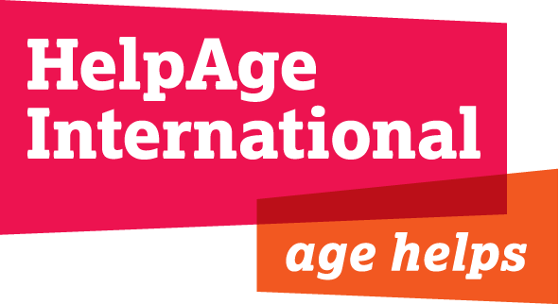
Consultancy: Consultation with older people affected by humanitarian crises
Terms of Reference
Objective: To survey perspectives of older people affected by humanitarian crisis to enable their voices to he heard in consultations ahead of the World Humanitarian Summit.
Reporting to: Humanitarian Policy Manager, Humanitarian Team (HuT)
Supported by: Advocacy and Communications Dept (ACD)
Duration: 18 days, starting asap, to be completed by 26 July 2015

Background
The first-ever World Humanitarian Summit (WHS) will take place in Istanbul on 26-27 May 2016. The Summit is intended to set an agenda for change to make humanitarian action fit for future challenges. In preparation for the Summit, regional and thematic consultations are taking place to identify the issues to be addressed by the Summit and its aftermath.
In order to help ensure the impact of humanitarian crises on older people and their resulting humanitarian needs receive the attention they deserve in the Summit, HelpAge International wishes to provide a channel for the views and opinions of older people affected by humanitarian crises to be heard in WHS debates. We plan to do this by conducting surveys in a number of countries with Older People’s Associations (OPAs) and HelpAge Network partners that are or have been involved in HelpAge’s humanitarian programmes.

The role
We are seeking a consultant to design the consultation and work with HelpAge Country Offices and Network partners in a number of countries to enable them to conduct the survey using a common set of questions. The consultant will collate and analyse the results and work with HelpAge’s Humanitarian and Communication teams to communicate the findings in various formats and media.

Key tasks and outputs
- Design and implement a survey that can be used on and offline with a common set of closed and focused questions to be developed by the consultant
- Identify between five and ten countries in which to carry out the survey, ensuring a range of different contexts are included (conflict, natural disaster, protracted crisis, recurrent short-term crisis etc)
- Work closely (remotely) with HelpAge country/regional offices and Network partners in those countries to enable and support them to conduct the survey, obtain responses and document the process with photo and video material
- Collate and analyse survey results and materials and write a report that will provide content for a range of advocacy and communication materials for WHS processes
- Advise HelpAge on the creation of different communications outputs including policy messages, factsheets, infographics, photo and video content to engage audiences with our WHS messages.

Consultant profile
- Excellent written and verbal communications skills in English
- Able to distil diverse content into strong evidence-based policy statements and engaging stories
- Excellent research skills, including the design and analysis of community surveys
- Experience of managing production of print and multimedia content for a range of audiences
- Excellent copy editing and proof-reading skills
- Experience of engaging audiences in a wide range of socio-cultural contexts including on and offline
- Able to manage multiple tasks and work under pressure to meet deadlines
- Good team working and negotiation skills.
- Ability to work in Spanish and/or French would be an advantage
The deadline for submission is midnight Thursday 25 June 2015. All interested applicants must submit their expression of interest s and a proposed methodology to hai-hr@helpage.org

Likely options: Pakistan, Nepal, Lebanon, OPT, South Sudan, Sudan, Ethiopia, Philippines, Haiti, Colombia, Ukraine

