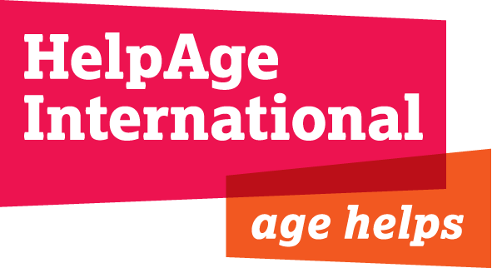

Consultancy: Study of community-based social protection, Kayin State
Terms of Reference
Objective: To conduct a qualitative analytical study of informal mechanisms and practices in Kayin which provide forms of community-based social protection to local residents in vulnerable situations.
Duration: October 2015 to December 2015

Background
The European Union is funding a project being implemented by a consortium of HelpAge International, the Karen Baptist Convention and Golden Plain Livelihood Development Service Cooperative in Kayin State called “Creating an Enabling Post-conflict Environment for Populations in Kayin State, and Facilitating the Safe Return of IDPs and Refugees”.

The 4-year project is based on establishing and supporting Village Development Committees (VDCs) in three townships: Thandaunggyi, Hpapun and Kawkreik. VDCs are committees managed by an inclusive group of community members to promote village economic and social development, including sustainable livelihoods appropriate to the context.

In order to help promote inclusive development that embraces vulnerable members of the community, HelpAge International wishes to provide a study of informal community-based social protection arrangements in Kayin. The aim of the study is to expand understanding on the risks faced by vulnerable groups and available community assets in order to inform state and national level social protection discussions.

We plan to do this by conducting a desk review of documents related to Kayin State culture/society, social protection, community-based social protection and the current Kayin situation as well as Myanmar’s new national Social Protection Strategic Plan.

The role
We are seeking a consultant to conduct a qualitative analytical study of informal mechanisms and practices in Kayin which provide forms of community-based social protection to local residents in vulnerable situations.

Key tasks and outputs
- Work closely with HelpAge management and consortium partners to discuss, clarify and outline the scope of the task.
- Produce a detailed design of the research study, including the workplan, methodology, sample of locations/respondents, and tools, for agreement by HelpAge.
- Conduct a desk review of documents related to Kayin State culture/society, social protection, community-based social protection
- Produce a review of the current Kayin situation as well as Myanmar’s new national Social Protection Strategic Plan.
- Conduct field research in Kayin villages, through qualitative methods, including key informant interviews and household interviews, as well as focus group discussions.

Consultant profile

- University degree in a relevant field
- Substantial practical and theoretical knowledge of rural community life in developing countries, preferably Myanmar and Kayin State
- Proven experience of social protection, community resilience or community development work
- Excellent research skills, especially in conducting semi-structured interviews and focus group discussions
- Ability to distil diverse content into strong evidence-based policy statements and engaging work
- Excellent written and verbal communications skills in English
- Strong analytical and summarising skills
- Able to manage multiple tasks and work under pressure to meet deadlines
- Good team working and negotiation skills

The deadline for submission is midnight Sunday 27th September 2015.
All interested applicants must submit their expression of interests and a proposed methodology to fon@helpageasia.org.

