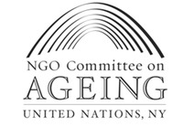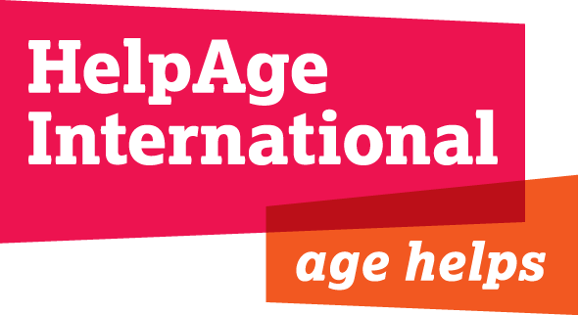

Response of the Stakeholder Group on Ageing
Zero Draft rev1 4 July 2014

We call on Member States to
We welcome the recognition in the chapeau that ‘people, of all ages and abilities, are at the centre of sustainable development’ , and the commitment to ‘strive for a world that is just, equitable and inclusive’.

This reference to ‘people of all ages’ is a step towards the framework reflecting the reality an ageing world, in which older people will constitute 16 per cent of the population by 2030.

We are nevertheless very concerned that this recognition does not carry over to the goals and targets. In the revised draft there is only one reference to ‘people of all ages’ and no references to ‘older persons’.

The language of ‘people of all ages’ can avoid the neglect of people in older age and therefore should be included in the Post 2015 Framework.

Our call to Member States
- Insert in paragraph 4 of the chapeau, the Madrid International Plan of Action on Ageing with the other cited Programmes and Plans of Action. It would fit well after the Beijing Platform of Action and further strengthen the social pillar of the post-2015 development agenda.

- Maintain target 1.2: by 2030, reduce by at least half the proportion of people of all ages living below national poverty definitions

- Amend target 1.3 to: by 2030 implement nationally appropriate [ADD: universal] social protection [DELETE: measures] [ADD: systems] including floors with a focus on coverage of the poor and people in vulnerable situations
Rationale: In support of a universal approach, the Recommendation Concerning National Floors of Social Protection was adopted by Member States at the 101st session of the International Labour Conference and emphasises the “universality of protection” as a key principle in terms of the responsibility of the State. The 2012 Rio+20 resolution states “the need to provide social protection to all members of society, fostering growth, resilience, social justice and cohesion, including those who are employed in the informal economy. We strongly encourage providing social protection floors for all citizens.”

- Reinstate ‘of all ages’ in the health goal: attain healthy lives for all [ADD: at all ages]
Rationale: While global population ageing is in part an outcome of progress made in the health sector it also presents a major challenge, and the need for strengthened health systems to support ageing populations. A goal of healthy life for all at all ages recognises this reality. The removal of ‘at all ages’ from the goal suggests a move away from this inclusive approach, and risks the neglect of people in older age.

- Support and maintain target 3.4 with an amendment to: by 2030 reduce substantially morbidity and mortality from non-communicable diseases (NCDs) through prevention, [DELETE: and] treatment, [ADD care and support], promote mental health and wellbeing, and strengthen prevention and treatment of narcotic drug, alcohol, and substance abuse
Rationale: The removal of ‘premature deaths’ defined by an arbitrary chronological age range – people between the ages of 30 and 70 – is welcome. This target risked excluding population groups, including those in older age who account for two-thirds of deaths from NCDs worldwide. The focus on both mortality and morbidity in the amended target recognises the importance of addressing the needs of those living with NCDs. Adding ‘care and support’ to prevention and treatment in the target would ensure the continuum of care necessary to meet the holistic health needs of people of all ages. Universal, age inclusive and appropriate health targets are crucial to tackle people’s current unmet health needs in older age.

- Amend target 3.6 to: achieve universal health coverage (UHC), including financial risk protection, access to essential health care services, and access to safe, effective and affordable essential medicines and vaccines for all [ADD people of all ages]

- Amend target 4.5 to: by 2030 eliminate the gender [ADD: age] disparities and ensure equal access to all levels of education and vocational training for people in vulnerable situations, including persons with disabilities

- Amend goal 5 to: attain gender equality, empower women [ADD: of all ages] and girls everywhere

- Reinstate women ‘of all ages’ in target 5.1, to: end all forms of discrimination against [DELETE: women and girls] [ADD: girls and women of all ages]
Rationale: A feminisation of ageing is occurring. In 2012 for every 100 women aged 60 and over globally there were 84 men. The figure decreased to 61 men for every 100 women aged 80 and over. Women in older age experience multiple and intersecting forms of discrimination. Gender-based and other inequality can accumulate over a life time and be exacerbated in older age, having devastating effects unless specifically addressed. While the inclusion of ‘all women and girls’ in the revision is welcome it does not go far enough. The post-2015 framework must tackle gender inequality in all its dimensions, including through the explicit recognition of an approach for ‘girls and women of all ages’.

- Amend target 8.4 to: by 2030 achieve full and productive employment and decent work for all women and men, including for young people, [ADD: older persons] and persons with disabilities, and equal pay for work of equal value

- Amend target 10.2 to: by 2030 take actions to empower and promote the social and economic inclusion of all irrespective of race, ethnicity, [ADD: gender, age, disability] or economic status.

- Amend goal 11 to: make cities and human settlements [ADD: age friendly,] inclusive, safe and sustainable. This builds upon the WHO age-friendly cities program.

- Maintain target 17.15: by 2020, increase significantly the availability of high-quality and timely data disaggregated by income, gender, age, race, ethnicity, disability, geographic location and other characteristics relevant in national contexts, with capacity building support to developing countries, especially LDCs

- Amend target 17.16 to: undertake regular voluntary monitoring and reporting of progress on SDGs, led by governments, [ADD: utilising the participatory bottom-up approach], within a shared accountability framework, including means of implementation, the global partnership among Member States and multi-stakeholder initiatives and partnerships. At the 2nd meeting of the HLPF civil society groups were all but unanimous in calling for a people-centered monitoring process.
July 2014: Stakeholder Group on Ageing NY
Further information: Jim Collins jcoll152@gmail.com; Sylvia Beales sbeales@helpage.org

