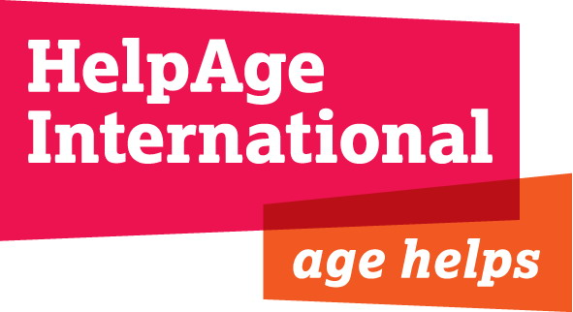

JOB DESCRIPTION

Job title: Regional Programme Manager

Grade & salary: ISB & £29,464 gross per annum

Department: Programmes

Location: Eurasia and Middle East (EME) Regional Office, Amman Jordan, with frequent travel in the region

Responsible to: Regional Director

Responsible for: Programme staff in Lebanon and Ukraine

Terms and conditions: Fixed term, 1 year renewable, accompanied post
Start date: ASAP

Relations with others: Affiliates and partners organisations in the HelpAge network in the region and EME Regional Office staff. Interaction as required with
Departments and staff in the London office

Background:
HelpAge International is a global network of not-for-profit organisations with a vision of a world where older people fulfil their potential to lead active, dignified, healthy and secure lives. The HelpAge International network has more than 100 affiliates and 300 partners across more than 70 countries. HelpAge International has a secretariat with offices in London and Brussels, and six regional centres covering South Africa, East/West/Central/Africa, East Asia/Pacific, South Asia, Latin America/Caribbean and Eurasia/Middle East.

HelpAge’s newly established Eurasia and Middle East Regional Office is based in Amman, Jordan. The Country Programmes in Kyrgyzstan, oPt and Moldova are directly managed by the respective Country Offices with overall support from the Regional Office, while support to other HelpAge affiliates and partners in the former Soviet Union, including Kazakhstan, Russia, Ukraine, Armenia, in Eastern Europe including Serbia, Bosnia-Herzegovina and Albania, and in the Middle East including Lebanon, Jordan and Syria is given directly by the regional office.

Job purpose
The post will have a particular focus on developing and managing HelpAge’s emergency intervention and humanitarian assistance across the region, currently focused on the Ukraine and Syria crisis.
Further, the post-holder will support HelpAge’s country offices, affiliates and partners across the region to ensure quality programme implementation, including donor compliance, internal and external reporting, financial monitoring, activity planning, and timely execution, including setting up and supervising monitoring and evaluation plans. S/he will help identify partners and affiliates’ capacity needs and provide mentoring and training as appropriate. Working with other members of the regional team, s/he will also contribute on identifying and pursuing funding opportunities. Finally, s/he will ensure that country offices, affiliates and partners adhere to HelpAge and global quality standards including accountability, transparency, gender mainstreaming.

Key responsibilities

- To work with country programmes and partner organisations in order to effectively manage project activities to agreed timescales including the proper management of project budgets and other resources with support as necessary from others in EME and London office
- To support specifically HelpAge’s emergency responses in the region, at present the Ukraine and Syria crisis. In particular, to contribute to the development of HelpAge International’s Ukraine and Syria crisis response strategy and lead on the planning and development of the programme in accordance with international humanitarian standards and principles and HelpAge policy and corporate strategy.
- To provide line management and support to the Regional Inclusion Programme Manager (Jordan), Regional Health Coordinator (Lebanon) and Emergency Programme Manager (Ukraine)
- To represent, as necessary, HelpAge in the region, in particular in strategic and coordination meetings involving humanitarian stakeholders, including governmental agencies and institutions, protection and health organisations, UN agencies and donors
- To add to the capacity of partner organisations through appropriate training/workshops and technical support
- To produce narrative and financial reports as required, frequently under tight deadlines
- To undertake project/ programme monitoring and evaluations, in collaboration with partner organisations
- To monitor overall project expenditure and financial reporting in liaison with finance staff
- In collaboration with HelpAge’s Humanitarian Policy team, to identify opportunities to generate and disseminate evidence on the situation and needs of older people and people with disabilities as well as examples of good practice and learning.
- To cooperate with the HelpAge’s Advocacy and Communications Department, to develop communications material and ensure effective public communication on the programme
- To contribute as a member of the programme team to regional strategic planning processes and undertake cross regional activities as necessary
- To advocate for disadvantaged older people by influencing strategies, policies and programs with regional and national agencies
- To promote regional and national networking among organisations to mainstream work for and with older people
- To enable partners to share resources, plans and experiences.
- To contribute to the development of funding and cost recovery strategies and their implementation

Person specification:

Essential:
- Relevant university degree or equivalent in experience
- Excellent oral and written communication skills in English
- Substantial experience of planning and managing humanitarian programmes with demonstrable competence in programme development, implementation and monitoring of outcomes and impact.
- Demonstrable experience of organisational capacity building
- Ability to network with and influence a wide range of people and organisations, including government structures and NGOs
- Experience of developing and writing funding proposals and securing funding
- Experience of managing budgets
- Experience of supporting smaller/local organisations with project development and management
- Sound understanding of humanitarian principles and standards including the Code of Conduct for the International Red Cross and Red Crescent Movement and NGOs in Disaster Relief, Sphere minimum standards and Humanitarian Accountability Partnership (HAP).
- Excellent interpersonal, negotiating, and networking skills
- Cultural awareness and sensitivity
- Training, coaching and facilitation skills
- Excellent analytical, planning and management skills
- IT user skills
- Experience of managing multicultural teams and remote management of international and national staff in different locations
- Experience of managing security policies and protocols to ensure the safety and security of programme staff and beneficiaries
- Willingness to travel to the region, sometimes at short notice.

Desirable:
- Relevant post-graduate degree
- Familiarity with the Middle East and/or Eastern Europe/Post-Soviet regions
- Russian and/or Arabic language skills
- Understanding and work experience of ageing issues and health issues facing older people in emergencies

