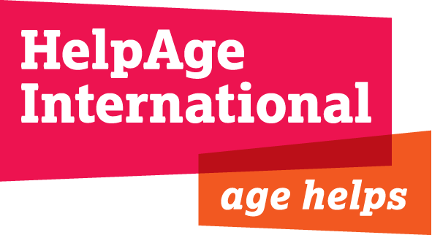

Programmes Intern, East West and Central Africa (EWCA) Region

Department: Programmes
Location: Nairobi, Kenya
Responsible to: Fundraising and Awards Manager

BACKGROUND
HelpAge International's vision is one of a world where older people fulfil their potential to lead active, dignified, healthy and secure lives. HelpAge is an international network, bringing together more than 114 affiliates and 200 partners working with older people in over 50 countries. The EWCA Regional office works with a range of partners across several countries to deliver programming in a number of key areas: HIV/AIDS & health; income security & livelihoods; emergency response & DRR and rights of older people.
The Regional Office implements several multi country health programmes in the region funded by DFID, SIDA and Irish Aid all focussed around the issue of ensuring quality health care access for older persons. The programmes are implemented in countries in the EWCA region (Ethiopia, Uganda, Tanzania) as well as Southern Africa region (Mozambique, Zambia, Zimbabwe).

SCOPE OF WORK

The Program Intern would be part of the Nairobi based Awards team led by the Regional Head of Programmes and will play a role in supporting the Awards Manager and Country teams to develop proposal and concept notes. The person will be based in Nairobi and is not normally expected to travel to country programmes. The person will work with an experienced and friendly team of professionals in a dynamic work environment and will stand to gain and learn significantly from the assignment.

RESPONSIBILITIES

- Participate in review of donor calls and funding opportunities for specific country programme including those that are regional in nature. Provide the feedback to the relevant team members.
- Develop specific concept pieces and proposals for submission to donors and other partners- based on competencies of HelpAge and agreed programme designs. This will require review of current literature within and external to HelpAge, team meetings etc.
- Routinely check key donor websites for new calls for proposals/ other funding opportunities, as well as INGO websites for consortia opportunities.
- Undertake research on donor funding trends and funding alternatives and share with funding and programme teams to facilitate donor engagement.
- Keep track of important deadlines for proposals and concept note and work on internal timelines for submission.
- Update consolidated regional funding chart on a monthly basis and circulate to relevant country office, London and Regional Office
- Liaise with fundraising persons in country offices and establish other areas of support.

WORKING WITH OTHERS

The post holder will work closely with a range of team members based in the region and country teams in performance of the above responsibilities.

PERSON SPECIFICATION

- Degree in a relevant subject
- At least 1 year of prior experience with a non-profit organisation
- Knowledge of fundraising and budget management tools
- Ability to write concept notes and proposals and willingness to turn around within agreed timelines.
- Excellent communications and writing skills
- Interest and willingness to learn from the volunteering role, contributing effectively to the team’s work.
- Experience in health programmes- practical or academic will be useful. Interest and experience on monitoring and evaluation aspects will be an added value.

CONDITIONS

The person will be provided with,

- A cost of living allowance of USD 750 per month paid locally
- Accommodation at shared guest house in Nairobi and transportation to the office
- Return airfare
- Travel insurance

