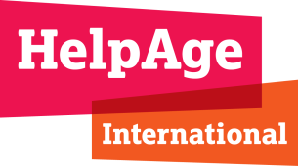
JOB DESCRIPTION

JOB TITLE: Network Coordination and Development Manager

DEPARTMENT: Network, Advocacy and Communications (NAC)

SALARY: Salary up to £43,000 based on skills and experience
RESPONSIBLE TO: Director of Network, Advocacy and Communications

KEY RELATIONSHIPS: Regional Heads of Network Coordination and Development and Regional Communications staff; key head office teams including Global Advocacy and Ageing, Campaigns and Communications, and Global Technical Unit; Network members, in particular those in Europe.

JOB PURPOSE:
- To provide a range of coordination, project management and communications support to the Director of Network, Advocacy and Communications and the three Regional Heads of Network Development to further strengthen HelpAge’s Global Network (HAGN).
- To provide direct coordination and development support to the HelpAge network in Europe.

JOB RESPONSIBILITIES AND KEY TASKS

Strategic Development
- Work closely with the three Regional Heads of Network Development (RHNDs) and the Director of Network, Advocacy and Communications to develop and deliver the Global Network Development Strategy.
- Work closely with HelpAge International’s European network partners to build on the progress achieved so far with the EU network programme and further develop network relationships in Europe.
- Drive forward key activities to support increased network collaboration globally and, in particular, in Europe, e.g. connecting members, convening members around key issues or events, supporting opportunities for learning and exchange.
- Provide network development perspective to development of other organisational strategy and planning documents, e.g. country and regional annual plans.
- Contribute to cross organisational strategy to strengthen age focussed civil society organisations/platforms.

Membership
- Oversee the new membership system, managing fee collection and supporting the development of membership benefits and initiatives aimed at strengthening the membership and growing the network.
- Develop appropriate materials for new and existing local HelpAge Global Network members to understand their membership benefits and how to ask for advice, help and support.
- Provide communications and other requested support to the RHNDs to implement the new Membership model at the regional level.
- Develop special projects for different types of members e.g. leadership programmes, technical packages (i.e. training + on-line resources + mentoring), campaign training, thematic membership groups.
- Coordinate regular Network updates, including input to Board meetings on membership and de-affiliation.
- Build strategic alliances with new members and other stakeholders particularly in Europe.
- Support greater horizontal cooperation regionally and globally between CEO / Board members of different network members.

Visibility and Communications
- Prioritise working in ways that seek to strengthen the profile and work of members in their own geography.
- Lead work to strengthen communications, connections and sharing of skills, knowledge, resources and data between members at global, regional and national levels.
- Ensure global network achievements are well profiled within HelpAge International’s internal and external reporting and communications.
- Support regional offices to design and deliver major conferences and events involving network members.
- Oversee the HelpAge Global Ambassador scheme, working with the HRNDs to develop work making use of this asset and facilitate e.g. invitations to speak at relevant conferences / meetings.

Coordination and Convening
- Ensure strong mechanisms are in place to support the sharing of assets, tasks and information across the Global Network.
- Work closely with other teams to foster more collaborative and interdependent working between members on relevant projects e.g. establishing task/campaign teams with clear focus and goals.
- Ensure mechanisms are in place for members to be better connected to technical support, training, and knowledge from HelpAge and other members.
- Establish database holding information on network members and ensure this is kept up to date with input from across the organisation / network.
- Assess capacity gaps across the network and make recommendations as to how these can most effectively be addressed in different areas of work.
- Ensure appropriate mechanisms are in place to collect feedback from members about HelpAge International’s work and share this feedback internally.
- Share two way communication between HelpAge International Board and network members, working with the global Head of Network Development.

Resource Development
- Support the development of fundraising for network activities and support network members to fundraise in particular for the European Network.
- Work with Resource Development and other teams to develop proposals for network activities.

PERSON SPECIFICATION

Essential:

- At least five years’ progressively senior experience in the international development and /or humanitarian sectors.
- Strong project management skills and the ability to manage multiple, complex tasks to meet deadlines.
- Excellent interpersonal and representational skills.
- Excellent communication skills (written and verbal).
- Proven experience in advocacy or campaigning work, including experience working within networks and/or large partnerships.
- Experience successfully developing networks and/or innovative partnerships.
- Demonstrable experience of fundraising and developing funding proposals.
- Proven ability to work collaboratively and within a decentralised, matrix management structure.
- Ability and willingness to travel internationally for work.
- Commitment to HelpAge International’s mission and values.

Desirable:

- Experience working on ageing and older people’s issues.
- Experience working in a developing country context.
- Language skills (Arabic, French, Hindi/Urdu, Spanish).

HelpAge International is committed to providing our staff with continuous professional development, flexible working and opportunities to thrive within an inclusive and diverse environment.
As part of our commitment to promoting gender diversity we are the only international NGO member of the BITC Gender Campaign.

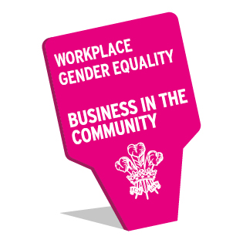 | 