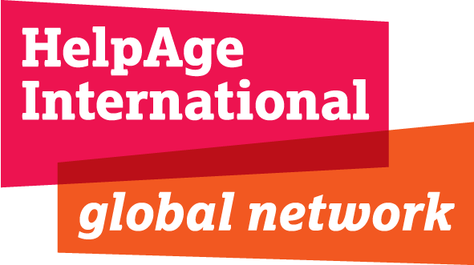

Volunteer Job Description

Job Title: Multimedia Content Volunteer
Contract: Minimum of 3 months (ideally 6 months)
Start Date: ASAP
Location: London (Flexible hours)
Terms & Conditions: Lunch and Travel Expenses Paid
Department: Policy, Advocacy and Campaigns Department

Responsible to: Communications Assistant

HelpAge International
The contribution older women and men make to society - as carers, advisors, mediators, mentors and breadwinners - is invaluable. But growing older is not without its problems.

HelpAge International helps older people claim their rights, challenge discrimination and overcome poverty, so that they can lead dignified, secure, and healthy lives. Our work in over 75 countries is strengthened through our global network of like-minded organisations – the only one of its kind in the world.

Our vision
Our vision is a world in which all older people can lead dignified, healthy and secure lives.

Our mission
Our mission is to promote the wellbeing and inclusion of older women and men, and reduce poverty and discrimination in later life.

The opportunity
This will be a great learning opportunity for a university or undergraduate or post-graduate student looking for practical experience in campaigns and communications work to fit around their studies. The main purpose of the role will be to support the maintenance of our multimedia content for our global network of affiliates and partners.
We are looking for an enthusiastic volunteer to help us with our policy monitoring work.

This role also provides an opportunity to join a team that produces a variety of HelpAge publications including newsletters, briefings and reports and manages a large photographic library.

Responsibilities
Update and maintain multimedia content library
- Copy edit case studies and testimonies according to HelpAge’s guidelines
- Communicate with regional focal points to follow up on case study and project information
- Keep log of available case studies in Case Study Mapping document
- Assist in developing better strategy for use of Flickr externally and visual content strategy (eg. use of photo stories, Pinterest, user generated content for campaigns)

The post holder may be asked to undertake additional tasks, commensurate with status, after consultation and the provision of necessary support and training as appropriate.

Person specification
Essential:
- Strong editing skills, ability to proof-read simple documents and good organisational skills
- Familiar with Flickr
- Able to multitask and meet critical deadlines
- Methodological and reliable
- Good interpersonal skills
- Proficiency in Word, Excel and familiarity with Outlook
- Ability to work in a multicultural environment
- Demonstrable interest in international development (fundraising and communications) and photography

Desirable:
- Photo editing skills
- Additional languages (Spanish)
- Demonstrable knowledge of Adobe Bridge

Application Details
Please submit CV and Cover Letter explaining how you meet the specifications in the description to Human Resources HelpAge-HR@helpage.org

Application deadline
04 November 2015

