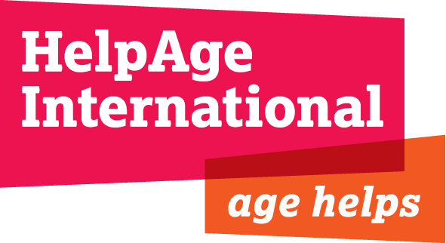

JOB DESCRIPTION

JOB TITLE: Programme Funding Officer

LOCATION: London

CONTRACT: Permanent, Full Time

DEPARTMENT: Resource Development

JOB GRADE/SALARY: D, £30,000- £34,000 gross per annum

RESPONSIBLE TO: Programme Funding Manager

KEY RELATIONSHIPS: Regional and Country Offices, Programme Team & Finance Team

Background

HelpAge International is the Secretariat of a global network, currently with 114 member organisations with a vision of a world where older people can lead dignified, healthy and secure lives. The Headquarters of the Secretariat is in London, with six Regional Centres in Thailand, Nepal, Jordan, Chile, Kenya and South Africa. We also have a small office in Brussels to represent us at the EU. We employ more than500 people worldwide.

The London-based Resource Development (RD) team includes six Programme Funding Officers and a Programme Funding Manager. The RD team supports staff throughout the organisation to raise funds from a diverse range of donors for its development and humanitarian work. Their role is diverse, spanning the whole funding cycle, from project design and proposal development, through to contract management and reporting.

Each Programme Funding Officer plays a critical role in the mobilisation of funds for work in a specific geography, supporting colleagues in international offices to raise and manage funds from institutional donors, trusts and foundations and, more recently, corporates and other emerging donors. Members of the HelpAge network are also increasingly leveraging funds from non-UK markets for HelpAge’s programmes, e.g. through affiliates in the US and Germany and the Programme Funding Officers also support their efforts.

Working within a small and dynamic team in London, this post offers the opportunity to also be a central member of a regional field-based team which is, in turn, delivering programme on the ground – the Programme Funding Officer being expected to undertake regular and sometimes extended field support visits.

Job purpose
To support the institutional fundraising and contract compliance efforts of regional programmes comprising donor research, proposal and report writing, training and capacity building of staff and partners.

Job responsibilities and key tasks

- To work with the management and staff of a designated Regional Office and its associated Country Offices to develop and implement funding plans and strategies to meet agreed funding needs

- To support the planning processes of international offices and departments through the provision of donor intelligence

- Ensure that funding proposals and reports submitted to donors are of the highest quality and consistent with plans and capacities

- To facilitate input from and work collaboratively with technical and finance staff on the development of proposals, budgets and reports for submission to donors

- To disseminate information and provide guidance to International Offices on funding opportunities and donor compliance

- To support the fundraising activities of HelpAge’s affiliates through the provision of information and support to proposal and report writing and development

- To monitor and support compliance with internal approval and quality control systems

- To support the development of partnerships with other NGOs in line with annual plans and strategies

- Support Regional and Country offices in the management of projects, including monitoring of project implementation, negotiations with donors and timely narrative and financial reporting

- To maintain an oversight of a portfolio of donors and ensure that information on these donors is effectively recorded, analysed and disseminated to relevant staff.

- To research and identify new donors and support the development of funding relationships

- To travel to Regional and Country Offices on support visits and in order to train and build the capacity of HelpAge’s staff and partners in resource mobilisation and donor compliance

- To attend relevant regional meetings and conferences and participate in regional planning processes

- To contribute to the development and maintenance of grants management systems and systems to co-ordinate all HelpAge International’s fundraising activities

- To participate in cross-organisational initiatives and processes, particularly related to those that monitor fundraising and financial performance

- To contribute to the planning, income monitoring and knowledge sharing activities of the Resource Development team

- Maintain up to date knowledge of regional work through regular communication, monitoring of funding plans and visits

- To participate in and represent HelpAge in donor and other external meetings and networks

Person specification

Essential
- Demonstrable experience of liaising with statutory and/or non-statutory donors, including the DFID, European Commission, and/or other major bilateral/multilateral donors, trusts and foundations
- Experience of supporting the development and implementation of fundraising strategies and plans
- Experience of cross-cultural capacity building and training
- Proven analytical and research skills and the ability to think strategically in relation to funding
- Experience of reviewing, writing and presenting project proposals, formal applications and donor reports
- An understanding of international development and project planning and implementation, including the use of tools such as logical frameworks
- Fluent in English with excellent written and verbal communication skills
- Able to work proactively and supportively within a team
- Able to travel to and work with staff in HelpAge’s overseas programmes, sometimes at short notice
- Able to manage multiple and complex tasks and work under pressure in a deadline-focused environment
- Good word processing and spreadsheet skills
- A degree calibre level of education or equivalent in experience

Desirable
- Experience of working in, supporting or mobilizing funding for work in Asia and/or Africa
- Language skills , preferably French/German/Spanish
- Marketing qualification/experience
- Experience of responding to tenders and other less conventional income generating approaches

