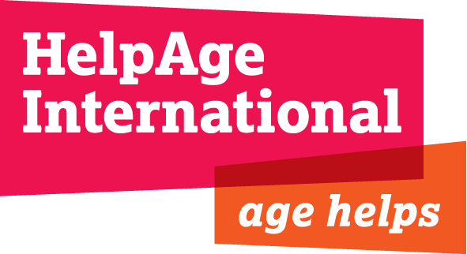

JOB DESCRIPTION

Job Title: Network Advocacy and Communications Officer

Department: Advocacy and Communications

Location: London

Contract: Permanent

Responsible To: Head of Strategic Alliances

Responsible For: Volunteers/interns

HelpAge International helps older people claim their rights, challenge discrimination and overcome poverty, so that they can lead dignified, secure active and healthy lives. Our work in over 75 countries is strengthened through our global network of like-minded organisations - the only one of its kind in the world.

Rapid population ageing is a key issue everywhere in the world, especially the developing world. One in five people will be over 60 by 2050.

Background
HelpAge International has a secretariat in the London office, six regional centres and country offices around the world. The secretariat works with 100 affiliate and 200 partner organisations in 75 countries. It is the only global network representing older people’s organisations, undertaking grassroots programming and local, regional and international advocacy work.

This role supports the growth, influence and advocacy capacity of the network and Affiliates of HelpAge International.

The International Advocacy and Communications Department

The team, with members in London and each regional office, leads on communications, campaigns, fundraising communications, network development, advocacy, digital and media to deliver HelpAge International’s vision and mission by:

- Delivering a smart advocacy agenda that increases profile and understanding of ageing in developing countries
- Leading on and coordinating global campaigns that inspire action on ageing
- Leading effective external communication and brand awareness, by building organisational and network capacities in communication
- Supporting the growth of a strong global network of organisations to promote the rights of older people.

Through our Age Demands Action and Action/2015 campaigns, our Post-2015 and Global AgeWatch programmes, we support older people and their organisations to have their say in global and national decision-making processes.
Job Purpose

- To promote and support strategic development and growth of the network.
- To strengthen and grow the advocacy outreach of the network, with a focus on building its profile and capacity to advocate and campaign on agreed priority areas.
- To manage the secretariat function of the HelpAge global network and further strengthen internal communications.

Responsibilities, tasks and activities

Strategic development of the network

- Profile network members’ activities, including input to advocacy, campaigns, resource and policy development.
- Take forward specific actions for increased network collaboration such as engagement in new strategy, consultations, training workshops and use of network brand.
- Support regional staff with network initiatives and identification and induction of new members.
- Support resource development for the network.

Promote network engagement in advocacy and campaigns

- Ensure network engagement in core campaigns including Age Demands Action and Action/2015.
- Lead network engagement in our Post-2015 programme, including coordinating meetings across HelpAge and the NY Stakeholder Group on Ageing, developing and maintaining oversight of the campaign plans, supporting resource development, research for campaign activities, developing external material and providing regular website updates.
- Promote network engagement with the Global AgeWatch programme, liaising on content development and supporting them in their use of the Index.

Manage Secretariat function of network

- Ensure strong communication between the CEO office, London teams and network on external affairs, including regular briefings to the network from the CEO.
- Maintain and develop intranet, including setting up profiles for and inducting new staff and members, and sending out monthly eNewsletters.
- Provide expert support for London staff on the network including trainings and inductions for new staff, and ensure all relevant information is maintained and up to date.
- Develop and execute new ideas for learning, sharing and action within the network, for example through webinars and toolkits.
- Maintain and update member profiles on the website, and provide regular network reports for the CEO and the HelpAge board.
- Manage fee collection and further develop membership benefits package.
Other

- Support the development of annual planning and reporting requirements.
- Participate in HelpAge cross-departmental working groups where appropriate.
- Contribute to the fundraising efforts of ACD through leading or contributing to the design of proposals and budgets for submission to donors.

Key relationships and contacts

The postholder will work closely with the wider International Advocacy and Communications team including Communications/Network Officers in regional centres. You will closely collaborate with the CEO office, programmes, policy, finance and resource development colleagues who work with members on a day-to-day basis. You will also support the building of strategic alliances with organisations external to HelpAge, including United Nations agencies, to deliver lasting change for older people.

Person specification

Essential

Education / Qualifications and knowledge

- Degree in relevant subject area (preferably communications or international development) or equivalent work experience.

Experience

- Experience of supporting a membership-based network, engaging organisations and individuals to work collaboratively.
- Experience of delivering engaging and creative internal communications strategies and approaches.
- Experience of working with people at a distance using a range of communications platforms.
- Experience of project management.
- Experience of intranet management.
- Experience of working in a multicultural setting.

Skills and abilities

- Excellent interpersonal, presentation (oral and written) skills and attention to detail.
- Research, writing and editing skills.
- Proven relationship building skills and ability to establish and maintain good working relationships with a wide variety of colleagues in other departments, Regional Development Centres and Country Offices.
- Proven ability to multi-task, be flexible and meet deadlines.
- Problem solving skills, with a focus on finding effective solutions.
- Commitment to team working.
- Good IT skills including all Microsoft Office applications.
- Ability to work on own initiative and be proactive.
- Willingness and capacity to travel.

Desirable

- Knowledge of social media.
- Interest in the international development sector.
- Experience of online training.

