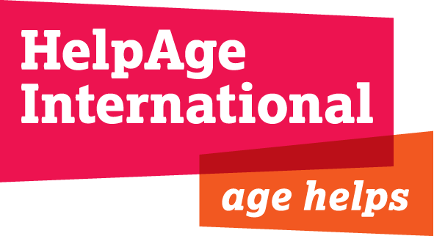

Job Description – Income Security Policy Adviser

Job Title Income Security Policy Adviser

Grade E

Location: Secretariat, London with up to 3 months travel per year

Department: Policy and Strategy Department

Responsible to: Social Protection Policy Adviser

Responsible for: Volunteers, interns, consultants as required

Contract: Full time, 2 year contract

Background

HelpAge International (HelpAge) is a global network, helping older people claim their rights, challenge discrimination and overcome poverty, so that they can lead dignified, secure, active and healthy lives. Our policy work underpins our external influencing agenda and communications outreach work. It supports and builds on the organization’s programming and evidence work in our strategic priorities of social protection, livelihoods, health and care, rights and discrimination and humanitarian response. Ending the poverty and discrimination faced by millions of older women and older men has been identified as the primary objective in HelpAge’s strategy to 2015.
The Income Security Policy Advisor works in close cooperation with the Social Protection Policy Advisors in a sub-team on income security within the Policy and Strategy Department. The post-holder also works closely with the Programmes Department, Advocacy and Communications Department, HelpAge’s international offices and wider global network of affiliates.

The members of the Policy and Strategy Department:

- Monitor, initiate and participate in dialogue and debate around ageing and older age
- Lead research and generate and mine evidence around ageing and older age
- Develop and agree organisational and policy strategy positions
- Influence policymakers’ decisions and policy development
- Provide technical input, standards and learning to internal and external programmes and initiatives

Overall purpose of the job

The post will contribute to HelpAge’s organizational strategic goal that more households with older people are able to maintain, adapt or increase their income and food security.

The specific purpose of the post is to guide and support HelpAge’s global and national-level policy influencing on income security in older age. This policy work recognizes that incomes of older people can come from a variety of sources including continued work, family support, assets and savings, and social protection (pensions and other cash transfers). The focus of this post will be to deepen HelpAge’s understanding of income in older age, particularly on issues of work and livelihoods. The post will draw on existing research and data, evidence from HelpAge’s programmes, and develop new research areas in order to strengthen our organizational position and contribute directly to policy influencing and shaping practice.

The post will build on HelpAge’s recent work on rural livelihoods (which has included analysis of ageing farming workforces), but with stronger orientation towards macro-economic questions of productivity, and national-level policy on retirement, land and property rights, financial inclusion and other factors affecting income in older age. It will also align with, and contribute to, HelpAge’s well-established work on social protection policy at national and international level.

Research, evidence and international policy influencing (50%)

- Keep abreast of global debates and emerging evidence on income security in older age, to support policy positioning and influencing across the organisation.
- Work with colleagues in the Policy and Strategy Department (and the wider organisation) to identify strategic arenas for policy influencing at a global level.
- Lead the development of research to fill evidence gaps on older people’s work and livelihoods. Key areas are likely to include retirement trajectories, land and property rights, financial inclusion and other factors influencing older people’s livelihoods and income security in rural areas of low- and middle-income countries.
- In particular, continue with HelpAge’s research on the ageing of the agricultural workforce and develop additional focus areas of research
- Contribute to policy influencing on social protection at both national and international level through analysis of relevant work and livelihood trends.Work to influence key international policy processes that relate to the above mentioned thematic areas, and represent HelpAge at relevant conferences and meetings; strengthen and expand strategic relationships with key stakeholders
- Write reports, research and policy briefings as well as news stories for internal and external use.

Technical input and organisational learning (30%)
- Provide policy support to HelpAge’s partners and staff on national policy influencing on work and livelihoods, including through:
  - Sharing evidence and guiding development of policy influencing strategies
  - Supporting the design and implementation of policy-focused projects on income security
  - Providing direct support and guidance to national governments

- Coordinate the organisational Working Group to facilitate learning on older people’s work, land- and property rights and other specific aspects of income security in older age

Policy and Research Programme development and management (20%)

- Work with the Policy and Strategy Department and Resource Development Department to develop funding proposals for policy and research projects in the thematic field of work and livelihoods
- Provide ongoing technical support and managerial oversight of these projects
- Support HelpAge staff and partners to integrate strong policy outcomes to service delivery programmes and projects
- Manage consultants undertaking technical work on work and livelihoods for HelpAge

Person Specification

Essential

- Masters-level degree in a relevant subject
- Experience working in low- and middle-income countries on issues relating to work, livelihoods and/or social protection
- Good understanding of current debates on employment in low- and middle-income countries, such as questions of informality and rural livelihoods
- In-depth understanding of research design and applied experience of qualitative and quantitative research methodologies
- Policy-influencing experience at national and international level
- Project design and management skills, including research and policy projects
- Ability to think strategically and analytically
- Excellent verbal and written communication skills: ability to put complex concepts in a concise and simple manner
- Ability to work under pressure to short deadlines in a fast paced environment
- Sensitivity and diplomacy in handling/negotiating different viewpoints and personalities
- Willingness and ability to travel overseas at short notice
- Good IT skills including all Microsoft Office applications.

Desirable

- Experience of using statistical packages such as STATA and SPSS
- Good level of (spoken) Spanish, French or other relevant language
- Experience working on policy and/or practice related to population ageing and older age, particularly in low- and middle-income countries
- Experience working on land and property rights or rural livelihoods and agriculture in low- and middle-income countries
- Good level of understanding on employment in low-and middle-income countries, food security and social protection

