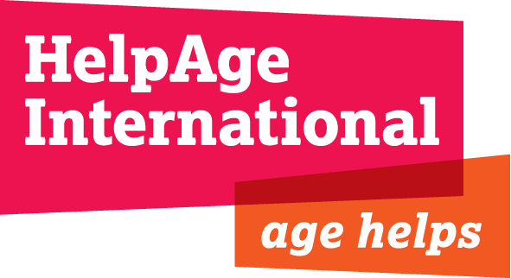
JOB DESCRIPTION

JOB TITLE: Human Resources Assistant

GRADE & SALARY: Grade B- with excellent benefits

LOCATION: Secretariat, London

DEPARTMENT: Finance, IT and Support Services

REPORTING TO: Head of Human Resources

BACKGROUND:

HelpAge International is the Secretariat of a global network, currently with 114 member organisations with a vision of a world where older people can lead dignified, healthy and secure lives. The Headquarters of the Secretariat is in London, with six Regional Centres in Thailand, Nepal, Jordan, Chile, Kenya and South Africa. We also have a small office in Brussels to represent us at the EU. We employ more than 500 people worldwide.

Over recent years significant progress has been made in developing and establishing the role of HR and strengthening related systems and administration.
We lead on the development of strategies to ensure our staff are aligned and engaged with our aims and objectives, and that they have the skills to maximise the impact they make. We work with managers and staff across the organisation to support good people management.

PURPOSE OF THE JOB

Provide an efficient general and administrative HR support service to staff and managers.

The role is critical in ensuring operational support to the HR team through supporting all manner of administrative tasks and requests related to general queries, processes, systems, policies and general HR administration, escalating enquiries where necessary.

RELATIONS WITH OTHERS:

The post holder will report to the Head of Human Resources, relate to staff and managers (international and UK) and work closely with the HR Coordinators.

Key Responsibilities

Recruitment & Selection Administration

- Support and co-ordinate recruitment campaigns for UK and International positions ensuring HelpAge’s recruitment processes are followed

- Support the Coordinators on shortlisting, interviewing and assessment of candidates. Coordinate the involvement of international recruiting managers and staff in expatriate recruitment.
- Issue all related paperwork and follow up on reference checks for all new employees, UK based and International. For International staff, ensure required health checks are completed.
- Collect data to produce recruitment statistics at the end of the year.

Learning and Development

- Work with the HR Learning and Development Coordinator, to support in the organisation of training events when required.
- Provide administrative support on aspects of global learning programmes
- Creating and updating guides for users of learning management systems
- Ensuring relevant learning and development information is available on the intranet

Pay and Benefits

- Administer the outsourced payroll and check and reconcile monthly payroll management information, reporting on service and delivery standards of the payroll supplier.
- Act as the first point of contact on payroll queries from line managers, staff and payroll providers.
- Process and track payroll changes for UK and international staff. Ensure all changes are correctly authorised.
- Maintain HelpAge International’s pension scheme.
- Administer insurance claims and liaise with insurance providers as appropriate.
- Responsible for maintaining and co-ordinating the insurance policy for international staff.
- Support staff on emergency medical claims, providing advice and guidance and liaising with the insurance broker.
- Liaise with insurance brokers on all aspects relating to insurance policy and any other related changes. Provide data to finance department in the annual insurance review.
- Process school fees payments for international staff as well as other contractual benefits.

HR Administration and Systems:

- Provide an effective HR administration service.
- Follow up on contract management, including contract and probation end
- Maintain appropriate HR administration systems (including HR database) and ensure they are maintained on a timely, accurate and confidential basis.
- Process invoices for Human Resources department.
- Diary management for departmental meetings and minute taking where necessary.
- Contribute to ad hoc projects as requested by the Head of HR, including research on relevant topics
- Ensure all staff have relevant contractual paperwork during the course of their employment.
- Assist with visa monitoring of staff in order to comply with UKBA requirements
- Be responsible for updating the HR pages on the intranet
- Assist with flights bookings when required
- Undertake any other duties as and when necessary to fulfil the objectives of the HR section, the department or HelpAge.

PERSON SPECIFICATION

Essential:

- Proven experience in HR administration or qualified/part qualified in a formal HR qualification.
- Experience of working in a busy administrative role, supporting in multiple activities and dealing with a wide variety of internal/external customers
- Experience of recruitment and selection processes
- Experience of developing and maintaining efficient and effective administrative systems
- Understanding of Human Resources and its principles
- Strong IT skills including use of spread sheets, databases and social media.
- Self-starter, well organised and able to prioritise effectively in order to maintain high service level standards and efficiency.
- Flexible, co-operative and supportive team player.
- Approachable and supportive manner, with strong customer service skills
- Ability to deal with a wide range of people and establish effective working relationships with staff and managers.
- Attention to detail and a high level of accuracy.
- Good communication skills with fluency in English to produce high quality and accurate correspondence and documents.
- Can demonstrate an appreciation of confidentiality and exercise discretion.

Desirable:

- Knowledge and experience of HR software.
- Experience of working in an international environment.
- Working towards and HR qualification.

