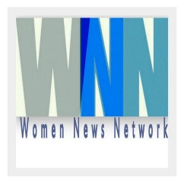 | 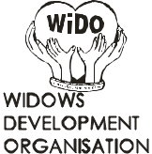 | 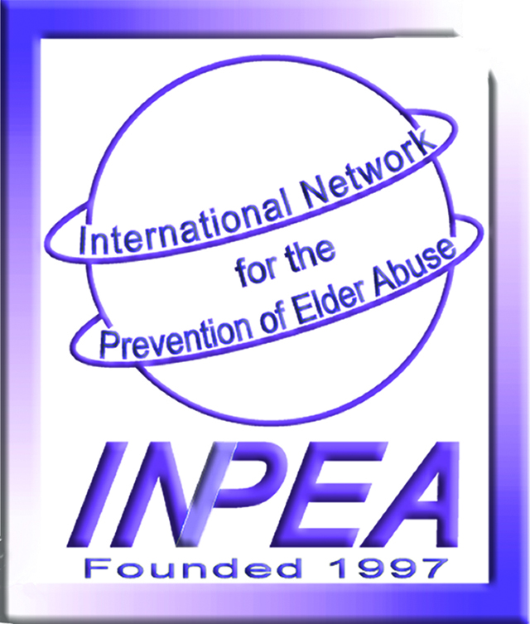 |  | 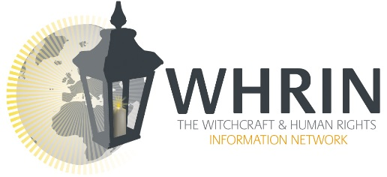
 | 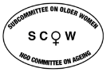  NY | 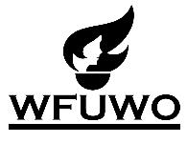 | 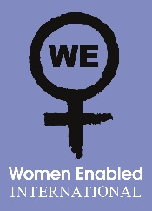 | 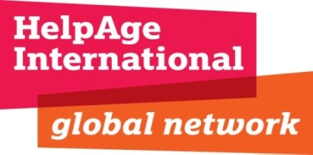

UN Commission on the Status of Women Session 59
WITCHCRAFT ACCUSATIONS - VIOLENCE & TORTURE -
WOMEN & CHILDREN
March 11, 2015
4:30 pm – 6:00 pm
Salvation Army Center – Auditorium
221 E. 52nd St. – Between 2nd & 3rd Avenues - NYC
Distinguished Speakers:
- Ms. Marta Santos Pais, Special Representative of the UN Secretary - General on Violence Against Children – Statement
- Mr. Sam Togba Sleswion, MSW – INPEA, International Network for the Prevention of Elder Abuse, Liberia
- Mr. Gary Foxcroft, Executive Director, WHRIN - Witchcraft & Human Rights Information Network – Statement
- Dr. Eleanor Nwadinobi, President, Widows Development Organization, Nigeria – Health Implications of Witches Accusations against Widows & Children
- Ms. Lois A. Herman, Coordinator WUNRN, Women's UN Report Network – Power Point on Global Witchcraft Allegations
- Ms. Stephanie Ortoleva, President of Women Enabled International - Targeting as Witches, Women & Children with Disabilities
- Ms. Lys Anzia, Human Rights Journalist & Founder of WNN-Women News Network – Witchcraft Accusations & The Law in India
- Ms. Cristina De Rossi, MA Social Anthropology, Writer on Gender, Anthropology & Social Justice – Witchcraft Accusations as a Means of Social Control & Targeting of Women in a Global Context – Statement

Moderator: Ms. Lois A. Herman, Coordinator WUNRN, Women’s UN Report Network
Panel Sponsors: INPEA, Susan Somers & WUNRN, Lois A. Herman

