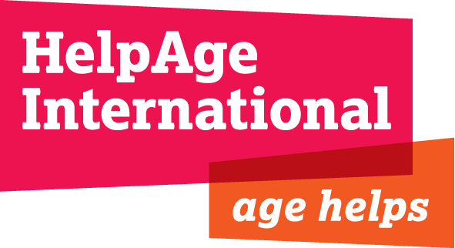

JOB DESCRIPTION

Job Title: Programme Officer - Haiti

Grade: D - £27,366 gross per annum

Location: Secretariat, London

Department: Worldwide Emergencies (WWE)

Contract length: 6 months with possible extension

Responsible To: Head of Emergencies

Responsible For: consultants and volunteers

Key Relationships:
- Close working relationships with Haiti team.
- Close working relationship with Age UK (International Division)
- Close working relationships with the Worldwide Emergencies Department, Programme Funding Officers, and Finance team
- Liaison with external groups and networks that relate to the countries/regions that the post holder supports

Background
HelpAge International is a global network of not-for-profit organisations with a vision of a world where older people fulfill their potential to lead active, dignified, healthy and secure lives.

Older people are still largely neglected as a resource or as a vulnerable group in disaster settings. We are moving from 500 million people over 60 in developing countries today to over 1.4 billion by 2050. Responding now to the needs of older people in emergencies and preparing for tomorrow is a critical and pressing humanitarian agenda.

With 78 affiliates and 300 partners across more than 50 countries the HelpAge International network brings together hundreds of organisations worldwide. HelpAge International has a secretariat with offices in London and Brussels, six regional centres in Africa, East Asia/Pacific, South Asia; Latin America, the Caribbean and Central Asia, 12 national offices and a number of emergency programmes.

Haiti

A massive 7.0 magnitude earthquake struck the Caribbean country of Haiti on 12 January 2010. The extent of the devastation is still not clear but news reports indicate thousands of people may have died. This was Haiti's worst quake in two centuries and hit south of the capital Port-au-Prince.
HelpAge International has a programme office based in Port-au-Prince, which has been working in Haiti over the last eight years.
We have deployed our emergency team there and they will be supported by our international sister organisations HelpAge USA, HelpAge Germany, and in the UK Age Concern and Help the Aged.

Purpose of the job
- To provide all necessary administrative and logistical support to the Haiti emergency programme
- Guide and support the Haiti programme to develop knowledge and understanding and ensure this knowledge is available and shared across HelpAge
- Supporting the Haiti programme to ensure HelpAge fulfils its legal contractual obligations to the DEC, donors and other stakeholders.

AREAS OF RESPONSIBILITY

Programme Support
- To assist the Head of Emergencies and Emergencies Programme Co-ordinators for Haiti to meet the support needs of the Haiti programme. This involves project development and management, donor contracts, administration, monitoring and evaluation, assisting capacity building of the offices and partners working on the programme, and developing effective systems. This will be done through distance support and possible field visits.
- To collate and manage all internal and external documentation on the Haiti programme
- To maintain an overview of the Haiti programme financial plans, using tools such as the Financial Planning Sheet and Core Costs Analysis and assisting the Haiti team to keep these updated.
- To ensure that HelpAge meets all donor requirements (based on advice from the Resource Development Department.
- To ensure that the intranet and internet are updated regularly

Contract Management
- To be responsible for the management of donor contracts, liaising with programme, finance and resource development staff in line with HelpAge procedures and with the authority to require the timely submission of reports and information for donors and HelpAge internally.
- To work with the Haiti team on preparation and presentation of narrative and financial reports in accordance with donor contracts.

Financial Monitoring
- In collaboration with the Haiti Accountant and International Accountant for Emergencies, to monitor programme income and expenditure against approved budgets and facilitate transfers within agreed budgets on a regular basis
- To liaise with the Finance team and international staff on regular financial reports and financial reviews on a monthly basis

Organisational learning
- To coordinate with the Emergency Programme Coordinator to collect knowledge and information on the Haiti programme through reports, regular communication and the use of knowledge management systems.
- To assist in the design and implementation of programme reviews, evaluations and research studies.
- To attend and contribute to departmental and other HelpAge International meetings and to the development of policy, plans and improved working practices, programme planning, budgeting, monitoring and evaluation.

Administration
- To act as first point of contact for the Haiti team on all matters of UK administration, responding to issues raised in the Haiti programme requiring action from the London office and to queries from internal and external colleagues.
- To ensure that standard systems where available are used within/between the Haiti team and the London office for the exchange of information.

Other tasks
- To make arrangements for consultancy support to the Haiti programme, drawing up terms of reference in conjunction with HR and other appropriate members of staff.
- To Ensure compliance against the DEC Accountability Framework and the HelpAge Framework (once developed) for the Haiti programme
- To support the external sharing of HelpAge International’s programme experience with a view to influencing policy and practice.
- Taking into account the rapidly changing environment, it may be necessary to modify this job description
- Collaborate with the Communications team on the media outputs around the 1 year anniversary of the Haiti earthquake

- Undertake any other duties as necessary to fulfil the objectives of the WWE department or HelpAge.

Extent of Authority:
The post holder is expected to operate within all HelpAge policies and procedures and to refer to the Head of Emergencies on:
- Major deviations to country budgets and contracts
- Critical and sensitive issues related to IOs staff or the programme.
- Approval of major programme proposals and donor reports

Person specification
Essential
- A degree-level education or equivalent work experience.
- Overseas and/or UK project experience in emergencies.
- Experience of producing funding proposals and reports.
- Experience of budgeting and financial monitoring.
- Experience of summarising and presenting information.
- Strong communication and interpersonal skills: able to communicate and interact with a wide range of people and organisations at all levels with tact and diplomacy
- Flexible in terms of time and activities as required by an emergency response programme
- Strong and supportive team player.
- Able to manage and prioritise own workload to meet deadlines.
- Excellent command of written and spoken English.
- Excellent IT skills (including WP, spreadsheet and database)
- Able and willing to travel overseas if required.
Desirable
- French and/or Creole language skills.
- Experience of working/living in the Caribbean.

