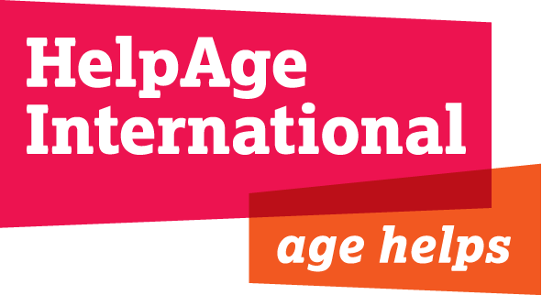

JOB DESCRIPTION

Job title : Food, Security and Livelihoods Coordinator

Location : Juba with regular travel to other States in South Sudan

Contract Duration: 6 months with possibility of renewal

Responsible to: Emergency Programme Manager, South Sudan

Responsible for: FSL in South Sudan

BACKGROUND:
HelpAge International is a global network of not-for-profit organisations with a vision of a world where older people fulfill their potential to lead active, dignified, healthy and secure lives. With over 70 affiliates and 300 partners across more than 50 countries the HAI network brings together hundreds of organisations worldwide. HelpAge has a secretariat with offices in London and Brussels, six regional centres in Africa (the East, West and central Africa Regional Development Centre – EWCARDC – with which the South Sudan programme is linked), East Asia/Pacific, South Asia, Latin America, the Caribbean and Central Asia, seven national programmes and a number of emergency programmes.
HelpAge began its current emergency programme in South Sudan in response to the conflict after independence in December 2013. Work began in June 2014 to establish an office in Juba, identify the needs of older people in the three Protection of Civilians Centres and address these needs through the distribution of NFIs, construction of older peoples centres and advocating with NGOs to factor in planning that improves access to services for older people.
HelpAge is now looking to expand its work in 2015 to address the needs of older people in outlying areas including Akobo east (Jonglei state), Fashoda and Manyo (Upper Nile) and North Tong (Warrap). Subject to funding these interventions will improve the lives of 21,000 older people and their families through activities focusing on nutrition, protection and food, security and livelihoods. Interventions will be a mixture of direct work with older people, advocating with other agencies and local capacity building.
Overall Job purpose
The Livelihoods Coordinator main responsibility is to coordinate and lead the implementation of HelpAge’s FSL work in South Sudan. This will be through advising, managing and supporting teams on the ground, conducting training and capacity building of staff including in market assessment, engaging with relevant NGOs, UN and other agencies and clusters.

S/he will improve FSL of older people and their families through a range of approaches, including cash transfers, cash vouchers, livelihood options (including micro-finance, food security, farming and off-farm activities) and base the programmes on sound and ongoing assessment analysis of the markets and affected population needs, vulnerabilities and capacities.

A key role of the successful candidate is to build the capacity of national staff members including capacity to take the role in the longer term.

The role will support teams in three or more outlying areas (possible Akobo East, Tong North and Fashoda and Manyo) as well as Juba.

Key Duties & Responsibilities

- Lead the implementation FSL project in line with existing HAI policies and frameworks and donor regulations.

- Ensure that the FSL project integrates community approaches, DRR, gender sensitivity and capacity building into all activities as appropriate.

- Conduct market assessments and livelihood options appraisals at the start of any new work, involving older people and building the local capacity of staff and other members.

- Establish and maintain effective work plans, program reporting, monitoring and evaluation (lessons learned) systems for both internal and external use

- To lead the baseline/livelihoods assessment, this should guide the development of measurable and achievable indicators that would be reflected in the design of the M&E framework.

- Develop FSL programming operational procedures, systems and programme guidance.

- Use evidence and learning from FSL work to advocate for inclusion of older people in the livelihoods work of other organisations and for longer term social protection systems for the most vulnerable. This may include some training / awareness raising.

- Recruit, manage, coach and build the capacity of staff as per operational needs and requirements. Draft or review the TOR of technical consultants where needed.

- Participate in overall strategic planning for the HelpAge South Sudan programme where needed;

- Ensure compliance with funder requirements and HelpAge rules and regulations.
- As the overarching FSL budget holder, be accountable for all aspects of financial & resources management.

- Ensure, in liaison with the Emergencies Programme Manager, that team members operate in a secure environment and comply with security procedures and policies.

- Develop and maintain positive working relationships with HelpAge staff, national and local authorities, international and national organisation, as well as technical focal points in livelihoods. Coordinate all planned projects with the international community to ensure consistency and lack of duplication.
- Design systems and ensure accountability, specifically to older people and specifically our client group and to international standards guiding international relief and development work, while actively engaging beneficiary communities as equal partners in the design, monitoring and evaluation of our field projects.

Person Specification

Essential:
- Degree or equivalent experience in sustainable development, international development studies or related field experience
- Substantial experience in livelihoods, market assessments, cash transfers, cash vouchers, poultry management and food security interventions.
- Experience and background knowledge of poultry management mainly at rural set-up
- Experience of designing and starting up programs
- Experience of working in difficult emergency situations.
- Significant experience of recruiting and supervising teams, and a proven ability to provide support, guidance and training to local staff.
- In-depth knowledge and experience of working with international donors.
- Communication and reporting skills (verbal and in writing).
- Co-operative and supportive team player in a cross-cultural environment.
- High level of proficiency in English is required.
Desirable:
- Experience working on donor-funded programs.
- Knowledge of humanitarian standards and codes, including SPHERE.
- Experience managing complex and complicated activities with time sensitive deliverables in unstable environments.

