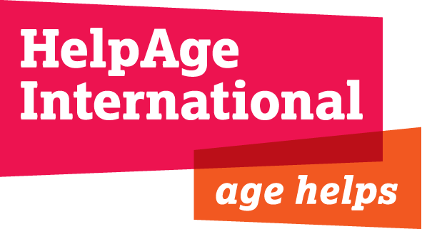

JOB DESCRIPTION

Job title: Finance & Support Services Manager

Location: Yangon

Grade and salary: ISB& £29,464 gross per annum

Contract Duration: 2 years (with possible extension) –accompanied post

Responsible to: Country Director, Myanmar

Responsible for: National Finance Manager, National Admin and HR Manager

Background to HelpAge International - Myanmar
HelpAge International (HelpAge) is a global network of not-for-profit organisations with a mission to work with and for disadvantaged older people worldwide to achieve a lasting improvement in the quality of their lives. HelpAge International’s East Asia Pacific Regional Office (EAPRO) is responsible for the regional programme, working in partnership with affiliates and partner organisations in more than 20 countries in the region.
HelpAge is widening the scope of its work in Myanmar. Currently, HelpAge, in collaboration with relevant Government agencies and partners, is implementing several projects that support older people and other vulnerable groups strengthening their livelihood and food security, health and DRR capacities. In particular, the project activities focus on promoting participatory development approaches for the formation and capacity development of Self Help Groups and inclusive Village Development Committees (for older people and other vulnerable groups) to reinforce their existing livelihood activities, starting new income generating activities, provision of community based Home Care service and awareness raising in health. The overall aim of the programme is to reduce poverty and vulnerability in general and to facilitate older people’s participation in community development.
Over the last 5 years, HelpAge Myanmar programme has grown significantly with funding support from the EU, LIFT and KOICA and is expected to expand further over the next f years. In 2014, the European Union approved a proposal submitted by HelpAge and three co-applicants for the call for proposals titled Supporting Public Health Institutes (Investing in People). The four year project is called Strengthening public health capacity to respond to Myanmar’s disease transition. We are now looking for a full time experienced international accountant to support HelpAge Myanmar to reinforce its finance management systems and capacity building of staff and partners.

Job purpose

The post holder will be responsible for managing Finance & support services (Administration, HR& IT) ensuring adequate, accountable and flexible systems and controls for the country programme. To produce reports, information and analyses on this area to the Country Director and key staff in EAPRO, London Secretariat and donors. To participate in the strategic decision making processes in Myanmar as a Senior Management Team member.

Key responsibilities

- Manage and support the national finance manager to reinforce existing procedures and systems for financial management and control in compliance with HelpAge International and donor requirements.
- Ensure compliance with Myanmar statutory and other financial obligations such as tax, levies and statutory returns
- Manage and support the HR manager to reinforce existing procedures and systems for HR management and control in compliance with HelpAge International and donor requirements.
- Brief the Country Director on matters associated with finance, HR, IT and admin on a monthly basis.
- Jointly review the current accounting systems for the recording of all financial information with the national finance manager and arrange upgrading it if necessary.
- Oversee the year-end procedure, ensuring that all financial returns are completed accurately and to the required timescale.
- Liaise with the regional finance manager on key financial issues for all programmes including co-funding, financial reporting, key variances and any remedial action required
- Monitor accuracy of financial reports and ensure timely submission according to HelpAge International and donor requirements
- Work closing with the Country Director to ensure that through and effective budgetary control is undertaken in the Myanmar Programme.
- Ensure monthly meetings are held with project managers to discuss key variances, reasons for these, and any remedial action that is required.
- Guide the national finance manager on overseeing the budgeting, budget monitoring, forecasting and MYFR processes, liaising with budget holders and contract managers to ensure that procedures are understood and timetables communicated.
- Support proposal development ensuring that HR, budgets and scenarios for co-financing and cost recovery are considered
- Support Programme staff in the production of project budgets and proposals, advising on assumptions, risks and opportunities contained within the budgets.
- Plan and implement strategy for long term HR development in Myanmar
- Ensure that all procurement guidelines are met, following HelpAge and donor requirements
- Support reinforcing systems and procedures relating to logistic operations, for examples: procurement, storage and distribution with supplier database; rigorous assets and materials controls compliant with donor and HelpAge requirements.
- Support the development and implementation of financial management capacity building of staff and partners
- Oversee and guide systems and procedures relating to office management, material and services management such as sourcing office equipment and supplies this includes computers, furniture and stationeries and maintaining inventories.
- Liaise with contractors and service providers for efficient and cost effective servicing and repairs of material and equipment ensuring procedures are followed and observe

Person Specification

Essential:

- Qualified Accountant (CCAB body or equivalent) or qualified by experience
- International experience beyond home country in managing large country programme budget with UN agencies/INGOs, preferably including Myanmar or South East Asia
- Substantial relevant experience in Admin, IT, logistics and HR department with UN agency/INGOs at an appropriate level.
- Production and interpretation of management accounts; and advanced spreadsheet skills
- Proven ability to provide support, guidance and training to managers; training skills and the ability to pass on knowledge to others
- Knowledge and experience of working with international donors, particularly the EU & ECHO
- Analytical skills, both organisational and financial
- Communication and reporting skills (verbal and in writing)
- Co-operative and supportive team player in a cross-cultural environment;
- Exceptional coordination, and prioritisation skills, with a proven track record of managing competing demands
- Experience of coordinating multiple functions, roles or departments
- Demonstrable experience of managing and developing staff
- Fluency in English; speaking, reading and writing

Desirable:

- Experience of working in Myanmar or South East Asia
- Experience of working with local NGO partners
- Experience of working collaboratively with UN agencies/INGOs
- Experience or working knowledge of ageing and the issues facing older people
- In-depth knowledge and experience of operating computerised accounting systems.
- Experience of SUN accounting system

