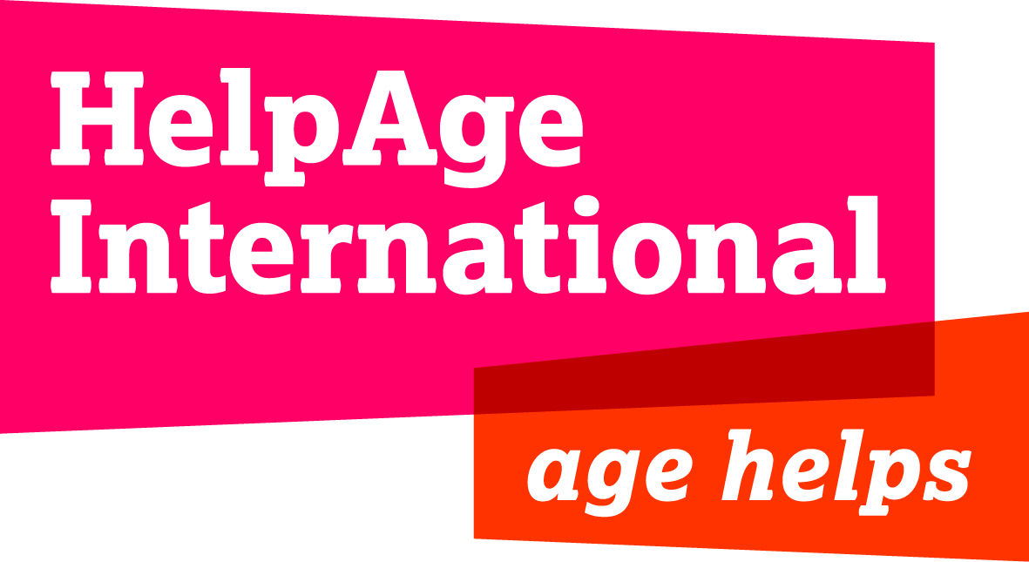

HelpAge Requires Expert Consultancy Services

HelpAge International Nepal is an international non-governmental and non-profit organisation working in Nepal since May 2012 in 10 districts on various areas such as livelihoods, disaster risk management, inclusive health, and social protection. Under its 2015 Nepal Earthquake Response Project, HelpAge’s Inclusion-Protection programme is commissioning an Action Research to assess the impact of the April earthquake on Older People and Persons with Disabilities, particularly on how the post-disaster response has focussed on the specific needs and vulnerabilities of these two population groups. The research is to be conducted in seven districts, which also fall under the Government of Nepal’s 14-most affected list, namely, Kathmandu, Kavrepalanchok, Sindhupalchowk, Makwanpur, Bhaktapur, Nuwakot and Gorkha.

For this purpose, HelpAge seeks expert consultancy services from interested professionals/organisations to conduct the aforementioned study.

Who Can Apply: Independent national and international consultants/organisations who meet the eligibility criteria indicated in the Terms of Reference (TOR), the full details of which are found in this weblink : www.merojob.com/helpage

How to apply: Eligible candidates are requested to read thoroughly the detailed ToR and submit both technical and financial proposals outlining proven qualifications and eligibility for the Consultancy, along with a Cover Letter detailing acceptance of all terms and conditions, and an updated organisational or individual profile/CV, by no later than 1600 hrs local time, 8th of October 2015, Thursday, via email to info.np@helpagesa.org with the subject line: Expression of Interest for Earthquake Impact Study.

Note: Email or telephone enquiries will not be entertained. Applications received after the closure of the submission deadline and/or compiled/written without adherence to stated requirements will be deemed ineligible. HelpAge International Nepal reserves the right to reject any or all applications.

