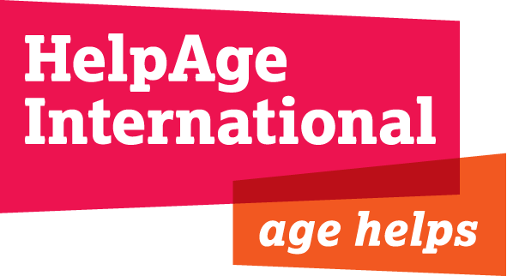
JOB DESCRIPTION

Job Title: Country Director, Ukraine

Grade & Salary: ISC & £35,560 gross per annum, plus benefits

Location: Kiev, with at least 30% travel in the East (once every 2 weeks)

Department: Programmes

Responsible to: Regional Director Eurasia and Middle East

Responsible for: Ukraine emergency programme team

Relations with others: Affiliates and partners organisations in country and Eurasia and Middle East (EME) Regional Office staff. Interaction as required with departments and staff in the London office, in particular the Humanitarian Team (HuT)

Terms and Conditions: 1 year international contract (extension depending on funding), accompanied position

Background
HelpAge International is a global network of not-for profit organisations with a vision of a world where older people fulfil their potential to lead active, dignified, healthy and secure lives. With over 70 members and 300 partners across more than 70 countries the HelpAge network brings together hundreds of organisations worldwide. HelpAge has a secretariat with offices in London and Brussels, six regional centres in Africa, South Asia, SE Asia, Eurasia and Middle East, Latin America and the Caribbean.

HelpAge started working in Ukraine in 2013, by supporting its local affiliate, Turbota pro Litnih v Ukraini (TLU), the biggest local organization focusing on older people, to develop and manage joint development programmes focused on good governance, accountability, and development of local networks. With the onset of the current crisis, HelpAge started a humanitarian assistance programme in November 2014, focused on providing age-specific essential relief items, psycho-social support and protection.

To date, more than one million people have been internally displaced within Ukraine itself and the United Nations estimates that 60% of them are older people.

Job Purpose
The Country Director is responsible for managing and expanding the existing humanitarian programme in Ukraine, in line with the HelpAge global and regional strategy. Further, in cooperation with HelpAge’s Regional Office for the Middle East and Eurasia (based in Amman, Jordan), the Country Director will contribute to supporting HelpAge’s local affiliate, TLU, in developing and managing joint programmes with HelpAge International as appropriate.

Key Responsibilities:

- To collaborate with the Regional Office in Jordan and the Programmes Department in London to define an appropriate and effective strategy for HelpAge’s humanitarian work in Ukraine, ensuring it contributes to HelpAge’s global strategy.
- In collaboration with the Regional Office, to produce regular programme plans and reports in accordance with approved strategic plans.
- To manage HelpAge’s humanitarian intervention in Ukraine, ensuring an effective and efficient response for older people that is accountable to beneficiaries, donors and other stakeholders.
- To support the delivery of the advocacy plan to ensure the inclusion of older people in the humanitarian programmes of other humanitarian actors responding to this crisis.
- To explore new operational and strategic opportunities for the programme and develop plans for current emergency intervention in Ukraine.
- To identify, develop and manage the financial resources required to support the programme including proposal development, maintaining good donor relationships and donor reporting.
- To manage and develop HelpAge’s partnerships and relationships in Ukraine with partner agencies, local and international.
- To represent HelpAge in relevant Clusters, UN inter-agency meetings and other coordination fora and ensure that programme activities are coordinated with relevant authorities, UN agencies and NGOs.
- To be responsible for staff management, including recruitment, development, capacity building and appraisal.
- To ensure HelpAge’s practice complies with the Ukrainian laws and NGO regulations, including labour law.
- To maintain the security policy and plan for HelpAge staff and ensure staff safety through adherence to security guidelines and evacuation plans and to ensure the security and maintenance of HelpAge property in Ukraine.
- In cooperation with finance and programme staff, to provide monthly financial reports and monthly and quarterly narrative updates on programme activities and relevant contextual developments, and to monitor overall project expenditure and project progress.
- In cooperation with programme staff, to document evidence and learning from the programme so that it can be shared within HelpAge and also developed as external advice, advocacy and communication materials.
- To ensure public communication materials on the Ukraine programme are provided regularly for the HelpAge website, intranet and other outlets.
- To undertake project/ programme monitoring and evaluations, in collaboration with partner organisations
- To undertake travel both within and outside Ukraine as necessary in order to fulfil the above.

Extent of Authority:
The post holder is authorised to make decisions within the framework of the agreed budget and programme proposals within the limits defined in HelpAge’s procurement and finance policies.

The post holder is expected to operate within all HelpAge policies and procedures.

PERSON SPECIFICATION

Essential
- Substantial experience of managing international development and humanitarian programmes and a strong understanding of humanitarian policy and principles and challenges
- Demonstrable knowledge and experience of major bilateral and multilateral donors, specifically the EC, ECHO, UN agencies, DFID, OFDA including excellent understanding of contract compliance
- Substantial professional experience in at least one of the following fields in humanitarian contexts: protection, public health, livelihoods
- Creative, entrepreneurial approach to programme development, proposal development and fundraising, including excellent knowledge of project cycle management and logical framework analysis
- A self-starter with the capacity to work with limited supervision and support
- Strong communication and diplomatic skills including representation, networking and negotiation
- Experience of leading and managing teams, including international and national staff in different locations
- Proven capacity to develop and manage budgets with multiple funding sources
- Strong analytical and numerical skills
- Experience of working with local partner organisations and of working in collaboration with other INGOs, including large consortia
- Experience of working in insecure and politically sensitive environments and willingness to work in difficult conditions
- Experience of managing security policies and protocols to ensure the safety and security of programme staff and beneficiaries, including remote management experience
- Able to prioritise work and meet tight deadlines
- Fluent written and spoken English

Desirable
- Relevant post-graduate degree
- Experience of working in Ukraine and/or post-Soviet region
- Knowledge and experience of ageing and issues facing older people in emergencies
- Russian and/or Ukrainian language skills

