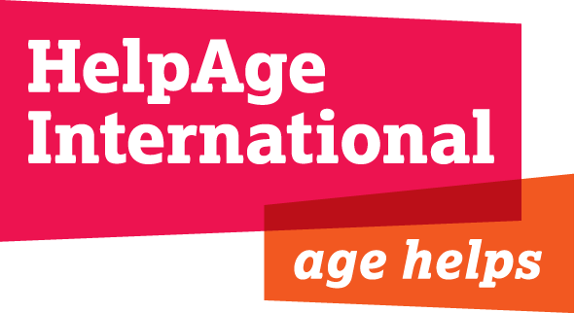

Job Description

Job Title: Communications and Campaigns Manager

Department: Advocacy and Communications (ACD)

Grade and Salary: F & £40,640 gross per annum

Location: London

Responsible to: Director of Advocacy and Communications

Responsible for: The Communications and Campaigns team in London (6 staff)

Contract: 4-6 months

HelpAge International

HelpAge International helps older people claim their rights, challenge discrimination and overcome poverty, so that they can lead dignified, secure active and healthy lives. Our work in over 75 countries is strengthened through our global network of like-minded organisations - the only one of its kind in the world.

We believe age helps. The contribution older women and men make to society – as carers, educators and workers – is invaluable. But growing older is not without its problems.
Rapid global ageing is a key issue for the developing world. One in five people will be over 60 by 2050. As part of the Advocacy and Communications Team, your challenge will be to raise awareness of global ageing and mobilise action to support the rights of older women and men.

HelpAge International has a secretariat in London, seven regional centres and country offices all around the world. The secretariat works with 400 affiliate and partner organisations and mobilises over 200,000 campaigners in our Age Demands Action campaign. It is the only global network working with and for people’s organisations, undertaking grassroots programming and local, regional and international advocacy work.

This role manages global communications and campaigns that change the lives of older people across the world and help ensure that they enjoy their rights to healthcare, social services and economic and physical security.

The International Advocacy and Communications Department

The team, with members in London and each regional office, leads on communications, campaigns, fundraising communications, advocacy, digital and media to deliver HelpAge International’s vision and mission by:

- Delivering a smart advocacy agenda that increases profile and understanding of ageing in developing countries
- Leading on and coordinating global campaigns that inspire action on ageing
- Leading effective external communication and brand awareness, by building organisational and network capacities in communication
- Supporting the growth of a strong global network of organisations to promote the rights of older people

The team seeks to give older people a platform to express their concerns directly.

The team will merge with the Policy department later this year, hence the short term nature of this contract.

Background

HelpAge has significantly grown its advocacy, campaigns and communications capacity over the past year to build profile, support fundraising and change policy in favour of older men and women. We have a strong International Advocacy and Communications strategy and campaigns agenda. We now want to strengthen and deepen the capacity of our organisation and network to implement these strategies in a coordinated way for maximum effect.

Job Purpose

- Leading and developing the HelpAge Campaign agenda to grow a global movement of supporters active on ageing issues.
- Ensure the use of strong, integrated communications across the HelpAge network, and internally within the organisation
- Strengthen communication and campaigns by building resources and capacity of affiliates and staff.
- Be part of the senior management team for the Advocacy and Communications Department involved in the strategic direction of our work and the Managers Forum in HelpAge.

Scope and Limits of Authority

- Line management responsibility of the Communications and Campaigns team in London (6 staff)
- Provides strategic support and co-ordination of International Advocacy and Communications staff in regional offices and Network.
- Manages Consultants and Interns.

Areas of responsibility for 6 months

Campaigns and advocacy

Leading and develop HelpAge Convention Campaign agenda and growing a global intergenerational movement of supporters active on ageing issues

- Strengthen campaign strategy for Convention on the Rights of Older People ensure link to regional strategies and develop partnerships with other stakeholder groups.
- Support Campaign staff grow Age Demands Action and Action/2015
- Work with Humanitarian team to develop integrated plan for HelpAge International engagement in 2016 World Humanitarian Summit
- Project manage Global AgeWatch 2015 programme to ensure the various components are integrated and delivered on time.

Communications

- Support the development of HelpAge International communication strategy and brand refresh in line with our new strategy to 2020. Ensuring we have strong set of corporate communication resources relevant and used by all stakeholders.
- Jointly develop fundraising proposals that have strong advocacy and communication elements and budget allocations with international offices, affiliates, network and campaign partners.
- Work with Media manager to build media profile of campaigns.
- Further develop global communications planning processes that strengthen the HelpAge network, and support the London Team and International offices and affiliates to embed effective advocacy, communication and campaign programmes and plans that respond to local contexts and agreed global aims.

Other

- The jobholder may be asked to undertake additional tasks, commensurate with status, after consultation and the provision of necessary support and training as appropriate
- The jobholder is expected to operate within all HelpAge policies and procedures

Key Relations:
The post holder will work closely with HelpAge affiliates and network partners, HelpAge colleagues (International Advocacy and Communications team, Policy and Programme Departments, Resource Development Department) and senior staff in other international agencies.

Person Specification
Requirements | Essential | Desirable
Education, Qualifications and Knowledge | - Educated to degree level or equivalent work experience
Experience | - Substantial experience of managing a global communications team and distance management  - Experience of managing multi-faceted global campaigns with multiple actors  - Proven experience of developing and implementing communications strategies and plans.  - Proven experience of creating innovative and impactful multi-media resources for a variety of purposes including fundraising, campaigning, advocacy, policy and service providers.  - Experience of building a shared vision across multiple actors and generating resources for maximum impact.  - Experience of brand management in an organization with multiple stakeholders (partners, network members etc.)  - Experience of securing financial resources for communications work. | - Experience of brand strategy, compliance, growth and risk management in a complex organization.  - Experience of and demonstrable interest in issues of ageing in the developing world.  - Experience of working internationally and distance management.
Skills and Abilities | - Budget management skills and  - Strong representational and negotiating skills, ideally gained within international institutions and range of networks.  - Excellent team management skills and experience of delivering effective training programmes within a global organisation.  - Excellent verbal and written communications skills  - Experience of working with civil society organisations in the global South | - Language skills particularly Spanish, Russian or French  - Understanding of media and digital communications and awareness of new developments in these fields.

