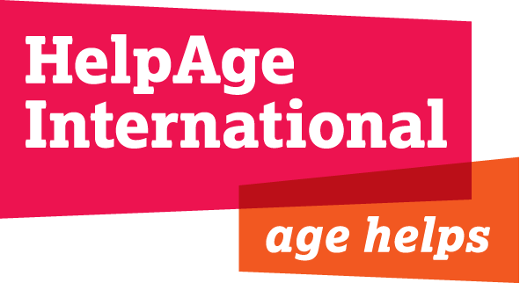

Job Title Change Manager

Grade & Salary: Competitive

Location: Secretariat, London

Department: Chief Executive’s Office

Reporting to: Chief Executive

Length of contract: Fixed term for 10 months with a possibility of extension

Background

HelpAge International is the world’s leading network of organisations working with and for older people. Founded 30 years ago, we have steadily grown our global network, which now consists of more than 115 organisations, committed to and actively engaged in advancing the rights and improving the lives of older women and men in their own countries and internationally. These organisations together raise and spend in excess of $1.5bn of their own funds, every year, the great majority on their work with older people.

As well as acting as the Secretariat for our Network members, HelpAge International also directly delivers an extensive portfolio of development and humanitarian programmes in lower and middle income countries, and a diverse and ambitious body of policy, advocacy and campaigning activities. We have an incredibly motivated and skilled team of staff and network members around the world – together, we are having a real impact.
As the implementation of our Strategy 2020 gathers pace, the Board and Directors team are focussed on an ambitious change agenda for 2016, at the centre of which is our commitment to develop an ever more networked way of working. 2016 is also expected to see a Joint Programming Agreement struck between HelpAge International and up to three “supporting affiliates” (Age International, HelpAge Deutschland and HelpAge USA).
There are also important external factors that are likely to directly contribute to shaping our change agenda in 2016, such as the outcome and actions arising from DFID’s Civil Society Review and a new set of Framework and Affiliate agreements with Age International, after the expiry of the current 4 year period in March 2016.
As a result of the significance and cross-functional nature of the change management agenda over the next 12 months, a fixed-term position of Change Manager is being created, reporting directly to the Chief Executive. H/She will work closely with the Directors team.

Job Purpose:

- To support the Chief Executive and Directors team of HelpAge International with the planning and implementation of various organizational and network development change projects

Job Responsibilities:

Project Management

- As change targets and strategies are set, conduct impact analyses, assess change readiness and identify key stakeholders.
- Establish clear mechanisms for project management and oversight and manage relevant meetings
- Plan, lead and report upon complex cross-organizational change projects.
- Lead cross-organisational processes to develop the core content of project deliverables. Assign responsibilities, work with responsible staff and teams to create and implement action plans.
- Ensure that realistic objectives and timelines are agreed with relevant staff.
- Be the front person on all aspects of the partnership with the stakeholders and associated agency partners during activation and live phase
- Deploy monitoring tools and agree on follow-up mechanisms.
- Identify and establish performance realization metrics and mechanisms.
- Report project progress to senior stakeholders and ensure risks and other relevant issues are escalated appropriately.

Communication

- Work with the CEO, Directors supporting affiliates and a wide range of internal and external stakeholders to develop internal and external communication strategies and plans to ensure a smooth transition to the desired outcomes
- Maintain strong relationship with all stakeholders to ensure all are fully informed of relevant activities

Personal Specifications

Essential

- Commitment to HelpAge International’s mission, values and behaviours (essential), and a desire to help build a better world for older people.
- Solid experience and a proven track record of achievement within a NGO context.
- A seasoned project manager that has proven experience in managing more than just a single project, with multiple elements. Naturally you will be fully proficient in all aspects of project management, including the ability to plan, control, and direct to achieve specific outcomes, scope management, requirements definition, and risk and issues management
- A highly effective leader and stakeholder manager with a reputation for skilfully understanding, advising and adapting to a range of stakeholders to achieve results
- . Demonstrated ability to think strategically, to analyse complex information and offer creative, practical solutions.
- Excellent influencing and negotiation skills, the ability to influence and motivate others. The role will involve liaison with a wide range of people, both internally and externally, and will require the ability to deal with people at all levels with credibility, tact and diplomacy
- Demonstrated ability to remain objective/neutral
- Intellectually flexible – a lateral thinker, open to new ideas and methodologies
- Proven ability to embrace and champion change
- Results oriented, with experience in developing and monitoring performance measurement/benefits realisation mechanisms
- Demonstrated ability to promptly adapt to different ways of working (flexibility), as in this new organization the context is quickly evolving
- Demonstrated ability to act independently and take on challenges willingly
- Exceptional communication skills – both written and verbal.
- Experience in change management processes in NGOs

Desirable
- Hold progressively senior operational or management roles within a recognised INGO

