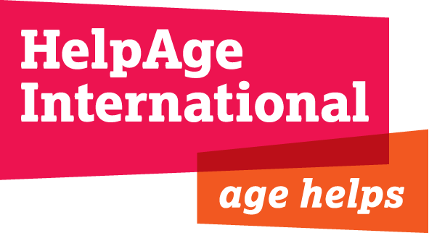
JOB DESCRIPTION

Job Title: Country Director, Kyrgyzstan

Grade & Salary: Between EUR 1,250 - EUR 1,550 gross per month, depending on experience

Location: Bishkek, with regular travel as required

Department: Eurasia and Middle East (EME)

Responsible to: Regional Director Eurasia and Middle East

Responsible for: Kyrgyzstan country office

Relations with others: Affiliates and partners organisations in country and EME Regional Office staff. Interaction as required with departments and staff in the London office.

Terms and Conditions: 1 year contract with possible extensions, national contract, Kyrgyz nationals only

Background
HelpAge International is a global network of not-for profit organisations with a vision of a world where older people fulfil their potential to lead active, dignified, healthy and secure lives. With over 70 affiliations and 300 partners across more than 50 countries the HelpAge network brings together hundreds of organisations worldwide. HelpAge has a secretariat with offices in London and Brussels, six regional centres in Africa, South Asia, SE Asia, Eurasia and Middle East, Latin America and the Caribbean.
HelpAge’s programme in Kyrgyzstan is currently focused on Non-Communicable Diseases, in particular Diabetes; livelihoods activities; social protection; and advocacy, networking and campaigns to ensure older people’s rights are respected and their voice is heard.

Job Purpose
The Country Director is responsible for managing HelpAge’s country office in Bishkek, and for ensuring future programme development in country. Further, in cooperation with HelpAge’s Regional Office for the Middle East and Eurasia (based in Amman, Jordan), the Country Director will contribute to supporting HelpAge’s local affiliate, the Resource Centre for Elderly (RCE), in developing and managing joint programmes with HelpAge International as appropriate, as well as to further HelpAge’s global, regional and country strategy.

Key Responsibilities:

- To collaborate with the Regional Office in Jordan and the Programmes Department in London to define an appropriate and effective strategy for HelpAge’s work in Kyrgyzstan, ensuring it contributes to HelpAge’s global, regional and country strategy.
- In collaboration with the Regional Office, to produce regular programme plans and reports in accordance with approved strategic plans.
- To manage HelpAge’s programmes in country, ensuring an effective and efficient response for older people that is accountable to beneficiaries, donors and other stakeholders.
- To explore new operational and strategic opportunities for the programme and develop plans for current and future activities in Kyrgyzstan.
- To identify, develop and manage the financial resources required to support the programme including proposal development, maintaining good donor relationships and donor reporting.
- To manage and develop HelpAge’s partnerships and relationships in Kyrgyzstan with partner agencies, local and international.
- To represent HelpAge in relevant UN inter-agency meetings and other coordination fora and ensure that programme activities are coordinated with relevant authorities, UN agencies and NGOs.
- To be responsible for staff management, including recruitment, development, capacity building and appraisal.
- To ensure HelpAge’s practice complies with the Kyrgyz laws and NGO regulations, including labour law.
- To maintain the security policy and plan for HelpAge staff and ensure staff safety through adherence to security guidelines and evacuation plans and to ensure the security and maintenance of HelpAge property in Kyrgyzstan.
- In cooperation with finance and programme staff, to provide monthly financial reports and monthly and quarterly narrative updates on programme activities and relevant contextual developments, and to monitor overall project expenditure and project progress.
- In cooperation with programme staff, to document evidence and learning from the programme so that it can be shared within HelpAge and also developed as external advice, advocacy and communication materials.
- To ensure public communication materials on the Kyrgyzstan programme are provided regularly for the HelpAge website, intranet and other outlets.
- To undertake project/ programme monitoring and evaluations, in collaboration with partner organisations
- To undertake travel both within and outside Kyrgyzstan as necessary in order to fulfil the above.

Extent of Authority:
The post holder is authorised to make decisions within the framework of the agreed budget and programme proposals within the limits defined in HelpAge’s procurement and finance policies.

The post holder is expected to operate within all HelpAge policies and procedures.

PERSON SPECIFICATION

Essential
- Substantial experience of managing international development programmes for a respected INGO
- Demonstrable knowledge and experience of major bilateral and multilateral donors, including the EC, UN agencies, DFID, USAID including understanding of contract compliance
- Creative, entrepreneurial approach to programme development, proposal development and fundraising, including excellent knowledge of project cycle management and logical framework analysis
- A self-starter with the capacity to work with limited supervision and support
- Strong communication and diplomatic skills including representation, networking and negotiation
- Experience of leading and managing teams, including international and national staff in different locations
- Proven capacity to develop and manage budgets with multiple funding sources
- Strong analytical and numerical skills
- Experience of working with local partner organisations and of working in collaboration with other INGOs, including large consortia
- Experience of working in insecure and politically sensitive environments and willingness to work in difficult conditions
- Experience of managing security policies and protocols to ensure the safety and security of programme staff and beneficiaries, including remote management experience
- Able to prioritise work and meet tight deadlines
- Fluent written and spoken English

Desirable
- Relevant post-graduate degree
- Knowledge and experience of ageing and issues facing older people
- Previous experience as a country director

