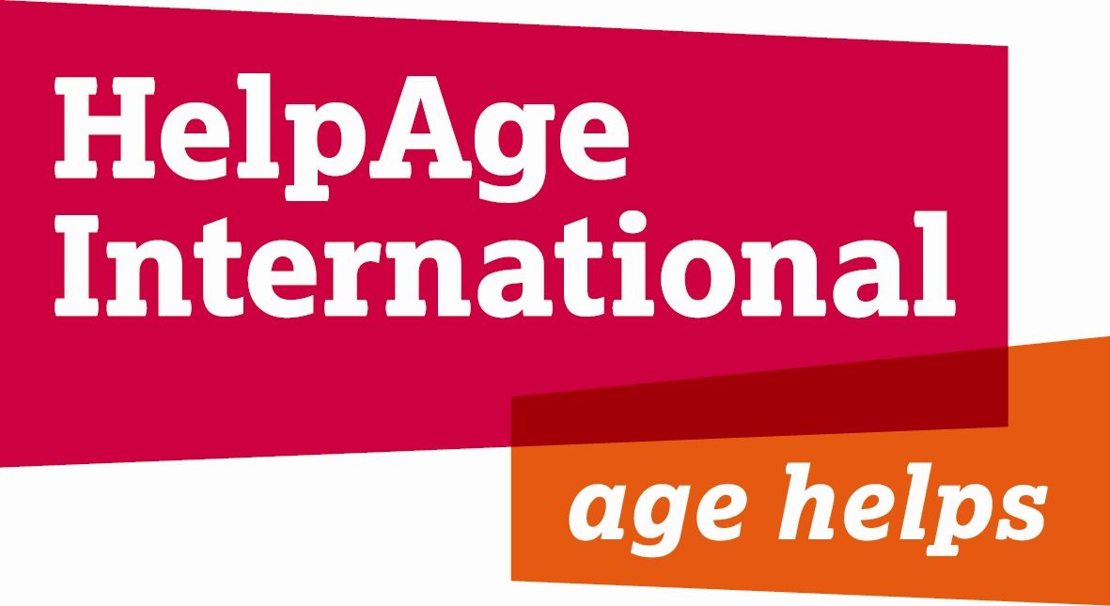

JOB DESCRIPTION

Job Title: Campaigns Co-ordinator

Location: London Head Office

Department: Advocacy and Communications

Grade & Salary: E & £30,460

Contract Type: Permanent

Responsible to: Director of Advocacy and Communications

Responsible for: Consultants, Interns

HelpAge International
The contribution older women and men make to society – as carers, educators and workers – is invaluable. But growing older is not without its problems.
HelpAge International helps older people claim their rights, challenge discrimination and overcome poverty, so that they can lead dignified, secure, active and healthy lives. Our work in over 75 countries is strengthened through our global network of like-minded organisations – the only one of its kind in the world.
Rapid global ageing is a key issue for the developing world. One in five people will be over 60 by 2050. As part of the Communications Team your challenge will be to raise awareness of global ageing and ensure the voices of older men and women are heard.

The International Communications Team
The team with members in London Secretariat and each regional office delivers HelpAge International’s vision and mission by:

- Delivering policy change by better communicating with our key stakeholders and generating support for disadvantaged older people in developing countries
- Raising HelpAge International’s profile by increasing recognition and support amongst audiences
- Helping deliver funding by stimulating donor support

The team manages global campaigns and the International Communications Strategy and seeks to give older people a platform to express their concerns directly.

Job Purpose

- To establish campaigning as a core activity for HelpAge International
- To maximise HelpAge International’s profile and impact through delivery of timely and effective campaigns.

Areas of responsibility

The Campaigns Co-ordinator will maximise HelpAge International’s profile and impact through delivery of timely and effective campaigns, including HelpAge International’s annual Age Demands Action campaign on the UN International Day of Older Persons on 1st October.

Age Demands Action co-ordinates delegations of diverse older men and women to meet directly with their governments in nearly 50 countries worldwide. This initiative seeks to give older people a voice to lobby for immediate improvements and for longer term systematic change which will enhance the quality of their lives.

Over the next three years there will be a special focus on building solidarity between activists in Africa and Europe through our Linking Lives project, funded by the EU. This aims to raise awareness of development amongst the public in Europe and demonstrate that older people are valuable members of society who deserve to be supported through overseas aid, just like other vulnerable groups in society.

Campaign Management

- To manage, design, implement and evaluate campaign strategies for HelpAge International.
- To lead on the development and implementation of the Age Demands Action campaign and to devise additional high profile global campaigns that engage interest in ageing.
- To motivate campaign stakeholders (i.e. international offices, affiliates, other organisations) to participate in campaigns; in particular to encourage the participation of older campaigners.
- To manage and co-ordinate the involvement of International offices and affiliates. working with them to deliver effective global and national level campaigns by building capacity, mobilizing support and ensuring the network pulls together resources and forces.
- To provide information and expertise in advocacy and lobbying to specified international offices, affiliates and supporters carrying out campaigns led by HelpAge International.
- To galvanise interest and support for HelpAge International’s campaigns, including publicising campaigns to external audiences and carrying out public speaking engagements.
- To research, write and ensure the delivery of a range of campaign publicity and information materials aimed at a wide range of audiences.
- To forge strategic relationships with other organisations to deliver effective campaigns e.g. media organisations; child based agencies; think tanks.
- To build the capacity of HelpAge International regional communications staff and other specific staff and affiliates to enable them to campaign more effectively. This will be achieved by developing training materials, running campaign days, etc.
- To create a secure resource base for campaigns by advising on inclusion of campaigns in programme fundraising initiatives, by liaising with external organisations such as sponsors to progress joint campaigns and research activities, and by acting as an ambassador for HelpAge International.

Person specification

Essential

- Proven relevant campaigning experience, e.g. co-ordinating or working on global campaigns

- Proven experience of using on-line communications in campaigning and building on-line constituencies.
- Experience of lobbying global government and multilateral targets, particularly the EU.
- Strong interpersonal skills, including the ability to handle a wide range of contacts tactfully and effectively, and to lead a cross-departmental team
- Outstanding communication skills (both written and verbal) with the ability to network and influence target audiences
- Experience of producing multi-media resources including video and reports for media outlets.
- Experience of developing advocacy strategies, and creative planning and ability to help ensure that clear plans are in place and taken forward
- Strong project, people and team management skills; meets organisational and external deadlines
- Track record of developing project proposals and raising funds for communication projects
- Excellent IT skills
- Knowledge of international development and current affairs
- Experience of working in coalitions
- Commitment to issues affecting older people
- Education to degree level or equivalent

Desirable

- Experience of working in, or with organisations in, a developing country
- Experience of supporter database development
- Strong media presence and good track record of achieving media coverage
- Experience of mobilising non-government organisations in the developing world
- Ability to speak Spanish

