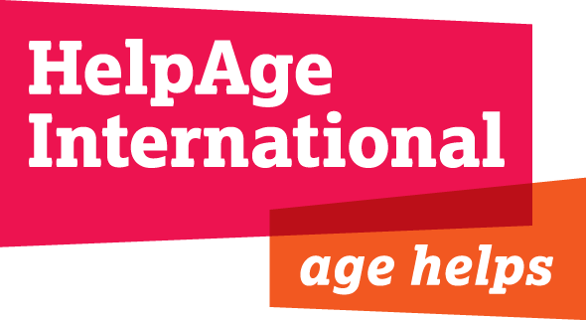

Job Title: Administrative Assistant

Grade & Salary: A £20,668 per annum (for full time working)

Location: Secretariat, London

Department: Chief Executive’s Office

Reporting to: Executive Assistant

Length of contract: 6 weeks

HelpAge International

The contribution older women and men make to society – as carers, educators and workers – is invaluable. But growing older is not without its problems.
HelpAge International helps older people claim their rights, challenge discrimination and overcome poverty, so that they can lead dignified, secure, active and healthy lives. Our work in over 75 countries is strengthened through our global network of like-minded organisations – the only one of its kind in the world.
With more than 70 affiliates and 300 partners across more than 50 countries the HelpAge International network brings together hundreds of organisations worldwide. HelpAge International has a secretariat with offices in London and Brussels, seven regional centres in Africa, Asia/Pacific, Latin America, the Caribbean and Central Asia, several national programmes and a number of emergencies.

Overall Purpose of Job:

To help provide confidential and efficient administrative support to the Executive Assistant.

Job Responsibilities:

Support to Executive Assistant in the following areas;

Board
- Assist with preparations for Board and Committee meetings.
- Prepare packs for Board meetings.
- Help arrange flights, visas, hotel bookings and expenses for Board members.

Directors
- Help arrange Directors away days
- Prepare briefing packs for CEO and Director of Programmes
- Help organise and monitor CEO and Director of Programmes monthly expenses
- Book meeting rooms or external venues for meetings
- Take minutes of meetings as and when needed
- Arrange all staff meetings
- Help arrange flights, visas and hotel bookings for the CEO and Director of Programmes

General
- Deal with and support other general administrative matters, as agreed
- Provide back up to the Executive Assistant
- Take on specific research or projects, as agreed
- Operate within all HelpAge International policies and procedures

Person Specification

Essential criteria

- Experience working as an administrative assistant
- Significant experience in organising meetings
- Advanced level skills in Word, Excel, PowerPoint and Outlook
- Excellent verbal and written communication
- Ability to work on own initiative and prioritise own workload

Desirable criteria

- Experience of arranging travel

