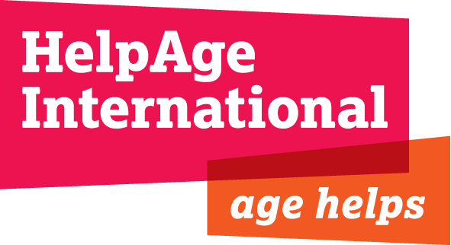

JOB DESCRIPTION

Job Title: Administration and Liaison Assistant

Salary and Grade: JOD 750 gross per month

Department: Eurasia and Middle East Regional Development Centre

Location: Amman, Jordan

Contract type: One year, with possibility of renewal

Responsible to: Regional Finance Manager, Eurasia and Middle East (EME)

Background
HelpAge International is a global network of not-for-profit organisations with a vision of a world where older people fulfil their potential to lead active, dignified, healthy and secure lives. The HelpAge International network has more than 100 affiliates and 300 partners across more than 70 countries. HelpAge International has a secretariat with offices in London and Brussels, and six regional centres covering South Africa, East/West/Central/Africa, East Asia/Pacific, South Asia, Latin America/Caribbean and Eurasia/Middle East.

HelpAge’s newly established Eurasia and Middle East Regional Office is based in Amman, Jordan. The Country Programmes in Kyrgyzstan, occupied Palestinian territories and Moldova are directly managed by the respective Country Offices with overall support from the Regional Office, while support to other HelpAge affiliates and partners in the former Soviet Union, including Kazakhstan, Russia, Ukraine, Armenia, in Eastern Europe including Serbia, Bosnia-Herzegovina and Albania, and in the Middle East including Lebanon, Jordan and Syria is given directly by the regional office.

Job Purpose
To support HelpAge’s regional office in Amman for secretarial, administrative, office management and logistical functions, including providing support for personnel files, communication and travels.

Main Job Responsibilities

- To develop and implement systems relating to office management, material and services management
- To act as an office secretarial and cover the reception when required including taking phone calls and receiving office visitors
- Ensure the operation and maintenance of all office equipment liaising with contractors and service providers to ensure efficient and cost effective serving and repairs of all equipment in the office
- Keep records of annual leave and public holidays for local staff
- Ensures the correct filing of all the administrative documents and of employees files, and ensures the confidentiality of all the documents related to personal files
- Communicate with EME team and UK office regarding office availability and closures
- Coordinate hotel and flight bookings and visa requirements for staff travel to and from Jordan
- Manages lease contracts and payment of utility bills for the office as well as for international staff housing
- Assist international staff, visitors and consultants regarding housing, utilities, and any other administrative requirements to reside in Jordan
- Liaise with local authorities to obtain necessary official documents in support of visa applications of HAI staff and consultants; and responsible for preparing all relevant documents
- Assist the regional staff in carrying out office communication functions
- Provide administrative and logistical support for meetings, workshops, training and staff visits

Experiences and Skills Required

Essential

- A degree calibre level of education or equivalent work experience

- Ability to analyze and deal with complex administrative matters and confident in dealing with government officials
- At least 2 years office management experience including arranging travel, conferences and workshops, maintain confidential personnel records
- Good IT and office equipment skills this includes Microsoft programme, outlook and maintenance of the office. Experience in managing information systems
- Experience in managing budgets relating to office expenditure
- Experience in team work, preferably in an international team
- Internet skills
- Fluent in English both written and oral
- Good communications skills including ability to explain complex issues verbally or in writing.
- Ability to write reports and business letters
- Cultural awareness and sensitivity

Desirable
- Experience and commitment to work with and for disadvantaged people, preferably older people
- Experience of producing presentation materials e.g. PageMaker or Power Point
- Knowledge of the geography and culture of the Eurasia and Middle East region

