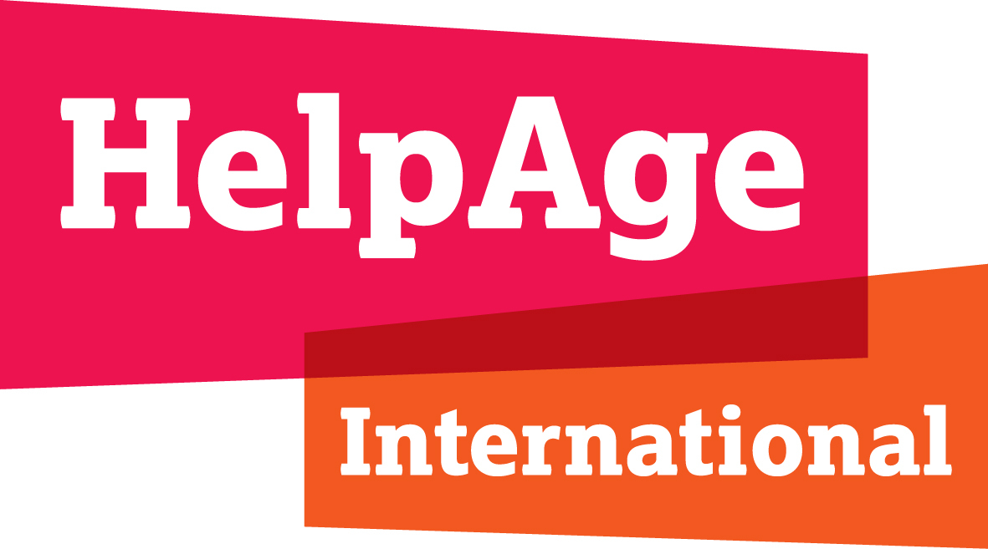

HelpAge International

Network communications volunteer position description

Volunteer role: Network communications volunteer
Department: Network Coordination and Development
Contract: Minimum of four months (number of days per week negotiable)
Start Date: August 2017
Location: London (flexible hours)
Pay: Lunch and travel expenses
Responsible to: Global Network Coordination and Development Manager

Why we want you

HelpAge International is the secretariat for the HelpAge global network – a diverse set of organisations and individuals working to promote the rights and meet the needs of older women and men around the world.

Do you want to stand up for the rights of older people? Are you interested in
communications and looking for flexible volunteering that fits in with your existing commitments? If yes - this is a great role for you. We’re looking for an enthusiastic volunteer like you to join our Network Coordination and Development Team to help us promote the global network and individual network members to internal and external audiences.

What you will be doing

Newsletter and stakeholder communications
- Collate, summarise and copy write content to schedule newsletters and updates for the global network.
- Update, refresh and revitalize the global network mailing lists and communications contact databases.
Website
- Auditing and reviewing existing website content focused on the global network to ensure it is effective and up-to-date.
- Updating and refreshing website content to ensure it accurately reflects the HelpAge global network members and ambassadors.
Social media
- Working with the Communications Coordinator, create and develop original content to raise awareness of the HelpAge global network and champion network members.
- Interact with network members on digital platforms to connect them to HelpAge International and each other.
- Monitor and schedule network facing posts for our Twitter, Facebook, LinkedIn and Instagram accounts, tailoring the content to different channels and audiences.
Internal communications
- Collate, summarise and copy write content for internal updates on network coordination and development

What’s in it for you?

You will:

- gain experience working in an international NGO
- learn about global networks and creating global movements
- enhance your knowledge about issues affecting older people
- meet experts in the field of development, human rights and ageing issues and develop new contacts – in London and around the world
- feel the satisfaction of being part of a global origination collaborating to achieve change for older people.

Your skills and qualities

You have:

- experience of working in a communications or marketing role
- experience and understanding of a range of social media channels
- excellent written communications skills, with the proven ability to write engaging copy for a variety of channels and audiences
- exceptional interpersonal skills
- excellent time management skills with the ability to juggle a wide range of competing demands
- strong IT skills to include MS Office and digital platforms
- a proactive approach to all areas of work with a ‘can do’ attitude and a flexible approach to work demands
- interest in international development, human rights and creating change via global networks
- enthusiasm for HelpAge’s aims and are interested in promoting what we do.

The post holder may be asked to undertake additional tasks, commensurate with status, after consultation and the provision of necessary support and training as appropriate.

HelpAge International

HelpAge International's vision is a world where older people fulfil their potential to lead active, dignified, healthy and secure lives. We are the secretariat of the HelpAge global network, bringing together more than 114 affiliates and 200 partners working with older people in over 50 countries.

Our vision

Our vision is a world in which all older people fulfill their potential to lead dignified, active, healthy and secure lives.

Our mission

Our mission is to promote the wellbeing and inclusion of older women and men, and reduce poverty and discrimination in later life.

Application details

Please submit your CV and cover letter explaining how you meet the specifications in the description to:

Johanna.phillips@helpage.org

Application deadline

Monday 31 July 2017

