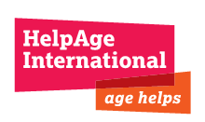

HelpAge International Uganda

With
Implementing Partner: Uganda Reach the Aged Association-URAA)

End of Project Evaluation

Bundibugyo and Kasese districts

FINAL

END-PROJECT EVALUATION REPORT

APRIL 2012

Prepared by:
Kasule Matthew
Executive Director
Maviggo Dev. Consult (U) Ltd
P. O. Box 26446 Kampala (U)
Tel/Fax: 041-4-256967
Mobile: 077-2-484652/075-2-484652
Email: maviggo@gmail.com, mat_kasule@yahoo.com

EXECUTIVE SUMMARY

0.0 Overview:
The vulnerability and exposure to livelihood risks suffered by elderly is lifelong forgotten development dilemma where policy and program interventions in the new millennium should be directed. HelpAge International helps the older people claim their rights, challenge discrimination and overcome poverty, so that they can lead dignified, secure, active and healthy lives. The major vulnerabilities to which older people are exposed include healthy insecurity, food, nutrition, and income insecurity, personal and physical insecurity and burden to care for OVCs.

There is therefore increasing recognition that people in low and middle income developing countries need better support social security systems and conducive policy environment that ensure equitable access to social services, food, income and social protection mechanisms. HelpAge therefore empowers its communities to demand for services from their governments and also builds necessary capacities to meet the livelihood needs. This is the only way this category of the vulnerable and neglected population of the world can be salvaged. It is in view of the above that HelpAge International using different programming models engenders to minimize and eliminate the risks and vulnerabilities to such external shocks and hazards by the elderly.

0.1 Program Action:
This was a three year program with a total budget of Euro 411,613 and project funding from EU of Euro347,584 implemented in the Rwenzori Region of Uganda in the districts of Kasese and Bundibugyo with a target population of 24,914. The program action titled “Improving the delivery of local government services to vulnerable older persons in Uganda, Rwenzori region, Bundibugyo and Kasese districts”.
The overall objective of the project is to contribute to poverty reduction and sustainable development in the two districts of Kasese and Bundibugyo of the Rwenzori region of Uganda through efficient and effective service provision to the population including marginalised older people. The specific objective is to empower community members, including vulnerable and marginalised older people, to influence the provision of services through their participation in the planning, implementation and monitoring of development activities.

Target Groups:
- 24,914 older people (12,280 males and 12,634 females) in the 2 districts
- 300 staff from Local Authorities from Rwenzori Region
- 180 staff from Civil Society Organisations from Rwenzori Region
- 200 paralegals from the two districts
- 1,950 community representatives from the two districts
50 policy makers at the national level – at national level
Expected results of the project included:
- Improved access to efficient and effective services responsive to the needs of older persons in the two districts.
- Older persons in the two districts increasingly included in local development processes.
- Effective dialogue between civil society and local authorities to promote equitable access to services by vulnerable groups.

0.3 Major Evaluation Objectives:
- Assess the extent to which the expected results of the project have been met and how the results have contributed to the reduction of poverty and sustainable development in the project areas including relevance, effectiveness, intended and unintended results and impacts.

- Assess the effectiveness of HelpAge’s organisational set-up/management systems in the delivery of the project including the extent to which they contribute to, or inhibit the delivery of, the project results including:- quality data management, M&E systems, project management, institutional development, partner management and institutional development, contract and financial management, inter-agency relationships, accountability and transparency and sustainability.

0.4 Implementation Strategies:
- Capacity Building and Skills Development;
- Awareness Creation;
- Institution of community structures; paralegals, OCMGs and Older peoples spokespersons;
- LGs and CSOs Dialoging Forums;
- Media Campaigns via radio, posters and leaflets;
- Participation in LGs policy and program development;
- Networking and policy advocacy;
- Exposure Visits;
- National Level Policy Dialoguing on Social Protection and Ageing issues.

0.5 Performance Assessment:

0.5.1: Improved Agricultural Extension and Support Services in Production Sectors:
The strategy resulted into increased access to NAADS program, micro-financial services, agriculture advisory services, engaging in non-agriculture enterprises by OPs and OPs opening kitchen gardens. As a result about 45% felt that the quality of agriculture advisory services was satisfactory moving from 8% at the time of baseline survey. But 10% said they were fully accessing them, whereas 47.5% felt that micro-finance provision was satisfactory against 12.5% who were fully accessing them. 30% were accessing banking services compared to only 8.75% who were fully accessing them.
The respondents ranked presence/availability/suitability of the existing poverty alleviation programs where NAADS was rated at 68.75%, CHAI 5.0%, FAL 1.25%, HOFKAM at 1.25% and 23.75% of the respondents reported that they were excluded from all the poverty alleviation so did not have any value for the interventions.
The level of poverty however is still very high with average household income in Kasese and Bundibugyo is 156,250 and 128,125 respectively yet monthly household expenditure is Shs 131,625 and 118,125 respectively for Kasese and Bundibugo for an average household of 8 persons meaning that the per capita income stand at Shs651 for Kasese and Shs533 respectively which is about US$0.26 and US$0.21 respectively.

0.5.2 Health Services Access and Quality:
35% of the respondents felt that they fully accessed the medical services and 26.25% said they moderately accessed them implying that only 36.25% were not satisfied with the services increasing from 65.6% at the time of baseline survey. Kasese district performed much better with 67.5% compared to 43.5% at time of baseline against 50% for Bundibugyo dropping from 56.5% at time of baseline survey. 63.75% felt that the quality of health services was satisfactory increasing from 40.2% at the time of baseline survey. Again Kasese ranked best with 72.5% as against 55% for Bundibugyo. Access to health services was also assessed in terms of distance to the nearest HU where 37.5% were within 1 km, 31.25% within 2 km and 31.25% above two km. Finally, 53% of the respondents felt that the project adequately achieved its goal of improving local government service delivery.

0.5.3 Access and Quality of Legal Services:
As a measurement of performance the program managed to train 200 paralegals against the targeted 390 which recorded 51% success rate. According to the Ops the assessment on the multi-variety score for the effectiveness; formation of paralegal clubs was 48.75%, effectiveness of legal service delivery 73.75%, utilization of paralegal kits by communities 11.25%, refresher training 23.75%, quarterly forums 18.75% and exchange visits 3.75%. But only 30% of Ops considered access to formal justice delivery through legal services as satisfactory and 40% considered police /prisons services satisfactory. And 53.75% felt that there was satisfactory access to justice by the Ops compared 80% which was set as the program target.

0.5.4 Participation in LG Programs and Governance:
The performance of the program action as far as participation in community and LGs programs and policies are concerned the following findings were recorded. From the household interviews 62.5% of the respondents said that there was increased participation of the OPs in planning community decision making processes; 77.5% for Bundibugyo and 47.5% for Kasese. 40% said there was satisfactory representation of OPs issues in the LGs decision making processes; 65% for Bundibugyo and 15% for Kasese.

On the other hand 41.5% reported that there was increased participation of OPs in LGs decision making processes; 77.5% for Bundibugyo and 35% for Kasese. 52.5% reported that there was increased participation of the OPs in implementing community programs and decision making processes; 67.5% for Bundibugyo and 37.5% in Kasese. 37.50% said OPs were participating in implementing local government programs and decision making processes; 52.5% for Bundibugyo and 22.5% for Kasese. For the entire measurement indicators Bundibugyo district performed much better as far as participation of OPs in community and LGs decision making processes.

0.6 Program Impacts:
- Overall 14.25% of the OPs households were pulled out of poverty according the OPs opinion surveys since by end of the project they were experiencing no survival and life security challenge. With regard to vulnerability to income insecurity there was a measured change of 1.25% positive reduction in the level of exposure to vulnerability.
- The districts and sub-county development programs integrated OPs issues in their plans and budgets although no financial resource allocations were delivered to the CBOs in the two districts. But the LGs co-financed the IOPD cerebrations in Kasese and Bundibugyo.
- The national assembly is studying the bill on the operationalisation of the OPs National Policy and constitution of the National Council for OPs.
- The implementation of SAGE has started in fourteen districts in Uganda although the program districts are not included among the pilot districts.
- Effective accessibility to essential services stands at the following rates; agricultural advisory services 11.25%., micro-finance services 12.5%, and banking services 8.75%. health services 37.5%, legal services 26.25%., information on government programs and policies. 52.5%.; education for OVCs 45% safe water 85%, mobile transport 11.25%
- Communities appreciate the opportunities to resolve civil disputes amicably both at household and community levels without resorting to formal justice systems which are costly and cumbersome for the Ops. There are reduced cased of family disputes, land conflicts and violence in communities and OPs persons now prepare wills.
- There is increased awareness of the service delivery and human rights particularly for Ops and there is increased collaboration between the communities, CSOs and LGs.
- Gender inequities have reduced due to positive behaviour change among household members and communities against archaic cultural stereotypes and females now engage in come generating projects, their inheritance rights are protected and participate in community programs.
- Some of the trained community paralegals, spokespersons and OCMGs have secured employment with other service providers and others are now empowered to engage in income generating projects.

0.7 Best Practices and Lessons Learnt:
- This program action resonates the cost-effectiveness of awareness creation and policy dialoguing among the CSOs and government in resolving vulnerabilities and exposure to risks by disadvantaged populations without necessarily through direct program targeting of assistance but with immense trickle down effects to wider publics.
- Working with community structures endears program implementation with targeted communities; creating sense of ownership and building synergies between the service providers with the local communities which creates requisite local capacities for the sustainability of program benefits.
- Once LGs are involved in CSOs programming, they can provide technical backstopping and facilitation to program implementation and harmonises programming between the respective service providers.
- In programming it is only to carry out serious problem, strategy, stakeholders, and policy analyses and organisational appraisal in order to have a viable program model that reflects the needs of the beneficiaries with effective implementation methodologies, monitoring and performance measurement systems to avoid strategy changes/over- congestion, staffing mismatches, coordination mishaps and inefficiencies during project implementations.
- Whenever, CBOs and or Associate Partners are to be involved in program implementation it should always be mandatory to have Memorandum of Understanding (MOU) describing the partnership arrangements, obligations, expectation and objectives.
- The program action should always incorporate capacity building and institutional development components within the proposed strategies and budgets.
- By Board members getting involved in program implementation creates complicities in accountabilities, compliance and loyalty to established management systems.
- Partnering with international NGOs brings a lot of advantages during the entire cycle of program action; grant application, implementation and reporting and transfer of expertise and international experiences.

0.8 Recommendations

0.8.1 Project Conceptualisation and Design:
In formulation of program interventions both HAI and -URAA need to properly identify the core problem that is to be resolved and causes of the core problems. The interventions should have linear objectives to the identified core problem and specific problems. At results level impacts indicators should be stipulated for the overall objectives and outcome (performance) indicators set against the specific objectives.

0.8.2 Monitoring and Evaluation Systems Reprofiling
HAI -URAA need to carefully appreciate and test their internal capacities with regard to M&E systems so that they can inform program development, baseline surveys, program implementation and monitoring, mid-term reviews and evaluation to avoid outcomes of low quality of study reports. There is need to strengthen the M&E capacities.

0.8.3 Strategy Analysis and Development:
HAI and URAA need to carry out an alternatives strategy analysis so as to make informed choices on the most cost-effective strategies given differing situations its interventions are geared at. The comparative strategy analysis would inform proper allocation of resources and forecasting the results of a given strategy in terms of coverage, cost, effectiveness and trickling down effects.

0.8.4 Partnership engagements
Before HAI and URAA engages partner organizations / groups there should always be a proper partner’s appraisal and the results of this should be well documented. The results of the appraisal should be used to assess the institutional, organizational, programming and financial capacity of the potential partner before a formal partnership arrangement is formalized.
Thereafter, the partnership should be formalized by signing a Memorandum of Understanding between URAA and the partner organizations. Such MOUs should outline the key roles and obligations of each party; the commitments and penalties should critically be spelt out so as to avoid any excuses by either party during or at the end of partnership period.

0.8.5 Networking and policy advocacy
Potentials and possibilities of networking with other development agencies in the programme areas should always be explored in development work since this not only promotes information sharing but also minimizes duplication of work and resources by different actors. Therefore this calls for following the theory of comparative advantage which entails each player to concentrating on programmes where it has more knowledge, expertise and resources. In this particular case HAI and URAA should have indentified development practitioners with whom to network to strengthen direct service delivery to the Ops to compliment HAI and URAA policy dialoguing.

0.8.6 Phase out strategy
Although the effective service delivery was basically a short term intervention that was aimed at influencing policies and building local capacities and ownership of country programs, its achievements should be used as stepping stone for the future programmes in the districts. Post -Project should be designed in such way that medium and long term plans are visualized since such projects are of long term nature. Hence the successes of this project should be integrated in the new projects. This will ensure the continuity of the activities and the capacity already built will re-enforce the implementation of new activities.

0.8.7 Country Coordination Office Re-profiling:
HAI needs to take a strategic decision to empower the CCO to rightly and optimally perform its roles. The current staff level needs to be upgraded and if there are any skills gaps in the key thematic areas of the organization, necessary capacity building should be arranged. The mandates of the CCO should be reviewed with a view of strengthening the country program to perform roles of overall planning, coordination and supervision of the country programs. Key areas include programming, institutional and organizational development and financial management.

0.9 General Conclusion:
The program action was timely interventions to prepare communities to recover from post-conflict situations of the region and indeed its results are commensurate with the project investments. It achieved reasonably the planned outputs and generated the desired results to some extent. The project positively contributed to reductions in levels of vulnerabilities particularly with regard to OPs discrimination, rights protection and poverty maligning post-conflict effects and impacts. There are a lot of lessons and best practices that should be replicated and management should critically integrate the recommendations made in this evaluation into its decision domains.

List of Abbreviations

ACAO Assistant Chief Administrative Officer
ACODEV-U Action for Community Development Uganda
ADA Age Demands Action
ARDC Africa Regional Development Centre
ATM Automated Teller Machines
BOD Board of Directors
BUFASIGA Bundibugyo Foundation for the Aged Sustainable Income Generating Association
BUHAHO Bundibugyo Hand for Hope
CAFO Community Aged Foundation
CAO Chief Administrative Officer
CBOs Community Based Organisations
CC Country Coordinator
CCIO Child Concern Initiatives Organization
CDOs Community Development Officers
CEDAW Convention on the Elimination of All Forms of Discrimination against Women
CEO Chief Executive Officer
CSOs Civil Society Organizations
DCC District Coordination Committee
DCDO District Community Development Officer
DDC District Development Committee
DHO District Health Officer
DMIS Data Management Information System
DPC District Police Commander
EC European Commission
EOC Equal Opportunities Commission
ESPP Expanded Social Protection Programme
FHRI Foundation for Human Rights Initiative
FURA Foundation for Rural Advancement
HAI HelpAge International
HBC Home Based Care
HIV/AIDS Human Infection Virus/ Acquired Immune Deficiency Syndrome
HU Health Unit
HURINET Human Rights Network
IDOP International Day of Older Persons
IGAs Income Generating Activities
ILO International Labour Organization
KADDE-NET Kasese District Development Network
KALI Karambi Action for Life Improvement
LC Local Councils,
LGs Local Governments
MGLSD Ministry of Gender Labour and Social Development
MOH Ministry of Health
NAADs National Agricultural Advisory Services
NCSPSP National Civil Society Platform for Social Protection
NGO Non-governmental Organization
NSSPI National Sector Strategic Plan of Intervention for OVC
OCMGs Older Citizens Monitoring Groups
Ops Old Persons
OPAs Older Persons Associations
OVC Orphans and Vulnerable Children
RDC Resident District Commissioner
ROTOM Reach One Touch One Ministries
RPM Regional Programme Manager
RSA Resident State Attorney
SAGE Social Assistance Grants for Empowerment
SCiU Save the Children in Uganda
TORs Terms of Reference
UBC Uganda Broadcasting Corporation
Ugsh Uganda Shillings
URAA Uganda Reach the Aged Association

Table of contents

EXECUTIVE SUMMARY ii
0.0 Overview: ii
0.1 Program Action: ii
0.3 Major Evaluation Objectives: iii
0.4 Implementation Strategies: iii
0.4 Performance Assessment: iv
0.5.1: Improved Agricultural Extension and Support Services in Production Sectors: iv
0.5.2 Health Services Access and Quality: iv
0.5.3 Access and Quality of Legal Services: iv
0.5.4 Participation in LG Programs and Governance: v
0.6 Program Impacts: v
0.7 Best Practices and Lessons Learnt: vi
0.8 Recommendations vii
0.8.1 Project Conceptualisation and Design: vii
0.8.2 Monitoring and Evaluation Systems Reprofiling vii
0.8.3 Strategy Analysis and Development: vii
0.8.4 Partnership engagements vii
0.8.5 Networking and policy advocacy viii
0.8.6 Phase out strategy viii
0.8.7 Country Coordination Office Re-profiling: viii
0.9 General Conclusion: viii
List of Abbreviations ix
Table of contents xii
Table of Figures xvi
List of Tables xvii
CHAPTER ONE: BACKGROUND INFORMATION AND PROJECT CONTEXT 1
1.0 Introduction: 1
1.1 Project Concept and Context: 2
1.1.1 Description of Project Area: 2
1.1.2: Demographic Description of the Target Population: 3
1.2. 2 Major Evaluation Objectives: 8
1.2. Scope of the Assignment: 8
1.3 Evaluation Coverage, Approach and Methodology: 8
1.3.1 Coverage 8
1.3.2 Evaluation Approach: 9
1.3.3 Methodology 9
1.4 Limitations: 12
1.5 Report Structure: 12
CHAPTER TWO: 15
ANALYSIS OF FINDINGS ON PROJECT IMPLEMENTATION and PERFORMANCE 15
2.0 Overview: 15
2.1 Partnership Consortium Arrangement 15
2.2 Project Design Analyses: 16
2.3 Beneficiaries Characteristics and Statuses: 24
2.3.1. Age Clustering: 25
2.3.2 Religious Affiliations: 26
2.3.3 Marital Statuses: 27
2.3.4 Household Vulnerabilities and Exposure to Risks: 28
2.3.5 Household Incomes Sources: 31
2.3.6 Household Monthly Incomes and Expenditure Levels: 32
2.3.7 Household Living Conditions: 35
2.3.8 Households Possession of Items: 36
2.4: Service Providers Targeting OPs and Packages: 38
2.5 Performance, Impact and Sustainability Assessment: 39
2.5.1: General Aspect: 39
2.5.2 Overall Objective: 41
2.5.3 Improved Access to Agricultural and Non-Agricultural Support Extensions Services: 42
2.4.4 Improved Access to Health Services Delivery and Medication: 46
2.5.5. Education of OVCs: 49
2.5.6: Discrimination: 49
2.5.7: Provision of Legal Services: 50
2.6: Empowering Community Members including Vulnerable and Marginalised Ops to Improve Delivery of Services through Participation and Representation: 53
2.6.1: Representation and Participation in LGs Policy, Programs and Governance Structures: 53
2.6.2 Effective Dialogue between CSOs and Local Authorities: 54
2.6.3. Mass Media and IEC Materials: 58
2.7 Implementation Methodology and Strategies: 59
2.7.1 Overall Coordination and Implementation 59
2.7.2 Executing Agency-HAI-ARDC 59
2.7.2 Institutional Support and Assessments: 61
2.7.3 Uganda Reach Aged Association (Implementing Partner): 62
2.7.4 Associate Implementing Partners: 64
2.7.5 Other Institutional and Community Structures: 66
2.7.6 Monitoring and Evaluation: 68
2.7.7 Efficiency and Effectiveness Assessment: 72
2.7.8 Implementation Strategies Changes: 73
2.7.9 Contract and Finance Management: 74
2.7. 10: Networking and Inter-Agency Relationships: 75
2.8 Achievements and Failures: 75
2.9: Implementation Challenges and Sustainability: 77
CHAPTER THREE: 79
ASSESSMENT OF THE PROGRAMMING AND ORAGNISATIONAL INTERVENTIONS: 79
3.1 Introduction: 79
3.1 Program Design Efficacy: 79
3.2 Relevance of the Program Action Interventions: 80
3.3 Effectiveness of Program Interventions: 81
3.3.1 Overall Objective: 81
3.3.2 Health Services Provision and Accessibility: 82
3.3.3 Discrimination: 83
3.3.4 Participation and Representation in LGs Structures and Services: 83
3.3.5 Legal Services Delivery and Quality: 83
3.4 Effectiveness of Executing Agency and Implementing Partners: 84
3.4.1 HAI-ARDC: 84
3.4.2 Country Coordination Office: 85
3.4.3 Uganda Reach the Aged Association: 85
3.4.4 Associate Partners: 86
3.5 Empowerment of Community Structures: 87
3.6 Impacts: 87
3.7 Best Practices and Lessons Learnt: 88
CHAPTER FOUR 90
CONCLUSIONS AND RECOMMENDATIONS 90
4.0 General Overview: 90
4.1 Project Design: 90
4.2 Implementation Methodology: 91
4.2.1 Implementing Partners, Staffing and Community Structures: 91
4.2.2 Baseline Survey and Mid-Term Reviews: 91
4.2.3 Project Outputs: 92
4.2.4 Networking and Coordination: 92
4.3 Program Strategy Areas: 93
4.3.1: Agriculture and Non-Agriculture Service Delivery: 93
4.3.2 Health Services Access and Quality: 93
4.3.3 Access and Quality of Legal Services: 93
4.3.4 Participation in LG Programs and Governance: 93
4.5 Other Recommendations 94
4.5.1 Project Conceptualization and Design: 94
4.5.2 Re-profiling Monitoring and Evaluation Systems: 94
4.5.3 Strategy Analysis and Development: 95
4.5.4 Partnership engagements 95
4.5.5 Networking and policy advocacy 96
4.5.6 Phase out strategy 96
4.6 General Conclusion: 96

LIST OF FIGURES
Figure 1 Photo of an old lady with her house hold members 3
Figure 2: Respondents Age Categories: 4
Figure 3: Household Heads 4
Figure 4: Employment Statuses: 5
Figure 5: Nature of Employment Statuses: 6
Figure 6: Education and Illiteracy Levels: 6
Figure 7: Risks and Vulnerabilities Magnitudes 7
Figure 8: Respondents Religious Affiliation 25
Figure 9: Respondents Marital Statuses 26
Figure 10: Comparative Vulnerability and Exposures Magnitudes 28
Figure 11: Priority Livelihood, Services and Welfare Needs: 29
Figure 12: Old Persons’ Healthy Ailments: 30
Figure 13; Occupations: 31
Figure 14: Monthly Income and Expenditure Levels: 32
Figure 15: Household Sources Income Levels: 33
Figure 16: Organizations targeting the ops 37
Figure 17: Support services offered to the ops 38

LIST OF TABLES

Table 1: Key Informants and Respondents: 9
Table 2: project Design Efficacy Analyses: 17
Table 3: Districts' Age Clustering Baseline- End project period 24
Table 4: Respondents' religion 25
Table 5: Respondents' Seriousness of challenges 28
Table 6: Priority Livelihood, services and welfare Needs 30
Table 7: Occupations 32
Table 8: Monthly incomes and Expenditure Levels 33
Table 9: House hold sources income levels 35
Table 10: House Hold Materials: 36
Table 11: Households' possession of basic house hold items 37
Table 12: Effectiveness of agricultural and non - agricultural service 45
Table 13: Effectiveness Health Services in the two districts: 49
Table 14: Key output/Beneficiaries 57

CHAPTER ONE: BACKGROUND INFORMATION AND PROJECT CONTEXT

1.0 Introduction:
The purpose of this evaluation is to assess the effectiveness and efficiency of the implementation methodologies, profile achievements of planned results and objectives, ascertain the project impacts and sustainability and produce analytical information to guide future programming.
The overall project objective is to reduce poverty amongst disadvantaged older people in Rwenzori Region through efficient service provision and the specific objective is to empower community members to influence the provision of services through their participation in the planning, implementation and monitoring of development activities. The project, titled “Improving of local government services to vulnerable older persons in Uganda”, was intended to enhance the efficiency and effectiveness of service provision to the population including marginalized older people. The project was specifically intended to:
- To empower community members.
- Enable community members to influence the provision of services.
- Increase community members’ participation in the planning, implementation and monitoring of development activities.
- Support the creation of mechanisms that result in efficient service delivery and resource allocation and utilization accountability at LGs levels.
- Promote participatory community and civil society monitoring of public resources.
In essence this project action should have resulted into reduction of risks and vulnerabilities that affect and are experienced by old persons so that they age with dignity and security. So this evaluation is aimed at assessing whether the set project objectives and results were achieved.
This final project evaluation therefore makes an assessment as to how the project action responded to the specific problems that affected and were experienced by the project beneficiaries. An analysis on the efficacy of the project design is made to determine whether the project action correctly responded to the real and stated problems of the target communities using appropriate and suitable targeting and positioning strategies. Accordingly, the assessment will cover analyses of the project implementation methodologies, effectiveness and efficiency of the project interventions in the realization of the project results and whether necessary momentum has been created for the sustainability of the project outcomes. The evaluation will finally determine whether there are any direct and indirect impacts of the project actions; identify any best practices and lessons learned and make recommendations on appropriate future programming issues.

Project Concept and Context:

1.1.1 Description of Project Area:
The project area included both Kasese and Bundibugyo districts situated in Western Uganda within the Rwenzori-Albertline region bordering the Democratic Republic of Congo. Bundibugyo district is constituted by 15 sub-counties with a total population of 222,189 by 2009 of which 11,338 were above 60 years with an annual growth rate of 5.0. Kasese on the hand had a total population of 646,677 of which 18,417 are above 60 years with an annual growth rate of 3.6 with an average family size of 4.9 persons. The administrative set up is constituted by 20 sub-counties, one municipal council and three town councils with a total. Hence the total targeted population is about 30,159 of which about 53% are females. The sub-counties covered in the project area include; Mukinyu, Bugoye, Muhokya, Kyondo, Kilembe and Kasese Town Council in Kasese district and Bubandi, Ndugutu, Bubukwanga, Busaru, Rwebisengo, Harugari and Bundibugyo in Bundibugyo districts.
These Ops lack access to income and food security, health, education and extension services and are precluded in the enjoyment of basic rights and right of representation in policy decision processes and development programs. In most cases they are surviving below US$1 a day and experience scarcity of production resources, household amenities and state provided support systems. Generally, OPs are weak and economically dependent on others or their siblings for survival. Some of them however have a responsibility to look after their children and grand children who are in most cases classified as vulnerable. Evidence shows that there is rapid growth of ageing population in developing countries which requires mitigation measures both in terms of policy and program interventions to redress the vulnerability and risks-exposures experienced by Ops.
The project action primarily targeted older people, particularly those living in multigenerational households caring for orphaned vulnerable children (OVCs) and people living with HIV and AIDS (PLWA) and wider vulnerable groups such as people living with disabilities, in 13 sub-counties of Kasese (6) and Bundibugyo (7) in Rwenzori Region. Like in other African settings, the family is still the feasible central institution for caring for older persons hence it is the primary target unit of the project interventions.
This project action is a response to the multiple challenges and problems characterizing Ops in the two districts including physical and mental incapacity; inability to generate income, limited and or no access to quality community services, lack of awareness to Ops rights, public resources, and local government structures. These are reinforced by lack of harmonized social protection policies, exclusion from development initiatives and poor or non-representation on policy organs in Local councils.

1.1.2: Demographic Description of the Target Population:
According to the 1995 Constitution of The Republic of Uganda, Article 32 states that “the state shall make reasonable provision for the welfare and maintenance of the elderly” but update there is no explicit and comprehensive operationalised National Policy to guide and ensure their sustainable protection and care, welfare and inclusion of older persons, in the national development processes. The total population, in Uganda, above 60 years is estimated at about 1,196,439, of which 51.8% have never been to school, 61% are rated as illiterate, 70.1% of them are heading households implying that they have responsibilities for household income and food security of their dependants. The old people experience a myriad of challenges including, illness, disabilities, unemployment, income and food insecurity, displacement and discrimination among others.
The average year of the old age in the project areas is estimated at 68 years, where according to the evaluation household survey about 15% are above 80 years, 21% between 55-60 years, 40% between 60-70% and 22.5% between 70 and 80 years with an average family of 8 people. The photograph below shows that inn this household they are eleven members and all the adults are women.
Figure 1 Photo of an old lady with her house hold members
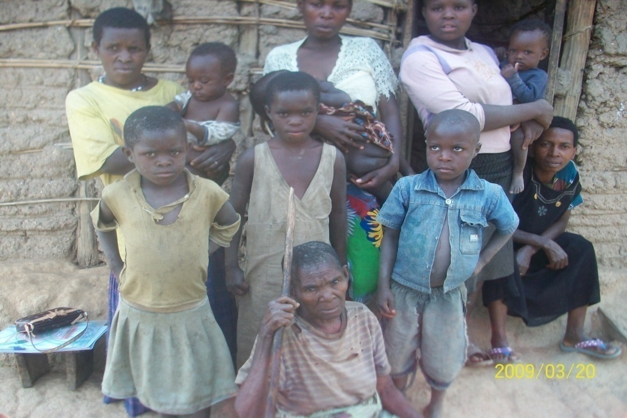
The photo in Kyambogho Kasese District depicts the OPs household living conditions and the household family sizes they look after composed of mainly grand children.
Figure 2: Respondents Age Categories:
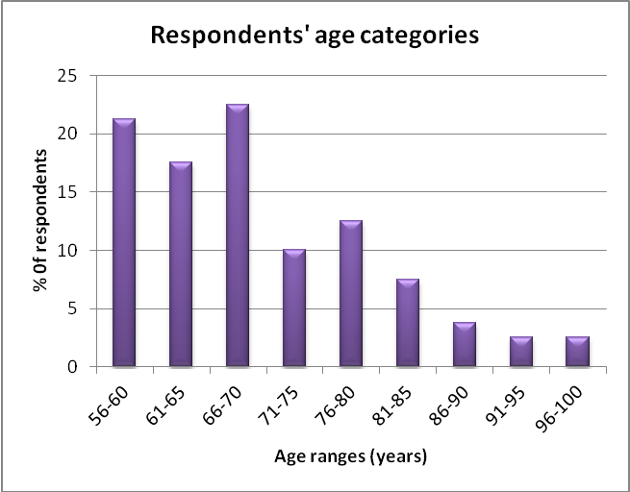
97.5% of the respondents are household heads where 56.5% are male household heads and 41.25% are female headed. Specifically, Bundibugyo 47.5% of the males are heading households, and 52.5% headed by females, compared to 65% males and 30% females heading households respectively in Kasese. Overall 45% of the respondents were married, 32.5% widowed 12.5% singles; but with cohabiting partner, 8.75% either separated or divorced and 1.25% single without a co-habiting partner. The chart below presents household heads by sex.
Figure 3: Household Heads
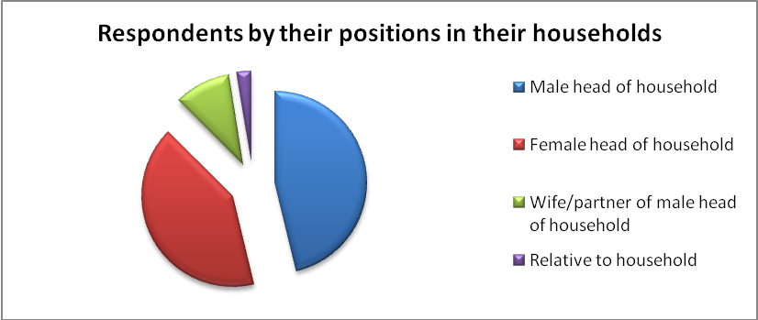
71.5% of the targeted communities have some form of employment, while 26.25% have no employment and 2.5% never responded. From the household survey only 17.5% of the beneficiaries have ever been in any kind of formal employment but in any case are not beneficiaries of pension schemes; where empirical evidence at national level puts the rate of beneficiaries to pension schemes by older persons at only 7.1%. The charts below present the nature and level of employment of the targeted communities.
Figure 4: Employment Statuses:
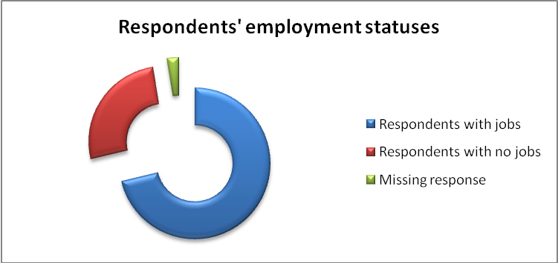

Specifically, 32% of the respondents in Kasese did not have any kind of employment compared to 20% for Bundibuggyo. 5% of the respondents in Kasese gave no response implying that they did not have any livelihood means. This implies that these people lack income security measures and therefore can scarcely afford to meet their livelihood needs hence putting their lives and those of their dependants under precarious conditions.

Figure 5: Nature of Employment Statuses:
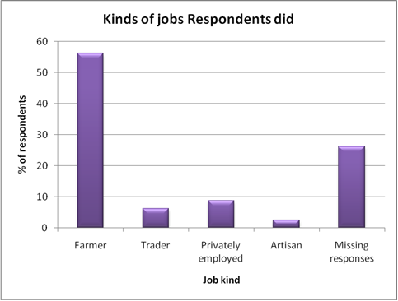
As illustrated above 56.25% of the Ops are engaged in agriculture which is characterized with low inputs resource productivity, farmer-price fluctuations, inaccessibility to markets, seasonal incomes and low inputs (labour, land and capital) returns. 17.5% are engaged in micro-enterprises (6.25% traders, 8.75% agriculture-related, 2.5% artisans); while 26.25% have no source of livelihood.
43.75% of the old age populations have never gone to school and 20% stopped in lower primary thus can be classified as illiterate. About 50% are not able to read and write as presented in the chart below;
Figure 6: Education and Illiteracy Levels:
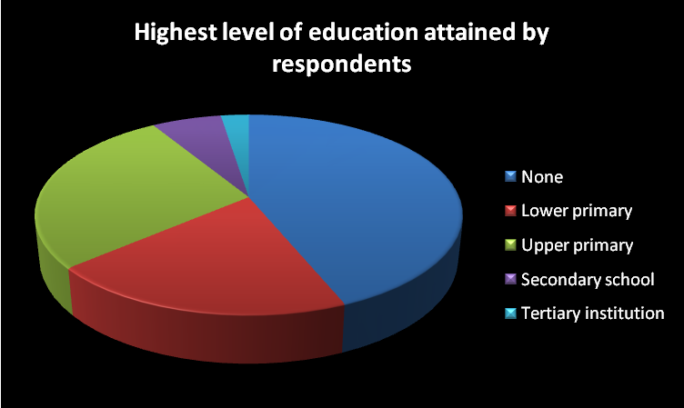
Given the fact that the majority of the beneficiaries 91.7% never went beyond primary education is a proxy indicator both for their inability to have had formal employment and illiteracy levels which greatly impact on their ability to access information and participate in public affairs. Besides, this predisposes the target communities to self employment in the substance agriculture.
As a result of the above livelihood and life styles conditions the targeted communities faced the following problems at project inception as established from the household surveys. The major vulnerabilities and risks faced by the OPs included ill-health ( sickness) rated at 32.5%, lack of adequate income 20%, loss of bread winner ( supportive relative) 16.25%, discrimination in communities 13.75%, food insecurity 12.5%, displacement 1.25% and those without any challenge 3.5%.

Figure 7: Risks and Vulnerabilities Magnitudes
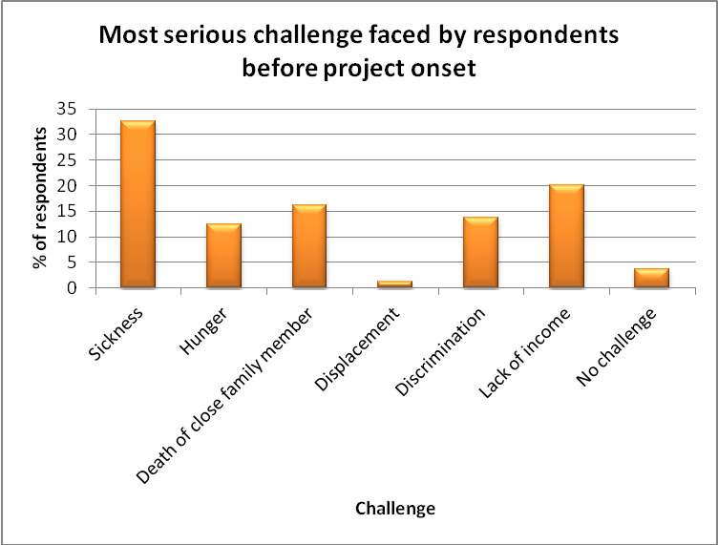
In assessing the impact of this project action, the evaluation will establish whether the OPs as a vulnerable target group were supported, mobilized and empowered to counter their vulnerabilities and minimize their livelihood and life styles risks as depicted in the above figure.

1.2. 2 Major Evaluation Objectives:
- Assess the extent to which the expected results of the project have been met and how the results have contributed to the reduction of poverty and sustainable development in the project areas including relevance, effectiveness, intended and unintended results and impacts.

- Assess the effectiveness of HelpAge’s organisational set-up/management systems in the delivery of the project including the extent to which they contribute to, or inhibit the delivery of, the project results including:- quality data management, M&E systems, project management, institutional development, partner management and institutional development, contract and financial management, inter-agency relationships, accountability and transparency and sustainability.

1.2.3 Scope of the Assignment:
The scope of the assignment entailed investigation key variables that reflect changed circumstances with regard to poverty reduction and sustainable development in the project areas as result of the program action which is measured by performance and impact indicators arising out of the project investments. The study further established the efficacy and effectiveness of the organization, institutional and management mechanisms in the realization of project objectives. Lastly the evaluation assessed how any of the cross-cutting issues and implementation strategies could have enhanced or retarded the realization of the project objectives and results and what could be the best practices and lessons learnt that can be replicated in other project designs and implementation. The study further established and emerging issues that need to be addressed in the future programming activities.
The questions for most of the investigation areas captured both qualitative and quantitative answers/information at household, community structures, local government and institutional levels etc… which shall be used to compare magnitudes of changes from baseline to mid-term evaluation and end of term evaluation values in order to assess performance against set targets.

1.3 Evaluation Coverage, Approach and Methodology:

1.3.1 Coverage
The evaluation covered six actors in the implementation; HelpAge; URAA-the implementing agency, Partners, community animators (Paralegals, Spokespersons and Monitors), central and local governments, CSOs and beneficiaries.
Table 1: Key Informants and Respondents:
Category | Males | Females | Totals
Focus Group Discussions | 75 | 30 | 105
Key Informants | 5 | 2 | 7
Beneficiaries Household Interviews | 36 | 43 | 79
HelpAge | 2 | 3 | 5
URAA | 3 | 3 | 6
Government Officials | 3 | 0 | 3
Totals | 124 | 81 | 205
Percentage | 60.5% | 30.5% | 100%

1.3.2 Evaluation Approach:
The evaluation makes a chronological assessment of the implementation process, precipitation of the project results, capturing facilitating and retarding factors scaling from the time of project inception, mid-term review and end of project implementation. A precise comparison of the magnitude of changed or stagnant statuses of the project performance variables is presented in the report. Judicious conclusions and recommendations are derived to guide future programming.

1.3.3 Methodology
The Consultant split the assignment into five phases, viz: (i) inception and planning, (ii) field work; (iii) literature review; iv) National and Regional consultations and v) data analysis and report writing.
(i) Inception and Planning: During this phase, the consultant carried out the following activities:
a) Synchronised the TOR with the technical proposal investigation variables and study methodology that formed a basis for study tools development. Held two meetings with the Country Coordinator and had a Skype discussion with the Regional Office and One meeting with URAA to agree on the Scope of Works of the assignment and itinerary. We thereafter prepared the final Inception Report, itinerary and expected schedule of the field respondents.
(ii) Field Work: The second phase, which was the Field Work, took place in Kasese and Bundibugyo covering three sub-counties and one municipal division.
- Held field based meeting in Kasese with the Regional Monitoring Officer, URAA Program Officer and Field Officers to have a thorough understanding and review of the investigation tools in a more detailed manner, and get the client’s assignment expectations. With the assistance of the Clients representatives , the Consultant revised the investigation tools and key respondents clustered into local authorities, project management, paralegals, spokespersons and old age monitors and key informants.

- The questionnaires for household survey, key informants interviews and focus group discussions were developed, reviewed and finalised through participatory processes involving the consultancy team, URAA staff, HelpAge Monitoring Officer, research assistants and interpreters. The interpreters were particularly drilled to internalise the household questionnaire for the proper communication and retrieval of questions and responses to and from the respondents.

- Refined and agreed on research questions and instruments for use in field data collection. The issues and questions given were divided into three research tool instruments to be used in data collection specifically covering; end-beneficiaries, key informants and focus group respondents.

- The sampling was purposive-predetermined based on the lists of sub-counties, parishes and villages where the project was implemented. A two structured sampling approach was used to select the parishes and villages where the survey would be conducted. At village level HH respondents were selected from known households where beneficiaries were located as per village listings.

- In order to collect relevant information in a consistent manner, the Consultant with guidance of the Field Officers and participation of Field Guides developed data collection guidelines and itinerary for the assignment. The following activities were undertaken:
- The Consultant undertook the field work in the two districts with guidance of the URAA Field Officers and field guides. In the field work, the Consultant undertook the following sub-activities;
- Key Informants Interviews: The Consultants held meetings with key informants selected at the inception and planning stage. The key informants included stakeholders (national and district officials, CSOs representatives, Partners representatives, HelpAge staff at Regional and CCO and URAA staff) that are considered knowledgeable about the project.

- Focus Group Discussions with key stakeholders. Five FGDs were held with relevant beneficiaries and stakeholders in the project area these included paralegals, OCMGs, spokes persons, beneficiaries’ representatives and associate partners’ representative. The discussions, which were very participatory, explored knowledge about project inception, implementation, results (achievements and challenges); project’s results areas and project management and coordination, quality of services, networking, key beneficiaries, perceptions and attitudes of the stakeholders on the project and its sustainability and suggestions for improvement.

- End-Beneficiaries Investigations: The investigations were very interactive conducted with assistance local interpreters, field officers who supported the consultancy team research assistants covering the entire spectrum of the scope of the assignment as detailed in section 1.2.2 and 1.2.3 to respond on all the implementation processes, performance and impact assessment indicators and how the project has impacted on their livelihood and sustainability capacities.

(iii) Literature Review:
- Collected and reviewed relevant project and implementation documents. These included, without being limited to; Grant Contract Document, Baseline Survey Report, Mid-Term Report Dec 2010, Trip Report June 2011, Training Reports and Half Year Implementation Reports, Progress Reports, and Work Plan Sheets (Log-Frame) etc….

- Reviewed the Narrative Program Reports 2009 and 2010 and Audit Report 2010.
c) Reviewed the project Logical Framework to confirm its relevance for the evaluation assignment in establishing project results as a basis for determining suitable performance and impact indicators that would be used in assessing the efficacy of project implementation strategies.
d) After the consultative meetings, document reviews and field work, the Consultant defined information gaps and, on this basis, carried out research and collected other relevant documents from HelpAge Country Office Resource Centre to fill the gaps. These included National Policy on Older Persons, CSO Strategy for Social Protection in Uganda 2011-2015, Pension Watch and other sector publications etc….
(IV) National and Regional Consultations:
At National and Regional level we interviewed the Country Coordinator, URAA CEO and Finance and Administrative Officer, Ministry of Gender-Social Protection Officers, and the HeplAge Regional Manager, EU Finance Officer and Contracts Manager that were consulted at the various stages of the assignment using different approaches.
(v) Data Analysis and Report writing: Based on the data and information collected from the above four research methodologies, the Consultant developed the report content structure and simultaneously collated the data collected and generated information on the SOWs of the assignment. Descriptive Statistics and the univariate analysis were used to generate tables, frequencies and percentages. The percentages were derived by establishing the given respective for a given measurement parameters against the total responses. Comparative analyses were made with regard to accessibility, quality and achievement of the program goals and objectives. Qualitative and the quantitative data were utilized and analyzed with the help of SPSS and Epi Info for comparative meaning of the study. In the analysis, the Consultant sought performance magnitudes, analysis of the technical criteria quality, assessment of the various intervention tools, sustainability; and best practices and lessons. The Consultant then documented conclusions and recommendations to be presented to the client.

1.4 Limitations:
The respondents’ mobilisation was inadequately conducted by project management for all the planned field activities to the extent that we missed some key informants, households interviews were in most cases delayed because respondents were in their farm fields, FGDs in Kasese were scantly attended. The geographical terrain of the project area made accessibility to some beneficiaries quite difficult given the time limits for execution of the assignment. The absence of the two previous Project Managers denied the consultancy team on key institutional memory of the history and progress of project implementation. The initial literature reports availed to the consultancy team by URAA and CCO had not included key reports on annual reporting and logframe which were only secured during first week on March. It was difficult to compare the service delivery and living conditions of the target communities between the time of baseline survey and end of project evaluation because the bases of computation were different and in most cases at baseline the scope of analyses were narrow.

1.5 Report Structure:
The report is organized in four chapters. Chapter One provides background information on the; project conception, project context and description of the project area and target population; evaluation terms of reference; scope, approach and methodology of the evaluation and limitations encountered. Chapter Two; presents the study findings on the project area, assessment of the project interventions for every designed implementation strategies, implementation and coordination arrangements and implementation sustainability and challenges. Chapter Three makes a judicious evaluation assessment with regard to measurement parameters; technical relevancy, efficiency, effectiveness, coverage; successes and failures, impact, implementation sustainability and challenges and quantitative performance assessment and giving the status as at project exit; lessons and best practices for replication. . Chapter Four makes major conclusions and recommendations based on study findings, intended to aid future programming, organizational strategies formulation and institutional development.

CHAPTER TWO:

ANALYSIS OF FINDINGS ON PROJECT IMPLEMENTATION and PERFORMANCE

2.0 Overview:
The chapter on analysis of findings on implementation and performance covers; partnership consortium, project design analyses, description of the project beneficiaries’ characteristics, implementation methodology and strategies, evolution of results area activities execution, and general program management and coordination. Key statistics on outputs and project results are presented and analyses made on achievements and failures. Lessons learnt, emerging Issues and Best Practices for replication are also presented.

2.1 Partnership Consortium Arrangement
The application and grant financing was under a consortium management arrangement with three partners; Executing Agency (Applicant), Implementing Agency( Affiliated Partner) and the Associate Partners ( Community Agents). HelpAge International was the contracting- executing agency with overall responsibility for oversight supervision and backstopping of project implementation, reporting and accountability as the Applicant for the Grant offer. HelpAge Regional Office was contractually responsible for accountability and project synergies with EU the financier of the project.
URAA on its part as the implementing partner had overall responsibility for the project field activities as well as providing the liaison and secretariat capability to project implementation acting with ancillary facilitation of its partners CAFO and BUSFASIGA. URAA worked through its partners; Bundibugyo Foundation for the Aged Sustainable Income Generating Association (BUSFASIGA) and Kasese Community Aged Foundation (CAFO) to identify beneficiaries and deliver project interventions. It was also expected that the project would support the evolution of strong community based key actors drawn from trained persons and groups with interest in the project service products. These had to operate in liaison with URAA project structures to undertake planning, community sensitisations and advocacy, coordination and reporting functions. URAA headquarters were located 359 km from the project office in Kasese where project management operated with a liaison office in Bundibugyo which was over 150 km away.
URAA and HelpAge Country Office also acted as the link offices with other Central Government ministries and Social Security Platform on policy and strategy matters; and with district local governments on service delivery and planning.
The nature of project coordination and implementation involving the various–multiple key players moreso geographically scattered i.e. Regional Office in Nairobi Kenya, Country Coordination Office-in Kampala, URAA Head Office, Project Office and Liaison Office generated a lot of complexities which affected smooth project implementation, monitoring, implementation methodology reviews and major policy decisions in some cases adversary affecting the quality of project implementation and results which is a common challenge for consortium implementation arrangements.
This arrangement greatly enhanced the quality of technical and programming approaches of the program action with technical backstopping and transfer of skills and international expereinces both from HelpAge International Headquarters and Regional Offices. URAA benefitted from institutional development capacity building received from HeLpAge and HelpAge International on the hand saved resources by just managing a Skelton staff Coordination and Supervision in Kampala. URAA on the other offered a suitable platform for inter-linkages with other development agencies and central government ministries and agencies which increased the visibility of HelpAge International.
The nature of project coordination and implementation involving the various–multiple key players moreso geographically scattered i.e. Regional Office in Nairobi Kenya, Country Coordination Office-in Kampala, URAA Head Office, Project Office and Liaison Office generated a lot of complexities which affected smooth project implementation, monitoring, implementation methodology reviews and major policy decisions in some cases adversary affecting the quality of project implementation and results. More specifically, the Associate Partners roles, obligations and benefits were not explicitly made clear to them because there was no Memorandum of Understanding signed between them and URAA to explain the cooperation arrangement.

2.2 Project Design Analyses:
The analysis on the efficacy of project design is aimed at establishing the relevance and accuracy of the project design in identifying the strategic problem, subsidiary problems, setting
of project objectives and formulation of implementation strategies and project results/outputs. The analysis looks at the linearity and correlations (vertical logic of the design) between the problems-project objectives and interventions/results areas to be able to assess its efficacy and identify design gaps.
The evaluation takes into account the fact that the project identified poor knowledge of rights and empowerment of community members on the one hand and poor decentralized service provision, governance and transparency on the other as the core problems to be addressed, both of which are contributors to poverty in the target population. The causes of some of the 9 identified problems Column One of the matrix which are correctly documented in the proposal; although they are not correctly linked with objectives, strategies and results areas. The consultant notes that project therefore sought to empower OP and community members to influence government policy and planning at local and national level.
On the other hand it worked with local and national government representatives and processes to bring their understanding of ageing and older people’s needs and rights up in order to equip them with the knowledge and tools to prepare and implement age friendly policies and services. The project employed a range of implementation strategies (Training and awareness raising, media engagement, paralegal training and organization, OCM training and organization etc.) some of which respond to various result areas in a holistic manner. The project was NOT delivering direct services, but was supporting a process of empowerment and policy change that takes time and cannot be finalized within 3 years. Hence it should be understood that empowerment of community structures is an important milestone in that policy process to e.g. have OP participation in local councils even if it does not guarantee final impacts it contributes to policy changes that may later impact on the target groups. Similarly by having the national policy on ageing passed and the ESPP approved is a milestone in getting cash into the hands of poor people which is what will eventually reduce their poverty. In view of that the evaluation will assess whether the project design was spurred effectiveness and relevance in the implementation of the program action by answering the following questions.
1. Were any of the activities planned in the project did or did not contribute to desired outcome. If some had no contribution what are the recommendations for changing them?
2. Were any of the indicators not useful in measuring the desired outcomes? If so what could have been the suitable indicators?
3. Did the results identified contribute to the specific and overall objective of the project?
4. Are there assumptions (endogenous and exogenous factors) that could have made and were not taken into account in design that impacted negatively on project implementation or
outcomes?
5. Comment on the various implementation strategies and their effectiveness in delivering the desired results.
6. What are the recommendations for putting in place better monitoring tools and mechanisms to ensure the correct data is collected, stored and analysed to measure project implementation performance and impact?
The evaluation will conclude this by establishing whether the project realised some of the planned results as will be presented in section 3.5 Achievements, Failures and Challenges. The table below presents the analytical findings of its efficacy.

Table 2: project Design Efficacy Analyses:
Problems Identification/ definitions | Objectives Definitions/setting | Strategies/Results Areas | Efficacy/Gaps Analyses of the Design | Conclusions
The project design did not identify the core problem against which the overall objectives was meant to resolve. |  | Reduction in poverty levels in the two districts especially among the vulnerable groups including older people. | The design did not identify the strategic problem yet it went ahead to set the overall objective. Secondly, the overall objective was mixed up with the implementation strategy “through efficient service provision” | Because the design did not provide descriptive status of the core problems a result the project to be resolved the design did not identify explicit impacts indicators/results to manifest reduction in poverty which is overall objective.
  Conclusions
 |  | District Plans and Policies reflect the needs of Ops and vulnerable groups. | This was adequate but no suitable monitoring process like budget expenditure tracking and reviews were provided for in the program design.
 |  | Percentage increase in budgetary allocation to the needs of the marginalised groups including Ops. | Budgetary allocations without making reference to actual expenditure towards needs of OPs would only amount to cosmetic strategy intervention with no tangible results.
 |  | Key Sectoral Policies and national plans explicitly make reference to the needs of the Ops and recommendations to address them.

 |  |  | Efficacy/Gaps Analyses of the Design | Conclusions
The design set one specific problem yet for every identified problem there should have been set a corresponding objective and results areas. | To empower community members and civil societies to influence the provision of services through their participation in planning, implementation, monitoring of development activities. | To strengthen downward accountability and performance of local governments through involvement of local communities. | The design did not identify the problem that needed to be resolved which essentially was lack of institutional and capacity among the OPs and community organisations to ensure appropriate accountability and accessibility by the OPs. | Consequently, the project action did not plan and budget for capacity building of the CBOS/CSOs supporting the target communities (CAFO and BUFASIGA).
Lack of information on local government structures, resources allocated and their accountability. | There should have been set a specific objective to reflect how lack of information has been resolved which is missing in the design. | Effective dialogue between civil society organisations and local authorities to promote inclusive and equitable access to services by vulnerable groups. | The design did not formulate any specific objective that would manifest the resolution of the identified problem thus no clear indicators were set to validate whether there was increased information flows and accountability on resources allocation and accessibility particularly by OPs. | Apart from the realisation of project outputs there are no clear results identifiable with this project intervention.

Poor quality service delivery and absence of essential services in health, community and productive sectors due to low resource capacity and delivery mechanisms. | There should have been set a specific objective to reflect how quality and access to services has been improved which is missing in the design. |  | Improved access to effective service delivery responsive to the needs of vulnerable OPs in the two districts.  The design only set the planned outputs without stipulating the outcome indicators that would drive the achievement of the overall goal. |  | The design did not formulate any specific objective that would manifest the resolution of the identified problem thus no clear outcome indicators were set to validate whether there was increased services quality and or delivery capacities and mechanisms targeting. |  |  | Although the OPs started accessing services they were hitherto not accessing (changes in quality and accessibility were not measured during program monitoring) thus the impact assessment was eventually lost.
Lack of policy on low level of awareness of the OPs rights and relevant entitlements. | There should have been set a specific objective to reflect what policy gaps were to be addressed and how they would impact/influence quality and access to services which aremissing in the design. |  | The design only set the planned outputs without stipulating the outcome indicators that would drive the achievement of the overall goal. It didnot provide for research on policy gaps yet that was the most effective way of identifying critical gaps that required policy dialoguing and building of community capacities. |  | The design didn’t set the desired objective, neither key features of the national policy to be addressed nor the results that would manifest the resolution of the problems in case the policy was put in place; apart from planning the necessary outputs. |  |  | Thus this problem area was left hanging although some actions have been taken to have a national policy and strategy on OPs and the Bill is before the National Assembly.
 |  |  | At least 50% older persons have improved knowledge of their rights and entitlements. |  | No clear results indicators were stipulated in the design. |  |  | Some good actions were taken in the realising the objectives and output indicator.
 |  |  | Issues of the ageing increasingly feature in the dialogue within local community authority structures. |  | No clear results indicators were stipulated in the design. |  |  | Some good actions were taken in the realising the objectives.
Lack of participation in local governments or exclusion of Ops in development processes at Local government levels. | To improve access to efficient and effective service delivery responsive to the needs of the Ops in the two districts.  The design had not identified the critical needs of the OPs and this was also not done at baseline survey stage. |  | At least 30 planning/review and other consultative meetings between local authorities and OPs take place. This was a strategy/output not a result indicator. |  | The design didn’t set how access and quality services delivery would be manifested and measured or rather what would be the desired the strategy results that would manifest the resolution of the problems in case the OPs were involved in LGs; apart from planning the necessary outputs. |  |  | Thus this problem area was left hanging although some actions have been taken to have a OPs in LGs councils and URAA and HelpAge engaging in national policy and strategy dialogues.
 | Old Persons in the two districts increasingly included in the local development processes and governance structures. |  | At least two community members including OPs formally representing Ops on each local council committee both at the district and Lower Government Levels. |  | This was a clear results indicator. |  |  | OP person’s agenda has been integrated in development plans and processes and OPs constitute part of the LC committees.
 |  |  |  | 10 Older Citizen monitoring groups formed and active in the community. This was a strategy/output not a result indicator. |  | No specific results were set as what the OCMGs actions would contribute to the achievement of the program action. | Thus this problem area was left hanging although some actions have been taken to have a OPs in LGs councils and URAA and HelpAge engaging in national policy and strategy dialogues.
 |  |  |  | Increased community engagements with policy makers about service provision and mechanisms for local governance. This was a strategy not a result indicator |  | No specific results were set as what the community engagements would contribute to the achievement of the program action. | Thus this problem area was left hanging although some actions have been taken to have a OPs in LGs councils and URAA and HelpAge engaging in national policy and strategy dialogues.
 |  |  |  | Increased dialogue within the communities on ageing issues. |  | No specific results were set as what the community engagements would contribute to the achievement of the program action. | Some good actions were taken in the realising the objectives and results indicators.

Absence or non-implementation of government poverty reduction initiatives (CHAI, PMA, NAADS, FAL, UPE, PAF etc.) where OPs are normally left out in accessing them. | To improve access to efficient and effective service delivery responsive to the needs of the Ops in the two districts. | Reduced number of cases of mistreatment of Ops by health staff at health centres. | This was a good indicator although issues of quality and effective access should have been integrated in the design. | As such no reports were generated on access and quality of services.
 |  | At least 50% of Ops have access to extension services in the two districts. | This was a good indicator although issues of quality and effective access, cost implications should have been integrated in the design. | Some good actions were taken in the realising the objectives and results indicators.
 |  | Increased availability of essential drugs for OPs. | This was a good indicator although issues of quality and effective access, cost implications should have been integrated in the design. | Some good actions were taken in the realising the objectives and results indicators.
 |  | Improved transport services for Ops. | The design should specified mode of transport and cost implications.

Note: All the colored cells in the matrix are the project design gaps.
The normal and correct program design must reflect effective project analysis of the identified problem for which the corrective action is to set a corresponding solution (objective) which should be inversely related to the problem. The problem has to be described/analyzed to determine its manifestations /variables e.g. if it is health which should be resolved then variables could be nutrition, disease epidemic etc... These become the results indicators. For every program/project there must be a core-problem and there has to be a corresponding overall objective (aim) and for every specific problem; a specific objective has to be set. At result level; for the overall goal there should be impact indicators, specific objective level there should be outcome indicators, strategy level there should be outputs indicators which should translate into outcomes-indicators and correspondingly these translate into impact indicators. There was a mix up- weaknesses with the logframe relating to overlapping outputs between result areas, confusion over indicators and general weaknesses during project implementation (from baseline through to final evaluation ) of recording, monitoring and responding to the indicators in the LFA. The outcomes indicators are at times referred as performance indicators. That kind of intervention logic is lacking in your logframe. Most of these are lacking in your logframe.
These omissions in the project design negated the proper articulation of the necessary project objectives to address the core (strategic) and ancillary problems affecting OPs in general. Although the ancillary problems were correctly identified, the design in some respects didn’t set the desired objectives and results indicators which adversely affected the quality and effectiveness of the project interventions to impact on the livelihood and quality of life of the OPs. The design lacked the vertical logic between outputs, desired results and project impacts given that no deliberate project instruments were designed to create, track and measure the project outcomes, impact and sustainability. The project proposal didnot provide an illustrative logframe linking project actions-outputs-results (outcomes)-impacts and sustainability. In some respects strategies were taken to be results w and in most cases the design reflected outputs indicators not outcome indicators. Indeed there was no exit strategy envisaged in the project proposal. In absence of performance and impact indicators it is unrealistic to assess whether the project realised its overall objectives. Such omissions need to be avoided in future programming.

2.3 Beneficiaries Characteristics and Statuses:
This analysis looks at the characteristics, assets bases and welfare statuses of the targeted communities as a benchmark to compare and measure the performance and impact of the program action between project inception and end of project implementation. Unfortunately, the data in the baseline survey report in a few cases was inaccurately presented where percentages of variables being analysed in most cases was not based on 100% something that makes its interpretation quite confusing. Where possible reference for purposes of comparison will be based on baseline information as will be found applicable. This evaluation therefore where applicable; is going to track the progress of program implementation and performance.

2.3.1. Age Clustering:
The study investigated the clustering of OPs by age group because this is significant when targeting the interventions. It will also be important to establish whether project management used the baseline findings on this to specifically target its interventions based on the level of vulnerability relative to each age group.
Table 3: Districts' Age Clustering Baseline- End project period
Age-Group | Baseline % |  | End of project % |  | Aggregate Average
 | Kasese | Bundibugyo | Kasese | Bundibugyo
55-60 | 27.4 | 15.6 | 17.5 | 25 | 21.4
61-70 | 48.3 | 39.1 | 30 | 50 | 41.9
71-80 | 17.5 | 23.9 | 25 | 20 | 21.6
81-90 | 6.5 | 21.4 | 17.5 | 5 | 12.6
91+ | n/a | n/a | 10 | 0 | 2.6
Totals |  |  | 100 | 100 | 100.0

From the above analyses the most dominant age group is between 61-70 with 41.9% followed by those between 71 -80 with 21.6%, 51-60 with 21.4% and above 81 with 15.2%. Age clustering is important because it has implications on exposure to gender vulnerability disparities, income and food insecurity, human resource productivity, ability to participate in community and public activities, personal health-care requirements and in some cases need for social security protection.
There are variations in age compositions between the two districts and depending on the period of analyses but what is important is that development (social protection) interventions should critically take into account the age category of the target groups in order to effectively respond to their needs and ascertain their abilities to deliver services to their colleagues. In the program design age clustering seems never to have been seriously taken as a necessary benchmark in targeting service delivery which in future should be integrated in programming.

2.3.2 Religious Affiliations:
Development practitioners need to consider the pivotal roles of religious organizations in the mobilization of the grassroots, service delivery and policy advocacy. As it is evidenced below the majority of the Ops belong to a given religious congregation which can be strong vanguards in addressing psychosocial, spiritual, social and economic support which the Ops normally require.

Table 4: Respondents' religion
Religion | % of respondents per district |  | Percentage of total respondents
 | Bundibugyo | Kasese | Percentage of total respondents
Catholic | 37.5 | 30.0 | 33.75
Protestant | 47.5 | 52.5 | 50
Muslim | 2.5 | 5.0 | 3.75
Pentecostal | 7.5 | 10.0 | 8.75
SDA | 5.0 | 0.00 | 2.5
Traditionalist | 0.00 | 2.5 | 1.25
Total | 100 | 100 | 100

Figure 8: Respondents Religious Affiliation
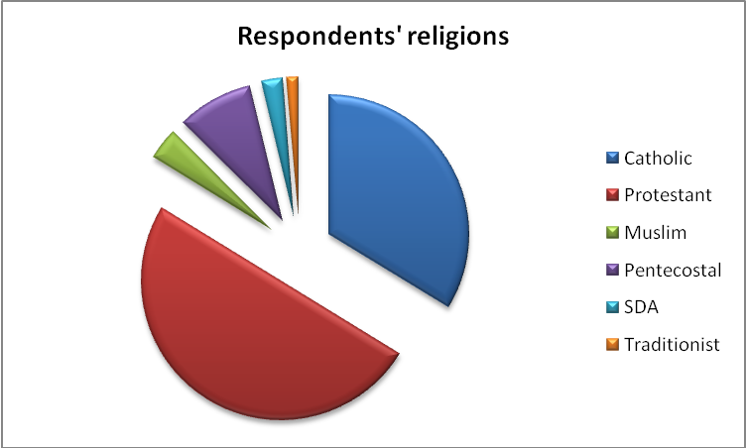

With the revelations above where 50% of the OPs are Anglicans, 33.75% are Catholics, 8.75% are Pentecostals, 3.75% are Muslims etc... it would have been more effective if URAA networked with the religious organisations given their bottom-up structures to disseminate information and in tracking of delivery social services something that didn’t happen. HelpAge and URAA need in future to recognise faith based organisations (FBO) as necessary partners to network with.

2.3.3 Marital Statuses:
The nature of marital statuses of the occupants of the household unit have a lot implications on their survival and resources ownership ability particularly for old women. The figure below provides an analysis of the marital composition of the targeted beneficiaries.

Overall 45% of the targeted beneficiary households are married against 32% that are widowed, 12.5% are single but with a cohabiting partner. Bundibugyo has the highest number of married couples at 52% against 37.5% for Kasese. Similarly, Bundibugyo has the highest number of widowed household heads standing at 40% compared to 25% for Kasese. In Bundibugyo there were no singles compared to 25% in Kasese. The level of vulnerability and exposure to income, welfare and deprivation risks is much higher for widowed women headed household and singles which has implications on their social security.

Given the patriarchy nature of the cultures in the project areas widowed women face insecurity of tenure and ownership of land after the death of their husbands as shall be explained by some of the case studies in this report. Accordingly, URAA and its partners integrated gender dimensions in its targeting of interventions and indeed it was one of the cross-cutting issues envisaged at project conception.

Figure 9: Respondents Marital Statuses
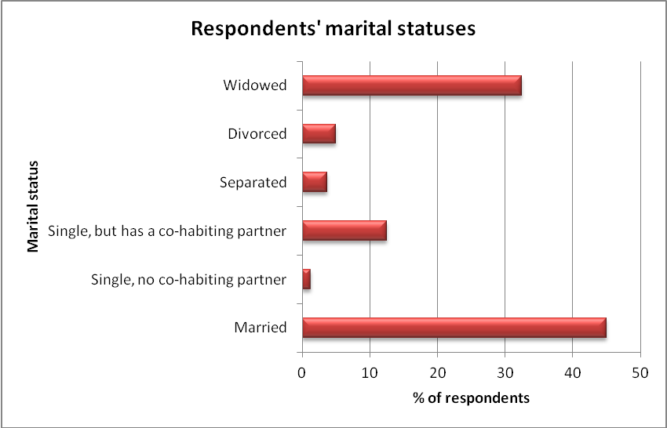

2.3.4 Household Vulnerabilities and Exposure to Risks:
In assessing the relevance of project action it is important to ascertain how the project interventions affected and or redressed the vulnerability and exposure to risks of the target communities by analyzing their level of access to their basic needs (abilities to cope with their challenges). Accordingly, this evaluation compares the level of deprivation or exposure to risks before and after project. (See figure 7) and comparative analyses in table 2.4 below.

Table 5: Respondents' Seriousness of challenges
Kind of Challenge | Percentage of HH at inception |  |  | Percentage of HH at Completion
 | Bundibugyo | Kasese | Aggregate | Bundibugyo | Kasese | Aggregate
Sickness | 35 | 30 | 32.5 | 27.5 | 27.5 | 27.5
Hunger | 7.5 | 17.5 | 12.5 | 5 | 17.5 | 11.5
Death of Relatives | 22.5 | 10.0 | 16.25 | 20.0 | 0 | 10.0
Displacement | 2.5 | 0 | 1.25 | 12.5 | 22.5 | 17.5
Discrimination | 17.5 | 10 | 13.75 | 12.5 | 2.5 | 7.5
Lack of Income | 15 | 25 | 20 | 10.0 | 22.5 | 16.5
No challenge | 0 | 7.5 | 3.75 | 12.5 | 22.5 | 17.5
Missing Response |  |  |  | 5.0 | 7.5 | 6.5
Totals | 100% | 100% | 100% | 100% | 100% | 100%
Figure 10: Comparative Vulnerability and Exposures Magnitudes
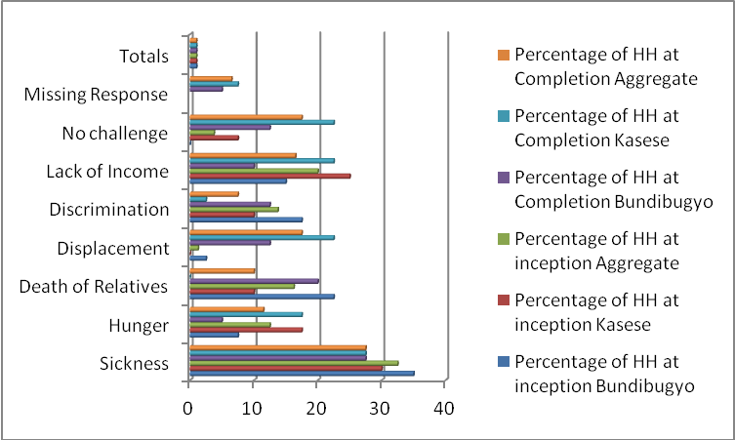
From the analyses above there is evidence that for most of the exposure to risks/vulnerability indicators there was reduction in the magnitude of the vulnerabilities. The analyses show that that they were significant changes with regard to sickness, discrimination, displacement and death of close relative. Two of the variables under analyses i.e. sickness and discrimination were aspects that the program action targeted and the other two are exogenous variables which possibly could have been included under assumptions. The analyses in following sections will establish correlation between these findings with program action interventions. This implies that there was positive impact realised during the project implementation period and indeed this is manifested by even the level of increase by those that had no challenges moving from 3.75% to 17.5%. Such indices measurements need to be integrated in the project as variables for monitoring and evaluation. The only variable where there was increased exposure to risks is displacement whose cause need to be investigated so that it is mitigated (it could be environmental, insecurity or community inspired). The analysis also brings out the major challenges which include health 27.5%, income insecurity 16.25%, and food insecurity 11.25% risks which poverty manifestations need direct interventions to minimise their hazards.
It is important to prioritise the most critical needs of the OPs which signal the activities and or interventions that can have significant impacts on their welfare and livelihood statuses. The analysis below presents the preference of priority needs both at project inception and at completion:
The analyses below further reinforce which particular strategic entry areas do the project interventions have to focus i.e. income generation with 57.5%, education 13.75%, health 12.5% and food security with 12.5%. Their significance remains constant over the project period but one observable conclusion is that there is need for direct interventions other than pursuing the policy advocacy and rights based approaches whose effects take long considering those governments’ responses and service delivery cannot be guaranteed in a short term.
Table 6: Priority Livelihood, services and welfare Needs
Kind of Need | Percentage of HH at inception |  |  | Percentage of HH at Completion
 | Bundibugyo | Kasese | Aggregate | Bundibugyo | Kasese | Aggregate
Food | 12.5 | 0.0 | 6.25 | 17.5 | 7.5 | 12.5
Medication | 2.5 | 15.0 | 8.25 | 12.5 | 12.5 | 12.5
School Fees | 17.5 | 22.5 | 20.0 | 15.0 | 12.5 | 13.75
Household Income | 57.5 | 60 | 58.75 | 52.5 | 62.5 | 57.5
Access to Market | 2.5 | 2.5 | 2.5 | 2.5 | 2.5 | 2.5
Roads Infrastructure | 5.0 | 0.0 | 2.5 | 0.0 | 2.5 | 1.25
Land | 2.5 | 0.0 | 1.25 | 2.5 | 2.5 | 2.5
Totals | 100% | 100% | 100% | 100% | 100% | 100%

Figure 11: Priority Livelihood, Services and Welfare Needs:
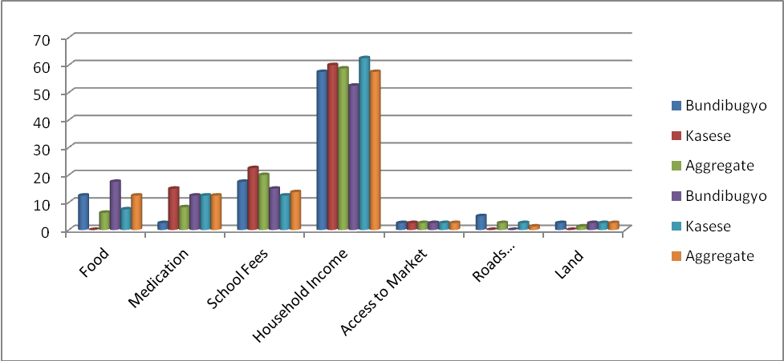
Further analyses of the health hazards exposures shows that hypertension 13.75%, backache 10% and malaria 8.75% are the major ailments. The first two needs specialised medications which at times are rarely provided in the hard to reach health centres implying that specific arrangements have to be made to enable the affected access such services. It is noticeable that 58.75% of the respondents’ didnot have health ailments but even then the 41.3% that are exposed to various ailments is proportionately big and has a lot of cost and productive time wastage implications.
Figure 12: Old Persons’ Healthy Ailments:
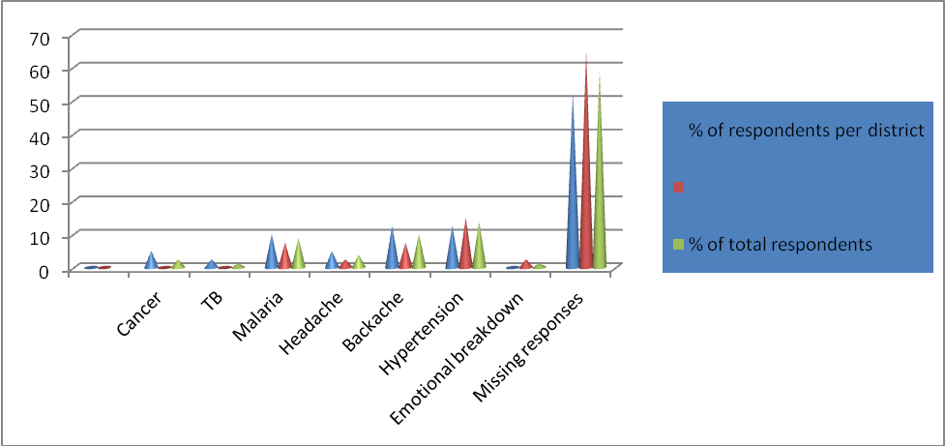

2.3.5 Household Incomes Sources:
The source and levels of incomes of the OPs is very critical to their social security and welfare status. From all investigations and by virtue of the education levels of the target communities agriculture stands out as the major occupation, followed with trading, wage earning and artisans but also they are some that lack regular occupations/income sources as presented in the table and figure below comparing situations between inception and completion.
Table 7: Occupations
Sources of Income/Occupation | Percentage of HH at inception |  |  | Percentage of HH at Completion
 | Bundibugyo | Kasese | Aggregate | Bundibugyo | Kasese | Aggregate
Agriculture | 53.8 | 44.8 | 49.3 | 70 | 42.5 | 56.25
Trading | 28.5 | 30.9 | 29.7 | 0.0 | 12.5 | 6.25
Service Provision | 7.6 | 17.7 | 12.65 | 5.0 | 12.5 | 8.75
Artisans | 0.0 | 0.0 | 0 | 5.0 | 0 | 2.5
Transfers from Relatives | 10.1 | 6.6 | 8.35 | 0 | 0 | 0
Missing Responses |  |  |  | 20 | 32.5 | 26.25
Totals | 100% | 100% | 100% | 100% | 100% | 100%

Figure 13; Occupations:
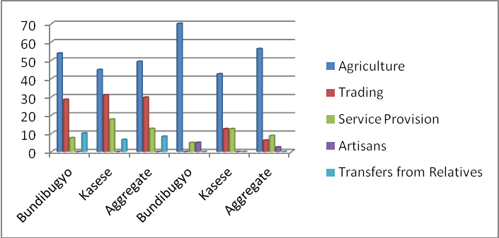
The analyses show that agriculture remains the major occupation and sources of income of the peasantry population where most of the OPs are anchored. Petty trading follows although the low figure for Bundibugyo at project completion is attributable to the fact that most of the respondents were from villages not rural growth centres compared to Kasese. This implies that URAA and its partners need to identify and support interventions that will enhance the productivity of the major sectors where the majority of the HHs ekes a living i.e. agriculture, micro-enterprises and service provision. The high level of the unemployed or people without income are instructive to finding appropriate means of cash transfer incomes to these target communities either by supporting their relatives or providing actual cash transfers from the state.

2.3.6 Household Monthly Incomes and Expenditure Levels:
Universally, poverty in general and low income levels in particular describe and manifest the level of deprivation and vulnerability of given category of people thus to understand the welfare and social security statuses of OPs we need to measure their income levels.

Table 8: Monthly incomes and Expenditure Levels
Quartiles | Percentage of Income Quartile |  |  | Percentage of HH Expenditure Quartile
 | Bundibugyo | Kasese | Aggregate | Bundibugyo | Kasese | Aggregate
Less 10,000 | 12.5 | 35 | 23.75 | 22.5 | 35 | 28.75
10,000-30,000 | 25 | 10 | 17.5 | 5 | 2.5 | 3.75
31,000-50,000 | 15 | 5 | 10 | 7.5 | 5 | 6.25
50,000-100,000 | 7.5 | 5 | 6.25 | 32.5 | 22.5 | 27.5
101,000-200,000 | 20 | 20 | 20 | 25 | 25 | 25
201,000-400,000 | 12.5 | 15 | 13.75 | 2.5 | 2.5 | 2.5
400,001-700,000 | 5 | 5 | 5 | 0 | 0 | 0
701,000-1,000,000 | 2.5 | 5 | 3.75 | 5 | 7.5 | 6.25
Average 128,125 156,250 142,188 118,125 131,625 124,875
Figure 14: Monthly Income and Expenditure Levels:
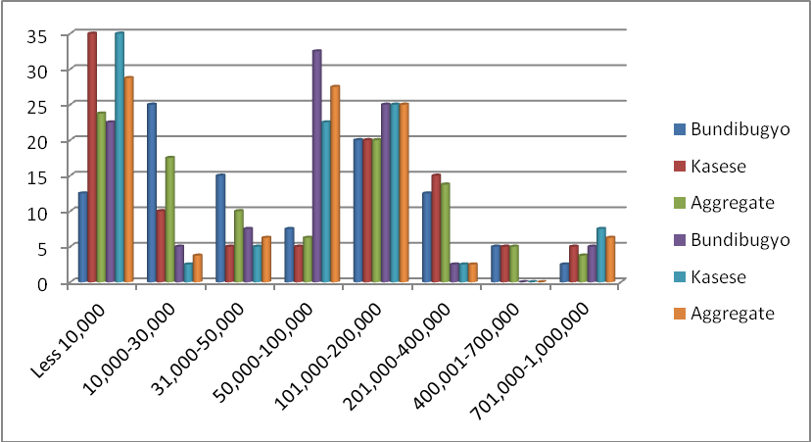
The analyses portray various explanations on the welfare and deprivation levels of the target communities. Over 50.25% of the HHs earn less than Shs50, 000/= per month and about 66.25% subsist on less than Shs100,000/= yet only 57.5% earn Shs100,000/= implying that about 9% of the households live beyond their income levels possibly depending on transfer earnings from their relatives. Kasese on average has a higher average income and expenditure levels compared to Bundibugyo reported as Shs156, 250/= and 131, 625/= compared to Shs128, 125/= and shs118,125/= respectively hence the latter is much deprived. Considering that the average family size is about 8 persons the per capita income levels for the project area is about Shs520.3 =US$.21 Worse still the level of deprivation is further explained by the fact that over 70% of the households survive on less than Shs100, 000/= per month signifying the unequal distribution of incomes. This has implications that all those subsisting below the poverty line of less than one dollar a day estimated at over 85% of the households need some kind of income subsidy to be able to survive. This pre-supposes that future programming interventions should establish the level of deprivation and income insecurity in order to proportionately determine the level of development assistance to uplift these communities from development deprivation and vulnerabilities. It is also worth noting that in whereas in some income brackets households are spending more than they are earning some HHs are making saving of their incomes. The explanation could be that those with income deficits are depending on income transfers from other sources to meet their expenditures. In future programming this needs to be investigated.
The data analyses in the table and figure below supports our arguments that transfer incomes from relatives and family members significantly contribute about 17.5% of the total sources of income coming second to agriculture which contributes 62.5% overall. Temporally causal work also plays a significant source of income 13.75% but that is only possible for the still energetic OPs below 65 years. What is noticeable is the low level of formal employment contributing just 1.5% of the income sources.
Figure 15: Household Sources Income Levels:
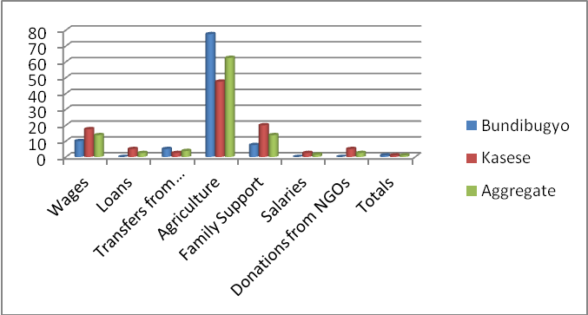
Table 9: House hold sources income levels
Sources of Incomes | Bundibugyo | Kasese | Aggregate
Wages | 10 | 17.5 | 13.75
Loans | 0 | 5 | 2.5
Transfers from Relatives | 5 | 2.5 | 3.75
Agriculture | 77.5 | 47.5 | 62.5
Family Support | 7.5 | 20 | 13.75
Salaries | 0 | 2.5 | 1.5
Donations from NGOs | 0 | 5 | 2.5
Totals | 100% | 100% | 100%

2.3.7 Household Living Conditions:
Household living conditions is one of the measurement indicators of the household welfare hence analyses of the same in this study renders credence to other analyses of the magnitude of the level of deprivation of the OPs in the two districts. From the survey on average dwelling units in Bundibugyo have three bedrooms compared to two bedrooms in Kasese and on average there 8 occupants per household. The major source of lighting is keresone lamps estimated at 91.25%. There is no H/Hs in Bundibugyo that was found using electricity for lighting compared to 17.5% for Kasese. As regards energy source 97.5% and 90% of the H/Hs in Bundibugyo and Kasese respectively use straws/firewood as source and the rest use charcoal respectively.
The other key areas of analysis include materials used for roofing, walls and floor. Comparison is made between the two districts:
Table 10: House Hold Materials:
Household Condition |  | Bundibugyo % | Kasese % | Aggregate %
Roofing | Iron Sheets | 100 | 97.5 | 98.5
Roofing | Tiles | 0.0 | 2.5 | 1.25
Roofing | Grass-thatched | 0.0 | 0.0
Wall | Mud and poles | 90 | 35 | 62.5
Wall | Burnt bricks with mud | 0 | 15.0 | 7.5
Wall | Un-burnt bricks | 0.0 | 5.0 | 2.5
Wall | Burnt bricks and cement | 2.5 | 5.0 | 5.75
Wall | Cement bricks | 7.5 | 40.0 | 23.75
Floor | Muddy and dirty | 90 | 47.5 | 68.75
Floor | Plank and concrete | 0.0 | 7.5 | 3.75
Floor | Plastered or cemented | 10.0 | 45.0 | 27.5
The construction materials of a dwelling unit not only indicate the environmental health sustainability of the household living conditions but also the durability and permanency of the dwelling unit which equally denotes the economic status of the household. Whereas, almost all the dwelling units in the two districts have permanent roofing materials, 90% and 35% of the walls in Bundibugyo and Kasese respectively are of poles and muddy materials. Equally, 90% and 47.5% of the floors in Bundibugyo and Kasese respectively are mud and dirty materials denoting that households are of low economic statuses. Relatively, Bundibugyo like in all other poverty measurement parameters is rated poorly as far as dwelling units’ construction materials.
From the FGDs it was established that construction of permanent houses poses a big problem to the OPs whereby they cannot afford to construct houses with permanent materials yet temporary ones are not only risky in terms attracting dangerous reptiles and mosquitoes they can collapse any time. It was reported that in Democratic Republic of Congo (DRC)- Habitat International builds low cost houses for the OPs something that could be replicated in Uganda.

2.3.8 Households Possession of Items:
Availability and access to given household assets is also another indicator of the welfare status of H/Hs. These assets are necessary for communication and information, household hygiene, and transportation. The medium of information dissemination is generally radios whereby on average 63.7% of the households have functioning radios compared to just 5% with television sets. This implies that dissemination of media messages has to use radios as the most appropriate media. The telephone coverage is also reasonable with 45% but Kasese has a higher density with 52.5% compared to Bundibugyo 37.5%.
Transport is also another essential household requirement but only 15% and 30% of the H/Hs in Bundibugyo and Kasese have functioning bicycles. Possible explanation for the low levels could be the high attitude terrain making use of bicycles less important. But still ownership of motorcycles is also very low 0% and 5% for Bundibugyo and Kasese respectively implying that transport is a major infrastructure problem in the project area.
Table 11: Households' possession of basic house hold items
Item | Possession by HH per district |  |  |  | % of total respondents
 | Bundibugyo |  | Kasese
 | Yes | No | Yes | No | Yes | No
Electricity | 2.5 | 97.5 | 25.0 | 75.0 | 13.75 | 86.25
Functioning radio | 62.5 | 37.5 | 65.0 | 35.0 | 63.75 | 36.25
Functioning television | 2.5 | 97.5 | 7.5 | 92.5 | 5.0 | 95
Functioning refrigerator | 0.00 | 100 | 2.5 | 97.5 | 1.25 | 98.75
Functioning telephone | 37.5 | 62.5 | 52.5 | 47.5 | 45 | 55
Functioning lantern | 35.0 | 65.0 | 57.5 | 42.5 | 46.25 | 53.75
Cupboard | 27.5 | 72.5 | 42.5 | 57.5 | 35 | 65
Functioning bicycle | 15.0 | 85.0 | 30.0 | 70.0 | 22.5 | 77.5
Functioning motorcycle | 0.00 | 100 | 5.0 | 95.0 | 2.5 | 97.5
Functioning car or truck | 0.00 | 100 | 0.00 | 100 | 0.00 | 100
Functioning boat or canoe | 0.00 | 100 | 0.00 | 100 | 0.00 | 100

2.4: Service Providers Targeting OPs and Packages:
The beneficiaries were asked to rank who they considered to be the most effective service providers targeting Ops in order to determine whether the program intervention rightly positioned its assistance on the most effective service providers.
From the responses belowve and from empirical evidence NGOs are considered the most effective service providers in most of the sectors so it questionable whether it was rational for the program action to invest in improving local governance service delivery other than supporting the NGOs and CBOs that target the Ops. It is quite surprising that FBOs that have grassroots networks everywhere are tailing as service providers targeting the elders something that needs to be addressed in future programming interventions. The implication of this analysis is that in future programming practitioners should target their interventions based on sector that will effectively deliver the intended services to the target groups in order to maximize impact and minimize waste of investment resources.
The findings are presented in the fig 16. below:
Figure 16: Organizations targeting the ops
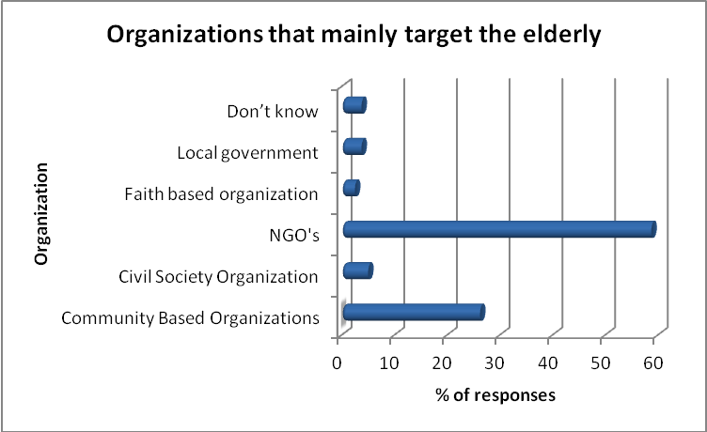
Further analyses revealed that there are disparities between the critical needs of the Ops as against what the service providers deliver. As elucidated below 42.5% of the services is psychosocial support, money 23.75% (57.5%), 8.75% agriculture supplies, food supplies 2.5% (12.5%) household supplies 6.25%, health supplies 1.25% (12.5%). None was offering school fees yet it accounted for 13.75% of the needs to support OVCs under the care of Ops. The figure below presents the service packages offered and figure 12 presents the ranking of needs.
Figure 17: Support services offered to the ops
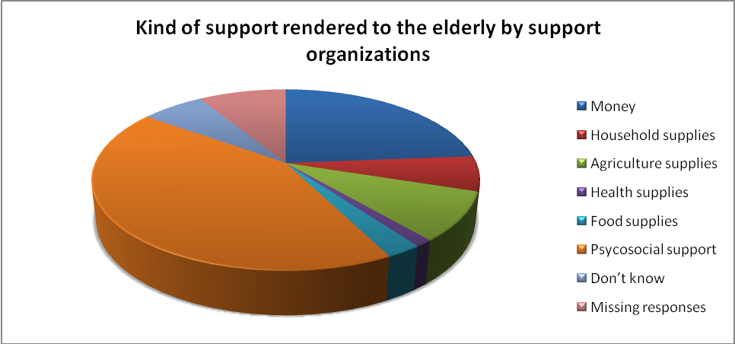
In view of the above analyses we look at how the program action has performance according to the priority needs of the Ops.

2.5 Performance, Impact and Sustainability Assessment:
Study Objective Three: Assess the extent to which the expected results of the project have been met and how the results have contributed to the reduction of poverty and sustainable development in the project areas:

2.5.1: General Aspect:
This assessment looks at how the program action outputs have contributed to the realisation of the planned results and whether those results have precipitated significant impacts on poverty reduction and sustainable development at beneficiaries, partners, wider society and national level. The assessment will further establish whether institutional capacity has been built for the sustainability of the program benefits laying a platform for new programs and which best practices and lessons that can be replicated.
The evaluation in order to determine the OPs needs investigated what the OPs considered to be their priority needs and challenges through both the household and FGDs.
The investigations as portrayed in fig 10 and 11 above ; reveal that 32.5% considered sickness to be the major challenge, 20% mentioned lack of income, 16.2% looked at death of close supportive relatives, and 13.75% highlighted discrimination as a challenge and 12.5% listed hunger as the challenges. On the hand when asked the critical needs 58.7% picked household income as the priority need, 13.75% listed school fees, 12.5% gave medication as the most critical need, and 12.5 % stated food as the most critical need. Thus in measuring the achievement of the program overall goal on reduced poverty levels and increased sustainable development the investigations will assess whether the program action contributed to reduction in any of the above vulnerabilities and increased access to the OPs life, welfare and livelihood needs.
The respondents in the two districts of Kasese and Bundibugyo felt that the program action identified the following as their major challenges which are clear manifestations of poverty and under development which required resolution by the program action to meet the needs of the targeted beneficiaries. Prior to the implementation of the program the key challenges which were faced by the old persons in the region included the following;
- Limited participation of the old people in the decision making processes at all levels i.e. family, community and local government level. The ideas of the old people were considered to be expired thus limiting their participation in the planning processes which resulted into exclusion of their needs in the local government plans and budgets.
- Community members had negative attitudes towards old persons. The old people were marginalized considered to be of no use to the community and in the worst cases considered to be expired and witches.

- Old people had limited access to productive resources and were less involved in income generating activities. Consequently this increased their (old persons) vulnerability and marginalization in the community.

- The decision making about health services and actual access to and utilization of health services by the old people was determined by the support and willingness of their relatives.

- Majority of the old people were not aware of some of the services and their rights that are available in the community and local government structures from which they can benefit. This was particularly mentioned in respect to government programs like NAADS, FAL, CDD and health services.

- The local government technical staff had poor attitude towards old people. Majority of the respondents in the focused group discussions lamented that the attitudes and conduct of majority of local government staff and other service providers were not user friendly towards the old people. In particularly health workers were mentioned to be harsh and using demeaning language when communicating to old people who were sick.

- Also prior to the program, it was mentioned that the old people themselves were self marginalized whereby they lacked self esteem. The old people could not come out to challenge the forces which were deterring them to access local government services. They were not organized to have a common voice
The analyses below look at how the program action delivered based on the identified needs of the final beneficiaries as against the set results areas and objectives of the program action.

2.5.2 Overall Objective:
The program action was expected to contribute towards reduction in poverty levels in the two districts amongst the most vulnerable and disadvantaged OPs populations. This was to be achieved through formulation of development plans and policies that reflected the needs of OPs with increased budget allocations in programs supporting the OPs. The design didnot indicate key impact indicators that would be used to measure whether there was poverty reduction and increase in sustainable development.
The level of poverty is still very high as revealed from figure 2.7 whereby the average household income in Kasese and Bundibugyo is Ushs156,250 and Ushs128,125 respectively yet monthly household expenditure is Shs131,625 and 118,125 respectively for Kasese and Bundibugo for an average household of 8 persons meaning that the per capita income stand at Shs651 for Kasese and Shs533 respectively which is about US$0.26 and US$0.21 respectively. Over 85% of the households are surviving on less than US$1. This shows that the Ops in the program area are deplorable poor and grossly deprived of survival means in terms of household incomes. But in absence of baseline data on income levels and per capita income it is not possible to assess whether the project contributed to poverty reduction using income levels as the measurement parameter.
This implies that there is still a lot to be done in terms of improved service delivery by LGs but also direct interventions by other development agencies particularly the NGOs and PSOs.
Further analyses using another measurement indicator shows that during the project period the number of people without any life, welfare, income and other livelihood challenges increased from 3.75% to 17.5% which means that about 13.75% households were pulled out of poverty if being without a challenge can be taken as a proxy for household’s wellbeing.
The reduction in sickness and discrimination can also be taken as indices on reduced vulnerability manifestations of poverty and underdevelopment as shall be explained later under the respective sections on the thematic areas.
There is evidence that through influencing district and lower local government policies OPs started accessing poverty alleviation programs as shall be explained below on access to agriculture and other extension services.

2.5.3 Improved Access to Agricultural and Non-Agricultural Support Extensions Services:
Food and income security are manifestation of sustainable development and poverty reductions so the analyses below assess whether the program action could have contributed to poverty reduction.
The program action facilitated the formation of 200 and 170 Ops groups in Kasese and Bundibugyo respectively to be able to access government poverty alleviation services. According to the Executive Secretary of BUSFASIGA 57 groups (33.5%) in Bundibugyo managed to access NAADS program services and 70% in Kasese are said to have accessed the NAADS program. In total 2,510 (33.8%) Ops persons are said to have accessed poverty alleviation funds out of the total of 7,423 Ops who were aware of the existence of poverty reduction funds.
In order to ease the Ops access to NAADS program the requirement for groups to have 30 members was quashed and reduced to 15 members as a result of effective dialogue with the LGs. The district NAADS coordinator was a key actor in ensuring that older persons’ groups that meet requirements be targeted first hence realizing a total of 57 groups benefiting. Accordingly, the Ops have benefited from training in modern agriculture practices, access to agriculture inputs and seedlings, improved animal breeds (goats and poultry), improved cassava cuttings, pigs, mangoes and banana suckers. The monitoring tools did not however capture data on the value of assistance received, percentage increase of those accessing since project inception, and what this could have contributed to their income and food security levels.

In Kasese and Bundibugyo, older persons are mobilizing resources to run their associations in a sustainable manner. For example, in Bundibugyo District, Bumadu Older Persons Group in Bundibugyo Town Council have mobilized Ugsh. 270,000 (Euro 80) while Bundimbali Bagurusi Kwerunganiya Association have mobilized Ugsh. 200,000 (Euro 59). In Kasese District, Mbunga Bakekulu Basyakulu Tukolere Haghuma Group in Kilembe Sub County have mobilized Ugsh. 700,000 (Euro 206) Kibandama Elderly Group in Kilembe Sub County has mobilized Ugsh. 500,000 (Euro 147) and Kasokero Twanzane Group in Kyondo Sub County has accumulated savings worth Ugsh. 542,000 (Euro 160). There is no updated data of the situation as at end of project compared to 2010 status.

Through capacity building most groups are able to manage record keeping mechanism of their finances and activities and have drafted constitution with support from government (CDO) and accessing a number of government services. However, these groups will need to enhance their skills in finance and record keeping to manage the funds they are building up but also to bring them to a level to which they can access credit from micro-finance institutions should they have viable projects.

Through the CSOs networks URAA has linked up with Foundation for Rural Advancement (FURA) to empower communities with knowledge in village savings and credit association training (VSLAs) reported to have started including at least 3 to 4 older persons in their trainings so that they can be incorporated in their existing group members trained, for this will give them an opportunity to benefit from FURA economic empowerment to these village groups in Kasese municipality, Munkunyu and Muhokya as reported by the FURA advocacy officer.

From FGD the participants reiterated that Old people were mobilized and facilitated to form savings and credit groups. For example in Harugale Sub-county, Bundibugyo District a total of 69 old people have been selected to benefit from the CDD by receiving goats. Though these groups were originally set up to enhance the incomes of the old people, they are also used as advocacy avenues to demand their (old people) access to local government services.
For example in the FGD held in Kasese District one of the participants admitted that; Before this program was started in the District, I had never thought that there organizations with projects which are designed specifically to target the needs of old people. I have been involved in community project targeting other vulnerable groups like PLWHA and PWDs but I did not know that even old people are considered to be vulnerable. Through my participation in this program I have learnt a lot thanks to URRA for their well thought intervention towards the always forgotten members of our communities ’’
The investigations revealed that about 12.5% have full access and 52.5% consider accessibility to agricultural advisory services satisfactory in Kasese compared to 10% with full access and 22.5% who consider accessibility satisfactory in Bundibugyo. Overall, 11% have full access and
42% have satisfactory access. With regard to quality of services, the investigations revealed that about 12.5% consider it as high quality and 50% consider quality of agricultural advisory services as satisfactory in Kasese compared to 15% that consider it high quality and 40% who consider quality of advisory services as in Bundibugyo. Overall, 14% rate it as high quality and 45% as satisfactory agricultural service delivery.
When effective agricultural service delivery is to be measured as the product of accessibility and quality of services; Kasese effectiveness stands at 13% compared to 13% for Bundibugyo against overall score of 13% for the entire program area.
With regard to micro finance services, the investigations revealed that about 5% have full access and 42.5% consider accessibility to micro finance services satisfactory in Kasese compared to 20% with full access and 52.5% who consider accessibility in Bundibugyo. Overall, 13% have full access and 48% have satisfactory access.
With regard to quality of micro finance services the score for high quality was 0% and 37.5% consider quality of micro-finance services as satisfactory in Kasese compared to 12.5% that consider it high quality and 52.5% who consider quality of micro-finance services as satisfactory in Bundibugyo. Overall, 6% rate it as high quality and 45% as satisfactory micro-finance service delivery.
When effective micro-finance service delivery is to be measured as the product of accessibility and quality of services; Kasese effectiveness stands at 3% compared to 16% for Bundibugyo against overall score of 9% for the entire program area.
With regard to banking services, the investigations revealed that about 5% have full access and 30% consider accessibility to banking services satisfactory in Kasese compared to 12.5% with full access and 30.% who consider accessibility in Bundibugyo. Overall, 9% have full access and 30% have satisfactory access.
With regard to quality of banking services the score for high quality was 2.5% and 40% consider quality of banking services as satisfactory in Kasese compared to 5% that consider it high quality and 17.5% who consider quality of banking as satisfactory in Bundibugyo. Overall, 4% rate it as high quality and 29% as satisfactory banking service delivery.
When effective micro-finance service delivery is to be measured as the product of accessibility and quality of services; Kasese effectiveness stands at 4% compared to 9% for Bundibugyo against overall score of 6% for the entire program area.
The investigations went further to establish the skills levels of the final beneficiaries to be able to meet the income and food security needs. 55% and 56% of the beneficiaries are not able to read and read respectively, only 53.5% have mathematical skills, just 7.5% have knowledge of appropriate technology in farming, 38.5% in enterprise management and less than 10% have any technical skills either in carpentry, hair dressing and sewing. This means the target beneficiaries have low absorptive capacity to productively manage farming and non-farming enterprises unless provided with more skills training. Accordingly, about 38.75% of the respondents felt that the program action addressed their income and food security need through groups’ formation to access poverty alleviation programs.
In order to assess the impact of the project the evaluation asked respondents on their critical needs before and after the project. It was established that before the project income security accounted for 58.75% of the priority needs yet at project completion it had only dropped to 57.5% but then food insecurity increased from 6.25% before the project rising to 12.5% which was negative possibly attributable to climate change, reduced land acreage or crop failures, increased demand on food supplies as reflected in the figure below.

Table 12: Effectiveness of agricultural and non - agricultural service
 | Kasese |  |  |  | Bundibugyo |  |  |  | Merged
Agricultural Advisory | No | Poor | Moderate | Full/ | No | Poor | Moderate | Full/ | No | Poor | Moderate | Full/
 |  |  |  | effective |  |  |  | effective |  |  |  | effective
Access | 27.5 | 20 | 40 | 12.5 | 55 | 12.5 | 22.5 | 10 | 18% | 16% | 31% | 11%
Quality | 12.5 | 42.5 | 37.5 | 12.5 | 7.5 | 52.5 | 25 | 15 | 6% | 48% | 31% | 14%
Effectiveness | 20% | 31% | 39% | 13% | 31% | 33% | 24% | 13% | 12% | 32% | 31% | 13%
Micro-Finance Services | No | Poor | Moderate | Full/ | No | Poor | Moderate | Full/ | No | Poor | Moderate | Full/
Access | 42.5 | 15 | 37.5 | 5 | 35 | 12.5 | 32.5 | 20 | 31% | 14% | 35% | 13%
Quality | 20 | 42.5 | 37.5 | 0 | 20 | 27.5 | 40 | 12.5 | 20% | 35% | 39% | 6%
Effectiveness | 31% | 29% | 38% | 3% | 28% | 20% | 36% | 16% | 26% | 24% | 37% | 9%
Banking Services | No | Poor | Moderate | Full/ | No | Poor | Moderate | Full/ | No | Poor | Moderate | Full/
 |  |  |  | effective |  |  |  | effective |  |  |  | effective
Access | 47.5 | 22.5 | 25 | 5 | 57.5 | 12.5 | 17.5 | 12.5 | 53% | 18% | 21% | 9%
Quality | 32.5 | 32.5 | 37.5 | 2.5 | 10 | 72.5 | 12.5 | 5 | 21% | 53% | 25% | 4%
Effectiveness | 40% | 28% | 31% | 4% | 34% | 43% | 15% | 9% | 37% | 35% | 23% | 6%
 | 20% | 31% | 39% | 13% | 31% | 33% | 24% | 13% | 12% | 32% | 31% | 13%
Micro-Finance  Services | No | Poor | Moderate | Full/ | No | Poor | Moderate | Full/ | No | Poor | Moderate | Full/
Access | 42.5 | 15 | 37.5 | 5 | 35 | 12.5 | 32.5 | 20 | 31% | 14% | 35% | 13%
Quality | 20 | 42.5 | 37.5 | 0 | 20 | 27.5 | 40 | 12.5 | 20% | 35% | 39% | 6%
Effectiveness | 31% | 29% | 38% | 3% | 28% | 20% | 36% | 16% | 26% | 24% | 37% | 9%
Banking  Services | No | Poor | Moderate | Full/ | No | Poor | Moderate | Full/ | No | Poor | Moderate | Full/
 |  |  |  | effective |  |  |  | effective |  |  |  | effective
Access | 47.5 | 22.5 | 25 | 5 | 57.5 | 12.5 | 17.5 | 12.5 | 53% | 18% | 21% | 9%
Quality | 32.5 | 32.5 | 37.5 | 2.5 | 10 | 72.5 | 12.5 | 5 | 21% | 53% | 25% | 4%
Effectiveness | 40% | 28% | 31% | 4% | 34% | 43% | 15% | 9% | 37% | 35% | 23% | 6%

2.4.4 Improved Access to Health Services Delivery and Medication:
The evaluation also looked at the level of health service delivery and attendant health related issues which impact on the health of the Ops and how these could have been impacted upon the Ops welfare and livelihood and or missed out in the program action. As already stated above where medication stood at 8.75% before the project, it increased to 12.75% by the end of the project and indeed this finding is amplified and qualified by the fact that respondents reported it as the most top most challenge standing at 27.5% by the end of the project after dropping from 32.5% as at project inception. This revelation shows that there was some positive impact caused during the project period. The above conclusions are supported by the following findings:
From FGDs both in Kasese and Bundibugyo the respondents reported that Local government staffs like health worker have started to appreciate that older people have to be treated as special category. For example it was reported that in government health centres older people are given priority whenever they go for services. The older people are excluded from lining which a practice has improved their (older people) access to health services.

As a result of exposure visits to Mukono, with facilitation of URAA, an idea was picked to earmark a specific day for Ops to attend health clinics at all the HUs in the district of Bundibugyo. Mrs Sibugyo Agnes; District Deputy Speaker reported that an ordinance is being drafted to have this provision in the delivery of health services. The District Medical Officer confirmed this when he stated that already a day has been set aside for older persons to receive free treatment in the government hospitals only waiting ratification by the relevant authorities. Bundibugyo district supported by the leadership has made effort to register older persons and provide them with identification cards to enable them easily access health services. As a result of the combined initiatives 7,307 people is aware of their right to access government services and according to available information 3,123 (42.7%) had access health services in Bundibugyo district. But it was mentioned that the patients in most cases were advised to get drugs from drug shops at a cost.

So far 5 HUs have arrangements to selectively attend to Ops health needs. In Bundibugyo Hospital, special medical personnel have been assigned to handle older persons and this has led to faster services to older persons. Ops waiting for medical care have been offered wwiting areas with seats such as benches in health facilities. Equally child care organisations in Bundibugyo such as Child Concern Initiatives (CCIO), Bundibugyo Women Federation and Bundibugyo Hand for Hope (BUHAHO) have sensitised and promoted observance of children’s rights and welfare, recognising the particular vulnerability of children under the care of older people.

The most challenging ailments in the project area include hypertension at 13.75%, backache 10%, malaria 8.75%, headache 3.75% and cancer 2.5%. Other diseases include eye-sight, dental problems, TB and emotional breakdown. 51.25% of the respondents have had some kind of ailment meaning about 8.55% either did not either seek or access medical services from the HUs.
The data in the table below shows that both Kasese and Bundibugyo have 35% full access by the respondents but Bundibugyo has a higher percentage of those with poor access 40% compared to Kasese which is 32.5%. Overall 62.5% of the Ops in Kasese find accessibility satisfactory compared to 60% for Bundibugyo. The entire program area if assessed records full access at 35% and satisfactory access at 61.5%

On the hand the data in the table above shows that Kasese has 40% high quality services compared to Bundibugyo at 20%. Similarly, Bundibugyo has a higher percentage of those with low quality/poor at 45% compared to Kasese which is 27.5%. Overall 72.5% of the Ops in Kasese find quality of health services satisfactory compared to 55% for Bundibugyo. The entire program area if assessed records high quality health services at 30% and satisfactory access at 63.75%.

If effective health service delivery is to be measured as the product of accessibility and quality of services; Kasese effectiveness stands at 37.5% compared to 27.5% for Bundibugyo against overall score of 32.5% for the entire program area.

The tables below present Ops opinions on the quality and level of accessibility to health services. Table 13: Effectiveness Health Services in the two districts:

Measurement | Kasese |  |  |  | Bundibugyo |  |  |  |  | Merged
Standard
 | No | Poor | Moderate | Full/ | No | Poor | Moderate | Full/ |  | No | Poor | Moderate |  | Full/
 |  |  |  | effective |  |  |  | effective |  |  |  |  |  | effective
Access | 0 | 32.5 | 27.5 | 35 | 0 | 40 | 25 | 35 |  | 0 | 36.25 | 26.25 |  | 35
Quality | 0 | 27.5 | 32.5 | 40 | 0 | 45 | 35 | 20 |  | 0 | 36.25 | 33.75 |  | 30
Effectiveness |  | 30.0% | 30.0% | 37.5% | 0.0% | 42.5% | 30.0% | 27.5% |  | 0.0% | 36.3% | 30.0% |  | 32.5%
Access to health services was also assessed in terms of distance to the nearest HU where 37.5% were within 1 km, 31.25% within 2 km and 31.25% above two km. These distances are very critical given that the roads are very poor and the most suitable mode of transport are motor cycles which are costly and scarce where only 2.5% of the beneficiaries HHs had motor cycles and just 22.5% have bicycles. Finally, 53% of the respondents felt that the project adequately achieved its goal of improving local government service delivery. This is a positive change for older persons as Kasuka, a 75 year old man from Bugoye sub-county said: “I was well received at the Hospital – the nurses receive us well and there is no lining up!” However, the unavailability of prescribed drugs at the health facilities remains a major challenge for older people. These are quite a reasonable statistics based on empirical evidences in rural areas implying that there was effective service delivery.

2.5.5. Education of OVCs:
According to the HH interviews school fees for orphans ranks one of the critical needs of the Ops standing at 20% at project inception and 13.75% at project completion. Although there was a drop in the magnitude of that need there was no direct program intervention to address this both in awareness creation and direct delivery of services by the community actors OCMGs, spokes persons and paralegals. But in Bundibugyo, BUSFASIGA had opened a school to offer education to the OVCs something that should have been streamlined in the program action. In Kasese; Munkunyu sub-county, the paralegals produced bricks and contributed 5000 of these to
Kinyamaseke Primary School where Save the Children in Uganda (SCiU) is supporting the construction of classrooms for the school.

The evaluation established that 72.5% of the correspondents considered access to UPE as satisfactory; 75% for Kasese and 70% for Bundibugyo whereas 70% considered the quality satisfactory; 72.5% for Kasese and 67.5% for Bundibugyo. These are quite impressive statistics based on empirical evidences in rural areas implying that there was effective service delivery but the issue of quality of education is quite debatable considering the pass rate of most schools in the project areas was very poor.

2.5.6: Discrimination:
Discrimination was and has remained one of the greater challenges of the OPs whereby at project inception it was 13.75% and by end of project it dropped to 7.5%. The OPs were discriminated in several respects including but not limited to access to social service delivery, poverty alleviation programs, access to legal services and enjoyment of their rights, citizenship, and abuse of their rights particularly based on gender differences.
This program action came up with several interventions to address the various deprivations and exclusion of OPs because of their age. In 2009, 952 (745 men and 205 women) community representatives and later in 2010 a total of 988 older people participated in a one day workshop to be sensitized on rights, available Government services and government structures. In Bundibugyo, 596 (396 male and 200 female) while in Kasese 392 (171 male and 221 female) participated in awareness workshop on the rights and needs of the Ops resulting into high knowledge of the Ops rights and entitlements, integration of Ops in government programs, instituting the policy frameworks for OPs social protection and their representation in policy decisions and program delivery. The activity raised awareness on older people’s rights, creating links with existing services in the community to address issues of older persons, enhanced older people access to their rights and entitlements, lobbying the local authority systems/structures to enhance older people’s participation in local governance and contribute to the demand driven services.
As a result the general perception about the older people has improved right from the family, community and district level. Older people are now considered to be part of the community who can contribute towards the planning and development of their areas unlike before the project. In the past they were looked as witches and weird as mentioned in one of the FGDs in Kasese and reechoed by the Deputy Speaker Bundibugyo. In actual fact some OPs in Kasese formed a group and named it “ Obukulu tebulita” meaning old age does not mean that they are no longer human beings or are nearing death. In the past these Ops persons would be neglected since they were destined for death and generally considered expired.
Through the formed groups, the older people have been able to have a common understanding of their problems. The older people in the districts united with common problems collectively approach their local government leaders and demand for their rights like being included in the government programs; NAADS and CDD which was not the case before the project. For instance during the reporting period older people were to be represented in the local councils an action that is currently being implemented by the respective districts’ LGs.
Besides, a close relationship has been built between the older people and the local authority helping the two groups to understand and support each other including putting demands to each other, a situation that has catalysed change in both groups resulting into development enhancement. For instance now it is normal for older people to actively demand their participation in the government planning process undertaken at the local councils which has gained fruits with a good number of older people participating in the programs.

2.5.7: Provision of Legal Services:
Throughout program implementation 17 paralegal clubs have been formed in Kasese district and 10 in Bundibugyo district. 200 paralegals have been trained 100 in Bundibugyo district and 90 in Kasese district. The program after training them gave them paralegal kits and copies of the National Constitutions as reference documents when delivering services. 10 paralegals ( 4 females and 6males had an exchange visit to Tanzania to acquaint themselves with experiences and techniques of handling complex issues and picking best practices in administration non-formal justice systems .

The paralegals have resolved a lot of community disputes ranging from land wrangles, domestic violence cases, thefts and assaults. They have assisted Ops to prepare wills, created awareness within communities on inheritance rights, the power and jurisdiction of Local Council Courts, Police roles, marriage rights, roles of paralegals and steps of advocacy. They have harmoniously worked with the police and magistrates courts and local councils.
The informal justice systems provided alternative functional justice delivery systems which are pre-requisites for democratic institutions and good governance; since denial of justice deprives the populations in this case Ops human rights, dignity and personal integrity e.g. Ops persons who had been denied roights to access services because they were considered non-citizens were able to have their complaints resolved by the paralegals in Bundibugyo. This alternative justice system removed the impediments and deprivation to access to formal justice with attributes of being accessible, affordable, free of transaction costs like transport to courts and bribes and was free of socio-cultural limitations since it was administered from communities that knew each other. The paralegals provided linkages between the formal justice delivery mechanisms and the rural communities through referral systems.
The Resident State Attorney, District Police Community Liaison Officer and District Community Officers in the two districts have continued to facilitate the community structures particularly the paralegals to ensure that justice is accorded and services are delivered to vulnerable older persons. In Bundibugyo, the Community Liaison Officer shared the list of the paralegals with the rest of the police team and gave the paralegals a mandate to access and give the police any information. He has also gone ahead to support paralegals in their groups and as individuals through telephone communication. In Kasese the Resident State Attorney gave the paralegals a mandate to seek for any technical assistance by visiting his office or through the phone. He has also given a copy of important simplified legal literature to URAA office which will be photocopied and shared with all the paralegals during the next support forum meetings planned for quarter one of year three.
Paralegals have been trained and equipped with knowledge and skills about human rights and how to advocate for the rights of those being marginalized especially the older people. To this effect the paralegals are confident that they can ably continue to advocate for the rights.
By end of project 7,057 (2,871 male and 4,186) had received awareness on rights to access legal services and indeed 1,921 (25.6%) accessed legal services on land, family disputes at sub-county courts and police stations through 564 meetings. As a result 2,604 cases involving men and 1,878 involving females were handled by paralegals, and those referred to the formal justice systems involved 1,106 men and 815 females. Paralegals on their own handled 4,482 legal cases. Several people who had been discriminated against because they were considered non-citizens their issues were resolved with assistance of the Paralegals and Resident State Attorneys. The services of the paralegals were cost-effective in terms of time spend, money cost saving and building social harmony within communities.
Paralegals now demonstrate more confidence and expertise in dealing with legal issues and ensuring that service delivery is improved among vulnerable older persons. They also planned to hold exchange visits in the different communities to share ideas and approaches to different scenarios of their work. The paralegals have formed clubs which has strengthened solidarity among paralegals who have more opportunities for support externally and within from pulling resources together and sharing information hence increasing efficiency of their services and their own well being. Community members and other stakeholders continue to be sensitized about the existence of the paralegal associations who are now well known increasing the impact of their work.
The paralegal clubs have in addition been involved in activities such as savings and credit; home visits to older persons’ homes; inter-club exchange/learning visits; income generating activities, such as brick-making and goat rearing. The clubs have enabled the paralegals to pool savings resources and engage in income generating activities to subsidize their incomes to be able to offer voluntary services to older people and community in general. It is for sure a testimony that if volunteers are well organised can bring change to a society and can become role models to others in the community.
In assessing of the impact of the program action, the evaluation established that 81.25% of the respondents said they were reasonably aware of the laws on the human rights of the OPs, 26.25% felt that access to police and legal services were excellent and 27.5% mentioned that they were moderate implying that at least 53.75% of the respondents considered access to such services were satisfactory; 45% for Bundibugyo and 72. 5% for Kasese. On the quality of such services 91.25% considered them satisfactory whereby in Kasese it was 95% and Bundibugyo it was 87.5%. These are quite impressive statistics based on empirical evidences in rural areas implying that there was effective service delivery if we are to compare with other districts without similar program action. However, it was noted that only 2.5% of the OPs had access to social security services and the same percentage considered their quality satisfactory; 57.5% had no knowledge about it and 40% considered discriminative and unsatisfactory.

As a measurement of performance the program managed to train 200 paralegals against the targeted 390 which recorded 51% success rate. According to the Ops the assessment on the multi-variety score for the effectiveness; formation of paralegal clubs was 48.75%, effectiveness of legal service delivery 73.75%, utilization of paralegal kits by communities 11.25%, refresher training 23.75%, quarterly forums 18.75% and exchange visits 3.75%. But only 30% of Ops considered access to formal justice delivery through legal services and 40% considered police /prisons services satisfactory. And 53.75% felt that there was satisfactory access to justice by the Ops compared 80% which was set as the program target.

2.6: Empowering Community Members including Vulnerable and Marginalised Ops to Improve Delivery of Services through Participation and Representation:

2.6.1: Representation and Participation in LGs Policy, Programs and Governance Structures:
With the National Older Persons Policy out, the Community Development Officers (CDOs) started establishing data banks for older persons who facilitated the mainstreaming of older persons issues in government programs and to sensitise the communities to ensure respect and dignity of older persons. A total of 12 dialogue forums were held, one in each sub-county facilitated by URAA staff and the District Community Development Officers of the respective districts with the following objectives:
- To hold a constructive dialogue between stakeholders to bring forth their views about the overall situation of older persons.
- To engage the stakeholders in outlining the rights of older persons and responsibilities of duty bearers in respect of the various groups they serve.
- To highlight key rights issues in the older people’s policy while sharing from the national constitution and other relevant policy documents concerning the rights of citizens.

As a result OPs started benefitting from the government programs as earlier reported in the analyses above. Functional Adult Literacy classes exist and some older persons were enrolled although there is no data on the total enrolment and indeed this component was scored as the worst with 2.5%.

The OPs started participating in community meetings to discuss government development programmes at sub-county, parish and village levels where older persons are increasingly represented. In Kasese older persons have increased appreciation and desire to be part of groups through which they are linked to credit and savings schemes by CAFO. There is a relatively high degree of participation in governance by older persons noted from the following statistics: in Kasese 9 older people (8 males and 1 female) are in the LC Five, while Bundibugyo has 3 (1 male and 2 female) in the same LC level. In Kasese, 23 older persons are represented at the Local Council One (LC1), 13 on Local Council Two (LCII), 9 on Local Council Three (LCIII). What is not clear is whether these OPs are in the LG councils as result of the program action. There is however a deliberate campaign to have a provision in the LG statute for the OPs to be represented in councils.

Another strategy was to use village information boards for increased access to local governance information and the local authorities who manage the boards have allowed the project to also place information on the board, decisions reached after a series of meetings with the project team. The project started posting information these information boards but no analyses were carried by the project whether the OPs were reading the information on the information boards and disseminating it to their community members.

In measurement of the performance of the program action as far as participation in community and LGs programs and policies are concerned the following findings were recorded. From the household interviews 62.5% of the respondents said that there was increased participation of the OPs in planning community decision making processes; 77.5% for Bundibugyo and 47.5% for Kasese. 40% said there was satisfactory representation of OPs issues in the LGs decision making processes; 65% for Bundibugyo and 15% for Kasese. On the other hand 41.5% reported that there was increased participation of OPs in LGs decision making processes; 77.5% for Bundibugyo and 35% for Kasese. 52.5% reported that there was increased participation of the OPs in implementing community programs and decision making processes; 67.5% for Bundibugyo and 37.5% in Kasese. 37.50% said OPs were participating in implementing local government programs and decision making processes; 52.5% for Bundibugyo and 22.5% for Kasese. For the entire measurement indicators Bundibugyo district performed much better as far as participation of OPs in community and LGs decision making processes.

2.6.2 Effective Dialogue between CSOs and Local Authorities:
This result area was expected to give strategic direction to the mainstreaming and harmonization of the Ops issues within the LG programming processes in line with the national development plans and policy frameworks. The strategy aimed at harnessing the technical and networking capacities of the CSOs to influence policy development but also to mobilize resources in a coordinated manner to enhance the delivery of services to the Ops.

The composition of the committees included the following:
District Community Development Officer (DCDO), Assistant Chief Administrative Officer (ACAO), District Police Commander (DPC), District Health Officer (DHO), LCV Secretary Social Services, Resident State Attorney (RSA), Representative of the Resident District Commissioner (RDC), District NGO Network, one representative of an international/national NGO working with children and or older persons; and representative from the Cultural Institution – the Obusinga bwa Rwenzururu. This composition ensured that there was representation of the key players in the delivery of services. One notable exception was the exclusion of the Faith Based Organisations yet they are key players both in policy dialoguing and service delivery in several sectors and have a big following.
Each district had a DCC, where Assistant District Administration Officer (ACAO) was the Chairperson of the DCC in Bundibugyo and Senior Community Development Officer (SCDO) was the Chair person for Kasese DCC.

The program action established the District Coordination Committee with the following mandates (TORs):
- Technical back stopping and support to project implementation.
- Review of activity plans and reports and harmonisation with District Development plan.
- Update of URAA and BUFASIGA on District Development programs and plans.
- Enhance interaction between older persons’ civil society organisations and district authorities.
- Spearhead and advocate for the inclusion of older persons into all Districts and sub county Development Plans.
- Ensure that government services are accessible to all older persons in the district.
- Monitoring and supervision of the project activities

As a result of the LGs and CSOs dialogues consultations knowledge and data on Older people’s issues and concerns was generated including poor nutrition, poor health, poverty, HIV and AIDS, burden of care of OVC, unemployment, poor shelter, water and sanitation, psycho-social issues, rights violations in respect of physical harm, property grabbing, neglect and discrimination, isolation, low self-esteem and limited access to social services.

The positive roles of older people as caregivers of OVC and PLHIV, custodians of wisdom, peace builders and advisors were greatly appreciated. The realisation that both the CSOs and Government officers have not been including and targeting older persons in the process of developing and implementation of the plans was a shock and they therefore pledged to involve them in the planning and implementation of projects.

Through these DCC strategic actions were taken to determine key areas of focus of the program action implementation, and directing the how the program action would be mainstreamed within the LGs and CSOs and facilitated. The DCC reported and reviewed the progress of the program action and identified challenges. Some of such areas agreed during the meetings included:

- Registering of all older persons in liaison with Local Councils. Stationery has been provided to all CDOs at the sub counties to register all older persons. This activity is ongoing and is due to be concluded in April 2011. Indeed in Bundibugyo by end of project implementation 5,304 Ops had been registered and issued with identity cards.

- Lobbying and advocating for resources allocation for older peoples programmes within the Local Authority programmes. And as such both CAFO and BUSFASIGA have been included in the LGs plans and budgets at district and sub-county levels in the program area.

- The use of district level government officers as facilitators in training sessions to promote ownership of the action but also make it easy for local leaders and lower government officials including older people themselves to support and buy in to approaches their senior officers are promoting. And the Regional State Attorneys, District Police Commanders, District Community Officers, District NAADS Coordinators have been very instrumental in the implementation of the program action.

- Encouraging the Local Government to provide more copies of the Older Persons’ Policy. This would mean that the government officers become familiar and are able to articulate the policy enhancing its implementation.

- Encouraging older persons to participate in planning at community level.

The above contributed to the spread and coverage of the program implementation and key outputs and beneficiaries as summarized in the table below.

Table 14: Key output/Beneficiaries
Category | Females | Males | Totals | Kasese | Bundibugyo | Totals | % of Females
Ops Awareness of legal rights | 4,186 | 2,871 | 7,057 |  |  |  | 59%
Ops awareness of poverty programs | 3,993 | 3,476 | 7,469 |  |  |  | 53%
Ops aware of health services | 2,687 | 1,981 | 4,668 |  |  |  | 58%
Ops awareness of OVCs services | 1,547 | 1,981 | 3,528 |  |  |  | 44%
Ops awareness of rights to participate in LGs planning and programs | 3,913 | 2,656 | 6,569 |  |  |  | 60%
Ops referred for legal services | 815 | 1,106 | 1,921 |  |  |  | 42%
Ops referred for legal services | 2,754 | 2,074 | 4,828 |  |  |  | 57%
Ops referred for poverty alleviation services | 3,376 | 4,060 | 7,436 |  |  |  | 45%
Ops referred for OVCs services | 1,946 | 1,792 | 3,738 |  |  |  | 52%
Ops referred for participation in LGs planning and programs | 1,840 | 3,722 | 5,562 |  |  |  | 33%
No of meeting held for legal services |  |  |  |  |  | 564
No of meeting held for poverty programs |  |  |  |  |  | 678
No of meeting held for health services |  |  |  |  |  | 570
No of meeting held for OVCs services |  |  |  |  |  | 518
No of meeting held for participating in LGs programs |  |  |  |  |  | 811
Paralegals Trained |  |  |  | 90 | 110 | 200
Paralegal clubs |  |  |  | 17 | 10 | 27
OCMGs trained |  |  |  | 60 | 70 | 130
OCMGs Groups
Spokespersons |  |  |  | 51 | 54 | 105
OCMGs Members Active |  |  |  | 60 | 70 | 130
Spokespersons Active |  |  |  | 51 | 54 | 105
No of Ops legal cases handled | 1,878 | 2,604 | 4,482 |  |  |  | 42%
No of paralegal groups that benefitted from NAADS, CDD and FAL |  |  |  |  |  | 110
No of paralegals for enhancing sustainability |  |  |  |  |  | 19

The above data shows how the establishment of the CSOs and LGs dialogue did improve the involvement in various actors in the program activities which enhanced its ownership but also increased uptake of concepts being promoted in the action. This further contributed to increased access to services by older people in areas such health, agriculture, water and sanitation and legal services. Older people are increasingly participating in planning processes, have been nominated and sitting in various committees.

In 2011 budgets in most sub-counties and district level have budgeted for older people and most importantly knowledge and skills of older peoples have been improved in various areas (rights and entitlements, group formation etc).

Discussion with both the district and CSOs officials during the evaluation indicated that a critical mass of actors through the community structures i.e. paralegals, OCMGs and spokespersons has created a strong force that will keep vibrant the Ops issues both at community and LGs levels. These structures present an opportunity to any future programs that may intend to handle Ops issues in the district. Besides, the program action has brought to the fore the Ops issues to the extent that most of the CSOs have now mainstreamed it in their programs and the LGs have also integrated it in their development programs and necessary policy formulation is taking place for the operationalisation of the programs for the sustainability of the program benefits.

Major challenge the committee is facing is the high turnover of the committee members especially in Bundibigyo district where recruited government do not stay for long due to the remoteness of the area but also as a result of the newly created district, Ntoroko, curved out of Bundibugyo. This is likely to affect the future continuity of the action which has to continue re-electing new members, reorienting them on the action but also empower them with appropriate skills and knowledge about older people’s issues.

2.6.3. Mass Media and IEC Materials:
The program action organized two (2) radio talk shows were held, one in Bundibugyo and one in Kasese. The talk shows were in local languages, that is, Lukonzo, Lubwisi and Runyakitara. The talk show in Kasese was held on 23rd August 2011 on Messiah Radio for one hour with the guest speakers being URAA CEO, URAA Program Manager, and CAFO chairperson who is also an OCMG. In Bundibugyo the talk show was held on 25th August 2011 on Development FM with the URAA CEO, District Community Development Officer and BUFASIGA coordinator who doubles as an OCMG being guest speakers. These two radio stations have a wide reach in the districts and beyond.

The subject matter of the two talk shows included the contents of the National Old Persons Policy with a view disseminating its provisions to both the communities and local leaders to call for the implemention these provisions. The talk shows also called on leaders to take responsibility for older people as citizens of their communities. Rights of older people as citizens were also discussed. At the end of the discussions, the community had an opportunity to participate in the show by calling in. The public raised more issues of concern and also joined the speakers to call for improved services to older people. As an outcome of the talk shows, URAA and her partners have continued to be called up by various radio stations for free airtime to discuss rights issues affecting older people. In the reporting period, URAA received up to four (4) offers of free airtime on the national radio. The sustainability of this action rests in the good relations created with the radios and the increased understanding of the plight of older people by radio management. URAA envisages calls for unpaid time to continue presenting the need for improved services to older people.

The two (2) radio play scripts were translated into Lubwisi language for Bundibugyo local dialect and Lukhonzo for Kasese local dialect. The scripts were translated by consultants and approved by URAA officers in the respective districts and CAFO/BUFASIGA representatives. The radio plays are divided into 12 themes/episodes that run for 25-30 minutes each. Radio Messiah is airing the play in Kasese district once every week on…..day at …..while UBC Radio is airing the play in Bundibugyo once every week on……..day at…………. The plays that started airing in December will run for 12 weeks. At the end of each episode, 15 minutes are provided for discussions and phone-in from the listeners. The themes for the radio plays are; rights of older people, HIV/AIDS and old age, poverty among older people, health access by older people, land and property grabbing, and education for orphans and other vulnerable children (OVC) under the care of older people among others.

In Bundibugyo, the airing of the play started in December. Listeners that fed back appreciated the format of the health episode as it clearly portrayed the actual situation of older persons in the communities. The listeners requested local authorities to find a solution to the problem of drinking contaminated water and living in poor health conditions with little attention from health officials.

URAA will continue to seek support from the district local government and radio stations to air particular episodes of the radio plays to mark specific events like the Day of the African Child, World AIDS Day, Women’s Day and International Day for Older Persons among others. URAA anticipates that the same spirit of providing free airtime will continue and this opportunity will be used to replay some episodes of the radio play.

The strategy for mass-media communication was quite relevant considering that only about 43% of the Ops can read considering that 63.75% of the HHs have functional radios and it is the most reliable source of information for the communities. 62.5% of the Ops expressed the opinion that the radios effectively delivered the Ops issues and correctly disseminated the national Policy on Ops compared 51.25% who felt that the radio plays were effective communication channels to deliver the Ops agenda messages. 46.25% of the Ops felt that the program action effectively addressed the impediment to knowledge and information about local governance services and policies.

2.7 Implementation Methodology and Strategies:
Study Objective Four: To establish organisation, operations systems, policy frameworks, partnership linkages and coordination, management arrangements, governance, financial management and M&E frameworks capacities in the delivery of project interventions and as necessary pre-requisites in the sustainability of the project outcomes and achievements. Establish how gender issues and the effects of the project on men and women have been captured.

2.7.1 Overall Coordination and Implementation
Project implementation and coordination involved essentially two partners; HelpAge International-the Executing Agency and Uganda Reach the Aged Association which was the Implementing Partner. At community level there were two Associate Partners Kasese Community Aged Foundation (CAFO) and Bundibugyo Foundation for the Aged Sustainable Income Generating Association (BUSFASIGA) which were key cooperating agencies in the implementation of the project.

2.7.2 Executing Agency-HAI-ARDC
HelpAge International Africa Regional Development Centre (HAI-ARDC) as signatory to the Financing Agreement was the Executing Agency responsible for ensuring compliance to the contractual obligations of the program action and financing guidelines. It was accountable for preparing the narrative and financial annual reports of the program action and instituting necessary audit and inspection actions for the proper utilisation of the resources. It provided institutional and organisational capacity building services and offered technical assistance in terms of monitoring and technical backstopping to enhance program quality. In order to consolidate its work and offer timely support to its partner the Country Coordination Office was established in May 2010.
HAI-ARDC provided technical support through backstopping offered by the HelpAge Regional Programme Manager, Social Protection Project Coordinator, Regional Communication Manager, Regional Monitoring Officer and Contracts Management Coordinator. They facilitated planning meetings and made three project visits that enabled URAA project staff to understand the project concept, approaches, and results as well as compliance. The HelpAge Tanzania Rights Coordinator and ARDC Monitoring and Evaluation Coordinator also provided support. The Monitoring and Evaluation Officer and Regional Program Managers participated in annual review meetings, supported commissioning and review of baseline survey, mid-term review and final evaluation. HAI ARDC commissioned the mid-term audit and final audit of the program transaction. The HAI ARDC also supported URAA finance department to build necessary capacities for the proper management of the financial and other project resources.
The establishment of the CCO provided a fulcrum and satellite focal point setting a foot print for HAI work in Uganda and offering close monitoring and support to the on-going projects including EU-UG034. The CC has supported URAA in both program work, networking with national and district partners, staff recruitment and most important in advocacy and policy dialoguing.
The CC participated in the recruitment of the Program Manager, regular field monitoring of the project, drafting terms of reference for both Mid-Term Review and Final Evaluation and contracting of the Final Evaluator. She participated in the UN Internal Day for OPs. She effectively participated and contributed to scope of businesses at national level dialoguing particularly with regard to Aged Persons Action Campaigns (APAC), National Social Protection Committee and made inputs in the 5 Year National Action Plans and OVCs/HIV Strategy and facilitated the formulation of the Action Plan for operationalisation of the Old Age National Policy. She has been active in the meetings with Ministry of Health, Ministry of Gender, Labour and Social Development, and establishment of a Platform to dialogue on the National Bill for OPs and instituting of the National Council for OPs. There is evidence that the CCO has greatly contributed consolidation of the relationship between HAI and its implementing partners, streamlining programming and strengthening networks with national agencies and the State. Generally reporting, cross-collaboration and linkages with national networks has greatly improved.
In addition CCO together with URAA were key players is collaboration with other partners in the organisation and refining the International Day for Old Persons (IDOP) agenda during both 2010 and 2011 both at district and national level. CCO participated in the Technical Working Groups (TWGs) supporting; HIV Prevention, Social Support and Protection, Systems Strengthening and Institutional Arrangements, Monitoring and Evaluation and Resources and Costing to feed into the new MOH and MOGLSD National Strategic Plans with a view of mainstreaming OPs issues. The CC has been instrumental in coordinating and providing linkages and information sharing with all other partners HAI is working with in Uganda and reinforcing the presence and visibility of its identity and country strategies within CSOs and State functionaries.

2.7.2 Institutional Support and Assessments:
HAI- ARDC carried out an institutional assessment of URAA in February 2010 producing a report with comprehensive assessment of the capacities and program development needs of the organisation. The assessment focussed on URAA’s vision and strategic directions, policy and operations systems, finance, human, and external resources management.
The report made recommendations on Board functioning, separation of mandates between the policy and program organs, management reorientation, policy reviews, programming re-engineering and resources mobilisation and institutional capacity development. These recommendations were expected to feed into this program action particularly with regard to human resource development, programming and partners’ development.
As a result of the institutional capacity assessment URAA has been able to achieve/establish the following:
- Review of the Strategic Plan (2007 - 2011) was carried out with support from EC Funds. The outcome of this exercise greatly influenced and contributed to the design of a new Strategic Plan (2012 - 2016). The lessons learnt from this exercise informed the new SP.
- Strengthening capacity in fundraising with Skills development and Fundraising Strategy URAA conducted a three day staff and management skills training in resource mobilization and fundraising. The organization is yet to assess the effect of this on staff productivity and resource mobilization and management. A fundraising strategy was developed with support from a consultant and it is also in place (in final Draft form) but in use.
- Development and Operationalisation of the Vulnerable Adults and Children's Policy, Security Management and Personnel Safety – These Policies were developed by URAA management, reviewed by URAA Board with support from Nairobi Office (ARDC). They were approved by the URAA Board and are now operational. For example, when using consultants in any piece of work, one of the documents annexed to the agreement/contract is the Vulnerable Adults and Children's Policy and the consultant should adhere to this.
- Financial Management and Accountability Systems - this was supported online and direct support visit by Nairobi Finance team. But this related ONLY to the projects where we have partnership with HelpAge.
- Finalisation of the HIV/AIDS workplace policy – the draft copy of this reviewed by the BOD and finalized and approved by the the BoD; and now operational.
As for the rest of of the other capacity building areas, there were no funds from EC to support their implementation. However URAA management mobilized funds from Cordaid to support the Board skills and Systems Enhancement. We now have a better BoD with a clear sense of their roles and responsibilities, no interference in the management of URAA (day-today business); and quite supportive.
What is not yet done is:
- Communication and Media Strategy and reporting mechanisms;
- Human Capacity Enhancement
- Operational Advocacy and Networking Strategy
URAA has in its new Strategic Plan has put in plan the above activities and will look for resources to have them implemented.
The above institutional development arrangements have greatly contributed to URAA policy and management strengthening and measures have been put in place for continuous streamlining and review of the respective strategies. There is full ownership and support of the said strategies by all the concerned parties.
In future programming institutional capacity development should constitute a key program action component both for the project staff and partner organisations.

2.7.3 Uganda Reach Aged Association (Implementing Partner):
URAA is Non- Profit making Non-Governmental Organisation founded in 1991 with an established Board of Directors and Management Secretariat. URAA is one of the Organisations championing the Ops interests, advocating for appropriate policies and programs and undertaking program interventions that address the aspirations of Ops. It is an Apex organization that brings together 88 CBOs and individual members with membership in East-Central, Central (Buganda) South and South Western Uganda. Of recent it has started operating in Northern Uganda.
URAA has consistently contributed to the capacity building of its associate partners by involving them in the situational needs assessment in 2008 that feed into the proposal development, selection of target sub-counties, final beneficiaries of the program actions, district and national networks. CAFO and UBSFASIGA have been linked to other district and CSOs through the intermediation and facilitation of URAA. URAA through various meetings, for a and participation in district and national meetings and events has raised awareness, created knowledge and information base on Ops, raised policy issues and agendas that have influenced both district and national policy development and programming on Ops development architecture. It has facilitated the creation of community structures; Ops groups, paralegals clubs, Old Citizens Monitoring Groups (OCMGs), District Coordinating Committees, Citizens Dialogues Forums ( Spokespersons), organizing and conducting radios talk shows, participating and feeding into the IDOPs and ADACs at district and national level and arhitecturing the CSOs Dialogue Forum on OPs.
URAA has effectively participated and contributed to scope of businesses at national level dialoguing particularly with regard to Aged Persons Action Campaigns (APAC), National Social Protection Committee and made inputs in the 5 Year National Action Plans and OVCs/HIV Strategy and facilitated the formulation of the Action Plan for operationalisation of the Old Age National Policy. It has been active in the meetings with Ministry of Health, Ministry of Gender, Labour and Social Development on establishment of a Platform to dialogue on the National Bill for OPs and instituting of the National Council for OPs. Most important it has established networks with national CSOs and central government ministries and agencies to influence policy development through the technical working Groups and national parliament.
URAA has increased perfected program action implementation, knowledge management, sharing and documentation, identification of advocacy issues and leverage of HAI country program in the eyes of government, development agencies and INGOs.
URAA however, has not sufficiently addressed the institutional development issues of its associate partners. Its association with the partners has been project specific without addressing their strategic needs. During the implementation of this program action; the associate partners have not been supported to develop strategic plans and strengthen their governance and management structures and systems. Whereas the project staff lacked some basic skills like in project monitoring and partners capacity development no training was provided to the staff to bridge that gap. Looking at the appraisal reports of the project staff no serious emphasis was taken to identify skills capacity gaps, performance assessment and necessary remedial actions. URRA human resource policies where staff recruitment is project specific negates staff stability and building of institutional memory which destabilizes both organizational development and program sustainability e.g. at the time of evaluation all the project staff contracts had been terminated and the Program Manager had resigned which affected the delegated staff loyalty to the evaluation team.

2.7.4 Associate Implementing Partners:
Both CAFO and BUSFASIGA have been associate partners in the implementation of this program action. According to the Partnership Statement under the Contracting Agreement Section 10, there is a requirement for establishing a substantive relationship between all collaborating partners in interpretation, acceptable and implementation of the EU funded program actions. Accordingly, all partners including the associate partners must be conversant with the application, standard contract agreement, receive reports of the program action (narrative and financial), participate in the strategy changes and agree on the equitable distribution of the project assets and project completion. This evaluation makes assessment on whether this has happened and analyses the capacities of these institutions in the furtherance of the benefits and services accruing from this program action.
Both CAFO and BUSFASIGA participated in the situational needs assessment (Ops problems identification) in 2008 that feed into the proposal development, selection of target sub-counties, final beneficiaries of the program actions, and district and national events like the IDOP. CAFO and BUSFASIGA have been linked to other districts and CSOs through the intermediation and facilitation of URAA. Both CBOs have actively participated in the creation of community structures; Ops groups, paralegals clubs, Old Citizens Monitoring Groups (OCMGs), District Coordinating Committees, Citizens Dialogues Forums (Spokespersons), organizing and conducting radios talk shows, participating and feeding into the IDOPs and ADACs at district and formation of the district the CSOs Dialogue Forum on OPs.
CAFO has an established BOD with 11 members and some of the members are part of the URAA BOD. CAFO has been collaborating with URAA since 2005 and demonstrated good partnership behavior. So far it has built a critical mass of 200 grassroots groups’ members. It has very good working relationships with the LGs Authorities and the Rwenzururu Cultural Institution. It is housed in the URAA Offices in Kasese and uses the former’s office facilities. It actively participated in all the program action interactions with the CSOs, LGs and media foras. Its identity and institutional status have greatly been enhanced as a result of this program action.
The consultant was unable to get information on the detailed institutional, governance and management statuses of this CBO. Whereas through this program action CAFO has facilitated formation of 200 OPs groups and BUSFASIGA 170 OPs groups there are no institutional mechanisms to integrate them into the governance and mandates structures of the mother organs. This will create future institutional challenges on the sustainability; subsidiarity and allegiance of these micro-CBOs to CAFO and BUSFASIGA. There are no clear mechanisms how CAFO gravitates its services and tutelage to the grassroots through well decentralised structures something that should have been foreseen by URAA as a senior partner. On the hand BUSFASIGA has established constituency, sub-county, parish and village structure for bottom-up coordination and administrative efficiency.
More fundamentally, for the sustainability of this project the associate partners have not undergone a similar institutional capacity assessment like what URAA received to address their capacity limitations. More apparent, sharing of reports and follow up of review recommendations (between URAA and CAFO) has been weak e.g. the Coordinator of CAFO mentioned that they did not receive any of the implementation reports, neither internalised nor have access to the application proposal, not mentioning being copied any management strategic decisions or reports of the program action.
BUSFASIGA was founded in 2005 by eight people; six of them are still living and members of the Board. It is registered with the DLG and a member of URAA. It has a BOD constituted by eight members. The BOD has Chairperson, Deputy Chairperson, Executive Secretary, Treasurer, Publicity Secretary, Secretary Mobilisation, Secretary OVCs and Welfare, Secretary Gender and Public Relations and One committee members. The office is managed by the Executive Secretary who holds Diploma in Public administration and Management with 7 years of experience supported by Office-Secretary/Stenographer with computer training certificate and two other support staff. All the staffs are volunteers but the Finance Committee of the Association is working on this to have them paid.
The association has a total of 170 micro- CBOs at village level with total membership of 5308 members in all the 15 sub-counties forming the district. They are organised in three zones-5 sub-counties each. Each zone has Chairperson, Vice Chair-Person, Secretary, Treasurer and OVCs/Welfare and at every village there is a committee with Coordinator, Secretary, Secretary Gender and Public Relations and Secretary OVCs and Welfare with the same structure at the Parish. BUSFASIGA convenes Annual general meetings to take policy decisions and approve annual plans.
BUSFASIGA is occupying office premises which are owned by PWDs where they have minimal office furniture and equipment, two computers, 3 printers, money safe, book shelf and filling cabinet. The occupancy of these offices is under some disputes with NUDIPU which dispute was forestalled by the DLG and MOGLSD something that should cautiously be watched to avoid backfiring. They have an established accounting and records keeping system with accounts records books, receipts and payment vouchers. There are strict income and expenditure policies in place. It was noted however that they have no bank account attributable to high bank tariffs rates. They have an annual workplan and budget. Their internal revenue collections from subscription were Shs4.5million and annual expenditure shs7.2million with grants from both URAA and district. The association has started a primary school with a total enrolment of 100 to support OVCs.
BUSFASIGA on its part had never implemented any project with URAA but participated in the situational needs assessment (Ops problems identification) in 2008 that feed into the proposal development, selection of target sub-counties, final beneficiaries of the program actions, and district and national events like the IDOP. So far it has built a critical mass of 170 grassroots groups’ members. It has very good working relationships with the LGs Authorities and the Rwenzururu Cultural Institution. This financial year, the DLG budgeted shs20 million for the Association's planned activities but this is subject to local revenue returns. It actively participated in all the program action interactions with the CSOs, LGs and media foras. Its identity and institutional status have greatly been enhanced as a result of this program action. It has developed a comprehensive registry data bank of OPs numbering over 5,308 who are all issued with an identity card as at the time of evaluation.
The above demonstrate that the association has minimal institutional arrangements for the delivery of services to its members, networking with partners and management of development programs. The major organisational challenges include inability to meet staff costs, inadequate funding of both its program and administrative costs and high expectations of its membership.

2.7.5 Other Institutional and Community Structures:
As a result of national campaigns the MOGLSD is in infant stages of setting up regional committees to coordinate OPs program. There is now an Interim Committee for Mid-Western with Headquarters in FortPortal with eight districts Kabarole, Bundibugyo, Ntoroko, Kyenjojo, Kamwenge, Kibaale, Kyegegwa and Kasese.
At district level District Coordination Committees and Civil Society Forums have been formed with clear TORs in both districts Bundibugyo and Kasese. These organs have been supportive of the program action and will certainly push forward the OPs agenda after the exit of the program. The problems with membership of these organs is that membership is normally constituted by technical officers who frequently relocate to other districts or change employment negating the continuity of membership and programs since the new members take time to appreciate and internalise what is expected of them. Secondly, there is no clear linkage between the CSOs Forums and the DCC and the community volunteer groups since they rarely interact because of budget implications and lack of focal point Chip whip to mobilise them.
At community level the program action instituted three community structures; paralegals, OCMGs and Spokespersons. These three groups have contributed to the awareness creation of the OPs policies and rights, access to legal and health services, participation in local governance, access to government poverty alleviation programs (NAADS and CHAI) and generation of data to feed into policy advocacy issues.
In Bundibugyo District 10 paralegal clubs exist and they are located in the following areas Bubukwanga, Ntotoro, Bundibugyo Town Council, Ndugutu, Bubandi, Njure, Harugali, Busamba, Busaru and Busaru Central; while in Kasese District 17 paralegal clubs establishes and located in the following areas: Kyanjuki-Mbunga, Kibandama, Namuhuga, Kabingo, Kinyamaseke, Kitsutsu; Bugoye, Ibanda, Muhokya, Kahendero, Kibiiri, Kyondo, Kasokero, Ibimbo, Kanyatsi, Base Camp, Kamulikwizi, and Nyakabingo.
The paralegal clubs are mainly involved in activities such as savings and credit; home visits to older persons’ homes; inter-club exchange/learning visits; income generating activities, such as brick-making and goat rearing. The clubs have enabled the paralegals to enhance their income status but also enabled them work better when offering their services to older people and community in general. It is for sure a testimony that if volunteers are well organised can bring change to a society and can become role models to others in the community that they can improve their status if resources are pulled together.
The program action trained 90 OCMGs who were constituted into 13 OCMGs groups; one group per sub-county. The OCMGs were mainly responsible for collecting data on all the program interventions and relying to the implementing agency and other functionaries of the program. The OCMGs were expected to organize quarterly meetings to review progress but it was noticed that the OCMGs had not performed to the expectation and as such refresher training sessions for OCMGs were organized. The OCMG members reported progress in monitoring services and collecting quality data on key issues regarding, health, agricultural services, representation and participation of older persons in planning processes, and level of awareness on the national policy on Older Persons.
From the FGDs it was noted that some of the OCMGs, they were not clear about what they were supposed to contribute towards the success of the project. Also some of the OCMGs were not well vast about the objectives of the project and its contribution to the rights of older people in the district. This judgment is similar to what is contained in the Trip Report observation where it was indicated that they were not able to use the data collection tools and lacked abilities to analyse the data. What is evident also there are errors in data presented which seems to be over exaggerated meaning that in some cases it was just estimations like in the case above where it was reported that 95% of those monitored received health services when you compare them with the evaluation findings.
The paralegals have been the most active and their presence is highly rated and felt as established from beneficiaries’ interviews that put it at 73.7% for paralegals, 42.5% OCMGs and 20% for spokespersons. It is apparent that there were no clear delineation between the roles and responsibilities of the three structures and in most cases there were overlaps in the practical execution of the same. Secondly, whereas the paralegals were given bicycles the rest were not give thus the former were advantaged. From administrative point of view the combined roles of the three structures could have been unified under one structure with specialities of key players which would even be more cost-effective and coordination would be simpler.
All in all these structures both at the regional, district, and community level shall continue to play a critical role in carrying forward the program action benefits both to the final beneficiaries, community level, LGs and national levels. A critical mass of skills base and knowledge on OPs issues has been created which with further programming will keep the OPs agenda relevant and active.

2.7.6 Monitoring and Evaluation:
The key milestones of a functioning M&E system include having strong instruments for assessing the relevance, efficiency, effectiveness, impact and sustainability of any program action arising from project investments. And the key processes to ensure that include research and planning, monitoring, implementation, mid-term reviews and final evaluation. This final evaluation therefore assesses whether the program intervention reflected the above principles and processes.
At proposal development there was clear articulation of the OPs problems which the project intervention was meant to address. It is however not clear how the 13 sub-counties forming the project area were selected to inform the proper formulation of program interventions that would redress specific problems of the target groups. The target population for the program action was set at 24,914 OPs which was the total population of the OPs in the two districts yet the project only covered 13 sub-counties out of over 37 sub-counties in the two districts. It is also not clear in the program action how the project services would trickle to the other sub-counties outside the project area.
As elucidated in section 2.2, the project design lacked vertical logical to be able to address all the identified problems and to contribute to the overall objective of the project. Indeed apart from setting of output indicators, the project proposal didnot stipulate the necessary specific objectives for each of the identified problems, neither the outcome/performance indicators. The impact (desired change) indicators and sustainability features were not well articulated. These omissions greatly affected the quality of program implementation and creation of systems and capacities for sustainability of services and project benefits.
As part of the M&E process a baseline survey was undertaken with the objectives of generating information on the current state of service delivery by local authorities to marginalized people with emphasis on access to services by older people in the two districts. The study also aimed at identifying social protection measures put in place to alleviate poverty, i.e. poverty funds, health care, social grants and pensions; gaps in programme implementation; and recommendations for improvement. The baseline information generated was expected to inform the project in setting of benchmarks on which project impact will be measured throughout the life of the project.
The baseline survey came up with the following findings:
- The districts have no specific program targeting Ops but grouped under the category of people living with disabilities and vulnerable persons;
- The Ops are not targeted by the micro-finance service providers and indeed are excluded as they are considered not credit worth;
- The Ops live lonely lives and in some cases in fear of even their own relatives who may crave to take over their own properties;
- Ops have limited access to medical services and essential drugs for Old Age ailments like diabetes, cancer and blood pressure given that they live in hard to reach rural areas with lean service delivery mechanisms.
- Many live in ungraded dwelling units with poor building materials that risk their lives with vermin and habitats for disease vectors.
- The priority needs of the Ops were as follows; food 27%, medication 18%, school fees 19%, household income 30%, access to market 2% and road 4%;
- Major challenges; sickness 48.8%, hunger 26.8% death of close relative 22.3% and no response 2.1%;
- 35.4% said they were accessing health services and the rest were not receiving them; but of those only 14.6% were receiving services from local governments; 4% NGOs, 23.6% from community while 33.1% were depending on their relatives;
- Major ailments; malaria 28%; emotional breakdown 13%, TB 8%, HIV/AIDS 5%, Cancer 2% and others 44%.
- 56.5% of respondents in Bundibugyo were satisfied with health service delivery in Bundibugyo compared to 43.5% for Kasese;
- 59.8% respondents in Kasese and 40.2% in Bundibugyo rates health services delivery as poor.
- The family size was seven persons and the majority age group was between 61-70 years but no specific percentages were given and those presented in the graphs were wrongly computed.
- 87% of the household members were children below 15 years which meant that the Ops continued shouldering the responsibility of caring for younger ones.
- Household income sources by gender were as follows; Agriculture 57.4 %( 42.9%), petty trade 22(35.4%), support from family members 6.4% (9.6%) and others 14.2 %( 12.1%).
- URAA was identified as the suitable and preferred voice to represent the interests of OPs both at sub-county and community level with confidence level of 40%, followed by councilors at 30% at sub-county level and churches 18% at level.
- At district level still URAA came out the preferred voice choice with 35% and councilors came second with 30%.
- At national level the President cam first with 34% followed with URAA and MPs at 23.5%.
- One interesting revelation was that the influence of councilors accounts for 41% of the policy formulation, whereas the wealthy account for 38% and powerful 13% both with private interests compared to NGOs with 5% and others 3%
- 68% felt that formation of Ops groups will greatly contribute to influencing policies within LGs structures that would bring about affirmative actions.
- 32% of the Ops knew of the government poverty alleviation programs, 68.5% did not know.
- 61.3% said the poverty alleviation services were not satisfactory and only 8 % said they were satisfactory and 30.9% did not know. Most of these programs were excluding Ops and tainted with corruption and discrimination tendencies.
The above findings will be compared with the end program findings to assess the performance and impact of the program.
In our view the baseline survey did not check the efficacy of the project design or rather ascertain the relevance of program actions to the identified problems of the target group to be able to inform on suitable strategy rolling out of the program and formulation of performance and impact indicators to revise the logframe. In retrospect the purpose of the baseline should have been to establish the current statuses of service delivery and living conditions of the target communities as a basis in redefining relevant program interventions to effectively and efficiently address the identified problems and achieve the desired objectives. For all the baseline statuses that were established there were no performance and impact indicators that were set and mainstreamed in the logframe. And most important whereas the overall project objective was to contribute to poverty reduction and sustainable development in the two districts, there was no clear monitoring strategy to track whether this was happening and what really constituted poverty reduction and sustainable development based on program design. The baseline survey essentially should have addressed those design omissions.
The baseline survey data presented in some of the tables was not statistically accurate for meaningful description of the various situations e.g. frequencies in some tables and figures didnot add up to over 100% something that was not even detected by the Client. Secondly, the report did not adequately generate data on poverty situations, quality, magnitude and accessibility to various services as a basis for setting benchmarks against which performance and impact indicators would be derived. The baseline survey should also have benchmarked the key service providers, their scale of operations, challenges and target groups in order to determine how the Ops were targeted and should be targeted through the program action. These omissions should be avoided in future programming.
Monitoring of the project was a tripartite responsibility of the field staff, URAA management and HAI ARDC. At project inception, the project staffs were exposed to activity planning and monitoring. Indeed project management consistently followed the project design in the implementation of project planned activities and monitoring of the planned outputs. Monitoring functions provided a basis for ensuring accountability for resources, informing management on desired strategy revision actions like in case of staff changes, producing information to guide evaluation and major program decisions. The monitoring reports; quarterly and annual narrative reports provided information on what activities were accomplished, those deferred or skipped, challenges encountered, achievements and lessons learned which were well articulated although no analyses were made.
What is not clear from the reports is the structuring of the monitoring responsibilities/focuses at the three stages; what information and data generated, feedback and follow-up mechanisms in place at the respective stages and avoidance of unnecessary massive data that could not used to inform programming and avoidance of duplications of functions. One other weakness identified with the monitoring system was lack of cumulative tracking of implementation progress and follow up of some recommendations. Like in case of formation of OPs groups there are no trend analyses of how many groups were formed, when and where (in graphical/tabular form) over the project implementation period and reports on their activities progress and institutional requirements over time.
A mid-term evaluation was carried out in December 2010 which was internally conducted. Normally, mid-term reviews are meant to encapsulate assessment of the relevance, efficiency and effectiveness of program action with a view of establishing how the project interventions/results are contributing to the overall objective of the project. The midterm review major findings contributed to and enhancement of necessary community, CSOs, local authorities and national levels actors to strengthen service delivery for Ops and to establish program and policy systems to deliver services to the Ops which were highlighted in the report. It profiled the progress on activities executions and results recorded and how this had contributed to awareness creation, participation and inclusion of Ops in government programs and policy organs. It reported on implementation partner’s institutional development and gaps in the execution of the program action and presented institutional networks with other service providers to create space for deepening and widening the programs for Ops. Strategic actions to cascade the Ops agenda at both local and national level were noted and outlined. The report identified key challenges both internally and external which required practical and strategic actions.
On the other hand, the midterm review didnot establish who the service providers were targeting the Ops, at what level and what service packages were being delivered, what were the critical needs of the Ops and gaps, and at what level of deprivation were the target persons as benchmark statuses for informing the strategy interventions. Yet, this was the critical and last stage that strategy analyses would have been undertaken; project design realigned to plug design gaps and revise the logframe to reflect project outputs, outcome, and performance and impacts indicators. Midterm review should have been a key milestone to challenge the project design and provide strategic direction on necessary program revisions. The midterm review did not also provide the cumulative statuses and trends analyses of outcomes achievements in reference to project inception statuses and drawing major conclusions and recommendations based on the findings. Besides, there was no systematic comparison of what the statuses ( with regard to poverty reduction and sustainable development) at mid-term review compared to project inception, and progress made deriving from the previous narrative report findings and recommendations.
The consultant finds the TORs for the evaluation quite adequate although not necessarily sufficient as stipulated in the purpose of the evaluation: is to assess the effects of the project on the target population and the project’s contribution to policies, strategies, programs and structure in improving accountability and access to services by older people and other vulnerable groups. Additionally, the evaluation would analyze the project’s contribution towards the set objectives in relation to the changing political, economic, and social scenarios. The evaluation report will present achievements/impacts of the program, identify key lessons learned, best practices, and recommendations that will provide both HelpAge and its partners with valuable information.

2.7.7 Efficiency and Effectiveness Assessment:
In programming efficiency and effectiveness tracking and measurement is very essential in promoting program quality and economy. From the reports available there is no indication that there has been any critical activity and inputs costs analyses to establish their economy and set parameters that can be used in future programming. A few examples will augment this observation whereas for activity 1.1.1 the outputs recorded were just 44% of what was planned , activity 1.1.3 it was just 17%, activity 1.1.4 it was 47%, there is no were in the reports where cross analyses are made to determine whether any cost savings were recorded as a result of the drop in outputs. Secondly, there is no unit cost analysis to determine average expenditure for given outputs and or activities. There is no synchonisation of the narrative and financial reports to determine such analyses.
On the other hand whereas several strategies can contribute to a given result area e.g. training, radios and mass media communications, networking etc… can contribute to awareness creation and policy development, HelpAge has not instituted any mechanisms to assess the effectiveness and cost-efficiency of the respective strategies in terms of coverage, results generation, impact creation, absorption capacity and cost-implications.

2.7.8 Implementation Strategies Changes:
The program action undertook some changes particularly with management and implementation of some activities but otherwise there was no major strategy change.
During the second year of implementation URAA recruited a new CEO to replace the previous one who had separated with the organisation. The new CEO brought dynamisms and leadership charisma into the organisation and strengthened team work both within the management and between management and the BOD. With the appointment of the new CEO donor confidence was reinstated and as result CORDAID resumed funding some of the counterpart activities to this program action.
The first program manager who was by that time handling two projects was relieved of managing this program action so that a full-time manager would manage the program. A new program manager was recruited in October 2010. He managed the program until October 2011 before completion of the program duration ending December 2011. The changes in program managers in a way affected the consistent implementation and as such the evaluators could not full information on events of the program execution from all the responsible managers. It was also decided that the position of the Accounts Assistant in Bundibugyo be scrapped since the volume of work could warrant have two projects accounts assistants since most of the accounting work was performed at URAA head office.
Also the technical backstopping from London was minimised and instead a Country Coordinating Office was established in Kampala. This also saved the would-be required frequent supervision from Nairobi HAI ARDC.
Some program activities like exposure visits, media programs and refresher training of the community structures were rescheduled in interest of accommodating some external interference to the program e.g. the national elections in the country.
Generally, the implementation changes positively contributed to the quality implementation of the program action.

2.7.9 Contract and Finance Management:
We find that the Executing Agency has satisfactorily performed their accountability and reporting roles with the Financing Agency. Equally they have provided the necessary technical assistance to the Implementing Partner, in terms of capacity building, monitoring and evaluation and auditing and management of the financial resources. From the analyses of the Partners Implementing Contract what is provided for are the roles and dos and donots of the implementation partner not those of the Executive Agency which gave the Executing Agency exercise prerogatives to do anything. In the event of that the Implementing partner had little influence in strategically steering project implementation. For example; if the travel and perdiem costs incurred on ARDC, were allocated to capacity building of either URAA or CCO staff internal capacities would have been built to even outlive this project and most likely the quality of program implementation would have been better compared to satellite management and supervision. Similarly, contracting auditing services from Kenya yet the Audit firm has a branch office in Uganda defeats the economic reasons of the rationale since the Firm has country branch office which could competently undertake the same services.
The contractual arrangement where partner contracts agreements are annual signed other than signing one three year contract with provisions for administrative reviews annually would have been more cost-effective in terms timely program implementation, disbursement of funds, certainty on continuity of programs other than repeated annual signing which determines periodic disbursement and allocation of funds, culminating into persistent delays and hence impact on timely implementation of activities. Disbursement of funds should have been bi-annual but reporting could be quarterly with annual reviews which necessitate ARDC participation other than quarterly supervision and monitoring.
The direct ARDC supervision and monitoring of URAA undermined the country office in direct supervision and integration of URAA activities into HAI Uganda country strategy. By URAA working directly with EWCRA in everything submerges the CCO contribution to URAA strategic direction, program development and organization changes since everything is attributable to the EWCRA.
It has already been mentioned that by URAA not signing partners MOU with the associate partners has render program implementation less effective and undermined the authority of the associate partners in equitably participating in program reviews and planning of the exit strategy. Already there as complaints on the sharing of project assets yet it is provided for in the Partners Agreement under the Financing Agreement.

2.7. 10: Networking and Inter-Agency Relationships:
URAA in collaboration with HelpAge CCO has over the last three years built networks and inter-agency linkages with state organs, CSOs, district local governments which has immensely contributed to visibility and recognition of older persons to take necessary actions to institute necessary policies and programs to address the needs and rights of Ops.
URAA constituted the District Coordination Committee (DCC) with membership from LGs, CSOs, Faith Based Organizations and CBOs. The active CSOs at the districts; Child Concern Initiative Organization (CCIO), in Bundibugyo; Kasese District Development Network (KADD-net), Action for Community Dev’t Uganda (ACODEV/U), and Foundation for Rural Advancement (FURA) in Kasese district. As a result of the awareness creation, networking and advocacy Ops issues have been mainstreamed in all district, sub-county and districts’ networks programs. The DCC has been meeting quarterly to review progress and plan for the future of the Ops agenda. This forum identifies existing gaps and areas that require national dialoguing like the issue of exclusion of both districts in the national Social Assistance Grant for Empowerment (SAGE)- cash transfers. Budget provisions both at district and in Sub-counties have been planned to cater for Ops events.
The inter-agency framework is facing some challenges like lack of institutional funding for the collaborative meetings and action points of those meeting. Secondly, there are no systematic follow ups and feedbacks on decisions taken at the foras. It has been noted that there is need for the networks to priotise strategic and practical issues that need to be addressed given the resource constraints something that has not been done yet. As of now there is no capacity to cater for the entire Ops’ issues and agenda. It is also proposed to identify the most vulnerable Ops in the communities other than the blanket inclusion of all Ops when it comes to program service targeting.

2.8 Achievements and Failures:
The program action has recorded the following successes:
- Established a working consortium of three partners who have implemented this project without any major hiccups both in management and delivery of planned outputs;

- Collaboration with CSOs, LGs and National Agencies and Central Government has been very cordial and interactive with major successes in building partnerships on Ops national policy enactment and operationalisation, mainstreaming of Ops issues in government and CSOs program;

- Community structures i.e. strengthening CAFO with 200 Ops groups and BUSFASIGA with 170 Ops groups, training paralegals with 27 clubs, OCMGs with 13 clubs and Spokespersons and establishing their clubs has been successfully executed.

- Data-base of Ops in the two districts has been developed and is being updated;

- The districts and sub-counties have budgeted for Ops in their annual plans and budgets;

- Ops are now participating in policy formulation and benefitting from the LGs programs on poverty alleviation and their interests catered for;

- There has been momentous effective service delivery targeting Ops in the various sectors; health, agriculture and finance intermediation; justice sector, water and community development etc…..

- The level of discrimination of Op in accessing services and mistreatment has been contained and reduced at service delivery centres e.g. Health Centres, community and family level.

- Some level of poverty reduction and building of community structures for sustainable development has been recorded.
Failures:
- The bill on Ops hasnot been enacted, national strategy for social protection not finalised and the Ops national policy has not been translated in vernacular languages;

- Although the districts and sub-counties have budgeted for Ops; no actual resources have been released for the Ops programs;

- The program action could not meet the immediate material and financial demands of Ops to address their priority need e.g. medicine, food, shelter and school fees for the OVCs; and

- Governance and management of the Associate partners is structurally weak and financial resource starved to be able to sustainably deliver services to their constituents.

2.9: Implementation Challenges and Sustainability:
The evaluation through the FGDs sought the Ops opinions as to how the program action failed to address their challenges and needs where 68.6% felt that the program action should have offered cash transfers to the elderly; 26.1% felt that the field officers and community actors didn’t adequately cover all the vulnerable Ops and in most cases didnot visit them to get their views/needs and 13.3% felt the program should have provided food ratios.
When asked about access to social security none of them said had access to social security; and their preferred social security services according to their preferences coping mechanisms/subsidies should be 17.8% access to loans/micro finance services, 25.1% cash transfers, access to clean water 7.15%, 14.3% security of property and person; electricity 7.15% ; subsistence provisions ( food ratios) and the rest had request.
The major success of the program action according to the OPs opinion pools; were 62. % felt that awareness of Ops rights was a major success, 6.9% improved skills for self-sustenance; 10.3% formation of OPs groups; 13.8% acquisition of knowledge and skills on savings and borrowing; and 6.9% gaining self-esteem by OPs.
These finding through the key informants interviews came out with the following observations:
Sustainability Milestones:
- The knowledge and skills acquired by the community structures i.e. paralegals, OPs spokespersons and the OCMGs will have permanent impact on the way communities respond to OPs issues and has created an invaluable resource base for community organisations and mobilisation.

- The program interventions on community justice delivery systems, human rights, access and accountability for service delivery, CSOs and LGs coordination in service delivery and policy dialoguing resonate the national development priorities and policy direction which have build strong linkages among the various actors.

- The establishment of village saving groups among the most vulnerable groups has created a seedbed for well intentioned programs of mainstreaming the marginalised OPs into the financial intermediation processes who would otherwise be excluded. Several organisations including FURU and ACVODE are integrating these VSA into their service delivery.

- The momentum for Ops policy dialoguing and strategy development has reached a point of no return bringing on board so many players hence it is geared in the right direction both at the district and national level.
Sustainability Challenges:
- Without donor funding it is unlikely that GOU and districts will adequately finance the programs that target the elderly considering its merge resources that are allocated in the social security and rehabilitation sector.

- The wider public and OPs specifically are more interested in getting material hand out other that the right based activities of this program hence need for review of the program interventions to come up with more direct intervention mechanisms to respond to the revealed and felt needs of the target groups.

- CAFO and BUSFASIGA require a lot of capacity building and institutional development to be able to carry forward the program benefits and sustain the needs of their constituencies.

- There is lack of corporate abilities and capacities among the community structures to meet organisational, economic and financial value requirements for the continuity of the program

CHAPTER THREE:

ASSESSMENT OF THE PROGRAMMING AND ORAGNISATIONAL INTERVENTIONS:

3.1 Introduction:
This chapter analyses whether the program action as encapsulated in the project design created the necessary and sufficient conditions for ensuring that there is effective service delivery to address the needs and challenges of the OPs and whether the same were correctly identified at project design to be able to design the appropriate design. According the assessment looks at the relevance, effectiveness, efficiency and impacts of the program interventions. The evaluation will compare the implementation results targets with the evaluation performances. The evaluation further presents the assessment whether the implementation methodologies correctly delivered the intended services and whether there was proper program execution and partners’ coordination and adequate management, operations and M&E capacities for the intended implementation methodologies of the program action.
The evaluation further presents whether necessary capacities have been created for the sustainability of the program benefits, best practices and lessons that can be replicated to inform future programming. The effect of networking and policy advocacy and integration of gender issues is evaluated.

3.1 Program Design Efficacy:
As elucidated in fig 2.2 whereas the project design set out the overall objective of the program which was poverty reduction and sustainable development and presented reduction in poverty levels for the vulnerable groups and their inclusion in district plans and policies as key indicators; the design faltered in the following;
- The design didnot identify the core problem i.e. if it was poverty what were the key manifestations of poverty with regard to the OPs e.g. what were their income and expenditure levels and or deprivation levels as far as service delivery was concerned. In the event of that the design didnot stipulate the magnitude of the desired changes in poverty levels and or changes in access to services;

- The design didnot explicitly and implicitly reflect/define what would constitute poverty reduction and sustainable development as basis to direct the implementation of the program action.

- The design didnot identify the policy gaps e.g what was the budget allocations targeting services for the OPs and the national policy laps excluding the OPs. Because this was not done there were no explicit areas of concentration for the program action which stretched the program action elastically trying to cover a lot of things.

- Because of the above there were no specific, explicit and simple impact indicators that would reflect the resolution of the core problem.

- For each of the identified problems the design should have formulated a corresponding specific objective inversely related to it, against which the results areas and outcomes would be set.

- The intervention logic did not reflect translation and linkage between the output indicators into the results (outcomes) indicators e.g. institution of the community structures result into more OPs accessing services.

- The program design did not indicate the total number of OPs in the target sub-counties but instead took the total district OPs populations as the targeted populations which makes it difficult to assess the program coverage and performance.

- Lastly the design didnot carry out a strategy analysis to come up with the minimum strategies that would have generated the desired results e.g. for awareness creation they could have identified the most effective strategies e.g. advocacy clubs for music, dance and dram, EIC materials and media other than whole list of so many activities. Cost-effective analysis of each strategy should have been done.
Because of those design omissions the program action could not adequately and sufficiently address the identified needs and challenges of the target groups.

3.2 Relevance of the Program Action Interventions:
The program action realistically reflected the national development priorities and was in congruence with the EU Country Strategy and HelpAge International Global Action Strategies. The design correctly identified that there was a policy gap; institutional and structural weaknesses and service delivery distortions hampering the OPs from enjoying their rights and equitably accessing services and resources for their livelihood and life needs;
But the program action lacked a micro- level interface with the priority needs and challenges of the targeted beneficiaries. The program action should have been based and framed according to the measured levels of the identified needs as presented in section 2.3.4 of this report. These microscopic analyses should have informed the program action formulation to the extent that explicit and clear strategies that would deliver on the above could have been derived from those needs and accordingly the program resources allocation and delivery mechanisms realigned to achieve the revealed preference needs.

3.3 Effectiveness of Program Interventions:
The program action has created the irreversible awareness on the rights and needs ( estimated at 73.5% at community level) of Ops at family, community and within CSOs and LGs estimated at 22% and national level and their issues is now very vibrant in policy dialoguing and programming. Community assessment on the effectiveness of the community structures and strategies is estimated at OCMGs 72.5%, paralegals 73.5%, spokespersons 50%, paralegal forums 48.5%, Ops groups 71.2% and media campaigns 62.5%, local service delivery 41.2% and citizens dialogue groups 42.5%, information boards 20% and posters and leaflets 43.7%. Partners’ capacity building and institutional development is estimated at 5% and local authorities capacity building estimated at 8.7%.
The assessment looked at how the communities view the program’s effectiveness on identified problems where 7.5% feel it delivered on creating knowledge on local governance, information on policy on OPs 56.%, participation in local governance 33.7%, involvement in district planning and monitoring 10%, implementation of government programs 6.2% and harmonised social protection policy 7.5%.
The above statistics present the level of satisfaction by the communities on the effective of the program action in delivering on the intended program objectives and strategies.
In our analyses we assess how the program delivered as against the set program objectives and strategies in the sections that follow below. following analyses.

3.3.1 Overall Objective:
The overall objective was poverty reduction and sustainable development which implicitly meant the program action positively impacting on the needs, vulnerabilities and challenges of OPs.
The program action rightly influenced policies for the inclusion of the OPs in the existing poverty alleviation initiatives i.e. NAADS, CDD, FAL etc..... Available data shows that about 7,436 Ops persons were referred to the poverty alleviation programs but there is no indicative data as to how many OPs actually received assistance from the program and what value of assistance that was allocated and or received. But from our micro-level evaluation analyses we established that 26.5% had directly benefitted from the poverty alleviation programs. About 42.5% were accessing agriculture advisory services as against the project target of 50%, yet 30% were accessing financial services. According to the beneficiaries perceptions the program on poverty alleviation achieved 38.75% of its overall goal.
Income and expenditure levels constitute the standards and basis for poverty measurement; in this case the per capita incomes for Kasese and Bundibugyo were estimated at US$ 0.26 and US$0.21 respectively which shows that the populations are still dismally poor. But because there were no baseline data on income levels it is not possible to estimate whether there was any increase in the household incomes. But from our analysis we established that income as a priority need dropped from 58.75% to 57.5% meaning that there was some positive change of 1.25%. But when compared to food security; food accounted for 6.25% of their HHs at project inception compared to 12.5% at project completion which means there was increased food scarcity or demand which negatively impacts on the OPs HHs welfare. Hence, there are mixed revelations whether overall there has been aggregate reduction in poverty levels or vulnerability levels. In aggregate if we are to consider those who had no challenge as households with adequate welfare and income security the percentage increased from 3.75% to 17.5% meaning that 13.75% HHs were pulled out of poverty possibly because of the program action.

3.3.2 Health Services Provision and Accessibility:
According to the needs assessment access to health services accounts in aggregate 48.75% (32.5% for sickness and 16.25% death of supportive relative) of the OPs critical challenges meaning it is quite essential in redressing their vulnerabilities. From our investigations, we established that this level of vulnerability had dropped from 48.75% to 37.5% a percentage change of 11.25% which is quite a remarkable drop in the level of vulnerability and exposure to health and death hazards within the communities. Further analyses show that demand for health services has increased from 8.75% to 12.5% which may be attributable to positive change felt by the OPs as a result of the receptivity of the health workers. From secondary data from URAA 42.7% of the OPs were accessing health services but from our consumer perceptions surveys we established that 35% were accessing services giving a reasonable variation in terms of accessibility. From our analyses 8.55% of the OPs who would require medical services were not accessing them as per consumer surveys which again are a reasonable statistics from similar empirical surveys. Finally, again from the consumer survey perceptions 53% of the OPs felt that the project had achieved its objective in effective health service delivery and 52.5% felt that accessibility to health services was satisfactory. The FGDs revealed that access to drugs was still poor and normally they would purchase them from private drug shops. From key informant interviews and FGDs there is evidence of positive attitude by health workers towards OPs patients and indeed special provisions have been organised at Hus for their reception and handling. But because there was no baseline data on accessibility of health services it is not possible to measure the program action performance and impact.

3.3.3 Discrimination:
Discrimination was one of the nightmares facing the OPs since they used to be referred to as weird, witches, people who were not worth living. They used to be discriminated at family level, communities and in public places even in accessing services. From our analyses it was statistically established that discrimination as a critical challenge dropped from 13.75% at project inception to 7.5%; a percentage change of 6.25% which was quite substantial impact. Both in FGDs and key informants testimonies there were evidences of the recognition of OPs rights to living, accessing services, and being treated like the rest of humanity. In a few cases people who used to be mistreated because they were referred to as non-citizens from DRC and nationals (refuges) were reintegrated with the communities. Generally, there is now a positive perception about the OPs where both the Ops have gained self-esteem and confidence and public have a positive attitude about the OPs particularly with regard to access to services e.g. at health units.

3.3.4 Participation and Representation in LGs Structures and Services:
There has been increased representation of the community and civil society organisations in influencing the delivery of services to the Ops. The OPs because of the increased awareness created by the campaigns through the community paralegals, the spokespersons and OCMGs are now able to demand for their inclusion in decision making and access to services. According to the household surveys it was revealed that NGOs account for 58.5% of service providers targeting the OPs, CBOs 26.5% compared to LGs that account for 3.75%. This demonstrates that the OPs and wider public have a lot of confidence in non-public actors in the delivery of services and capable of demanding services from the LGs. This finding however brings out one implication that in targeting of development assistance, it is more viable to channel it through the CSOs and CBOs if tangible benefits are to be maximised. The LGs and sub-counties in the project areas have now included budget provisions for Ops in their development plans and instituted changes in delivery of services like at health units and accessing NAADS programs which have increased accessibility by OPs as demonstrated in section 3.3.1 and 3.3.2 above.

3.3.5 Legal Services Delivery and Quality:
The program action successfully identified, trained and facilitated the paralegals as had been planned in the project document. The paralegals delivered on their expected mandates and indeed created the necessary awareness and local capacities for OPs rights awareness, mobilisation of the OPs to form groups, redressing the OPs community disputes and arbitrating in community wrangles over property, domestic violence, assaults, discrimination, marriage and inheritance problems and writing of wills. They mobilised Ops to pool savings and manage group credit delivery through VSA and provided essential services and supplies to vulnerable persons. The services have resulted into positive behaviour changes both by the OPs and service providers particularly in the LGs. Consequently, civic structures have been instituted to strengthen local community governance, service delivery and mobilisation of the OPs to where possible engage in economic production.
The paralegals have built rapport with formal justice delivery systems such that referral of cases is now easy and the latter provide technical support to the community structure to deliver alternative justice services which are easily accessible and affordable by the OPs.
As a measurement of performance the program managed to train 200 paralegals against the targeted 390 which recorded 51% success rate According to the Ops the assessment on the multi-variety score for the effectiveness; formation of paralegal clubs was 48.75%, effectiveness of legal service delivery 73.75%, utilization of paralegal kits by communities 11.25%, refresher training 23.75%, quarterly forums 18.75% and exchange visits 3.75%. But only 30% of Ops considered access to formal justice delivery through legal services and 40% considered police /prisons services satisfactory. And 53.75% felt that there was satisfactory access to justice by the Ops compared 80% which was set as the program target.

3.4 Effectiveness of Executing Agency and Implementing Partners:
This assesses whether the implementation systems put in place effectively delivered on their mandates and the expected outputs were realised. Besides, it assesses whether they was effective coordination among all the key players and strengthened capacities in the delivery of services as planned in the program action. The key players include HAI-ARDC, CCO, URAA, CAFO and BUSFASIGA which this analysis looks at.

3.4.1 HAI-ARDC:
The Executing Agency using its international and regional experiences, expertise and specialised knowledge in managing development programs particularly targeting the Ops was a valuable asset in providing technical backstopping assistance in terms of coordination of program conception, inception, implementation, monitoring and evaluation. It commissioned necessary auditing services. Through contractual execution it ensured that there was efficient and accountable grant resource utilisation and compliance to narrative and financial reporting. Through consultations with both the donor and implementing partners it adjusted the implementation mechanisms like creating the CCO to strengthen program coordination and supervision. Similarly, there changes in program management at field level and international offices which were enacted to increase productivity and cut costs respectively.

On the contrary, whereas the CCO was instituted its mandates were not fully operationalised since the ARDC continued to directly manage the program, practically leaving the CCO like a liaison office disfranchising its mandates and authority to supervise and provide guidance to the implementing partner. The CCO was adequately staffed to perform its coordination and technical backstopping role as an agency of the ARDC to the extent that it didnot have technical program and management staff to support the CC.
From the analysis on the project design efficacy, data management and M&E performance it is evident that ARDC has a weak research, planning and M&E systems. The program action lacked effective systems in guiding the implementing agency on the operationalisation of the M&E systems, data management and reporting to the extent they are no consistent reports that give the cumulative progress of the program action implementation. Most important there were no systems to monitor the translation of outputs into outcomes and finally into the desired impact to the extent that the external evaluation has had to reinvent the wheel practically starting from scratch.
The annual signing of contract is also considered very bureaucratic and unnecessary if there are effective coordination systems and M&E systems. This wastes time and impairs the implementer’s confidence and ownership of the program action where HAI –ARDC wield excessive authority over the direction of the program future something that negates the provisions and spirit of the financing agreement with EU.

3.4.2 Country Coordination Office:
The CCO has under the circumstances enhanced the profile of HAI not only in increasing the its visibility but also effectively engaging all the stakeholders from the national agencies, the implementing partners, establishing networks with other CSOs and coordinating the various program activities.
The evaluator concurs with the second year assessment that the position of HelpAge CC has been useful in bringing together the entire organisation and country in a more coordinated manner. Reporting is enhanced even for projects that go beyond the projects that are funded by HelpAge. Due to the facilitative role brought in by the CC position, there is more communication between URAA and the HelpAge programme in Northern Uganda.
The role of the CC is becoming very vital in the implementation. Her presence has given URAA publicity as we are jointly seen advancing ageing. For country level opportunities there is better access with the country office rather than from Nairobi. There is increased access to networks and forums which have wider reaching impact to which URAA was also exposed to through the CC. What is now required is to re-profile and fully operationalise the mandates of the CCO to effectively execute its roles and exert its authority.

3.4.3 Uganda Reach the Aged Association:
URAA has effectively performed its roles as the implementing partner by consistently following the program design activities and outputs. It has cautiously managed the project resources, including human resources, logistics, material and financial resources. It reasonably implemented the institutional assessment recommendations which have seen the organization transformed in terms of the relationship between the BOD and management, CEO steering of the organization, reviewing its strategic plan, instituting policy changes and streamlining programming.
URAA has effectively engaged with government and non-government actors in raised the Ops agenda both at policy and programming level. It has been a key player in the operationalisation of SAGE, the institution of the Social Security Platform, participating in the drafting of the Strategy for Social Protection and mechanisms in mainstreaming Ops issues in the national development plans.
It has built strong synergies with the district authorities and its associate implementation partners which have created fertile ground for the furtherance of the Ops agenda in the district. It has ably coordinated the CSOs and community structures in the district which has formed a strong voice and framework for the championing the Ops agenda in a more collective manner.
From the analysis on the project design efficacy, data management and M&E performance it is evident that URAA has a weak research, planning and M&E systems. As an implementing partner it had a responsibility to translate the program action into its desired direction and identifying the strategy omissions for corrections. It lacked effective systems in guiding the program office, as to how to partner with the associate partners and build their capacities, managing the M&E systems, data management and reporting to the extent they are no consistent reports that give the cumulative progress of the program action implementation. Most important there were no systems to monitor the translation of outputs into outcomes and finally into the desired impact to the extent that the external evaluation has had to reinvent the wheel practically starting from scratch.
URAA to a greater extent overlooked either deliberately or inadvertently the need to have an MOU with the implementing partners which disenfranchised them to the extent that effectively they were just like participants in the implementation of the program action. Specifically, the associate partners did not participate in the planning of program actions but rather just facilitated them, were not copied any of the monitoring and financial reports, had no knowledge on the management of resources and were never consulted on any of the strategy and management issues of the program action changes or execution.

3.4.4 Associate Partners:
The Associate partners have grassroots networks and structures that accentuated the implementation of the program action. Both CAFO and BUSFASIGA played a big role in the mobilization and establishment of the community structures i.e paralegals, OCMGs, and spokespersons and Ops groups that now stand at around 370 with a total membership of over 7,000 OPs. The two organisations have reported marked improvement in their technical skills, systems and polices including transformation of the management and governance. They have well established linkages with the Local Authorities and LGs, the regional cultural institution and the CSOs operating in the districts. They have played a significant role in building of local partnerships with other actors and reprofiling of the local advocacy.
Both CAFO and BUSFASIGA understandably as CBO have weak governance and management systems because they lack necessary resources both financial and human resources. They donot have necessary policy and operations systems to advance them to a level where they can effectively deliver on their mandates. The evaluator was able to look at the BUSFASIGA action plan but it was evident that they donot have necessary resources to implement it. There is need either for URAA or any other agency to assist these CBOs to carry out an institutional capacity assessment and thereafter develop a strategic plan that can direct its strategic future.

3.5 Empowerment of Community Structures:
The program action has resulted into creation of community structures with 199 paralegals trained and 27 paralegal clubs operational. 130 OCMGS and 105 spokes persons have been trained. 200 and 170 OPs groups have been formed in Kasese and Bundibugyo districts respectively and over 6,569 persons are aware of their rights to participate and benefit from the government programs.
These community structures create necessary conditions and operational environment for continued advancement and sustainability of the OPs issues both at community and public foras. In effect the OPs are increasingly influencing and participating in government program and governance.

3.6 Impacts:
The program action from our evaluation delivered on the following impacts:
- Overall 14.25% of the OPs households were pulled out of poverty according the OPs opinion surveys since by end of the project they were experiencing no survival and life security challenge. With regard to vulnerability to income insecurity there was a measured change of 1.25% positive reduction in the level of exposure to vulnerability.

- The districts and sub-county development programs integrated OPs issues in their plans and budgets although no financial resource allocations were delivered to the CBOs in the two districts. But the LGs co-financed the IOPD cerebrations in Kasese and Bundibugyo.

- The national assembly is studying the bill on the operationalisation of the OPs National Policy and constitution of the National Council for OPs.

- The implementation of SAGE has started in fourteen districts in Uganda although the program districts are not included among the pilot districts.

- Effective accessibility to essential services stands at the following rates; agricultural advisory services 11.25%., micro-finance services 12.5%, and banking services 8.75%. health services 37.5%, legal services 26.25%., information on government programs and policies. 52.5%.; education for OVCs 45% safe water 85%, mobile transport 11.25%

- Communities appreciate the opportunities to resolve civil disputes amicably both at household and community levels without resorting to formal justice systems which are costly and cumbersome for the Ops. There are reduced cased of family disputes, land conflicts and violence in communities and OPs persons now prepare wills.

- There is increased awareness of the service delivery and human rights particularly for Ops and there is increased collaboration between the communities, CSOs and LGs.

- Gender inequities have reduced due to positive behaviour change among household members and communities against archaic cultural stereotypes and females now engage in come generating projects, their inheritance rights are protected and participate in community programs.

- Some of the trained community paralegals, spokespersons and OCMGs have secured employment with other service providers and others are now empowered to engage in income generating projects.

3.7 Best Practices and Lessons Learnt:
- This program action resonates the cost-effectiveness of awareness creation and policy dialoguing among the CSOs and government in resolving vulnerabilities and exposure to risks by disadvantaged populations without necessarily through direct program targeting of assistance but with immense trickle down effects to wider publics.

- Working with community structures endears program implementation with targeted communities; creating sense of ownership and building synergies between the service providers with the local communities which creates requisite local capacities for the sustainability of program benefits.

- Once LGs are involved in CSOs programming, they can provide technical backstopping and facilitation to program implementation and harmonises programming between the respective service providers.

- In programming it is only to carry out serious problem, strategy, stakeholders, and policy analyses and organisational appraisal in order to have a viable program model that reflects the needs of the beneficiaries with effective implementation methodologies, monitoring and performance measurement systems to avoid strategy changes/over- congestion, staffing mismatches, coordination mishaps and inefficiencies during project implementations.

- Whenever, CBOs and or Associate Partners are to be involved in program implementation it should always be mandatory to have Memorandum of Understanding (MOU) describing the partnership arrangements, obligations, expectation and objectives.

- The program action should always incorporate capacity building and institutional development components within the proposed strategies and budgets.

- By Board members getting involved in program implementation creates complicities in accountabilities, compliance and loyalty to established management systems.

- Partnering with international NGOs brings a lot of advantages during the entire cycle of program action; grant application, implementation and reporting and transfer of expertise and international experiences.

CHAPTER FOUR

CONCLUSIONS AND RECOMMENDATIONS

4.0 General Overview:
These conclusions and recommendations derived from this evaluation are meant to compare what was aimed at against results situated within a wider context to establish whether the overall goal and specific objectives of the project were achieved. The evaluation analyses provide critical information that can be used to make proper performance assessment and to guide future programming. Specific recommendations are made to address programming and organisational development gaps to enhance quality of URAA and HAI services.
From the outset it can be concluded that the project delivered on the planned outputs but since results indicators were not derived and informed from the baseline statuses of the targeted communities and service delivery it is not possible to assess achievement levels of desired performance and impacts. This anomaly is a fundamental programming element that URAA and HAI should address in future programming. Also makes it difficult to measure real-impact at the micro level.

4.1 Project Design:
The project design although it catered for the necessary program elements for a effective right based program interventions, it failed to specifically align necessary program elements that would contribute to resolution of problems specific to the targeted communities. The objectives and results (outcomes) needed to be specific to each identified problem from the situational and needs assessment. The log frame and implementation matrix did not follow ideal intervention logic framework and did not to provide linkage from output to outcome and finally to and impact indicators. Consequently, there was no adequate M/E framework that would guide tracking of program inputs, activities, results, impacts and challenges at a micro-level. The M/E systems were structurally weak and deficient to inform proper program decisions and coordination.
In future program designs there is need to clear define the core-problem and specific problems against which overall and specific objectives should be aligned. Key results indicators should be determined at output, objectives and overall goal level with well analsysed strategies to deliver them.

4.2 Implementation Methodology:
The implementation framework involved project staffing, baseline survey, implementation of planned activities, partners capacity building coordination of CSOs and LGs structures monitoring and reviews and networking and advocacy.

4.2.1 Regional Technical backstopping and Program Staffing:
At planning stage it had been envisaged that the program manager would manage two projects with two support field officers, and two field accounts assistants and that London office would provide technical backstopping. This implementation arrangement was changed and a full time program manager was appointed and need for two accounts assistants dropped and CCO established in Kampala. The appointed field staff did however not have required experience, competence and but had commitment to the scope of their responsibilities and intervention areas. Management didnot provide necessary in-house and external training to them hence they sub-optimally delivered on data management, reporting and partnership development.
Both the community structures and OPs targeted confirm that the paralegals effectively delivered on most of their expectations and managed to implement all the planned activities within the specified project duration. The program received adequate support from both URAA and HAI although the M&E systems were weak.
On the other hand it not clear why after establishment of the CCO, it was not empowered to take over the backstopping responsibilities by the ADRC yet in essence that was the rationale for its establishment to save budget resources and ensure close support to the program action. This eventuality greatly affected quality implementation since ARDC could not always offer necessary support in time and in a way this created inaction between the authority of the CCO to supervise URAA and according report to HAI ARDC. There community volunteers since they were not appointed staff were not bound to comply with staff regulations and TORs hence there were no effective mechanisms to hold them accountable for any work-related relapses and hence in most cases they didnot deliver on their expected outputs

4.2.2 Implementing Partners, Staffing and Community Structures:
The consortium of partners adequately delivered on its mandates and effectively instituted necessary systems for the coordination of program implementation and reporting. The changes in the program management affected continuously program implementation a dn to some extent the field officers did however not have require experience, competence and but had commitment to the scope of their responsibilities and intervention areas. Management didnot provide necessary in-house and external training to them hence they sub-optimally delivered on data management, reporting and partnership development.
Both the community structures and OPs targeted confirm that the paralegals effectively delivered on most of their expectations and managed to implement all the planned activities within the specified project duration. The program received adequate support from both URAA and HAI although the M&E systems were weak.
There community volunteers since they were not appointed staff were not bound to comply with staff regulations and TORs hence there were no effective mechanisms to hold them accountable for any work-related relapses and hence in most cases they didnot deliver on their expected outputs.
The program designs should envisage the necessary staffing levels, skills capacities and necessary staff capacity development for sustainable program implementation. Workload planning both for the project staff and volunteers should be carefully instituted, monitored and appraised to avoid inefficiencies and work lapses.

4.2.3 Baseline Survey and Mid-Term Reviews:
The baseline and mid- term reviews although they generated information on the statuses of service delivery and OPs issues they failed to determine the benchmark performance and impact indicators for the proper formulation of the logframe.
The terms of reference for both, baseline, mid-term review and evaluation should have a clear purpose and objectives principally to check on the efficacy of the program design, establish, monitor and evaluate benchmark statuses of the areas of interventions, performance and impact indicators at the respective stages. There should be mapped linkages between program design, baseline survey, mid-term review and final evaluation. At respective stages concern needs to be taken on the relevance, effectiveness, efficiency and sustainability of the program action.

4.2.4 Project Outputs:
The program action delivered on the planned community structures although is some respects the targets were not achieved. Instead of 390 paralegals that were to be trained 200 were trained; 10 OCMGs were to be constituted but instead 13 were constituted one per sub-county with 130 members. 105 spokespersons were trained. The program organised necessary refresher trainings for the respective groups and took the paralegals to exposure visits in DRC, Mbarara, Mukono and Tanzania. Review meetings were conducted to reorient the community structures towards their expected roles and guide them in their inter-agency linkages.
The DCO committees were instituted one per district and CSOs forums were also set up for close collaboration between LGs and CSOs. District IOPDs were held both in 2010 and 2011 which were attended by district officials, CSOs and communities.
At national level URAA and HelpAge organised several meetings to influence OPs policies and programs, participated in the organisation of IOPD, engaged other CSOs to collaborate on the OPs agenda.

4.2.5 Networking and Coordination:
The project methodology greatly benefitted from the importance of networking with other key stakeholders. Key government institutions like the police, courts, technical officers and CSO actors were fully rendering their support to project implementation because there were formal arrangements for their involvement.
URAA programming framework realised the need to link with other service providers both in LGs and CSOs to provide direct services to the targeted communities e.g. NAADS, FURU for savings, and ACVODE for OVCs in order to secure livelihood support, and embedded services of advocacy machinations. All in all there overwhelming credit both on part of government institutions, CSOs and communities as to what URAA and HAI contribution has been to the developments in the areas and its credibility and transparency.

4.3 Program Strategy Areas:

4.3.1: Agriculture and Non-Agriculture Service Delivery:
The strategy resulted into increased access to NAADS program, micro-financial services, agriculture advisory services, engaging in non-agriculture enterprises by OPs and OPs opening kitchen gardens.
In future programming whenever right based program are designed it is important to provide linkages between policy and institutional deliverables against actual service delivery tracking how the targeted populations are benefiting from the program. Systematic systems should be instituted to get information from the service providers and beneficiaries on the performance and impact of the program action.

4.3.2 Health Services Access and Quality:
Consumers’ perceptions analyses revealed that 35% of the respondents felt that they fully accessed the medical services and 26.25% said they moderately accessed them implying that only 36.25% were not satisfied with the services. Finally, 53% of the respondents felt that the project adequately achieved its goal of improving local government service delivery.
Similarly, n future programming whenever right based program are designed it is important to provide linkages between policy and institutional deliverables against actual service delivery tracking how the targeted populations are benefiting from the program. Systematic systems should be instituted to get information from the service providers and beneficiaries on the performance and impact of the program action.

4.3.3 Access and Quality of Legal Services:
As a measurement of performance the program managed to train 200 paralegals against the targeted 390 which recorded 51% success rate. According to the Ops the assessment on the multi-variety score for the effectiveness; formation of paralegal clubs was 48.75%, effectiveness of legal service delivery 73.75%, utilization of paralegal kits by communities 11.25%, refresher training 23.75%, quarterly forums 18.75% and exchange visits 3.75%. But only 30% of Ops considered access to formal justice delivery through legal services and 40% considered police /prisons services satisfactory. And 53.75% felt that there was satisfactory access to justice by the Ops compared 80% which was set as the program target.
The above recommendation applies to this one also.

4.3.4 Participation in LG Programs and Governance:
The performance of the program action as far as participation in community and LGs programs and policies are concerned the following findings were recorded. From the household interviews 62.5% of the respondents said that there was increased participation of the OPs in planning community decision making processes; 77.5% for Bundibugyo and 47.5% for Kasese. 40% said there was satisfactory representation of OPs issues in the LGs decision making processes; 65% for Bundibugyo and 15% for Kasese. On the other hand 41.5% reported that there was increased participation of OPs in LGs decision making processes; 77.5% for Bundibugyo and 35% for Kasese. 52.5% reported that there was increased participation of the OPs in implementing community programs and decision making processes; 67.5% for Bundibugyo and 37.5% in Kasese. 37.50% said OPs were participating in implementing local government programs and decision making processes; 52.5% for Bundibugyo and 22.5% for Kasese. For the entire measurement indicators Bundibugyo district performed much better as far as participation of OPs in community and LGs decision making processes.

4.5 Other Recommendations

4.5.1 Project Conceptualization and Design:
HAI- and URAA need to situate its project formulations and design within proper conceptualisation of the problems (vulnerabilities) to be resolved supported with detailed benchmarks on their magnitudes and variability to be able to determine suitable and commensurate interventions. This presupposes HAI-URAA needs to re-profile its research and planning functions to cope with theoretical and empirical information to guide its programming.
HAI and URAA should adopt matrix programming that relates program components with programming criteria to enable it determine strategic, moderating and exogenous components. These should constitute basis in allocation of resources and formulation of strategies. Each project formulation should be cross-examined against all the performance measurement criteria to test the validity and adequacy of the design strategies.
HAI-URAA should stipulate a selection criteria not only for the beneficiaries, partners but also for the target areas that are well-thought out in terms of numbers, needs, relevancy to the project objectives and within given budget limits. This should follow prior mapping and profiling of the alternative and competing target areas, groups and partners.

4.5.2 Re-profiling Monitoring and Evaluation Systems:
HAI and URAA need to carefully appreciate and test their internal capacities with regard to M&E systems so that they can inform program development, baseline surveys, program implementation and monitoring, mid-term reviews and evaluation to avoid outcomes of low quality of study reports. It is always recommended that external resource persons be commissioned for execution of baseline, mid-term and external evaluations to independently and competently inform management on appropriate programming arrangements.
HAI and URAA should strengthen their M&E systems by carefully determining data management needs at community, project, program and organization level and being able to analsye provided data to inform program management and organizational programming and policy development.

4.5.3 Strategy Analysis and Development:
HAI and URAA need to carry out an alternatives strategy analysis so as to make informed choices on the most cost-effective strategies given differing situations its interventions are geared at. The comparative strategy analysis would inform proper allocation of resources and forecasting the results of a given strategy in terms of coverage, cost, effectiveness and trickling down effects. For example by choosing awareness creation, community structures, associate partners, CSOs-LGs collaborations, radios etc.. there was need to evaluate each of them following the above assessments. And during implementation reviews and evaluations would be made to compare targets with the actual results. The same should happen to whatever project strategy is to be adopted.

4.5.4 Partnership engagements
Before HAI and URAA recruits it partner organizations / groups there should always be a proper partner’s appraisal and the results of this should be well documented. The results of the appraisal should be used to assess the organizational, programming and financial capacity of the potential partner before a formal partnership is formalized. Further the results of the appraisal should assist in ascertaining the capacity gaps so as to draw a systematic capacity building program during the partnership period. Further at the end of the project / partnership the results of the appraisal would be used to gauge the skills a partner organization has acquired during the course of working with program action.
Also the partnership should be formalized by signing a Memorandum of Understanding between URAA and the partner organizations. Such MOUs should outline the key roles and obligations of each party; the commitments and penalties should critically be spelt out so as to avoid any excuses by either party during or at the end of partnership period. Cost-sharing project funding between partners and implementing agency harnesses ownership and subsidiarity between the two parties and militates against undue high expectations on part of the partners. Secondly, this sets precedent and preparedness for the partners to appreciate the responsibility and need to mobilize resources that will sustain the project results after expiry of project funding.
Finally, at the time of project exit from the project area HAI-URAA should provide certificates of appreciations to those partners who have performed as by the agreed on terms in the MOU. This will promote partners to work hard and lead to better programme performance as partners would be expecting a formal appreciation of their commitments.

4.5.5 Networking and policy advocacy
Potentials and possibilities of networking with other development agencies in the programme areas should always be explored in development work as it not only promotes information sharing but also minimizes duplication of work and resources. Therefore this calls for following the theory of comparative advantage which entails each player to concentrating on programmes where it has more knowledge, expertise and resources.
Further implementing agencies should always endeavor to network as a means of strengthening their advocacy agenda in order to influence policy makers for the betterment of the wider community. It should be noted that networking and advocacy are very vital in such programmes as effective service delivery which is implemented following a Rights Based Approach to development if meaningful impact is to be caused.

4.5.6 Phase out strategy
Though the effective service delivery was basically a short term intervention that was aimed at influencing policies and building local capacities and ownership of lGs programs, its achievements should be used as stepping stone for the future programmes in the districts. Post -Project should be designed in such away that medium and long term plans are visualized since such projects are of long term nature. Hence the successes of this project should be integrated in the new projects. This will ensure the continuity of the activities and the capacity already built will re-enforce the implementation of new activities.

4.6 General Conclusion:
The program action was timely interventions to prepare communities to recover from post-conflict situations of the region and indeed its results are commensurate with the project investments. It achieved reasonably the planned outputs and generated the desired results to some extent. The project positively contributed to reductions in levels of vulnerabilities particularly with regard to OPs discrimination, rights protection and poverty maligning post-conflict effects and impacts. There are a lot of lessons and best practices that should be replicated and management should critically integrate the recommendations made in this evaluation into its decision domains. HAI-URAA should without exception address all recommendations made but most importantly strengthen its research and planning functions not only to meet immediate foreseen results but build knowledge and information base to guide its program-portfolio development, inform new implementation arrangements, processes and structures that are supported with adequate funding base.

Annex 1: Terms of Reference

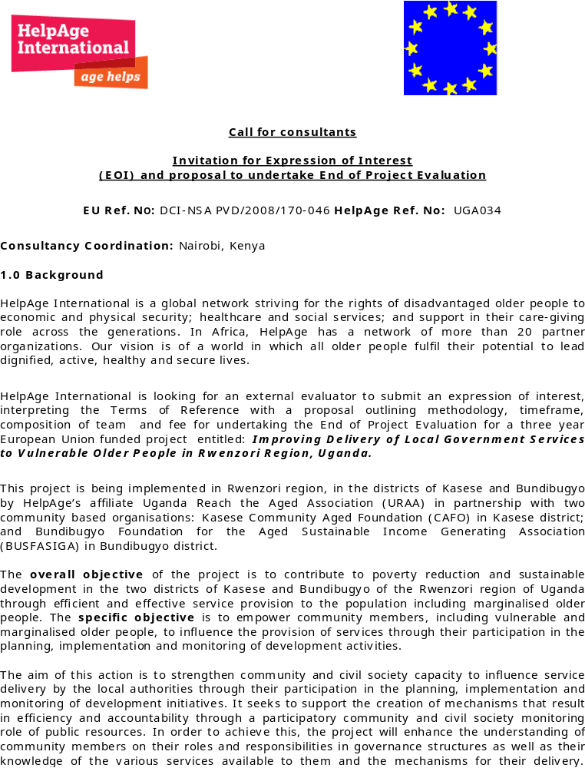Annex 11
 | Respondent's name | Age | G\ender | Telephone contact | County | Sub-county
1 | Jostina Kabonesa | 82 | F |  | Busongora North | Bugoye
2 | Nyangeno Yesinta | 82 | F |  | Busongora North | Bugoye
3 | Lazaro Masereka | 67 | M | 703322835 | Busongora North | Bugoye
4 | Malure Benjamin | 67 | M | 774312323 | Busongora North | Bugoye
5 | Joyce Kabadaki | 75 | F |  | Busongora North | Bugoye
6 | Jororina Itungu | 90 | F |  | Busongora South | Kilembe
7 | Dorica Byasonja | 55 | F |  | Busongora North | Bugoye
8 | Bira Lucia | 68 | F |  | Busongora North | Bugoye
9 | Zipora Biira | 56 | F |  | Busongora North | Bugoye
10 | John Khaghenda | 64 | M |  | Busongora North | Bugoye
11 | Zaverio Kihika | 68 | M |  | Busongora North | Bugoye
12 | Kalindiro Justine | 70 | F |  | Busongora North | Bugoye
13 | Bazara Rapheal | 96 | M |  | Busongora North | Bugoye
14 | Kabuho Dorisira | 55 | F |  | Busongora North | Bugoye
15 | Muhindo Ibrahim | 71 | M |  | Busongora North | Bugoye
16 | John Thabugha | 50 | M | 779823813 | Busongora North | Bugoye
17 | Kule Kalen | 53 | M | 787822215 | Busongora North | Bugoye
18 | Kevin Nyakato | 60 | F |  | Busongora South | Kilembe
19 | Maltina Kabafuma | 80 | F |  | Busongora South | Kilembe
20 | Kyakere Ivan | 98 | M | 785464718 | Busongora South | Kilembe
21 | Baluku Modesto | 40 | M | 784597241 | Busongora South | Kilembe
22 | Kabasinguzi Fabisa | 30 | M | 778464613 | Busongora South | Kilembe
23 | Masaba Were | 78 | M |  | Busongora South | Kilembe
24 | Muhindo Ajusi | 57 | M | 778420046 | Busongora South | Kilembe
25 | Kabugho Maria | 80 | F |  | Busongora South | Kilembe
26 | Tamwanzire Barnabus | 60 | M |  | Busongora | Bulembya Division
27 | Twesigye Ibrahim, | 66 | M |  | Busongora | Bulembya Division
28 | Masika Muhesi | 72 | M |  | Busongora | Bulembya Division
29 | Nyangoma Mary | 73 | F |  | Kasese municipality | Bulembe Division
30 | Edrida Biira | 75 | F |  | Kasese municipality | Bulembe Division
31 | Kabulinani Jane | 60 | F |  | Kasese municipality | Bulembya division
32 | Mukankusi Salima | 56 | F | 777184537 | Kasese municipality | Bulembya Division
33 | Kisembo Leonida | 64 | F |  | Kasese municipality | Bulembya Division
34 | Muhindo Josephine | 40 | F |  | Kasese municipality | Bugoye
35 | Malisa Biira | 80 | F |  | Kasese municipality | Bugoye
36 | Alima Kelito | 65 | F | 777169271
37 | Peregia Khabugo | 66 | F
38 | Bwambale Zakayo | 80 | M | _ | _
39 | Nabumati Edson | 56 | M |  | Busongora | Bulemya Division

Males 18 Females 21
BUNDIBUGYO
1 | Babisa Teopista |  | 60 |  | F |  | Bungendera | Ntotoro
2 | Bulungi Mitedio |  | 62 |  | F | 787213159 | Bungendera | Ntotoro
3 | Kabugo Victoria |  | 70 |  | F | 783616185 | Bungendera | Ntotoro
4 | Tibakulilyayo Federes |  | 70 |  | M |  | Bungendera | Ntotoro
5 | Alumbya John |  | 82 |  | M | 788128949 | Bungendera | Ntotoro
6 | Barimese Consolata |  | 60 |  | F | 788662288 | Bungendera | Ntotoro
7 | Ajuna Sara |  | 87 |  | F |  | Bungendera | Ntotoro
8 | Nalubweka Florence |  | 80 |  | F |  | Bungendera | Ntotoro
9 | Basemerya Andrew |  | 65 |  | M |  | Bungendera | Ntotoro
10 | Tebagwa Jackson |  | 60 |  | M | 785477611 | Bungendera | Ntotoro
11 | Manyumba Cecilia |  | 70 |  | F |  | Bugendera | Harugali
12 | Mbambu Perusi |  | 75 |  | F |  | Bugendera | Harugali
13 | Kingora Samuel |  | 67 |  | M |  | Bugendera | Harugali
14 | Mukeka Doris |  | 60 |  | M |  | Bugendera | Harugali
15 | Kasiya Biteyo |  | 90 |  | F |  | Bugendera | Harugali
16 | Kunahimbire Yonasaani |  | 67 |  | M | 781020296 | Bugendera | Harugali
17 | Musoki Yayeri |  | 62 |  | M | 783444778 | Bugendera | Harugali
18 | Nyamugamba Doris |  | 90 |  | F |  | Bugendera | Harugali
19 | Nanyumba Nehemia |  | 65 |  | M |  | Bugendera | Harugali
20 | Kahirwa Yosiya |  | 70 |  | M | 785526165 | Bugendera | Harugali
21 | Biira Edirona |  | 65 |  | F |  | Bugendera | Harugali
22 | Basambya Edireda |  | 62 |  | F |  | Bugendera | Harugali
23 | Kobusingye Jemima |  | 60 |  | F |  | Bwamba | Bundibugyo T.C.
24 | Bwambale Zakalia |  | 65 |  | M | 782215000 | Bwamba | Bundibugyo T.C.
25 | Musinguzi Yusuf | 60 |  | M |  | 773644779 | Bwamba | Bundibugyo T.C.
26 | Bahoire Joseph | 65 |  | M |  |  | Bwamba | Bundibugyo T.C.
27 | Biira Florence | 67 |  | F |  | 781649530 | Bwamba | Bundibugyo T.C.
28 | Kabagombe Consolate | 60 |  | F |  |  | Bwamba | Bundibugyo T.C.
29 | Mabiyo Bernard | 73 |  | M |  | 788128467 | Bwamba | Bundibugyo T.C.
30 | Takilingibwa Milia | 65 |  | F |  |  | Bwamba | Bundibugyo T.C.
31 | Kabonesa Veneranda | 70 |  | F |  |  | Bwamba | Bundibugyo T.C.
32 | Kaazi Evelyn | 78 |  | F |  | 782749618 | Bwamba | Bundibugyo T.C.
33 | Tinkansimire Peter | 60 |  | M |  | 788256423 | Bwamba | Bundibugyo T.C.
34 | Kabugho Hellen | 60 |  | F |  |  | Bwamba | Bundibugyo T.C.
35 | Bakika Antinina | 56 |  | F |  |  | Bwamba | Bundibugyo T.C.
36 | Nanyonga Imelda | 70 |  | F |  |  | Bwamba | Bundibugyo T.C.
37 | Butekateki Asiya | 70 |  | F |  |  | Bwamba | Bundibugyo T.C.
38 | Muganda Ignatius | 74 |  | M |  |  | Bwamba | Bundibugyo T.C.
39 | Katahbara Andrew | 72 |  | M |  | 777299467 | Bwamba | Bundibugyo T.C.
40 | Batume Onesimus | 74 |  | M |  |  | Bwamba | Bundibugyo T.C.

Males 18 Females 22
Annex 111: Household Beneficiaries Respondents:
 | BUFASIGA PARTICIPANTS
NAME | POSITION | TELEPHONE | AGE
Musoki B.Y. | Secretary for OVCSE | 772349668 | 69
Baluku Kasuka | C/M BUFASIGA | 783496738 | 76
Biira Milly | Member | 774780092 | 60
Balimese Isaac | Publicity & Mobilizer | 785527499 | 65
Kanyunyuzi Stella | Member | 789544099 | 48
Bakelwa Cornelius | CES | 782688635
Betamirwe Nsunga Isaya | General Secretary | 782592202
Kabatoro Sharon | Secretary | 788940890
 | FOCUS GROUP DISCUSSION PARTICIPANTS IN BUNDIBUGYO
NAME | AGE | SEX | DESIGNATION
Bagonza Sikahwa | 45 | M | CDO
Bwambale Asuman | 28 | M | CDO
Kamu Jim Gilbson | 30 | M | S/C chief
Kobusingye Grace | 28 | F | CDO
Balinsangayo S. | 29 | M | S/C/C
Byamukama Jonus | 27 | M | Speaker B.T.C
Masika Rebecca | 27 | F | CDO
Muhindo Frankline | 30 | M | CDO
Mugerwa B. Tibbs | 32 | M | LC III C/M
Monday Hanington | 28 | M | S/C speaker
Basiime T. Amos | 31 | M | LC III C/M
Mugisa Simon | 31 | M | S/C chief
Kwikiriza Amogon | 46 | M | S/C speaker
Musoha Simon | 35 | M | S/C NAADS
Musabe Timothy | 58 | M | Paralegal
Usime Grace | 28 | F | OCMG
Masereka Rashid | 39 | M | Spokesperson
Byesi Peter | 36 | M | OCMG
Kule Simon | 44 | M | OCMG
Kisoro Dolici | 36 | F | OCMG
Mwesige Kamath | 46 | M | Spokesperson
Wetire Francis | 39 | M | Spokesperson
Nyumayabo W. | 49 | M | Spokesperson
Biira Fatuma | 48 | F | Spokesperson
Kwikiriza Samaho | 53 | M | OCMG
Bakawerayo Andrew | 56 | M | Spokesperson
Biira Zapoora | 55 | F | Spokesperson
Soya Wilson | 56 | M | Spokesperson
Agasa M. Sowedi | 62 | M | Spokesperson

List of Participants

s.no | Name | Sex | Responsibility
1 | Baluku Benard Kidadi | Male | Paralegal
2 | Mughumbirwa Stanley | Male | ‘’
3 | Nambafu Grace | Female | ‘’
4 | Kalyabyamu Isaac | Male | ‘’
5 | Kabusinge Evelyn | Female | ‘’
6 | Balikwisa John | Male | OCMG & Spokesperson
7 | Daisy Miremba | Female | ‘’
8 | Mwahurwa Jackson | Male | Paralegal
9 | Muhindo Eric | Male | ‘’
10 | Kisembo Patrick | Male | ‘’
11 | Ndagire Prossy | Female | ‘’
12 | Muhindo Margret | ‘’ | OCMG
13 | Kiraba G | Female | Local leader
14 | Adreda Bagenda | Male | OCMG & Spokesperson
15 | Juma Alube | ,, | Local Leader
16 | Mauda Bafunze | Female | ‘’
17 | Assimwe Elly | Male | Paralegal
18 | Odjan B. Jonaliian | Female | ‘’
19 | Flora Masindi | .. | Local Leader
20 | Justus Isemusoro | Male | Beneficiary
21 | Jane Nyebaze | Female | ‘’
22 | Muhindo Verina | Female | ‘’
23 | Sabiti Gladys | Female | ‘’
24 | Tungu Kezia | Female | ‘’
25 | Herizono Sebita | Male | Beneficiary

Key Informants:
HAI-ARDC
Nesta Hatendi –CEO HAI ARDC;
Fiona Clark- Regional Program Manager;
Kihumba Roseline- Contracts Manager; and
Tewodros Amalset-Ex-Regional Manager.

HAI-CCO
Nakakande Frances Linda

URAA
Joseph Bitature Mugisha CEO
Kezia Mukasa-Program Officer
Penina Kagino- Finance and Administration Officer
Kemigisha Emily-Ex-Program Manager
Selvano Mwesigye Ag. Program Manager
Kisembo Jackeous-Field Officer Bundibugyo.

Partners:
Dr. Baluku John CAFO Coordinator
Mr. Mpakechus Hornereous-BUSGASIGA Executive Secretary

District Officials:
Kisungu Zakayo ACAO-Bundibugyo-Coordinator DCC
Mrs Agnes Sibugyo-Deputy Speaker, Member DCC Bundibugyo
Tembo Mbauta Zeribaberi Senior CDO Kasese-Chairman DCC.

NGO
Bwambale Adams Coordinator ACODEV-Member DCC

UBOS: 2009 Statistical Abstract But the total target population is for the whole district Ops not the 13 sub-counties covered by the district.
National Policy for Older Persons.
This figure needs to be validated as it appears to be over exaggerated based on the total number of beneficiaries as reported later in report.
Interim Narrative Report Year 2
EU-UG034 Zero Report.
Interim Narrative Report Year 2
Compared to 42.7% above who accessed medical services from the Hus.

