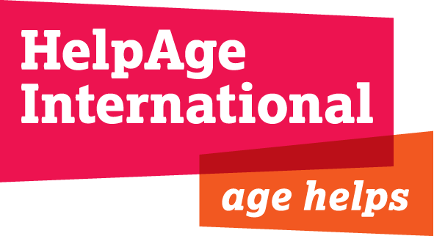
JOB DESCRIPTION
Job Title : Regional Resource Mobilisation Manager, Southern Africa
Department : Programmes
Location : Pretoria, South Africa
Responsible to : Regional Head of Programmes, Southern Africa Region
Key Relationships: Regional network members, programme teams, finance teams, global resource development team

Background:

HelpAge International is a global network of not-for-profit organisations with a vision of a world where older people fulfil their potential to lead active, dignified, healthy and secure lives. With more than 100 affiliates and 300 partners across more than 65 countries the HelpAge International network brings together hundreds of organisations worldwide. HelpAge International has a London-based secretariat and offices in Brussels, seven regional centres in East, West and Central Africa, Southern Africa, South Asia, East Asia/Pacific, Latin America, the Caribbean and Eastern Europe and Central Asia, and 15 national offices.

HelpAge International has been operational in Southern Africa since 2012, with the aim of working with, and for, vulnerable older persons to help them claim their rights, challenge discrimination and overcome poverty.

Job purpose:

To steer the growth of restricted and unrestricted income of HelpAge in Southern Africa from major multi-lateral, bilateral and private foundations by undertaking donor intelligence, providing advice and technical support to the development of high quality programmes that meet donor priorities.

Job responsibilities and key tasks:

Funding strategy and coordination

- Develop, monitor and drive the implementation of country/regional fundraising strategies, in line with the regional strategy.

- Ensure that regional and national fundraising strategies align with HelpAge’s global fundraising strategies.

- Engage and cultivate funding relations with institutional donors and other funders in the region (e.g. corporates in South Africa).

- Act as the regional focal point on funding, ensuring that all funding opportunities are shared across the region, and that communications are maintained with UK counterparts.

- Respond to the requirements of the programme work through alignment with a proposal development cycle that starts with a needs analysis and setting of objectives with the Programme team which aligns to the Regions strategic plan. Contribute as a member of HelpAge’s Global Resource Development team, sharing data, learning and experience related to fundraising.

Proposal development, reporting, contracts and systems management

- Support and encourage staff to develop clear schedules for proposal development processes which clearly indicate internal deadlines and required input for all stakeholders.

- Lead on the coordination and submission of high quality funding proposals for programmes taking place in the Sothern Africa region.

- Support the development of proposal budgets, ensuring that attention is paid to cost recovery for HelpAge and partners, and the inclusion of monitoring and learning activities.

- Ensure SAFRO programme proposals are compliant with HelpAge’s Accountability Framework procedure.

- Ensure that proposals, contracts, reporting deadlines etc. are accurately uploaded onto CMS. Keep the Head of Programmes alert to all reporting deadlines,

- Maintain all contract management documentation on London 'Everyone' Drive (proposals submitted, contracts, reports, key donor correspondence etc.)

Capacity building of national partners

- Contribute to the capacity development of partners in the region through the provision of training and support in resource mobilisation and donor compliance.

Other

- Work closely with advocacy and communication team to ensure that opportunities developed by the advocacy and communication strategy are maximised to generate new income.

- Undertake any other duties as and when necessary to fulfil the objectives of HelpAge International in the region.

Extent of Authority:

The post holder will play a key role in the diversifying HelpAge’s donor base in the Southern Africa region and will be expected to work with a high degree of initiative. The post holder will be expected to operate within all HelpAge’s policies and procedures.

Key Relationships:
Internal
- Southern Africa Regional Programmes team, Mozambique Country Director Finance and Admin Manager, and other country offices in Africa region.
- Resource Development team in London and globally.
- Liaison with relevant staff from HelpAge International in London.
- Country Age Network lead agencies/funding committees/officers

External

- Frequent liaison with external audiences, in particular with representatives of donor agencies, based in African countries.
- Direct communication with HelpAge International’s affiliates and partners in Africa on specific resource development issues.
Person Specification
Requirements | Essential | Desirable
Education, Qualifications and Knowledge | - Degree in relevant subject or equivalent work experience.  - Knowledge of development issues. Knowledge of project development
Experience | - Demonstrable experience of working with institutional donors, such as USAID/OFDA; EC/ECHO; major European government donors; UN agencies; or other major donors operating in the region.  - Experience of writing and reviewing funding applications and donor reports.  - Significant experience of representing organisations in meetings with donors, government officials and project partners.  - Demonstrable experience of training/facilitation in resource mobilisation, strategic planning, etc.  - Demonstrable experience of developing and monitoring complex donor budgets.  - Proven track record of securing funding and managing donor relationships.
Skills and Abilities | - Good analytical and research skills.  - Strong numeracy skills.  - Excellent time management skills and the ability to manage multiple and complex tasks in a deadline-focused environment.  - Excellent IT skills (Word, Excel, Microsoft Office, etc.).  - Fluent in English, with excellent written and verbal communication skills.  - Excellent interpersonal skills.  - Ability to influence and negotiate with a wide range of people and organisations, particularly donors, at all levels.  - Demonstrable cultural awareness, sensitivity and tact. | - Good working knowledge of Portuguese an advantage
Special Circumstances/Others | - Willingness to undertake travel within the Southern African region.

