World Humanitarian Summit and global population ageing
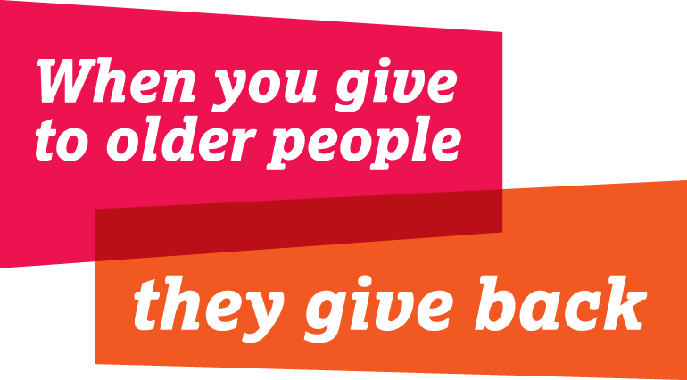
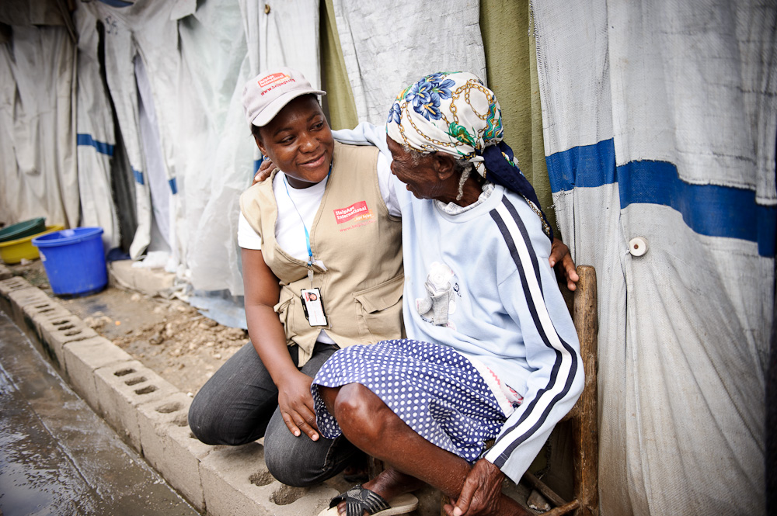

The World Humanitarian Summit presents a vital opportunity to consider the implications of global population ageing and ensure that the particular concerns of older people are included in the outcome. This briefing recommends how to include older people in three of the Summits themes: Reducing vulnerability and managing risk, Humanitarian effectiveness, and Serving the needs of people in conflict.

Reducing vulnerability and managing risk

Global population ageing presents a growing challenge to humanitarian response and preparedness.

Today, about 12.2 per cent of the world’s population is aged 60 or more (895 million people). In just four years’ time, the number of older people will surpass 1 billion. By 2050, there will be 2 billion older people, accounting for more than one-fifth of the global population.

By 2050, there will be nearly as many people aged 60 or over than children under 15.

Currently, two-thirds of older people live in developing countries, where disasters are more likely to occur and the effect to be greater. By 2050, this will be almost four-fifths.

Demographic changes demand that humanitarian assistance is adapted to the specific needs and risks of older people, particularly in the areas of health, nutrition and disaster risk management.

The overall efficiency and effectiveness of humanitarian operations is undermined by the exclusion of older people from programming in these areas. This may constitute a breach of the principle of impartiality.

Health interventions must address non-communicable diseases (NCDs).
- Research in Jordan and Lebanon found that 54 per cent of older refugees were affected by one or more NCDs, and 65 per cent showed signs of psychological distress. Interruptions in treatment for NCDs can prove fatal. The medical charity, MSF, has identified Syrian refugees affected by NCDs as the silent casualties of war – those dying from manageable diseases.

Nutrition interventions must include older people in assessments and response.
- HelpAge nutrition assessments in Dadaab refugee camp in Kenya, Chad and Ethiopia all found significant levels of malnutrition among older people, but no prior assessment of need or response activities.

Disaster risk management policy and practice must protect older people in crisis.
- During Hurricane Katrina in 2005, 75 per cent of those who died were aged over 60, although this age group only made up 16 per cent of the local population. In the Japanese tsunami of 2011, 56 per cent of those who died were aged 65, although this age group comprised just 23 per cent of the population.

Financing mechanisms must include older people.
Current humanitarian financing mechanisms are inadequate to provide the resources to address the needs of older people and other vulnerable marginalised groups.

- Three consecutive studies carried out by HelpAge International covering the period from 2010-2012, found that in 2010-2011, fewer than 1 per cent of projects included activities targeting older people and only 0.3 per cent were funded. In 2012, the proportion targeting older people had risen slightly to 2.1 per cent and the proportion funded to 1 per cent.

Humanitarian effectiveness
Meaningful participation of all affected populations, including older men and women must begin with a systematic assessment of their needs and capacities.
- Impartial, inclusive needs assessments must inform the design, targeting and delivery of assistance. Assessments must include:
  - Consultation and participation of older men and women
  - Collection, analysis and use of sex- and age-disaggregated data to support the design of accessible and appropriate response
- Older people have skills and capacities to support response delivery. Older people’s associations, established with support from HelpAge, provide a replicable model of community response that has proved successful in supporting needs assessments, distributions, psychosocial support and monitoring in contexts including DRC, Ethiopia, Gaza, Haiti, the Philippines and Sudan.
- Humanitarian standards such as Sphere provide little technical detail to address the needs of older men and women. HelpAge is leading a consortium of agencies developing minimum standards for gender sensitive age and disability programming that, when applied, will significantly contribute to programme quality and effectiveness.

Serving the needs of people in conflict
In armed conflicts, older people face a range of risks:
- Exclusion and discrimination linked to the impartiality of assistance
- Erosion of family and traditional support systems on which many older people rely to access services and meet their basic needs
- Access to information and documentation from which older people are often excluded due to challenges in understanding registration systems or written communications
- Limited access to basic services, including shelter, food and nutrition, livelihoods and recovery, and health as outlined above.
In Darfur in 2004, when huge numbers of people fled to urban centres, numerous older people reportedly arrived in IDP camps alone, having been separated from their families during the journey, or simply having stopped or been abandoned along the route due to physical exhaustion. Those arriving later also risk being excluded from registration and access to assistance.
Older people’s rights are protected in a general sense under existing international human rights treaties, humanitarian law, the Geneva Conventions and 1998 Guiding Principles on Internal Displacement.
Reaffirmation of these principles and laws must include recognition of their role in identify and protecting the most vulnerable, including older men and women.

Copyright © HelpAge International 2015
HelpAge International
PO Box 70156
London WC1A 9GB, UK
3rd Floor, Tavis House
1-6 Tavistock Square
London WC1H 9NA, UK
info@helpage.org
www.helpage.org

UNDESA Population Division, World population prospects: the 2012 revision, DVD edition, 2013
UNDESA Population Division, World population prospects
UNDESA Population Division, World population prospects
UNDESA Population Division, World population prospects
. HelpAge International and Handicap International, Hidden victims of the Syria crisis: disabled, injured and older refugees, 2014
. Humanitarian crisis grows, www.msf.ca/en/article/humanitarian-crisis-grows (25 February 2015)
. Fritsch P, Nutrition and baseline survey of older people in three refugee camps in Dadaab, October 2011, HelpAge International, 2011
. Fritsch P, Nutrition and baseline survey of older people in Haraze Albiar, Chad, June 2012, HelpAge International, 2012
. Fritsch P, Needs assessment survey of older people in Kolfe Keranyio, Addis Ababa, February 2014, HelpAge International, 2014
. HelpAge International and Handicap International, A study of humanitarian financing for older people and people with disability, 2010-2011, 2012
. Delgado A, Skinner M and Calvi P, Disasters and diversity: humanitarian financing for older people and children under five, HelpAge International, 2013 Wells J, The neglected generation: the impact of internal displacement on older people, HelpAge International, 2012, pp. 20-32 Wells J, The neglected generation, p. 19

