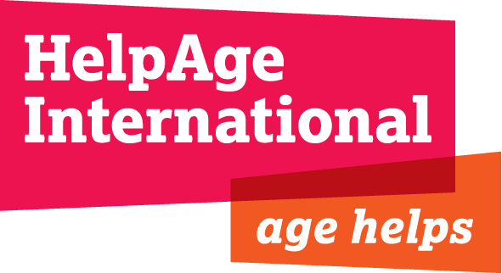
Using case studies and photos from the HelpAge Internal Image Library

We believe that Age makes a difference. The experience. The expertise. With age comes a deep understanding of the way things were, the way they are, and the way they could be. The contribution older people make to society is invaluable.

Therefore, our case studies and photographs aim to show older people in a positive way, in line with the United Nations Principles for Older Persons, which set out older people’s right to independence, dignity, care, self-fulfillment and participation. Images and case studies from HelpAge International are provided on the following basis:

Use of images, case studies and captions
Images should be used in accordance with the UN Principles and the European NGOs’ code of conduct on images and messages in an interdependent world, which we are obliged to follow. These emphasise the importance of respecting people’s dignity and choosing images based on values of respect equality, solidarity and justice. We also require that you avoid images and messages that potentially stereotype, sensationalise or discriminate against people, situations or places. Please get in touch if you have any queries.

Photos should be used accurately e.g. a photo from one country should not be used to represent another country. Captions, where provided, may be altered, so long as they remain accurate.

Protection of programme participants
We require people, to whom we lend our photos and case studies, to remove identifying features to protect identities. Hence, you must refrain from providing full names when providing detailed geographical information (beyond country names). When there are sensitive issues involved (e.g. HIV and AIDS, abuse, insecure political situation in the country) names must be changed to other culturally appropriate ones.

To comply with UK and International law, names of children (anyone below 18) must always be removed or changed.

Disclaimers
If a different name is used or you have used a case study of one person and a photograph of another, you must make this clear e.g. at the beginning or end write: Some names and details may have been changed to protect identities.

Credits
Please ensure that images are credited as shown (usually Photographer’s name/HelpAge International). Credits should appear next to the image concerned, unless the image is on the front page of a publication, when the credit may appear on the inside front or back page. ‘Alt text’ may be used for credits on the web (so the credit shows when the mouse is over the image).

Copyright
Please note that the copyright belongs to HelpAge, unless otherwise stated. Organisations borrowing images and case studies from HelpAge International do not have permission to lend on. Images may not be used for profit, or in any way that would disparage, discredit, embarrass or cause concern to the people photographed or to HelpAge International.

Period of use
Do not use images that are more than five years old.

Copy of materials
You are required to send us a printed copy or web link to materials in which photos have been used.

By accepting the above guidelines you will be formally obliged to follow them.
More information
Dama Sathianathan
HelpAge International, 3rd Floor, Tavis House, 1-6 Tavistock Square, WC1H 9NA, U.K.
Tel: +44 (0)20 7278 7628, Email: dama.sathianathan@helpage.org

