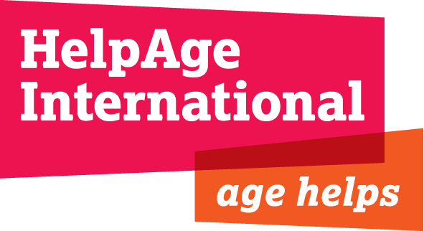

Terms of Reference

Review of affiliate partnership and investment models

- Summary

HelpAge International’s work is broadened and strengthened through its global network of affiliated organisations. Over the past six years, HelpAge has worked more closely with, and invested in, a small number of its affiliates, with one of the primary objectives being to diversify and generate new income streams for HelpAge’s programmes. These relationships have been formalised through individual partnerships agreements, some of which will expire at the end of 2013. The purpose of this consultancy is to review the successes and challenges of these partnerships, specifically with regards to the fundraising objective. One of the key outputs will be an assessment of value for money and cost effectiveness of the partnerships and recommendations for a more consistent and transparent investment model(s).

- Background

Partnership agreements have been signed between HelpAge and five independent organisations (affiliates) in the HelpAge network: HelpAge Deutschland; HelpAge España; WorldGranny (The Netherlands); HelpAge USA and HelpAge Korea. For some, HelpAge was instrumental in their formation/strengthening, for example, the establishment of HelpAge International España as a new entity in 2009, which now has its own Board and staff. As well as being important partners in the implementation of HelpAge’s policy and programme activities, these organisations are able to facilitate invaluable fundraising opportunities from public and private funding sources and from institutional funders that are often inaccessible to HelpAge directly.

Partnership agreements, setting out the terms of the relationship, vary from affiliate to affiliate. The agreements cover contributions to HelpAge’s advocacy and influencing objectives as well as fundraising. Financial investment arrangements which are attached to these partnership agreements also vary – they can take the form of a loan or a grant and are linked directly to financial targets and return on investment. Each partner agreement has a different approach, in part due to the different types of opportunities available in-country and the level of capacity of the affiliate.

Although not an explicit objective of the partnership agreements and associated investments, the financial sustainability of affiliates is fundamental to the approach adopted by HelpAge. If and how HelpAge’s partnership and investment has contributed to the sustainability of individual affiliates has yet to be determined.

It is important to note that, to date, HelpAge has used its unrestricted funds for investment into affiliates, which in return has primarily generated restricted income for projects, and income to cover overhead costs related to projects is often shared with the affiliate; usually on a 50:50 basis.

More recently HelpAge has invested separately in joint fundraising initiatives with three of these affiliates in order to establish new income streams, i.e. from the general public; these new partnerships are governed by separate agreements and, although these will not be the subject of this detailed review, they will need to be taken into account and could influence recommendations.

This review will be focussed on three partnerships: HelpAge Deutschland, HelpAge USA and WorldGranny; learnings and recommendations from this process will inform and shape other partnership agreements.

- Objectives

Although a review of progress and achievements in other areas covered by the partnership agreements will form part of this evaluation, the primary purpose of this consultancy is to focus on the financial return on investment.

The review will cover:

- An assessment of key, non-financial (e.g. policy and public awareness) achievements and highlights during the lifetime of the formal partnerships. This should include an assessment of their links to/added value with respect to fundraising.
- An analysis of the history, growth and development of each affiliate, noting the impact that HelpAge investment may have had on their evolution and sustainability.
- Assessment of the resources and capacity of affiliates to deliver objectives.
- Comment on the funding environment and context the affiliates are operating in.
- Key challenges in meeting the objectives of the partnerships.
- Financial return on HelpAge’s investment to both organisations.
- The pros and cons of the different investment models.
- Comparative approaches used by other organisations to generate income.
- Examples of investment models used by other similar (affiliated/federated) NGOs.
- Recommendations on future, cost effective and affordable investment models, taking into account the use of/opportunity costs related to HelpAge’s unrestricted funds.

- Process

The process for fulfilling this consultancy will include:

- Review of all partnership agreements, previous evaluations and other relevant documents.
- Review of relevant financial information.
- Interviews/meetings with relevant staff in affiliate organisations and staff in relevant HelpAge teams.
- Visit to one European affiliate.
- Interviews with other organisations that employ similar approaches to fundraising (e.g. through a federal structure, memberships, partnerships).
- Production of a report including executive summary (maximum 15 pages) with findings and clear recommendations that will inform future partnership arrangements (including presentation of draft report to and discussion with HelpAge Directors)

- Timescale

- 12 days including report production.
- Draft report circulated and reviewed by mid September 2013.
- Report and consultancy finalised by 1st October 2013.

- Consult specification

The consultant will be expected to have:

- Relevant experience of fundraising for international development.
- Experience of working with/capacity building of partner organisations.
- Knowledge of organisations that generate funds via an affiliated/federated structure.
- A broad understanding of value for money and cost effective approaches to resource mobilisation.

