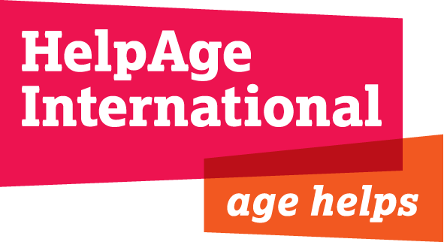

Corporate annual plan to March 2014

APPROVED MARCH 2013

Our vision and mission
Our vision is a world in which all older people fulfil their potential to lead dignified, active, healthy and secure lives.
We work with our partners to ensure that people everywhere understand how much older people contribute to society and that they must enjoy their right to healthcare, social services and economic and physical security.

Contents
Executive summary 3
Introduction 5
Priorities for our work this year 6
Achieving our Strategy to 2015 8
Global action 1: Enabling older men and women to have a secure income 8
Global action 2: Enabling older women and men and those they support to receive quality health, HIV and care services 12
Global action 3: Enabling older men and women to actively participate in, and be better supported during, emergency and recovery situations 16
Global action 4: Building global and local movements that enable older people to challenge discrimination and claim their rights 20
Global action 5: Supporting a growing global network of organisations to improve their work with and for older women and men 24
Our capacity to deliver 28
Financial summary 30

HelpAge International
PO Box 70156
London WC1A 9GB, UK
Tel: +44 (0)20 7278 7778
Fax: +44 (0)20 7387 6992
www.helpage.org
info@helpage.org

Registered charity no. 288180

Copyright © April 2013 HelpAge International

Executive summary
The launch and wide media coverage of our joint report with the United Nations Population Fund, Ageing in the Twenty First Century: A Celebration and A Challenge, and our new Global AgeWatch monitoring tool both created major opportunities to advance the issue of population ageing during the past year. Coupled with many successes in our country programmes and our national, regional and global influencing during 2012-2013, HelpAge and the global network have much to capitalise on in 2013-2014.
With consultations on the post-2015 development agenda underway, recognition by the UN that ageing must be a key feature of the development landscape will provide essential support for our work. It is important to mobilise our network, which now has 101 Affiliates and at least 200 partners, and our national programmes to work together to maximise our impact on this agenda. Seeing older people recognised in the development framework that follows the Millennium Development Goals is essential. This year, we will ask our Affiliates to support us in finalising a network development plan to 2015 to support this agenda and help build our next Strategy for 2015 to 2020.
Focused national and global campaigning and messaging is also essential. Alongside campaigning on the post-2015 development agenda, we aim to see the UN Open-ended Working Group on Ageing agree to establish a drafting committee for a new convention, both of which require concerted efforts by the network to influence governments and civil society. We will be working to influence regional legislation on ageing in Latin America and Africa, and we also plan to increase our submissions on violations of older people’s rights to UN treaty bodies and the UN Special Rapporteur on extreme poverty and human rights. National Age Demands Action campaigns and events on World Health Day on hypertension will continue to raise awareness of the impact that poor access to services, poor nutrition and lack of essential drugs have on the lives of older people. Finally, we will be launching HelpAge’s Global AgeWatch Index which will monitor the economic and social wellbeing of older people globally.
There are challenges to be faced for us to achieve our goals – we are starting the year with an income projection on par with 2012-2013, due to the end of a number of major grants and our management of the ACAPS project, and lower income from emergency programmes. The institutional funding market has become more competitive and the financial crises in many Organisation for Economic Co-operation and Development (OECD) countries continues to affect public fundraising. In response, we will work to increase our consortia bids, research donor opportunities outside of the UK and Europe and continue to invest in public or corporate fundraising with our Affiliates in Germany, Korea, the Netherlands, UK, and USA. We will also be launching our new UNJUST campaign to raise awareness on ageing and help our public fundraising.
Despite this, we remain ambitious. Our community-based work – particularly in fragile contexts – continues to expand. We are now seeing growth in service delivery activities, in older citizen’s monitoring work, and in Age Demands Action campaigns. We will be working to build the skills and confidence of older people to represent themselves in local and national campaigning and influencing. Activities with older women have always featured highly in our work, but we need better effort to follow through with our gender analysis. We are investing in both internal and external reviews of our gender work and will complete our guidelines for improvement.
We are sustaining strong momentum in our work to secure better incomes for older people, focusing on new pensions in eight countries and better access to pensions or age-related benefits in a further nine countries next year. We predict that 2.7 million more older people will access such support in the coming year. A global review of our social protection work will be completed. It will examine the impact of our work to date and guide us on more effective practice for the future. We have an important opportunity to promote the importance of social protection for older people through a joint report with the World Bank, Social pensions at a glance.
Our work to support resilient or “climate-smart” development is increasing in every region and integrates disaster risk reduction training and practice. While our focus is often on rural older people, there are also activities in East Africa and South Asia to directly support older people in urban situations. An objective this year will be to build our knowledge of the impact of price volatility, access to land, water and energy as key hazards to older people’s livelihoods. We will be working with other organisations to understand how we can measure the effectiveness of our resilience work better.
A review of our health and care work in five countries in 2012-2013 recognised that our work is most effective when interventions seek to build the skills and attitudes of service providers (particularly government staff), help older people access services, and when we help older people “function” better – for example, through better nutrition, eyecare services or regular pain relief, and provide psychosocial care and social or recreational activities. This year, activities will increase in these areas across all regions, with notably more delivery of eyecare services and a growing body of work on mental health. Direct health service delivery is most prominent in fragile contexts, for example in DR Congo, Ethiopia, Haiti and Myanmar, and also in India and Sri Lanka. Supporting care continues to be a key activity in 16 countries. However, this work remains challenging to fund.
The “ageing” of the HIV epidemic is becoming clear as those infected and affected by HIV grow older. Our work will focus on ensuring that HIV and AIDS service providers are trained and supported to deliver in an age-friendly manner. We will strengthen our advocacy interventions at country level to help older people demand better access to relevant prevention, testing, counselling and health services.
As we start the year, nine countries are delivering emergency response and recovery programmes, and we continue to build the capacity of our network and other agencies to plan and deliver better responses. We now have two important new tools to use in our work – our ALERT scenario planning model and our Help Older People in Emergencies (HOPE) training course – both of which have attracted interest from other humanitarian agencies. New best practice guidelines and research in emergencies will be produced, on eight key topics. We will review our work with older people’s associations in emergencies to understand how we may enhance their capacities both during and beyond a crisis. We will be working to ensure the better inclusion of older people in the emergency programmes of 24 key humanitarian actors at headquarters and field level, and we will continue our engagements with the UK Department for International Development (DFID) and the European Commission’s Humanitarian Aid department (ECHO) to improve their policies.
We continue to review our operational models: this year, we will cover our programmes in the Caribbean, Eastern Europe and Central Asia (now including the Eastern Europe and Russia programmes from Age International), and Latin America. We are working on nationalising our operations in a number of countries, with Cambodia at the forefront. We are continuing the process of decentralisation, investing further in expertise at field level. We are restructuring our Programmes team in London, reducing its geographical focus and moving to staff with more specific technical roles. Initiatives to improve the quality and effectiveness of our work continue and we will upgrade our information management and IT structures which are constraining our work in some areas.

Introduction
The implementation of our Strategy to 2015 is informed by the situation of older people, especially in the developing world, and the changes in the political, economic and social environment in which they live. The development of the humanitarian and development agenda to include and respond to the issues older people face is central to our work and operation. Many of these issues remain the same as in previous years:
- Overall insufficient attention to an ageing world and the understanding of the impact of ageing dynamics.
- The increasing negative effects on income of inflation in food and fuel prices.
- The lack of access to basic and geriatric healthcare.
- The ageing of HIV and AIDS.
- Climate change and the increasing impact and frequency of disasters.
- Poor social and economic exclusion and denial of the rights of older people.
There are some key external issues that are both opportunities and challenges for us. We shall monitor and respond to these issues:
- The impact of debt and domestic priorities for most member countries of the Organisation for Economic Co-operation and Development (OECD) and its potential impact on aid commitments.
- Increasing calls for international aid to be transparent, accountable and demonstrate effectiveness.
Our five-year strategy to 2015 has set HelpAge on an exciting and ambitious course. We are planning to implement and/or fund programmes in almost 40 countries, and our international campaigning work will continue to focus on strengthening our partnerships in 65 countries under the Age Demands Action campaign and building new global campaigns. We will continue to use the opportunities provided by global, regional and national events to promote the issues of older people.
This annual plan and budget for 2013-2014 captures our targets and operational priorities for the year. We are continuing to use our corporate output and outcome indicators – which are cumulative measurements from April 2011 – to demonstrate the progress we intend to make during the year. We will also outline the programme and operational priorities that we will monitor throughout the coming year.
Our work in 2013-2014 will continue to reflect a number of key multi-year priorities:
- Developing a strong global and local advocacy programme to increase our public position and support our policy agenda and our call for a convention on the rights of older people.
- Growth of our work in fragile states and countries experiencing complex political emergencies – we are working in 14 such countries this year.
- Continuing to expand the outreach of our direct service provision to people in old age.
- Changing our role in middle-income countries – becoming more focused as a “knowledge broker” and an influencing focused organisation.
- Strengthening our accountability, results and performance.
- Continuing to secure and diversify our funding and achieve moderate income growth that is balanced between restricted and flexible funding.
- Continuing to be cost efficient with a sustainable and appropriate infrastructure to support our operations.

Priorities for our work this year
This year, we are implementing almost 250 programmes and projects across the world with more than 200 partners. The specific changes we are targeting are outlined under the corporate indicator tables by each global action, but we will prioritise:
Increasing the visibility of global ageing
- Building on the success of the Ageing in Twenty-First Century report by launching an annual themed report linked to the Global AgeWatch index on 1 October.
- Securing ageing in the post-2015 development agenda.
- Creation of a global age programme with key UN agencies to achieve more policy impact and action in developing countries over the next 10 years.
- Developing consistent messaging and strategies between our policy, influencing and advocacy work in a number of key areas (i.e. policy messaging that is both technically sound and public facing).
Developing our programme and policy work
- Growing our social protection work at national and international level and through our accountability expertise.
- Deepening the impact of our humanitarian work, both in our own responses and through influencing and training of other agencies.
- Developing our health and care programme portfolio globally and maintaining a significant capacity to address the ageing of HIV and AIDS in Africa.
- Developing an organisational resilience framework, addressing the vulnerabilities of older people to disaster and climate change, and linking this to our work in securing incomes, health, emergency preparedness and rights.
- Working consistently on age and gender analysis in programme design and implementation.
Increasing our leverage and impact in weak and failing states
- Strong business cases are in place for such countries that are leveraging our core funds to grow our impact and reach, including working in consortia.
- Launch our UNJUST fundraising and advocacy campaign on emergencies to raise support for work in the most marginalised and fragile states.
Stronger local and global movements of older people seeking social justice and better protection of their rights
- Expanding our campaigns to 65 countries with two targeted Age Demands Action campaign actions each year in addition to 1 October events.
- Strengthening local movements of older people and Age Demands Action activists to improve their advocacy in co-ordinated national and global actions, so a further 2 million older people benefit from new or improved policies.
Strengthen the HelpAge International network
- Strengthening the network profile in targeted regions and continuing to grow our number of Affiliates and sisters, targeting organisations working on human rights, gender, disability, health and decent work.
- Improving network learning and sharing, advocacy and campaign activities and fundraising capacity.
- Working with our Affiliates to create a new strategy for HelpAge and the network for 2015-2020.
Ensure a step change in our evidence base and further strengthen our accountability approaches and systems - focussing on:
- Generating clearer standard operating procedures and management standards for core functions in our programmes.
- Improving internal communication and organisational information management systems and further developing a culture of sharing our experiences across the organisation.
- Strengthening our ability to measure the impact our work has on political decisions and government policy and programmes that benefit older people.
- Enhancing the public transparency of our work, in line with the International Accountability and Transparency Initiative by April 2014, focusing on publishing information on our externally funded grants.
Increase our unrestricted and flexible funding base
- Strategic engagement with at least two bilateral donors that have the potential to provide strategic funding.
- Increasing income from less traditional or alternative funding sources, e.g. through selling of services and developing funding relationships with at least two corporates to generate new types of funding and support.
- Strategic investment to ensure that our public fundraising in non-UK markets will deliver sustained and long-term unrestricted income.
- Building sustainable models for our work in middle-income contexts.
- Developing a number of major global programmes and marketing these.
Invest in our front line staff to ensure we have the best people, well equipped and supported to achieve our mission
- Investing in our people through leadership development for country directors and implementing other initiatives to ensure we attract and retain talent.

Achieving our Strategy to 2015

Global action 1: Enabling older men and women to have a secure income
Our vision is for all older people in developing countries to have a secure income.
The reality is that the lack of a secure income is one of the biggest problems facing older people. Half the world’s older people do not have a secure income, and fewer than one in five people over 60 receive a pension. The majority of the world’s older people live in developing countries and have little accumulated savings to help them in their older age. They have to work well into their older age, often in insecure, low-paid jobs. Unless action is taken to improve the situation, we estimate that by 2050, more than 1.2 billion older people will lack a secure income.
What are our aims?
We think the best way of achieving income security in older age is for governments to provide universal, social (non-contributory) pensions and to provide support in helping them remain economically active.
How are we doing this?
Making the case for income security in older age to governments, donors, regional bodies and the UN, with a special focus on social pensions.
Providing technical training and support to governments to improve existing social pensions.
Helping civil society and older people to lobby for new or improved pensions and cash transfers and monitor the delivery of existing ones at national and international levels.
Building and sharing evidence on the design, implementation and impact of social pensions.
Providing practical support to older people to access existing cash transfers.
Improving older people’s incomes by providing income-generating and rural development activities, vocational and business training and working with them to mitigate the impact of a changing environment.
Developing models of resilience to shocks, climate change and natural disasters.
In 2013-2014 we are prioritising:
- Investing further effort in developing social protection schemes and practice on social accountability, especially in fragile states.
- Expanding our work to protect older people’s livelihoods from shock, seasonal poverty and the impact of natural disasters and climate change.
- Increasing the availability of information and evidence on social pensions.
- Implementing programming, research and advocacy using our new livelihoods and resilience models for older people, and developing a clearer organisational resilience framework and measurement tools to improve the effectiveness of this work.
Table 1 below monitors the cumulative outcomes of our work in Global action 1 over the life of our strategy. Further to this, we have outlined key activities which will contribute to achieving our targets and will strengthen the effectiveness and quality of our work as a network in 2013-2014.

Table 1: Our targets for securing incomes for older people by March 2014

Strategy to 2015 indicator | Output and outcome indicators | Actuals at March 2012 | Predicted by March 2013 | Target by March 2014 | Changes for 2013-2014
We will enable older men and women to access a secure income
20 per cent more older men and women in 30 low- and middle-income countries are receiving state non-contributory pensions or benefits | Number of countries where HelpAge provides technical assistance to governments on social protection (pensions or benefits) | 21 countries | 24 countries | 26 countries | New or continuing initiatives to be developed in Bangladesh, Nepal, Pakistan and Sudan.
 | Coverage and value of new or improved social protection schemes (pensions or benefits) | £596 million more per annum to 2.5 million older people achieved | £831 million more per annum to 4.8 million older people estimated | £1 billion more per annum to 7.3 million older people estimated | £220 million more committed for 2.4 million more older people. New or improved social pension or social transfers are predicted in Kenya, Peru, Tanzania and Thailand.
Households with older men and women experience sustained improvements in their income and food security in 25 countries | Number of older people’s associations (OPAs) involved in income-generating work | 3,950 OPAs including 90,000 members | 4,100 OPAs including 133,000 members | 4,450 OPAs including 144,000 members | 350 new OPAs supported in 20 countries, with largest growth in Myanmar and Vietnam.
 | Number of older people working to reduce shocks (disaster risk reduction, seasonal poverty, drought and so on) | 122,000 older people | 140,000 older people | 160,000 older people | 20,000 more older people supported in 15 countries, notably Cambodia, Colombia, Ethiopia, Jamaica, Myanmar, Nepal, and Pakistan.
 | Number of older people getting new access to financial services | 52,000 older people | 88,000 older people | 95,000 older people | Significant programming will continue in 15 countries. A further 7,000 older people will be supported in micro-finance schemes.

By March 2014, our work to achieve our targets in social protection (pensions and cash transfers) will include:
- Working on the introduction of new schemes in eight countries – Cambodia, Colombia, Ethiopia, Kenya, Myanmar, Pakistan, Sudan and Tanzania.
- Continuing our direct work for improvements to existing social pension and cash transfer schemes with Affiliates and partners in nine countries – Bangladesh, Bolivia, Jamaica, Kyrgyzstan, Moldova, Mozambique, Nepal, Tajikistan and Uganda – primarily through technical assistance to government, campaigning and older citizen monitoring programmes.
- Supporting our Affiliates and partners to lead civil society action for better schemes in ten countries – Belize, Dominica, Ecuador, India, Paraguay, Peru, the Philippines, Sri Lanka, Thailand and Vietnam.
- Researching the feasibility of social pension schemes in at least four countries – Bangladesh, Kenya, Mozambique and Myanmar.
- Conducting national studies or reviews on social pensions and cash transfer schemes in Ethiopia, Tanzania and Thailand, and situational analyses in Colombia, Moldova, Tajikistan and Zimbabwe.
- Building our global information and resources on social pensions on Pension watch, introducing the publication published with the World Bank, Social pensions at a glance, and new Pension watch briefs for at least two countries.
- Improving the content of our global social transfers course and developing a new social pension course with the World Bank.
- Improving awareness and technical knowledge of key international and regional development actors including the Social Protection Inter-Agency Cooperation Board, the World Economic Forum, the African Union, the Southern Africa Development Community, the East African Community, the Association of Southeast Asian Nations (ASEAN) Secretariat, the International Labour Organization (ILO) and the Ibero-American Social Security Organisation.
- Convening regional conferences on social pensions in both East Asia and Latin America.
- Building our partnerships with the researchers and opinion-makers who participated in our international income security conference in 2012, including the World Bank, bilateral donors and the ILO.
By March 2014, our work to achieve our targets in securing older people’s livelihoods will include:
- Increasing our direct income-generating activities to include 350 new older people’s associations in 20 countries, with the majority of activity providing micro-credit or savings and loans schemes.
- A growth in the number of programmes supporting resilient or “climate-smart” rural development activities and integrating disaster risk reduction training and practices – Bangladesh, Cambodia, DR Congo, Ethiopia, Indonesia, Jamaica, Kenya, Myanmar and Uganda, and potentially, Burkina Faso and South Sudan.
- Continuing our programming on supporting older smallholder farmers in Jamaica, India, Mozambique and Zimbabwe and focusing on improving farming techniques, access to markets, commercial negotiation skills and access to government livelihood programmes. We will be reviewing whether this work is effectively including interventions related to resilience and sustainability.
- Focusing advocacy initiatives with governments on better age-friendly micro-finance services and livelihood programmes in India, Mozambique, the occupied Palestinian territories, Sri Lanka and Sudan.
- Producing a number of contextually relevant studies, learning materials and good practice guides including on the themes of:
- Age-friendly food security and livelihood experiences in East, West and Central Africa
- A scoping study on the urban livelihoods of older people in eastern Africa
- The support options for households having family members with HIV and AIDS in Africa
- The vulnerability of older people to exploitative informal credit services in Mozambique
- The livelihoods of rural-based older people in Myanmar and Pakistan
- An effectiveness review of older people and self-help groups in Myanmar and Vietnam
Learning objectives in our programming
- Finalising our Global review of advocacy on social protection (a programme effectiveness review) and a study on evidence to demonstrate the impact of social pensions and cash transfers.
- Reviewing the coherence between our policy messaging, campaigning and Affiliate/partner training on older people’s rights to economic security and social protection. In particular, whether our community-based work on older citizens monitoring is linking effectively to national influencing actions.
- Examining the role our work on grievance mechanisms plays in our wider promotion of social accountability.
- Increasing our understanding of the role of commercial insurance in risk reduction, for example catastrophe assessment scoring to assess insurance risks, micro-insurance and its relationship with our work on the right to social protection.
- Linked to our work on resilience, studying food price volatility, access to land, water and energy as key hazards to older people’s livelihoods and its relationship with disasters and long term climate change.
- Producing case studies on livelihoods in the context of urbanisation and migration.

Global action 2: Enabling older women and men and those they support to receive quality health, HIV and care services
Our vision is for older people to receive good, quality health and care services, and to be included in the response to HIV and AIDS, whether they are at risk of infection, living with HIV or in their role as carers.
The reality is that older people in developing countries still have limited access to age-appropriate health, HIV and care services. Governments still fail to invest in training geriatric and specialist health workers or in the infrastructure that could benefit older people’s health and care. Few governments are responding to the needs of an ageing population, and most fail to build services to prevent and treat chronic, non-communicable diseases (NCDs) such as heart disease, stroke, diabetes, Alzheimer’s disease and other dementias.
This investment is made all the more important by the increasing responsibility for care taken on by older people. For example, older people care for spouses or other family members who are sick, or for grandchildren whose parents either have migrated for work, are ill, or have died because of conflict, AIDS or other illnesses.
What are our aims?
We want to convince policy-makers to include older people explicitly in key policies, strategies, commitments and programmes that respond to health, care and HIV and AIDS, and to persuade them that population ageing has pressing implications for health systems, the delivery of healthcare and its financing.
How are we doing this?
Delivering health, HIV and care services to older people and those in their care.
Training health, HIV and care service providers to deliver better services for older people.
Lobbying for change in government policy and practice to recognise, finance and implement responses to older people’s health, HIV and care issues.
Raising the awareness of international and regional policy-makers on older people’s issues.
In 2013-2014 we are prioritising:
- Growing our health service delivery programming, focusing on better access to appropriate services, nutrition, HIV prevention and treatment and community, home and self-care initiatives. Training of low and mid-level health professionals and volunteers is a significant aspect of this work.
- Building our expertise on NCDs, focusing on improving functionality and quality of life in older age, by implementing new technical work, building our technical capacities and continuing our advocacy.
- Running Age Demands Action campaigns on World Health Day 2013 to advocate for government and World Health Organization (WHO) action on supporting healthy ageing and service provision for NCDs.
- Building quality evidence for WHO consultations on ageing and health in Africa and in preparation for the WHO World Health Report 2014 focusing on this issue.
Table 2 below monitors the cumulative outcomes of our work in Gobal action 2 over the life of our strategy. Further to this, we have outlined key activities which will contribute to achieving our targets and will strengthen the effectiveness and quality of our work as a network in 2013-2014.
Table 2: Our targets for health, HIV and care by March 2014
Strategy to 2015 indicator |  | Output and outcome indicators | Actuals at March 2012 | Predicted by March 2013 | Target by March 2014 | Changes for 2013-2014
We will enable older men and women and those they support to access quality health, HIV and AIDS and care services
Older men and women in 15 countries can prevent and manage chronic illness | Number of countries providing new geriatric/non-communicable diseases training for its health professionals |  | 11 countries | 18 countries | 18 countries | Focus will be on curriculum development and government health staff training initiatives, including new initiatives in seven countries: China, Bangladesh, Ethiopia, Kenya, Myanmar, Sudan and Vietnam.
Older men and women in 20 countries receive guaranteed free access to age-friendly health services | Number of older people reporting increased access to health services |  | 409,000 older people | 580,000 older people | 710,000 older people | 130,000 more older people accessing government health services or supported by direct programming. Growth is planned in 15 countries, with further significant growth in Tanzania.
Older men and women in 12 countries receive appropriate HIV and AIDS services | Number of governments increasing access to antiretroviral treatment or support services for older people and family members living with HIV |  | 5 countries | 6 countries | 6 countries | Work to advance access to government programmes in Uganda. Focus remains on strengthening access to government HIV and health services in our focus countries in Africa.
Older men and women receive a range of appropriate primary healthcare services in 25 countries | Total numbers of older people receiving improved access to community-based care |  | 54,000 older people | 95,000 older people | 120,000 older people | Significant programmes on community care implemented in 15 countries. High levels of growth in programming planned in DR Congo, Colombia, Haiti and Tanzania
 | Number of older people reporting improved health status (through improved access, service delivery, self-care, improved income, etc.) |  | 186,000 older people | 380,000 older people | 450,000 older people | 70,000 older people self-reporting improved health status. Our new “quality of life” assessment methodology will be piloted this year. High increases in 2012-2013 are attributable to increased health and care service access reported in Tanzania.

By March 2014, our work to achieve our targets in health, HIV and care will include:
Improving access to services and their quality
- Increasing local action by older people to improve access and quality of health and HIV services through older citizen monitoring in 14 countries. We are continuing to support older people to negotiate their access to affordable and appropriate services from governments, providing information on their rights, building their skills to collect data, monitor services and lobby for change.
- Direct delivery of primary health service, supporting health camps and mobile services in India and Sri Lanka, and training and support to health activists in Myanmar
- Providing health promotion and self-care programmes, focusing on NCDs in 18 countries. We are continuing to work directly and with government and partner health staff to provide health and HIV education and healthy ageing activities, such as exercise classes and nutrition.
- Increasing the delivery of eyecare services in 10 countries. Working with government and specialist service providers, we will be growing our support to older people to receive surgery, treatment and education. New initiatives will be continuing in Colombia, Nepal, Uganda and Zimbabwe. In Jamaica and Moldova, our work will also focus on the links between diabetes and other NCDs and eye conditions.
- Delivering home and community care in 19 countries, with larger initiatives in East and South Asia and across our Africa programmes.
- Improving mental health and care services, with Latin America leading on development of this work, with initiatives in Bolivia, Colombia and Peru, and using “southern cone” study for influencing and developing new engagements.
- HIV-specific programming, focusing on improved access to prevention education, testing and counselling, access to treatment and care services continues in seven African countries and will increase in Haiti.
- Building our support for training and education of low- and middle-cadre health and HIV workers in Cambodia, DR Congo, Kenya, Mozambique, Myanmar, Tanzania and Zimbabwe. Curriculum development work with government and academic institutions is a focus in Colombia, Kyrgyzstan, Pakistan, Peru and Tanzania.
Lobbying for change in policy and practice
- Our Age Demands Action campaign will continue to call for greater service delivery relating to NCDs and mental health. A particular focus for our campaigning and lobbying will be to raise awareness of ageing and health through World Health Day 2013 on hypertension and engagements on the post-2015 development agenda.
- We will work with the WHO’s consultation on ageing and health in Africa and work across all regions to prepare for a potential WHO World Health Report on ageing and health in 2014. In Africa, we will also work with the WHO to develop antiretroviral treatment guidelines.
- We will continue to advocate with UNAIDS to include indicators on treatment, care and support and epidemic monitoring for older people, using the platforms of the International Conference on AIDS and Sexually Transmitted Infections and national consultative meetings in Africa.
- Evidence on the situation of older people and care will be submitted to the UN Special Rapporteur on extreme poverty and human rights, aiming to influence the recommendations on care.
Learning objectives in our programming
- Improving the availability of essential medications: understanding how our work – particularly through service monitoring – can improve access to essential drugs, with some innovative pilot initiatives on mobility and transport commencing in Tanzania.
- Improving our nutrition work, using practical programming particularly in emergency and fragile contexts, to study, monitor and collect data to inform improved methodology and practice. This is a focus of our work in eastern Africa, Bolivia, Colombia, Kyrgyzstan, Mozambique, occupied Palestinian territories and Sudan.
- HIV-specific research in Africa will include work on the impact of access to antiretroviral treatments and blood testing and the needs of older people living with HIV.
- Developing learning and teaching materials for integrated health and HIV services and a model for primary health care using the management of NCDs and end of life care as an entry point for HIV services.
- Exploring health financing options in African and Central and East Asian countries.

Global action 3: Enabling older men and women to actively participate in, and be better supported during, emergency and recovery situations
Our vision is that older people affected by crises and disasters receive the assistance and protection they need, in accordance with humanitarian principles.
The reality is that, although older people have specific needs and also the potential to contribute to relief efforts, there are only a few programmes that target them specifically and so they continue to be left out of all stages of emergency preparedness, assessments and responses. About 35 million older people are affected by crises and disasters every year – about 10 per cent of the total affected. Older people also make up a large proportion of the people in displaced people's camps who are left behind in resettlement programmes. Sixty per cent of the world’s older people live in developing countries where disasters are more likely to occur and have the biggest impact. Demographic change also means their numbers are growing fast.
Yet our research shows that humanitarian donors do not allocate funding in proportion to need and that older people receive disproportionately little – just 0.2 per cent. Very few emergency responses provide healthcare or support for the diseases older people are living with. This puts them at greater risk and increases their isolation. In recovery, older people need continued psychosocial and financial support, with age-appropriate work or micro-finance opportunities, but they rarely receive it.
What are our aims?
We want humanitarian policy makers and aid workers to understand how humanitarian crises affect older people and to provide an appropriate level of programming support and funding for older people. All organisations must include older people in their emergency responses, in accordance with humanitarian principles.
How are we doing this?
Responding directly to the needs of older people in emergencies and supporting their own recovery efforts afterwards.
Ensuring that disaster preparedness planning uses older people’s knowledge and includes the support they need.
Building a body of operational experience and our technical expertise, on how older people can be effectively assisted and protected in emergencies.
Producing strong evidence and guidance to share with other providers of humanitarian assistance – and communicate this effectively.
Providing a high-quality service to other humanitarian actors to help them to integrate/mainstream older people in their policy and programmes.
In 2013-2014 we are prioritising:
- Responding to emergencies wherever practicable.
- Strengthening our preparedness planning for emergency responses investing in technical expertise, using new scenario planning tools and good practice guidelines.
- Using our new Helping Older People in Emergencies (HOPE) training programme to improve the preparedness and responses of other agencies and our own network.
- Increasing our mainstreaming and advocacy for greater inclusion of older people in humanitarian policy and response, including our network campaign “UNJUST”.
- Continuing to build our evidence and good practice materials.
Table 3 below monitors the cumulative outcomes of our work in Global Action 3 over the life of our strategy. Further to this, we have outlined key activities which will contribute both to achieving our targets and which will strengthen the effectiveness and quality of our work as a network in 2013-2014.
Table 3: Our targets for emergency and recovery work by March 2014

Strategy to 2015 indicator | Output and outcome indicators | Actuals at March 2012 | Predicted by March 2013 | Target by March 2014 | Changes for 2013-2014
We will enable older people to actively participate in, and be better supported during, emergency and recovery situations
Older men and women receive direct assistance from us and our partners to prepare for, withstand and recover from emergencies | Number of countries where we provide humanitarian assistance or recovery programmes* | 25 countries | 25 countries | 25 countries | At the start of the year, we have active emergency or recovery programmes in nine countries. We will respond appropriately to any new crises that occur.
 | Total number of people benefiting from emergency response and recovery programmes | 350,000 people | 427,000 people | 465,000 people | We will expand our support for emergency affected populations in DR Congo, Haiti, Pakistan, occupied Palestinian territories, Philippines and Sudan.
Ten major humanitarian agencies recognise and respond to the needs and capacities of older men and women in emergency preparedness, response and recovery | Number of countries where we work to improve national disaster preparedness and response plans | 20 countries | 22 countries | 23 countries | We will continue to progress new work with national and local disaster preparedness systems in India and Nepal and will be seeking to start new work in Belize.
 | Number of humanitarian agencies that specifically respond to older people's needs in their policy and programmes | 14 agencies | 18 agencies | 24 agencies | New partnership initiatives will be started with the Danish and Norwegian Refugee Councils and with Cafod, Care, Oxfam and Plan International under the ALERT emergency preparedness consortium.
*Note: These figures do not include work undertaken by secondments to other organisations, e.g. Chad, Mali and South Sudan.

By March 2014, our work to achieve our targets in emergencies will include:
Responding directly to the needs of older people in emergencies and early recovery
At the start of the year, we are running response and emergency programmes in nine countries – Colombia, DR Congo, Ethiopia, Haiti, Kenya, occupied Palestinian territories, Pakistan, South Sudan (with the Danish Refugee Council) and Sudan (Darfur). We are also exploring opportunities for partnerships in Syria and the surrounding countries and we will respond to new emergencies within these and other countries where practicable.
Building our preparedness to respond more effectively and quicker
We have ongoing response and preparedness work and capacity-building in 29 countries, with larger preparedness programmes in the Caribbean, East and South Asia and Latin America. This year, we will prioritise implementation of emergency preparedness (contingency) planning in 13 countries, using our ALERT preparedness and scenario planning model to identify appropriate response plans in these countries.
We will continue to focus on capacity building for staff and partners on emergency response management, needs assessment, health (including mental health and psychosocial care), nutrition, livelihoods, and protection interventions. We will hold a global emergency response and preparedness workshop for our staff and partners to support this. In particular, we will implement initiatives for rapid response teams in East Asia and in East, West and Central Africa.
We will run our new Helping Older People in Emergencies (HOPE) training programme in at least six countries this year and train our staff to deliver this course. Due to the high demand for this course from our partners and staff, we will develop a business plan to ensure delivery of this training programme can be sustained.
Building a body of operational experience
Globally, we continue to develop best practice guidance documents in our focus operational areas to improve the impact of response and recovery programmes with older people. This year, we will focus on producing technical guidance in eight areas:
- Humanitarian protection
- Nutrition
- Mental health
- Designing an emergency livelihoods response
- Working with older people’s associations in emergencies
- Age and disability
- Older people in disaster risk reduction
- Measuring resilience to disaster and climate change
We will also review our experience and practice in emergency and developmental programming on health and nutrition to ensure that our approaches are mutually supportive.
Producing strong evidence and guidance
To support the development of our technical guidance, we will review and document our programme experiences of working with:
- Older people’s associations in emergency response
- Mental health and psychosocial programmes
- Community-based protection models (with Handicap International and Save the Children)
- The impact of displacement and older people in displaced camps in Eastern and Central Africa
- An assessment and report on emergency food distribution in Tanzania
- Nutrition surveillance and appropriate foods for older people in Darfur
- Hurricane shelter techniques and resilience in Haiti
- Effective disaster risk reduction programming with older people.
We will also produce research on:
- Humanitarian Financing (our fourth study)
- The impact of the Japan earthquake/tsunami on older people (with the Japanese Red Cross).
- The impact of older people carers on childhood (mal)nutrition (with the London School of Hygiene and tropical Medicine)
- New methodology to assess nutrition coverage and development of a new Mid-Upper Arm Circumference tape for use with older age groups
This year, we will develop an organisational resilience framework using our cross-regional working group, ensuring that this framework encompasses work and best practice across all our strategic global actions.
Enabling other humanitarian actors to better include older people in their policies and programmes
All our programmes have identified key humanitarian actors or networks with whom they aim to work with and support to improve emergency preparedness and resilience programming with older people. A number of key areas of this work include:
- Working in consortia with partners in seven countries on preparedness and resilience programmes in the Caribbean and in East and South Asia.
- Continuing secondments to the Danish Refugee Council (South Sudan) and the World Food Programme.
- Working in partnership to create a global AgeCap roster of available expert personnel to support responses.
- We will continue to engage with DFID and ECHO to improve their funding mechanisms and programmes to better include older people and specific responses to their humanitarian needs.
- Policy engagements supporting the development of the post-2015 Hyogo Framework for Action on building the resilience of nations and communities to disasters, particularly focusing on improved inclusion of vulnerable groups (including older people) and the inclusion of gender and age disaggregated data in reporting.
- Collaborations with regional bodies, networks and institutions on resilience and risk reduction – these include working groups in the UK and in Europe, ASEAN in East Asia and CARICOM in the Caribbean, and we will develop master’s degree research programmes with a number of UK academic institutions, for example, the University College of London’s Hazard Centre and Oxford University.
On wider public campaigning, we will be linking our emergencies work with our new UNJUST campaign and ensuring our global and local campaigns use the opportunities of the UN Disaster Reduction Day on disability in 2013, and on the ageing population in 2014, to promote the issues of older people in emergencies.

Global action 4: Building global and local movements that enable older people to challenge discrimination and claim their rights
Our vision is to end age discrimination and see the rights of older people recognised, promoted and protected in national and international law and in practice.
The reality is that there is no international human rights convention which specifically protects the rights of older people. The existing human rights system does not adequately address this issue, nor are older people’s rights fully integrated into other developmental or government policies. Older people face discrimination on a daily basis because of their age, which affects their ability to earn a living, their health and their quality of life. All UN member states committed in adopting the Madrid International Plan of Action on Ageing to include ageing in all social and economic development policies, and to include older people in policies and programmes to reach the Millennium Development Goal of halving numbers of people living in extreme poverty by 2015. Yet only a handful of governments have concrete plans to implement the proposed policies and even fewer are providing dedicated resources to pay for them.
What is our aim?
We aim to see that ageing is on the political agenda and stays there. As building citizen voice is critical to holding governments to account, we are investing in age-related activism. We are doing this by supporting a movement, led by older people, to secure the rights and entitlements of older women and men.
How are we doing this?
Training older people’s groups and their communities to work on specific legal and rights issues, and to monitor the delivery of government services.
Monitoring international policy processes to ensure that older people’s issues are included, and that older people’s organisations are consulted.
Providing leadership, information, resources and campaigning platforms to allow older people to claim their rights and entitlements and fight age discrimination.
Mobilising action on specific forms of the violations of older people’s rights, working with older people and activists at community level to address violations.
Influencing the UN rights system and governments by providing evidence of specific rights violations, particularly against older women, to ensure that older people’s rights are better protected in law and in practice.
Building a growing movement of individuals around the world willing to support the cause of older people.
In 2013-2014 we are prioritising:
- Further growth of our community-based programmes to monitor service provision and ensure that older people are able to claim their rights and entitlements.
- Implementing five focused campaigns: supporting a convention, the post-2015 development agenda, emergencies, health and Global AgeWatch.
- Building robust evidence of age discrimination with our partners and continuing to submit reports to the UN rights system.
- Ensuring older people’s associations are supported to play a leading role in representing their issues to policy makers, particularly at national level.
Table 4 below monitors the cumulative outcomes of our work in this global action over the life of our strategy. Further to this table, we have outlined key activities which will contribute both to achieving our targets and which will strengthen the effectiveness and quality of our work as a network in 2013-2014.
Table 4: Our targets for our work with global and local movements to March 2014
Strategy to 2015 indicator | Output and outcome indicators | Actuals at March 2012 | Predicted by March 2013 | Target by March 2014 | Changes for 2013-2014
We will build global and local movements that enable older people to challenge age discrimination and claim their rights
Older men and women lead community action to realise their rights to services and practical support in 25 countries | Overall number of older people’s associations (OPAs) being worked with | 4,100 OPAs with 470,000 members | 5,900 OPAs with 545,000 members | 6,400 OPAs with 590,000 members | 500 new OPAs are planned in 23 countries, with higher levels of growth in Bolivia, Pakistan and Peru.
 | Number of older people’s associations monitoring government service delivery | 1,460 OPAs with 33,000 members | 2,500 OPAs with 46,000 members | 2,900 OPAs with 55,000 members | 400 new OPAs monitoring services will be created and trained in 17 countries.
 | Total number of older people assisted to claim existing entitlements | 125,000 older people | 230,000 older people | 295,000 older people | 65,000 older people will be supported in 13 countries, primarily through older citizen monitoring programmes.
Older men and women are helped by work that prohibits or reduces discrimination against them in 15 countries | Number of countries where we work to prohibit or reduce specific issues of abuse or discrimination of older people | 10 countries | 12 countries | 12 countries | New initiatives have commenced in Ecuador on older people’s property rights and in Kenya on older people’s rights within new legal frameworks relating to internal displacement.
 | Number of older people taking action locally around specific rights abuses and exclusion from services | 66,000 older people | 115,000 older people | 155,000 older people | Significant growth in active participation in campaigning and local influencing is planned in 10 countries, with notable growth in Haiti, Nepal and Vietnam.
 | Number of countries where we are producing reports to UN or other rights mechanisms | 11 reports from 7 countries | 12 reports from 8 countries | 17 reports from 10 countries | We plan to produce reports from five countries including submissions from Ghana and Mozambique.
A global group of one million committed supporters is developed by key HelpAge Affiliates | Total number of supporters (OPA membership, campaigners/activists, individual donors, etc.) | 605,000 supporters | 730,000 supporters | 745,000 supporters. | Growth is primarily through new supporters gained in the expansion of our OPAs and older citizen monitoring programme. Further growth in the supporter base of key Affiliates is also planned.
Our indicator on progress towards a UN convention is outlined in the section below.

By March 2014, our work to achieve our targets in building global and local movements will include:
Training older people’s groups and their communities in low-income and middle- income countries
We will support older people’s associations to lead action on issues relating to their exclusion from services. Across our national programmes we are aiming:
- To mobilise, train and support approximately 500 more older people’s groups and associations to manage project initiatives in 23 countries.
- To support approximately 380 more older people’s associations to monitor provision of services by government and other agencies in 17 countries.
- To support older people’s associations and activists to help 65,000 more older people to access a service or entitlement.
- To increase the direct involvement and activism of older people and their associations in national Age Demands Action campaigning as events and year-round monitoring, with a particular focus on stimulating this process in all the regions we work in.
Increasingly important is the growth of federations of older people’s associations to direct national and international attention to ageing. This year we will:
- Support older people’s associations in a number of countries to form district, state or national federations of older people’s associations, including Ethiopia, Bangladesh, Nepal, Myanmar, Cambodia, Jamaica, Colombia and India.
- Work across East Asia in particular to see recognition of older people’s associations and federations as formal actors in development planning and decentralisation.
- Support regional networks of older people’s associations in the Caribbean, Latin America, ASEAN nations and the European Union.
Providing leadership, information, resources and campaigning platforms
With a strong overlap between our work and that of the HelpAge global network, we will involve organisations from community to international levels in campaigns. We will prioritise:
A convention on the rights of older people We are aiming for the UN Open-ended Working Group on Ageing (OEWG) to establish a drafting committee for a new international legal instrument (convention).
UNJUST campaign We will launch this new campaign with our Affiliates in Europe and the USA to increase public awareness of ageing issues and support our public fundraising agenda.
Secure ageing in the post-2015 development agenda We aim to secure targets that will better deliver the rights of older women and men. We will engage in the consultations of the UNDP My World programme and lobby for ageing to be represented at High-Level Panel meetings and the 2013 UN General Assembly on MDGs.
Global AgeWatch To strengthen data on older people’s issues and ageing, HelpAge and UNFPA will launch HelpAge’s Global AgeWatch Index on 1 October. This will be the first analytical tool to measure and monitor the economic and social well-being of older people globally.
Age Demands Action on Health We will use our campaign to secure national action to reduce hypertension in older people on World Health Day.

Mobilising action around specific issues to prohibit and reduce discrimination and abuse
Older people, especially older women, often face acts of discrimination or abuse. We will work in 12 countries on programmes that prohibit or reduce such acts, and build our evidence to support our campaigns and submissions to UN human rights mechanisms. Our work on specific rights violations will include:
Action on violence and abuse in Central Asia, Bangladesh and Mozambique.
Gender-based discrimination across East, West and Central African countries, Kyrgyzstan and Moldova
Witchcraft-related violence and abuse in Kenya and Tanzania
Recognition before the law (legal rights and documentation) in Sudan and Tanzania
Political participation, autonomy and neglect in Kenya
Discrimination from government and other schemes on the basis of old age across East and Central African countries, Kyrgyzstan, Jamaica, Mozambique and the occupied Palestinian territories.
Access to justice across East and Central African countries, Colombia and Mozambique
Property, land and inheritance in Kenya, Mozambique and Tanzania
Influencing the UN rights system and governments
In the absence of a UN convention on the rights of older people, we promote the protection of older people by governments through existing UN mechanisms, such as the Universal Periodic Review of the UN Human Rights Council. The reports are used to hold national governments to account for the protection of their citizens.
We will increase our submissions to the UN system and improve the confidence and capacity of HelpAge international offices, Affiliates and partners to engage with human rights mechanisms and to produce rights-related policy reporting, influencing and advocacy. Three initiatives will assist this process:
- Research on older people’s rights We will produce country research reports for Peru, Mozambique and Kyrgyzstan and share the findings within the Office of the High Commissioner for Human Rights public consultation on older people’s rights.
- Community-based training Manuals for community-based training on human rights of older people piloted during 2012 will be finalised and shared.
- Rights learning groups in HelpAge We will merge the two existing working groups and review the group’s mandate, objectives and membership.
Our submissions to UN treaty bodies and UN special procedures will focus on:
- Gender-based discrimination in Kyrgyzstan, Moldova, Ghana, Peru and potentially Cambodia and Tajikistan.
- Economic, social and cultural rights in Thailand and Vietnam
- Human rights violations in Kenya, Kyrgyzstan and potentially Bolivia, Jamaica, Cambodia and Vietnam
- UN Special Rapporteur on extreme poverty and human right’s report on care
Our work to strengthen regional human rights mechanisms will include:
- Africa We will build national government support for the draft Protocol to the African Charter on Human and Peoples’ Rights on the Rights of Older Persons in Africa.

Global action 5: Supporting a growing global network of organisations to improve their work with and for older women and men
Our vision is an open, dynamic, flexible, transparent and welcoming global network with a strong core of Affiliates, who play a convening and energising role in maximising the impact of our work towards a better world for older people in having full recognition of their rights.
With almost 500 million older people living in middle-income and low-income countries, a network of age-focused organisations is essential. Our Affiliates and partners are powerful agents of change in their home countries, providing much-needed services and lobbying, and demonstrate the critical contribution that older people make to society. HelpAge was founded to build a global network of organisations working on ageing issues and promoting the rights of older people. This role is unique. We encourage organisations to join this global network. With our network members we highlight the largely-ignored realities of major demographic change, which is resulting in larger older populations.
Our aims are to:
Change the aid and government policy environment to improve the rights and entitlements of older people by coordinated action as a network.
Stimulate learning, sharing and good practice with and for older people by bringing together the expertise of our network as an authoritative voice on the issues for older people.
Deliver improvement in the lives of older people in practical ways by fostering mutual support among network members.
Ensure that HelpAge has strong governance and strategy rooted in the experience of older people.
Build financial support for the HelpAge network.
How are we doing this?
Encouraging strong, committed age organisations across the world to join the network and promote the rights of older people.
Working together on global campaigns and sharing information.
Providing expertise and support to the network to deliver effective and accountable programmes with older people.
Creating financially self-sufficient Affiliates to enable them to deliver their work at national level and contribute leadership, resources, expertise and learning to others in the network.
In 2013-2014 we are prioritising:
- Completing a Network Development Strategy to 2015, including engagement of Affiliates in our governance and the development of our new Strategy to 2020.
- Further developing and investing in regional and national networks of ageing organisations to engage in joint policy, influencing and programme work.
- Supporting organisations from nine countries, including Scandinavian countries, Brazil, Russia and South Africa to apply for affiliation.
The table below monitors the cumulative outcomes of our work in this global action over the life of our strategy. Further to this table, we have outlined key activities which will contribute both to achieving our targets and which will strengthen the effectiveness and quality of our work as a network in 2013-2014.
Table 5: Our targets for supporting a growing global network by March 2014
Strategy to 2015 indicator | Output and outcome indicators |  | Actuals at March 2012 | Predicted by March 2013 | Target by March 2014 | Changes for 2013-2014
We will support a growing global network of organisations to improve their work with and for older men and women
120 Affiliates, adopting the HelpAge values and visual identity, form a global network shaping and supporting a common agenda and leading national, regional and international initiatives |  | Number of Affiliates | 98 Affiliates | 101 Affiliates | 110 Affiliates | We are supporting candidates in nine countries to become Affiliates.
 |  | Number of Affiliates taking on lead role in network initiatives | 11 Affiliates | 27 Affiliates | 30 Affiliates | 16 Affiliates are supporting our initiative to strengthen the UN OEWG by national lobbying.
 |  | Number of countries where Affiliates are leading the network programme | 42 countries | 42 countries | 42 countries | We will expedite the nationalisation process in Cambodia, and we will review our programmes in the Latin America, Caribbean and Eastern Europe and Central Asia regions.
Global and national campaigns take place in 50 countries to demand changes in laws and policies to respect the rights of older men and women |  | Number of countries where older people are involved in national level action for improved services | 59 countries with 65,000 participants | 60 countries with 68,000 participants | 65 countries with 85,000 participants | Further growth of Age Demands Action and development of our Older People as Leaders initiatives.
 |  | Number of countries where we work to promote national policies, plans and/or laws on ageing | 28 countries | 32 countries | 37 countries | There will be a focus on five countries – Uganda, Indonesia, Dominican Republic, Pakistan and also on a number of Caribbean states.
 |  | Number of older people with potential to benefit from new or improved policies | 1.7 million more older people | 2 million more older people | 2 million more older people | 2 million more older people will benefit from new pension, health and ageing policies in seven countries.
Awareness in the UK and five OECD countries of the international ageing agenda is raised through campaigns and development education |  | Total awareness/reach and value of HelpAge brand (with narrative examples of success) (revised indicator) | 50 million people reached | 120 million people reached | 120 million people reached | The release of Ageing in the Twenty-First Century: A Celebration and A Challenge generated unprecedented media coverage of HelpAge and ageing issues. Our focus will be on sustaining this outreach.
Our indicator on policy change in OECD countries/Europe is outlined in the section below
By March 2014, our work to strengthen our global network will include:
Increasing Affiliation to the network
- Widening the global reach of the network, with the addition of new Affiliates from nine countries - Sweden, Finland, Brazil, Indonesia, South Africa, DR Congo, Burkina Faso, Mozambique and the occupied Palestinian territories.
- Continuing to develop local HelpAge organisations (in Cambodia and Tanzania) and encouraging existing partners to apply for Affiliation.
- Transferring support to partners in Eastern Europe, under our agreement with Age International. This will provide new opportunities for Affiliation in this region.
Strengthening our work together as a network
- Finalising a “road map” to enhance the engagement of Affiliates in our governance and new Strategy to 2020.
- Supporting Affiliates in East Asia to coordinate and implement policy development, influencing and learning under a new four-year programme.
- Providing structured support to our African Affiliates and partners to improve the design and delivery of their programmes, including wider use of intranet.
- Continuing to develop operating models in middle-income countries to strengthen Affiliates and local movements.
- Developing national networks on ageing in Ethiopia, South Africa, Lesotho, Zambia, Uganda, Tanzania and Peru.
- Working with Affiliates and partners to pilot or adopt our accountability framework.
- Continuing to develop the HelpAge intranet and encourage Affiliates to participate in our “communities of learning” in social protection, health, livelihoods and rights.
Supporting the specific needs of “sister” Affiliates
- Continuing to support Age International’s fundraising, communications and policy agenda, and its membership of the Disasters Emergency Committee. Specifically, we will support Age International to manage funding from UK trusts and foundations.
- Continuing to support to the advocacy and fundraising work of “sister” Affiliates – HelpAge Korea, HelpAge USA, HelpAge Deutschland, HelpAge International España and WorldGranny.
- Initiating a social enterprise partnership for fundraising with HelpAge Sri Lanka.
Developing and implementing a common agenda to promote the rights of older people
Our key objectives are:
- Completing a Network Development Strategy to 2015, including engagement of Affiliates in our governance and the development of our new Strategy to 2020.
- Ensuring strong Affiliate participation in our five global campaigns, with a particular focus on creating momentum and political engagements for a UN convention on the rights of older people, and with UNDP to secure ageing in the post-2015 development agenda (see Global Action 4).
- Encouraging more of network members to become accredited to the OEWG and to support our substantive policy input into the OEWG meeting in 2013. We will continue to provide technical support to the Global Alliance on the Rights of Older People in this area.

Influencing UK and European governments and the European Commission
We are continuing to support our European Affiliate network, AGE Platform Europe and VOICE. We are raising awareness and promoting policy change in European Union (EU) member states and the European Commission, focusing on policies related to social protection, decent work, emergencies and the post-2015 development agenda.
Our priorities this year are:
- To establish ourselves within the VOICE network as a leading voice on vulnerabilities in emergencies and building links with other NGOs, through sharing materials produced through our ECHO-funded humanitarian policy work and by contributing to joint position statements.
- To influence the European Parliament’s report on the post-2015 debate and the European Commission’s communication.
- To engage with the European Year of Citizens 2013, making particular links with older citizens and supporting our work towards a convention on older people’s rights and Age Demands Action campaign.

Our capacity to deliver
To deliver our global actions to 2015 we will:
Build income from diverse sources which can be applied flexibly to help us achieve our targets, with 20 per cent of our income from Affiliates outside the UK
- Our income will remain comparable to previous years, at £28.75 million in 2013-2014, compared to our forecast of £27.6 million in 2012-2013.
- We will invest in new market growth in Germany, Spain, USA, the Netherlands and South Korea and develop a strategy for corporate engagements. We are prioritising new investments in Germany and South Korea this year.
- We aim to secure funding from at least eight new, non-UK donors (four via HelpAge USA) and at least one Middle Eastern donor using the findings of a comprehensive thematic donor mapping exercise.
- We aim to secure a global funding partnership with at least one corporate donor to deliver new unrestricted income. We will also secure project-specific funding from at least three corporates as well as supporting Age UK to secure corporate funding for Age International.
- We will meet requests from our Affiliates and international offices for support on corporate fundraising. It is hoped that a three-month corporate fundraising secondment from Age UK to our Southern Africa office will generate opportunities.
- We will develop donor engagement strategies for four bilateral donors where there is most potential to leverage funding, particularly core funding. Potential donors include the governments of Norway, Denmark and Finland, in addition to our existing relationships with the UK and Swedish governments.
- We will conduct market research on funding opportunities via non-European bilateral donors, potentially in Latin America and East Asia, aiming to secure funding from at least three of these sources.
- We will support the fundraising strategy of Age International, prioritising the development of new sponsorship schemes for countries with fragile contexts and development of a “low-value” fundraising product focused on health.
Increasing our investments in programme monitoring, impact assessment and learning
- We have introduced a new Operations Unit in the London Policy and Programmes Department which will be responsible for quality assurance of programming, including monitoring, evaluation and knowledge management, alongside corporate planning and reporting.
- We will ensure that we secure or enhance our resource allocation from the DFID Partnership Programme Agreement with a strong year two report and evaluation.
- We will invest further to enhance our IT infrastructure to permit greater access across the organisation and network to our resources and information.
- Our biennial international staff meeting will be convened this year with a focus on learning and strategy development.
Continue to strengthen our governance and leadership
- We will ensure greater participation of our Affiliates in our organisational and network governance, with a focus on participatory development of our new Strategy to 2020.
- We will continue the development of our Leadership Group, ensuring an annual meeting, regular teleconferences and information sharing.

All HelpAge offices demonstrate high levels of accountable management practice
- We are continuing our investment in additional “roving” financial management expertise to support our offices.
- We will further invest in the development, implementation, support and compliance monitoring of existing and new standard operating procedures.
- We will continue to invest in technical support and training to enhance our security management practice globally, with a focus on countries with fragile contexts.
- We will continue to roll out our accountability framework across our own and partner programmes, with a new post of Accountability Officer created in the new Operations Unit.
- We will continue to develop our contracts management database to include the data and information required by the International Accountability and Transparency. Initial publishing of project data will be in early 2013-2014.
Geographical priorities
- We will continue our nationalisation processes in Cambodia, ensuring that these are documented for future review.
- We will complete a review of our strategy and management structure in Latin America and the Caribbean and in Eastern Europe and Central Asia.
- We will assess the feasibility of creating a new regional office for the Middle East and North Africa.
Invest in our staff to build the skills we need to achieve our strategy
- We will recruit new staff in our London and international offices to strengthen our capacity, with a focus on resource development and global programme development, emergencies, human resources and finance expertise.
- We will continue to run leadership training and online training programmes for senior and mid-level management staff.
- We will continue to invest in training in emergency response and preparedness.

Financial summary
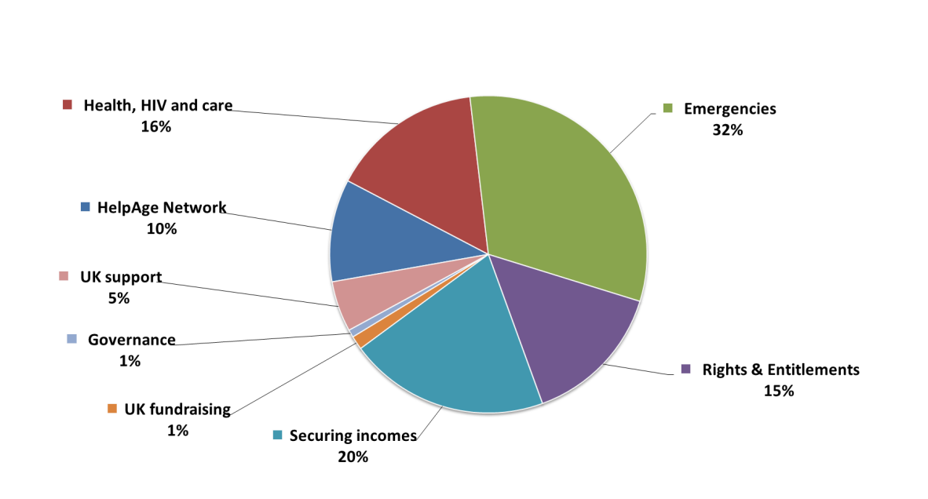
The annual budget is documented separately. Our projected income for 2013-2014 is £28.75 million, compared with our forecast of £27.6 million for 2012-2013 (an increase of four per cent). The charts below provide an indication of how we will meet our income target and how we will spend our funds in 2013-2014:
Programme expenditure by HelpAge’s Global Actions 2013-2014

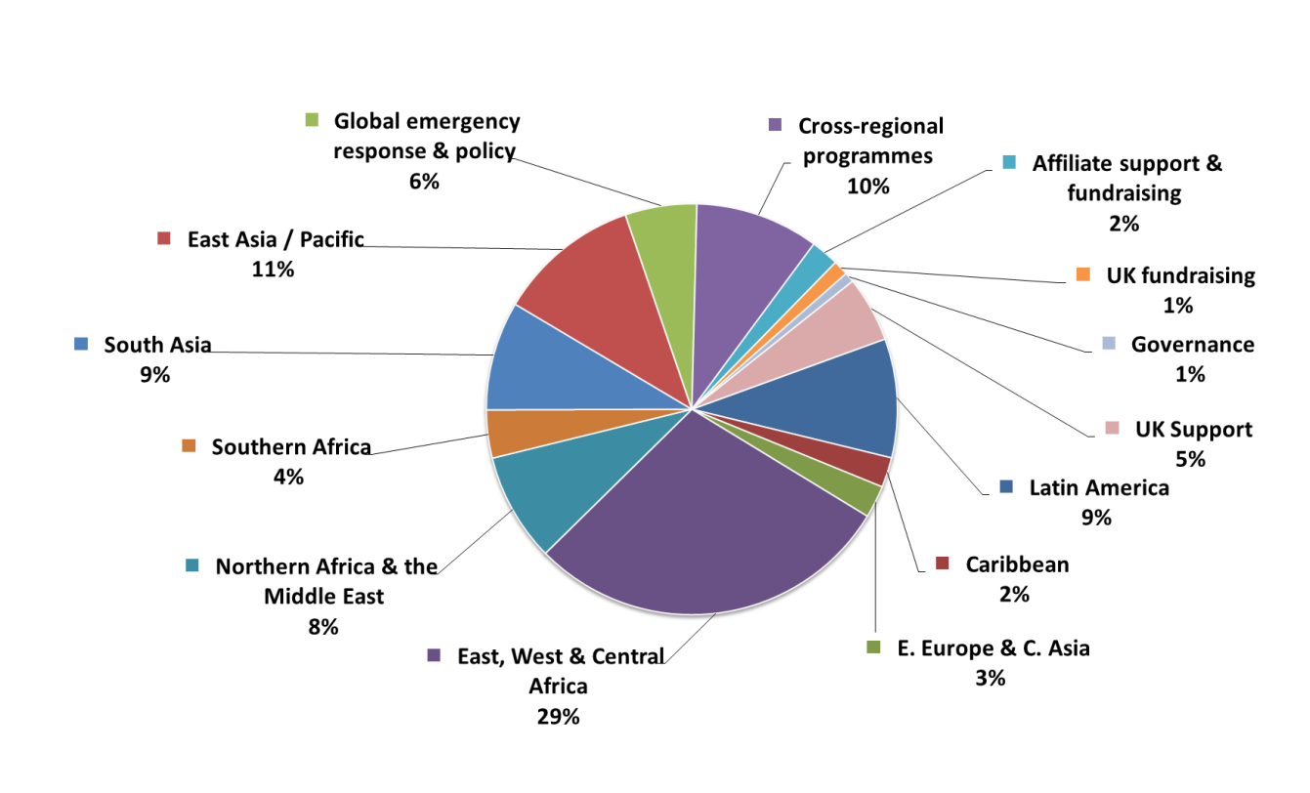

Programme expenditure by location 2013-2014

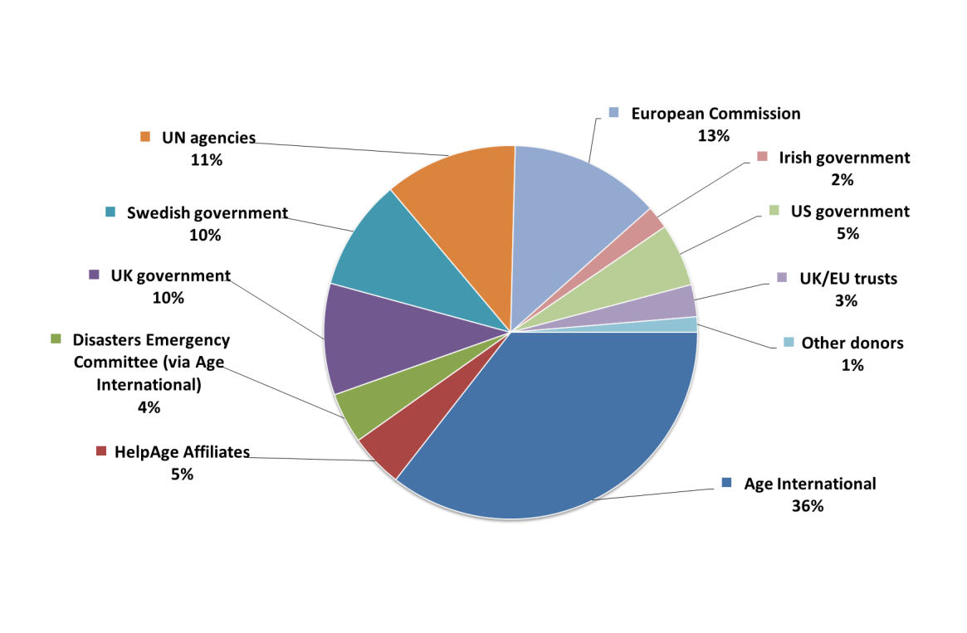

Where we will source our funding

Corporate annual plan to March 2014
HelpAge International
www.helpage.org

Countries with active emergency and recovery interventions are: Colombia, DR Congo, Ethiopia, Haiti, Kenya, the occupied Palestinian territories, Pakistan, Sudan and South Sudan.

